**Exercise 5: IP Subnetting [Configure IP Addresses and Unique Subnets]**

**Objective:** To IP Subnetting [Configure IP Addresses and Unique Subnets]

**Components**:

|  |  |  |  |
| --- | --- | --- | --- |
| S.No. | Device | Model | Qty |
| 1 | PC | pc | 6 |
| 2 | Switch | PT-Switch | 3 |
| 3 | Router | PT-Router | 3 |

**Addressing Table:**

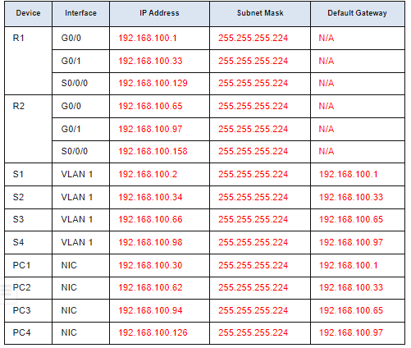

**Procedure:**

**Step 1:** Create a basic setup with 2 pc connected to a switch

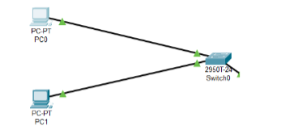

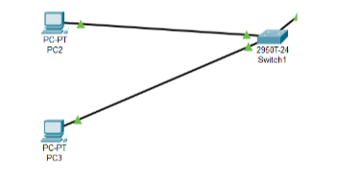**Step 2:** Make another setup like step1

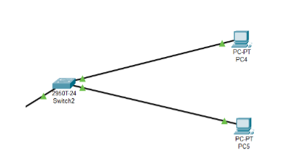**Step 3:** Follow Step1

**Step 4**: Follow step1

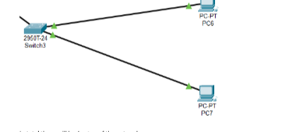

**Step 5:** Connect the first two switch to a router

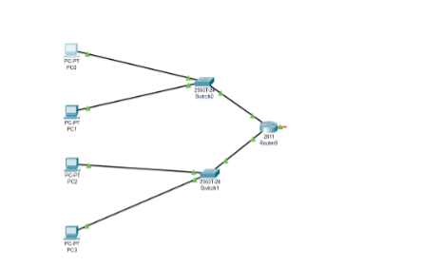

**Step 6:** Follow Step 5 for the remaining 2 setups.

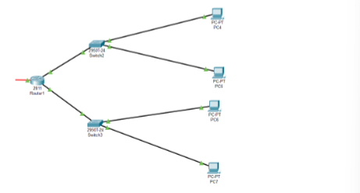

**Step 7:** Connect the two router with serial DCE To establish logical connectivity,

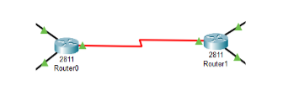

**Step 8:** In final the setup should look like this

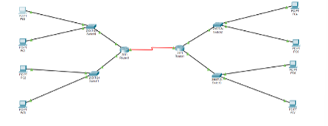

Step 9: Now Configure All the PC with given IP-address , subnet and default gateway as shown below

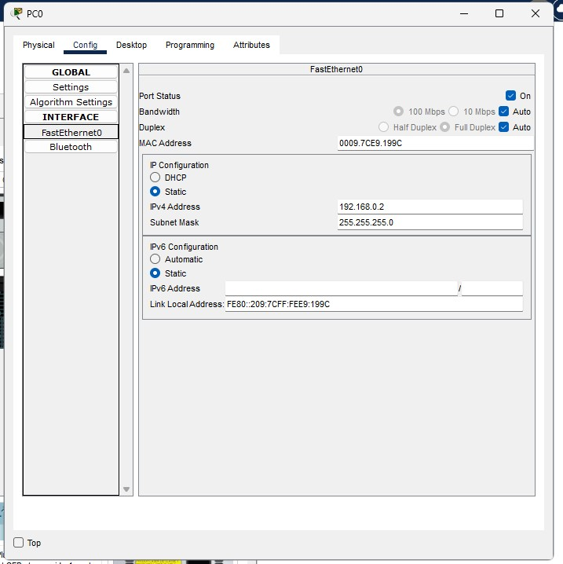

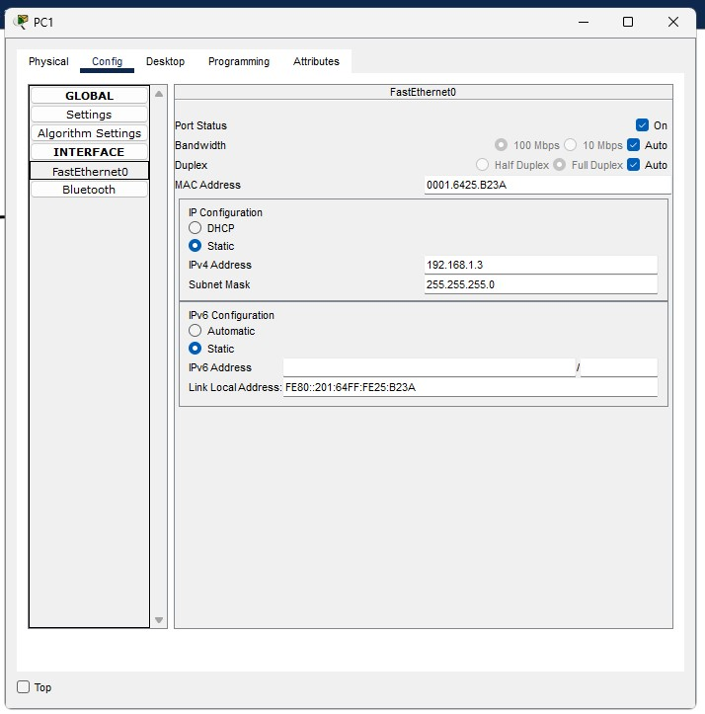

# **Step 10:** Router configuration

* Click on Router0 and select CLI.
* Press ENTER to start configuring Router1.
* Type enable to activate the privileged mode.
* Type config t(configure terminal) to access the configuration menu.
* Configure interfaces of Router1:
* Type interface FastEthernet0/0 to access FastEthernet0/0 and Configure the FastEthernet0/0 interface with the IP address 192.168.10.1 and Subnet mask 255.255.255.0.
* Type interface FastEthernet0/1 to access GigabitEthernet0/0 and Configure the FastEthernet0/1 interface with IP address 192.168.20.1 and Subnet mask 255.255.255.0.
* Type no shutdown to finish.

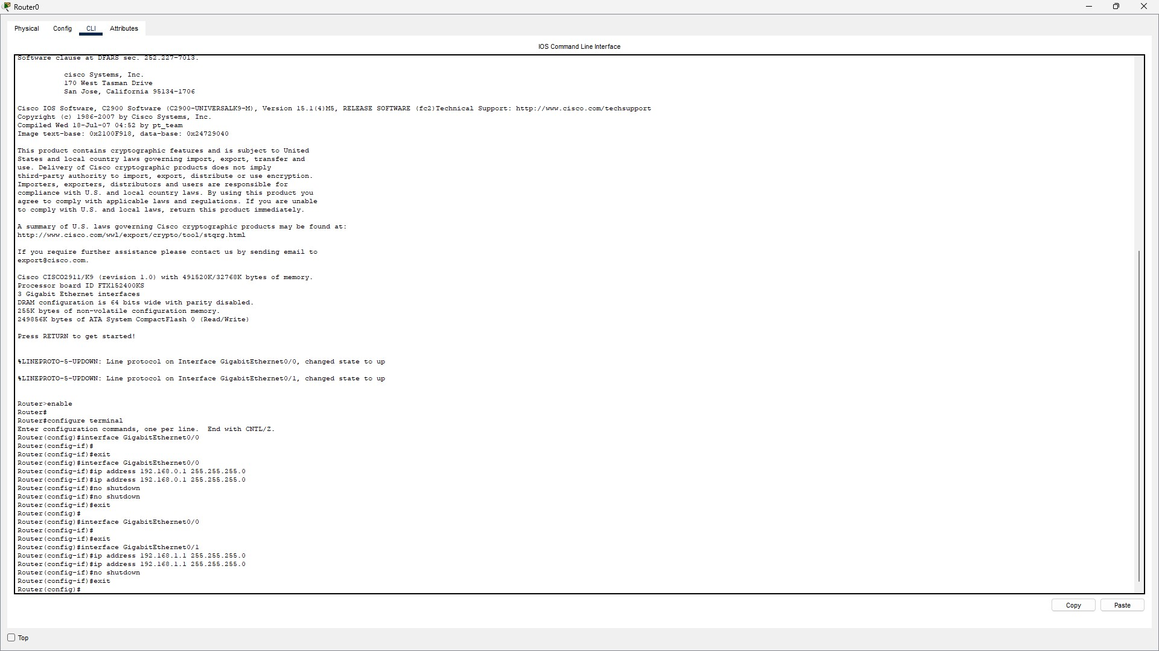

**Step 11**: Switch Configuraon

1. Console into the switch and enable privileged EXEC mode.

# Switch> **enable**

1. Enter configuraon mode.

Switch# **config terminal**

1. Assign a device name to the switch.

Switch(config)# **hostname S1**

1. Configure and acvate the VLAN interface on the switch S1.

S1(config)# **interface vlan 1**

S1(config-if)# **ip address 192.168.1.2 255.255.255.0**

S1(config-if)# **no shutdown** S1(config-if)# **exit**

1. Configure the default gateway for the switch S1.

S1(config)# **ip default-gateway 192.168.1.1**

S1(config-if)# **exit**

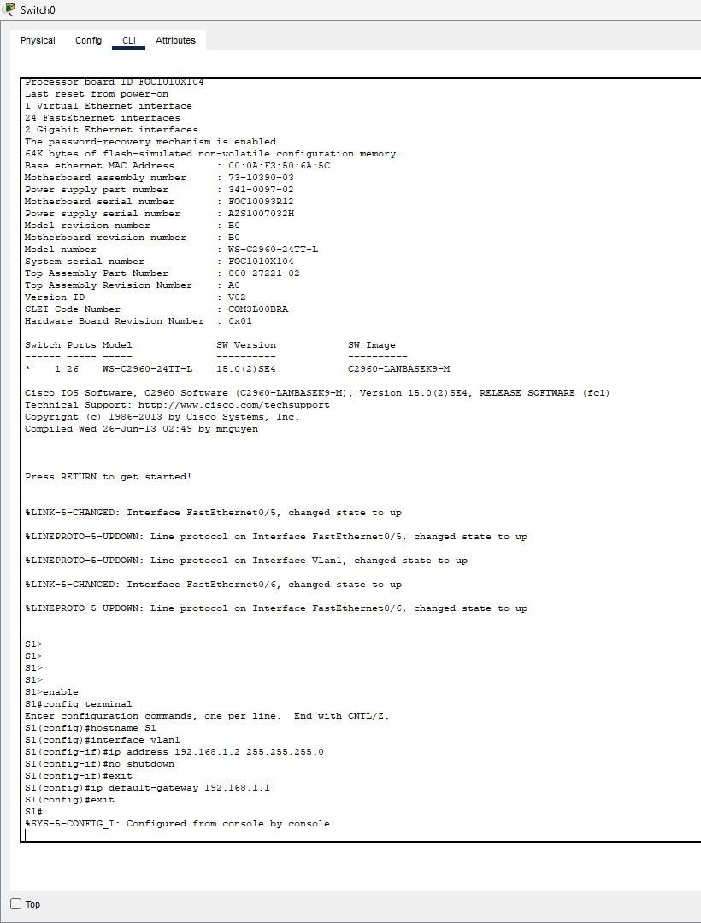

**Step 12:** Now both the PCs are physically and logically connected. To check the logical connectivity,

* + Click on PC1.
  + Select Desktop tab.
  + Click on Command Prompt icon.
  + Type ping 192.168.0.2 to fetch the output as follows

