**Exercise – 6 Static And Default Routing**

**Aim**

To Configure And Verify Static And Default Routing On Cisco Routers Using Packet Tracer.

**Pre-requisite:**

Static Routing, Default Static Routing

**Procedure:**

**To Configure Static Routing in Cisco Packet Tracer**

1. Select Router from Network devices. Place Two Routers.

Select PC from End Devices and place Two PC’s and connect them with copper cross over cables

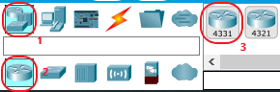 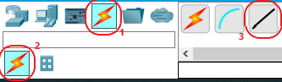 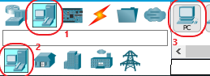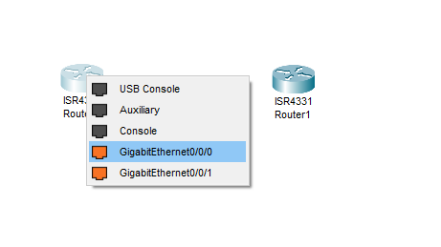

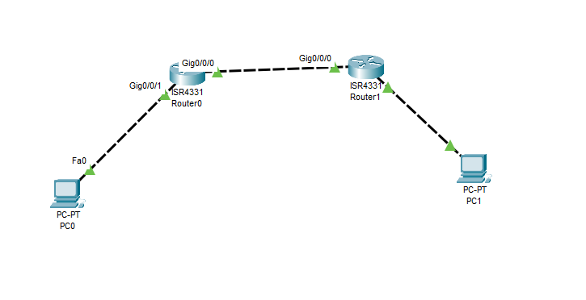

1. Configure the router0 using the following commands in CLI tab

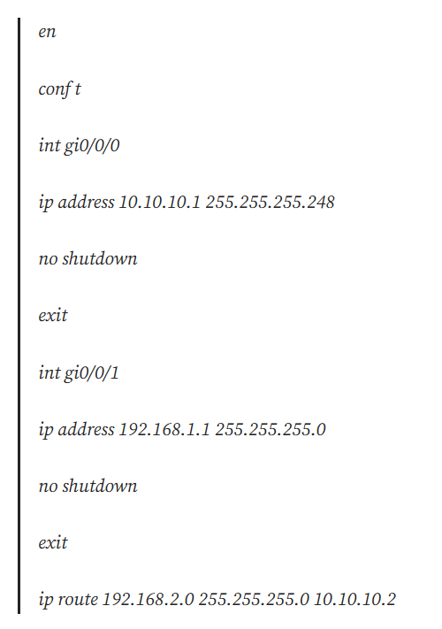

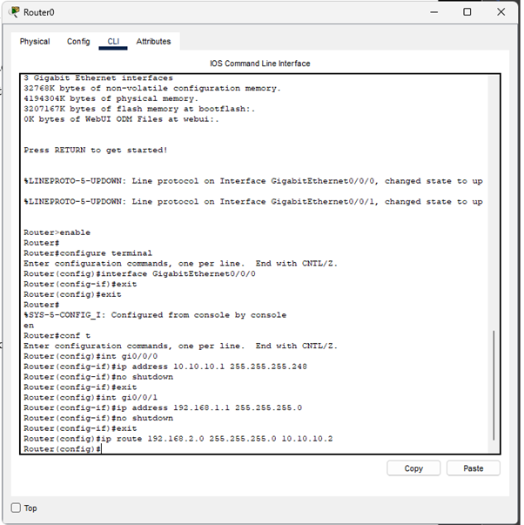

1. Configure the router1 using the following commands in CLI tab

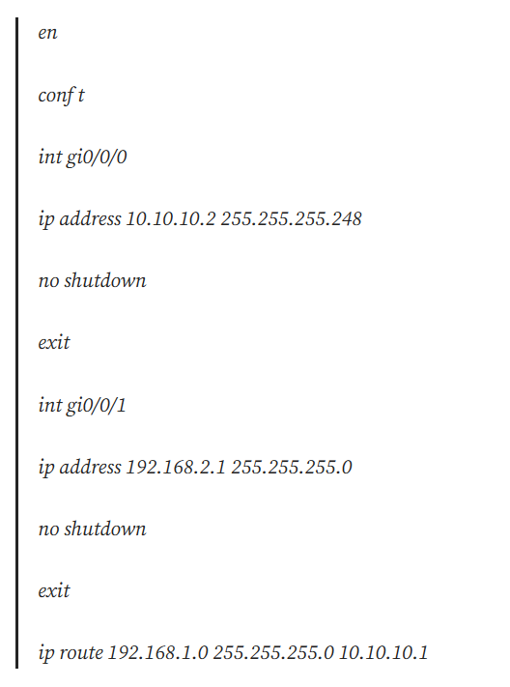

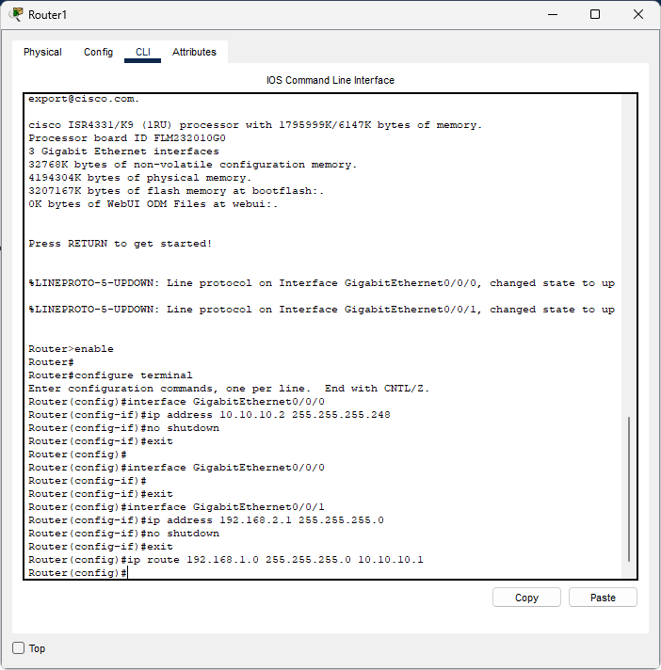

1. Configure the PC

Choose IP Configuration to do IP configurations, and insert the following informations.

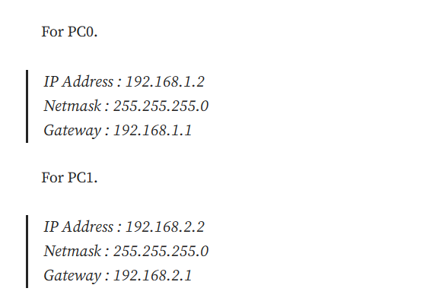

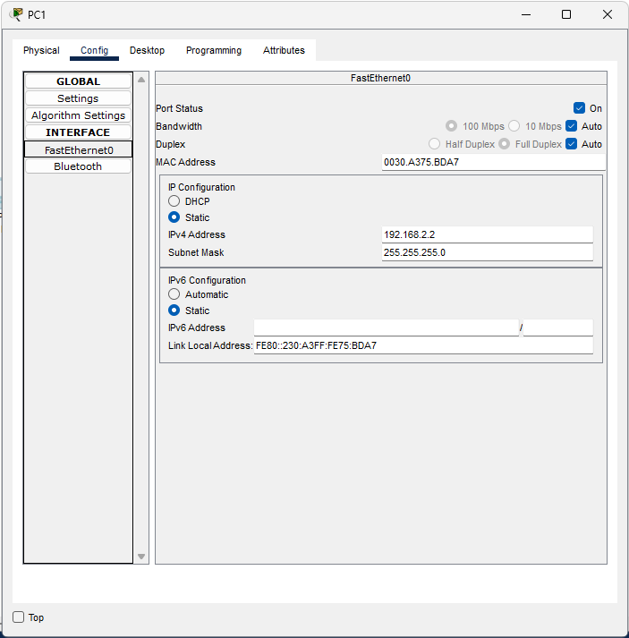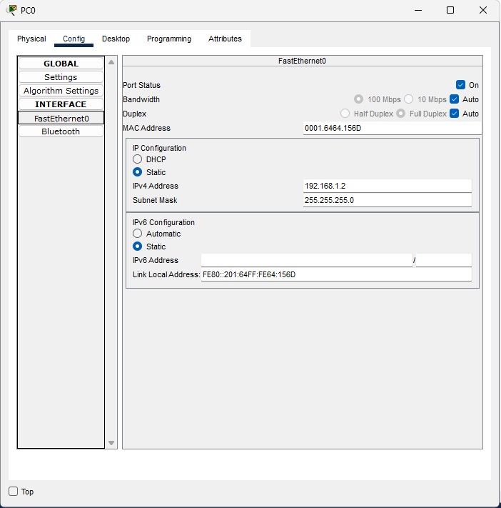

1. Ping test between the two PCs.

ping 192.168.1.2 from PC0, and ping 192.168.2.2 from PC1.

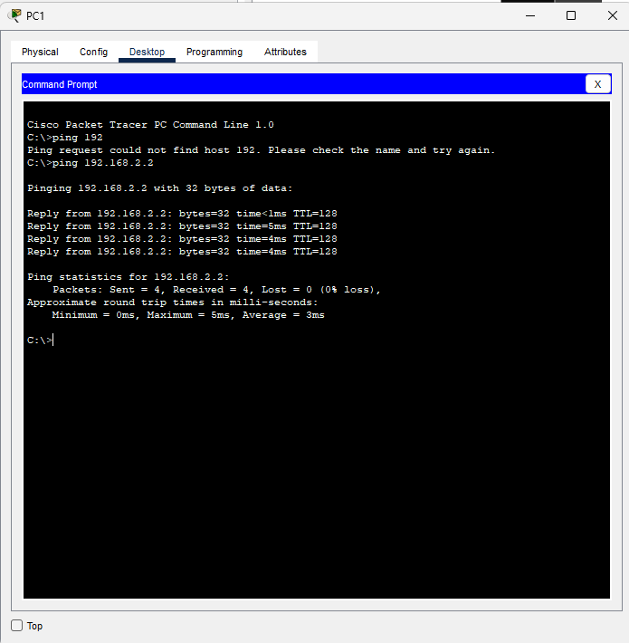

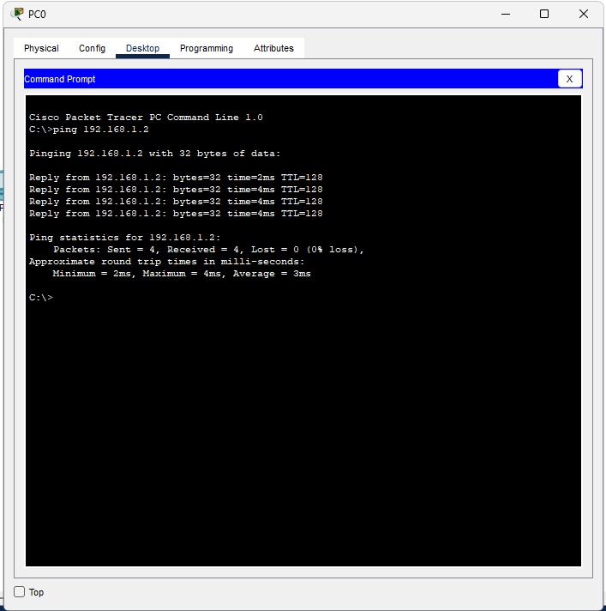

**Conclusion**

We have successfully completed static routing using cicso packet tracer.

**2. Configure a Static Default Route in Cisco Packet Tracer**

1. Place two routers and connect them using Serial Cable using Serial port

2. Place two switches one each side and connect them to router using copper straight through cable using Gigabit port on switch and Fast Ethernet port on router.

3. Connect two computer to switches on each side using same copper straight cable using fast Ethernet port from computer to Switch

4. Connect A server to Router R1 using same copper straight through cable

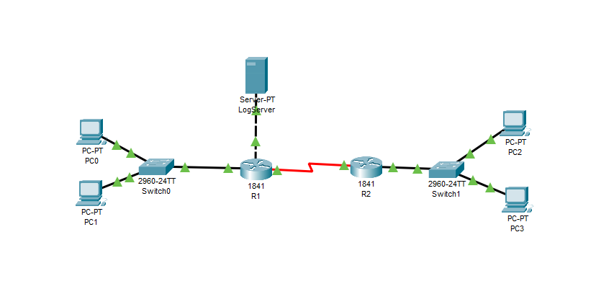

5.Configure the routing on the router R1

Run the following commands on the router R1 from the global configuration mode.

Router(config)#ip route 40.0.0.0 255.0.0.0 30.0.0.2

Router(config)#ip route 0.0.0.0 0.0.0.0 20.0.0.2

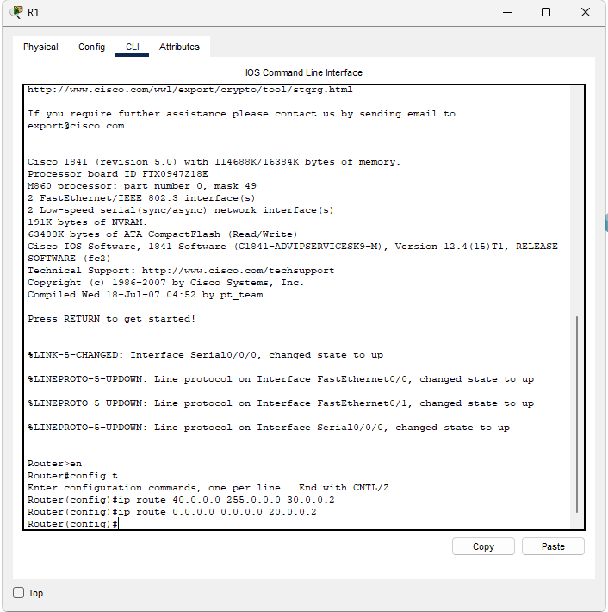

1. Configuring routing on the router R2

Run the following command from the global configuration mode on the router R2.

Router(config)#ip route 0.0.0.0 0.0.0.0 30.0.0.1

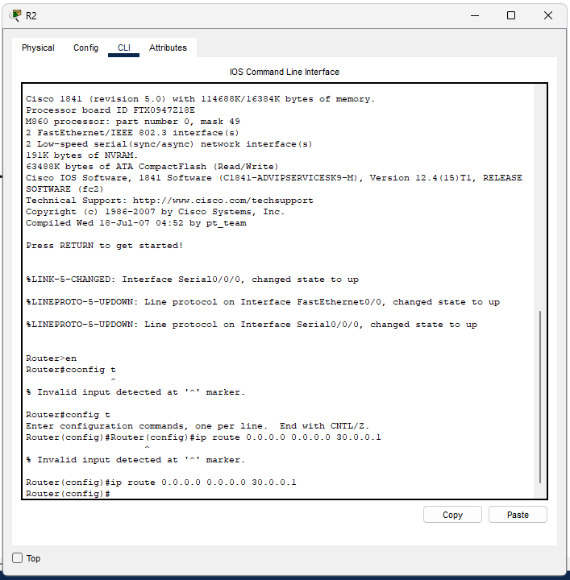

1. Testing the connection 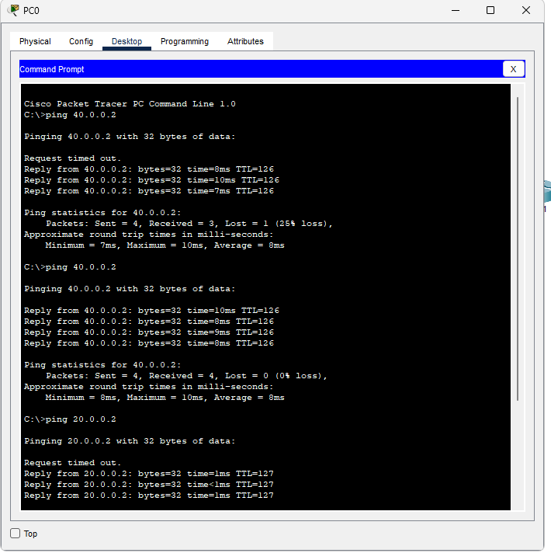

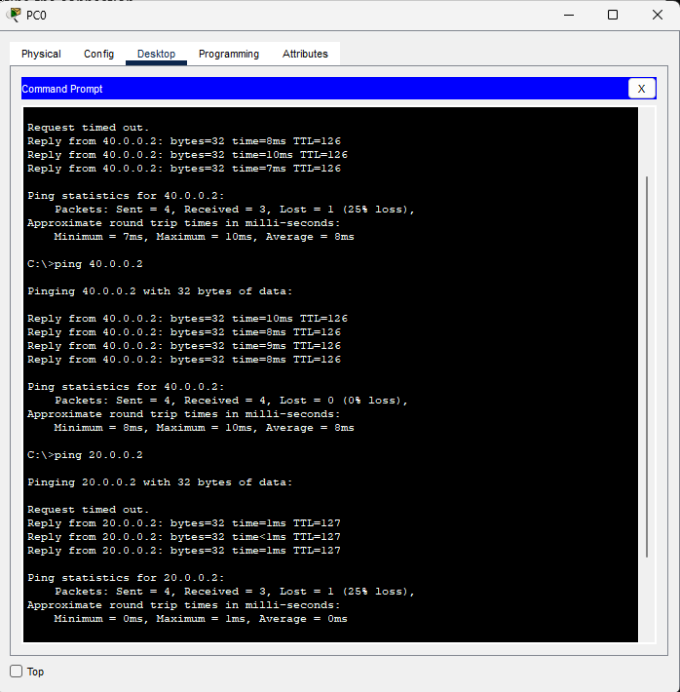

**Conclusion:**

We have successfully configured static and default routes on Cisco routers and verified their functionality.