**Exercise – 7 Static And Dynamic NAT**

**Aim**

To Configure And Verify Static And Dynamic NAT On Cisco Routers Using Packet Tracer.

**Pre-requisite:**

Static NAT, Dynamic Static NAT

**Procedure:**

**To Configure Static NAT in Cisco Packet Tracer**

1. Select Router from Network devices. Place Two Routers and connect them using Serial DTE cable.
2. Select a switch and place it and connect it to router using copper straight cable.
3. Select PC from End Devices and place Three PC’s and connect them with copper cross over cables.
4. Place a server and connect it to second router using copper cross cable.

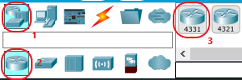

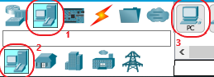

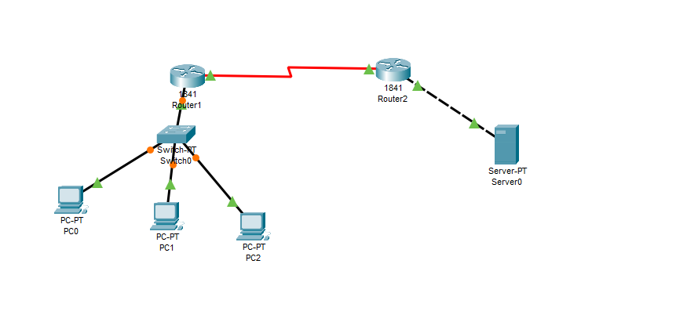

1. Configure the PC’s using the below configuration table

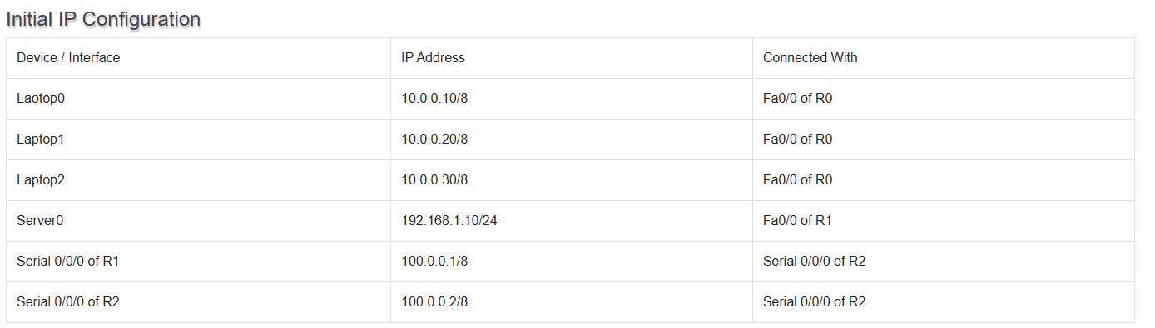

1. Configure Router R0

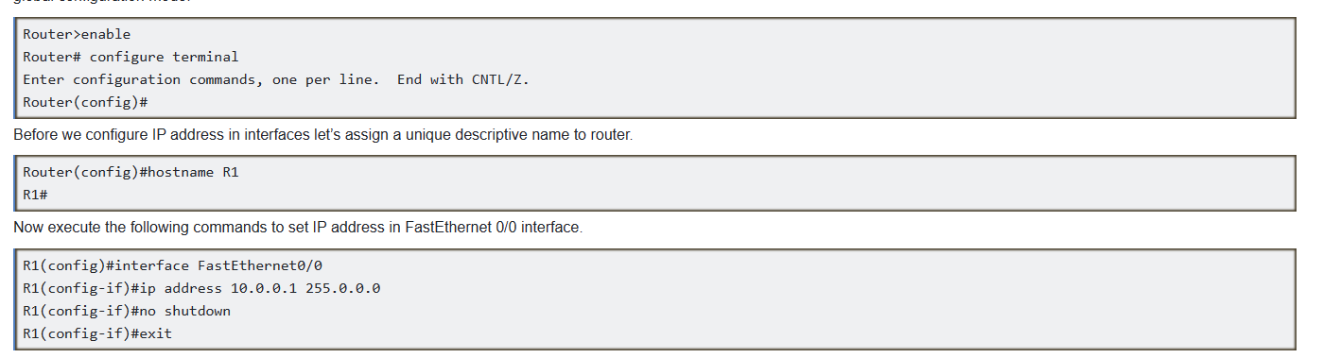

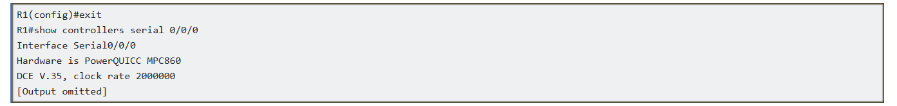 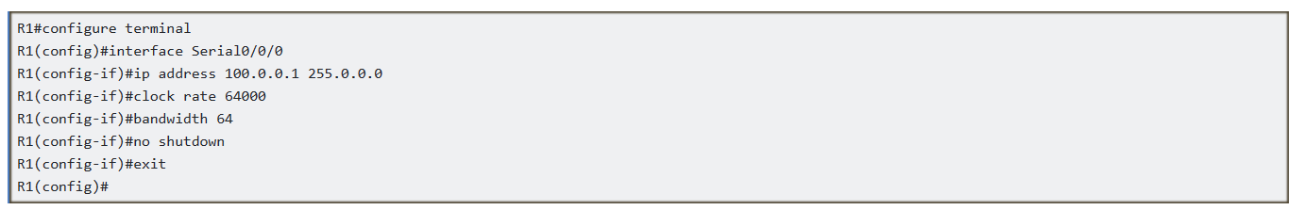

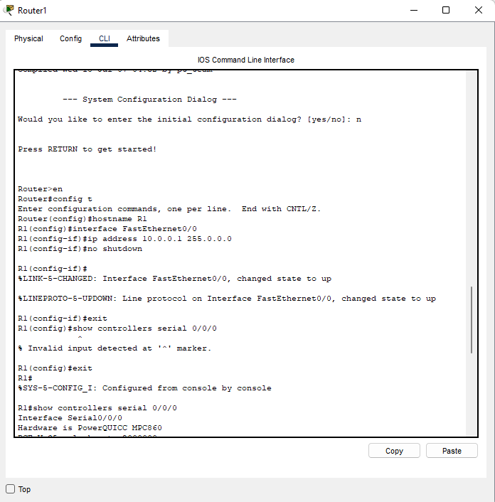 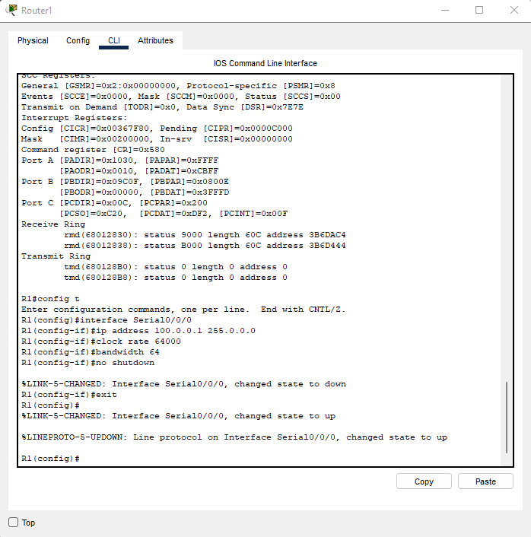 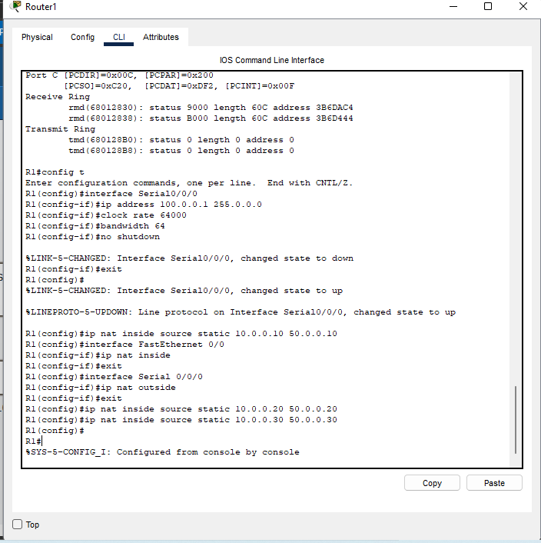 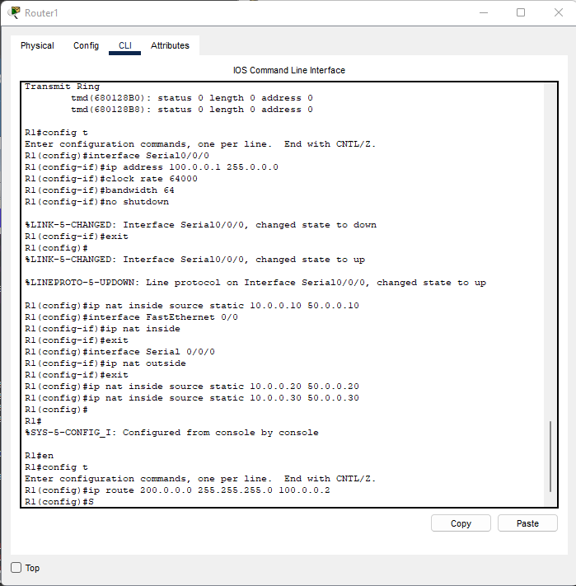 

1. Configure Router R1 using following commands

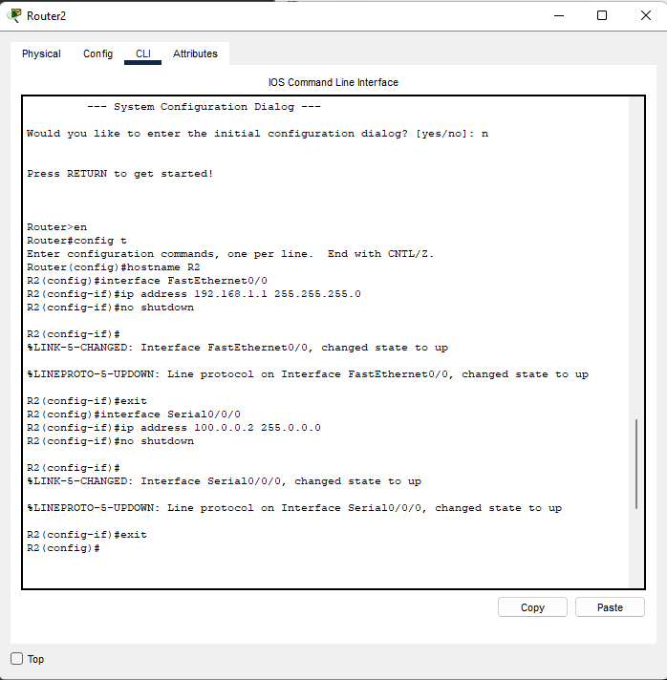 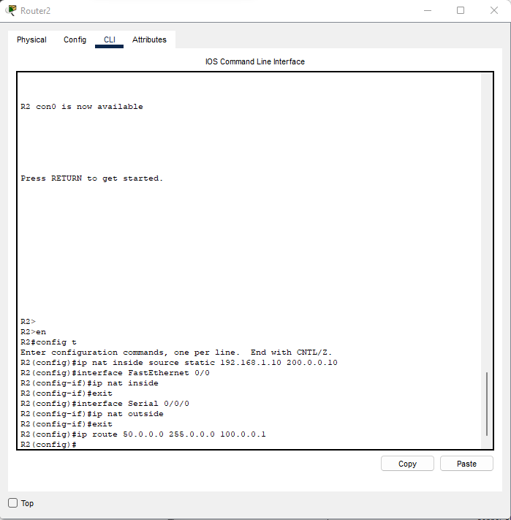

Configure Static NAT

Static NAT configuration requires three steps: -

1. Define IP address mapping
2. Define inside local interface
3. Define inside global interface

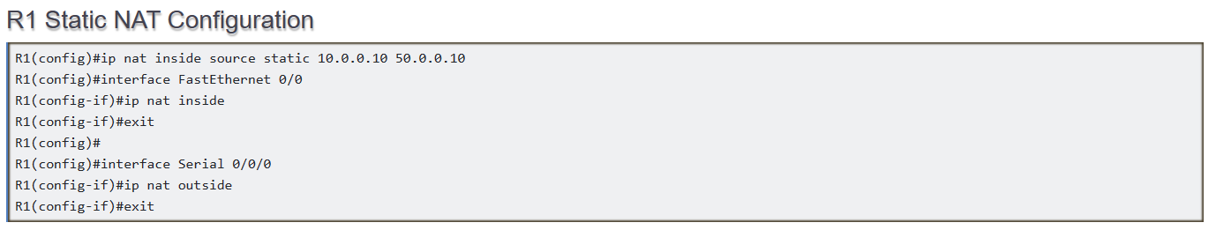



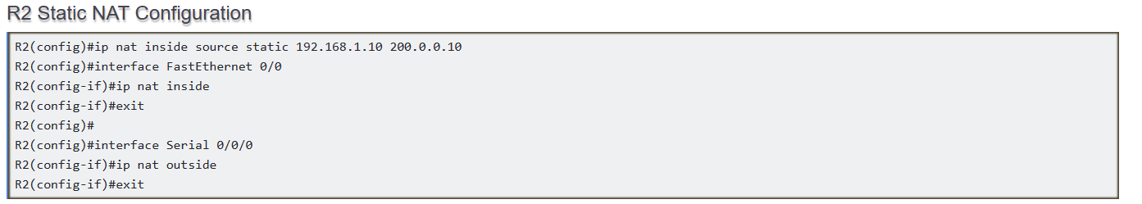 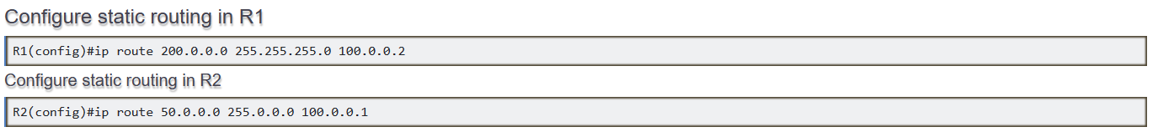

Testing Static NAT Configuration



To test this setup click PC0 and Desktop and click Command Prompt.

* Run **ipconfig** command.
* Run **ping 200.0.0.10** command.
* 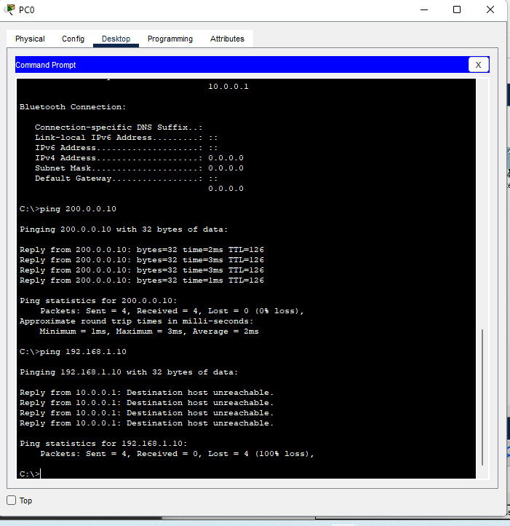Run **ping 192.168.1.10** command.

**Dynamic NAT**

1. Select Router from Network devices. Place Two Routers and connect them using Serial DTE cable.
2. Select a switch and place it on two switches on one side and one switch other side and connect it to router using copper straight cable.
3. Select PC from End Devices and place four PC’s and connect them to the two switches with copper cross over cables.
4. Place two servers and a PC and connect it to second router via third switch using copper cross cable.

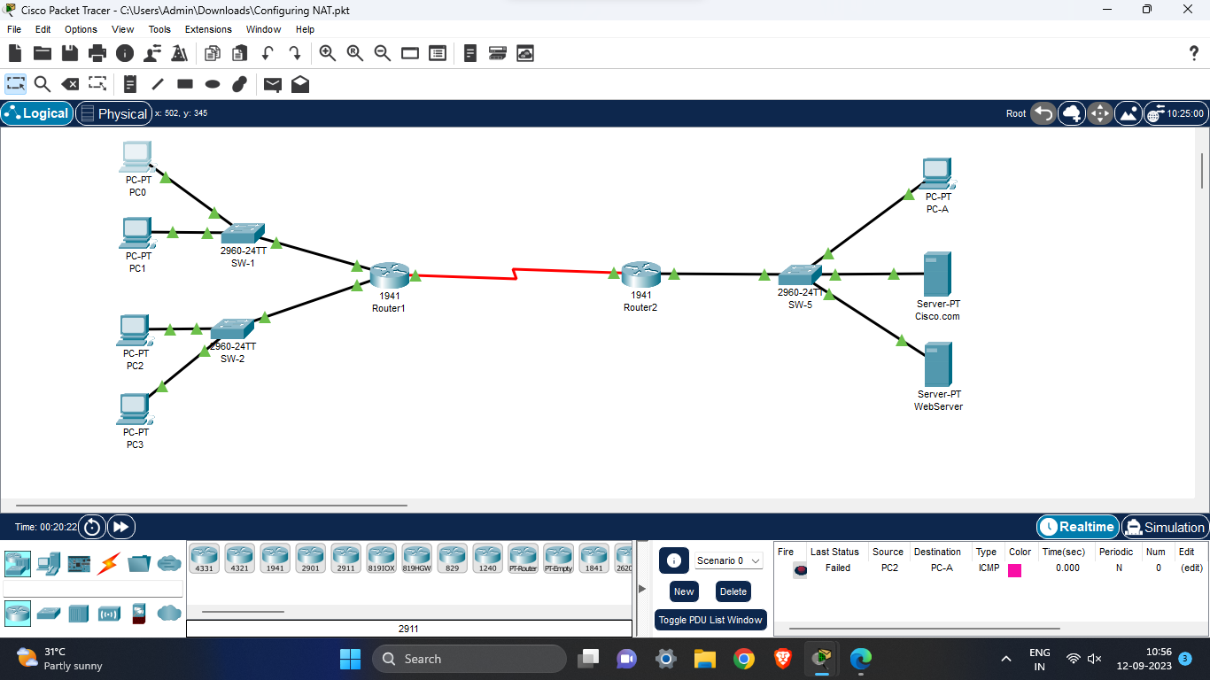

1. 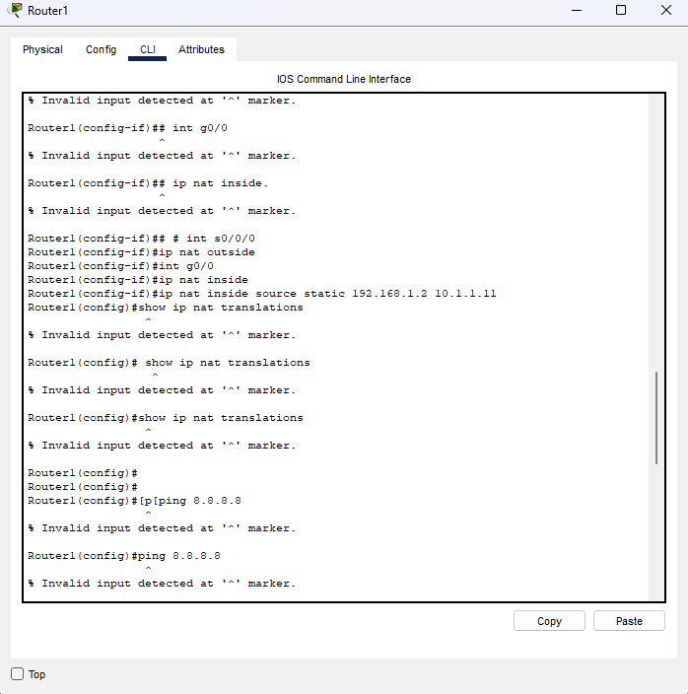Configure the router using following commands
2. Configuring the Dynamic NAT

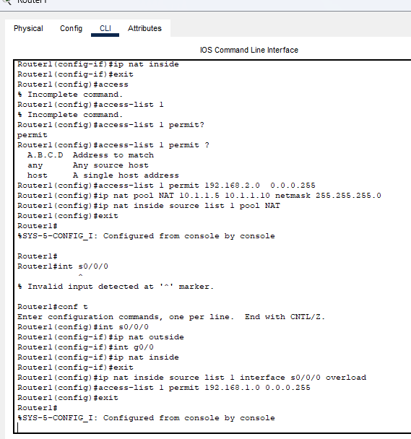

1. Test the connection using ping command on PC3

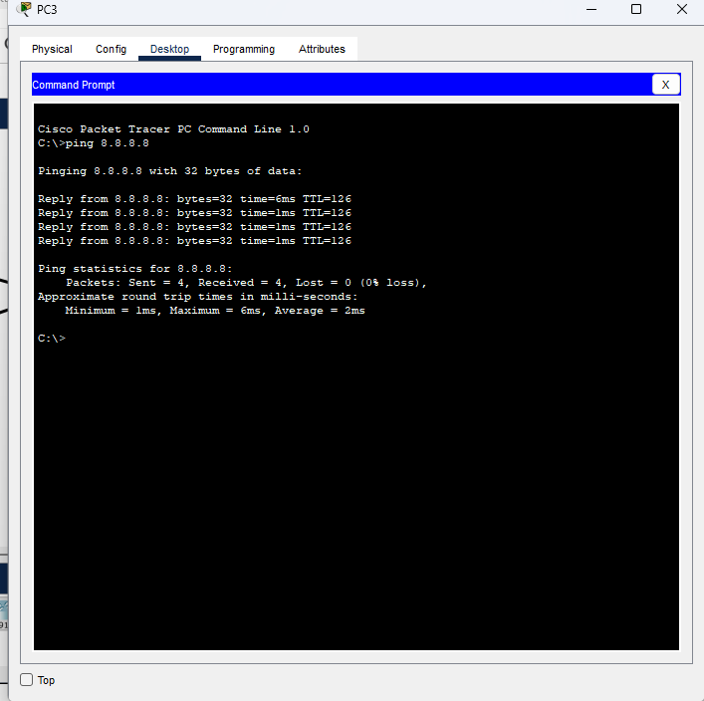

**Conclusion:**

We have successfully configured static and default NAT on Cisco routers and verified their functionality.