**Exercise – 8 Implementation of RIP 1 and RIP 2**

**Aim**

To Configuring RIP Versions 1 and 2 on Cisco Routers Using Packet Tracer.

**Pre-requisite:**

Routing Information Protocol (RIP)

**Procedure:**

**Configuration of RIP Versions 1:**

1. From the Network Devices category, select routers, and from the devices drag 4 2911 routers into the workspace.
2. Select the End Devices sub-category from End Devices, and drag 3 PCs into the workspace.
3. Connect all the devices using crossover cables.
4. Assign IP addresses to PCs and Router interfaces according to the topology in the below image. 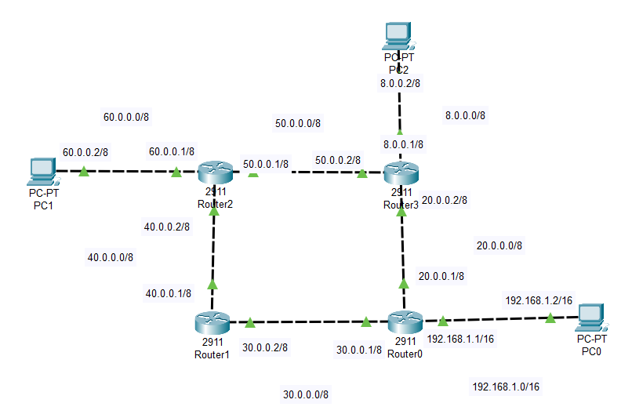
5. For configuring a PC, Click on a PC and a window will open, select desktop and then IP configuration, and enter the required IP, subnet mask, and default gateway.
6. For configuring Router, click on the router, in the new window select the Config tab, click on the connected interfaces, add their IPs and subnet masks, and switch on the interface. For IP assignment using CLI, navigate to the CLI tab in the Router window, and then follow commands given below.\

* Router>enable
* Router#configure terminal
* Enter configuration commands, one per line. End with CNTL/Z.
* Router(config)#interface gig0/0
* Router(config-if)#ip address 192.168.1.1 255.255.255.0
* Router(config-if)#no shutdown

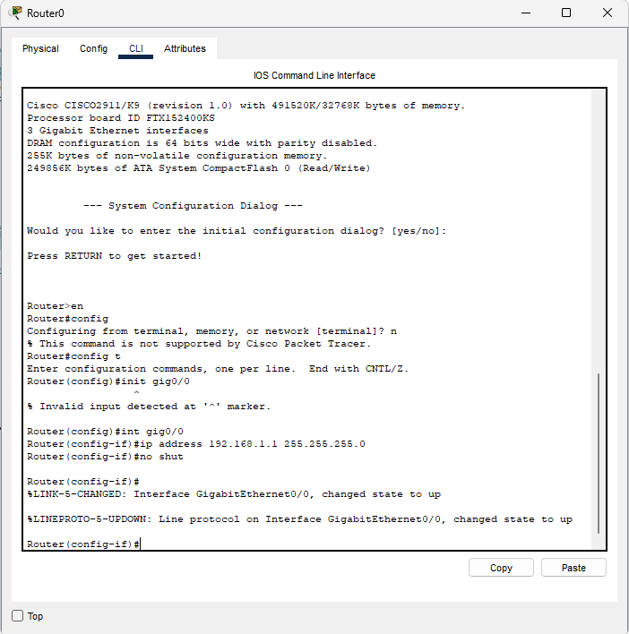

1. Similarly configure all the routers and PC’s
2. Now for configuring routing, first click Router 0, navigate to the CLI tab, enter no for entering initial configuration mode if prompted, and then enter the following commands on the CLI prompt to configure RIP version 1.

* Router>enable
* Router#configure terminal
* Enter configuration commands, one per line. End with CNTL/Z.
* Router(config)#router rip
* Router(config-router)#network 192.168.1.0
* Router(config-router)#network 30.0.0.0
* Router(config-router)#network 20.0.0.0

1. Similarly configure other routers, Router1, Router2, and Router3 according to connected networks using the above commands as a reference and using their specific neighbor network IPs in the above-mentioned syntax.
2. Test the connection by using the ping utility in the command prompt in a PC to reach another PC in other networks, the first packet might possibly not reach as it takes time for config to apply. The output might be similar to the image shown below.

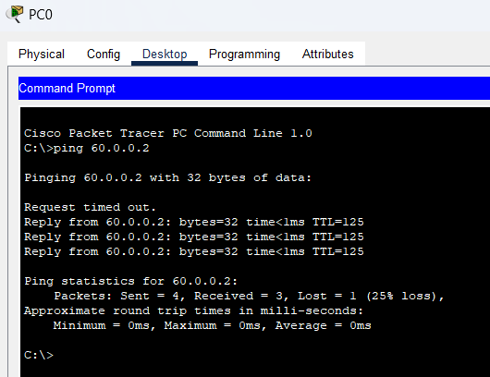

**Configuration of RIP Versions 2:**

1. From the Network Devices category, select routers, and from the devices drag 2 2911 routers into the workspace.
2. Select the End Devices sub-category from End Devices, and drag 3 PCs into the workspace.
3. Connect all the devices using crossover cables.

Assign IP addresses to PCs and Router interfaces according to the topology in the below image.

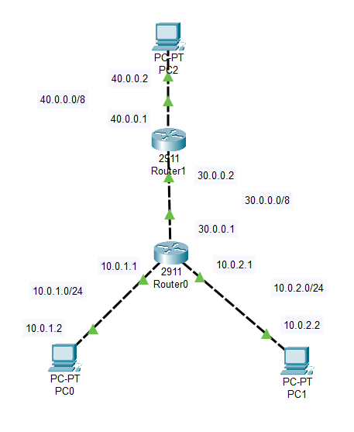

1. Assign IPs to PCs using the same method as above.

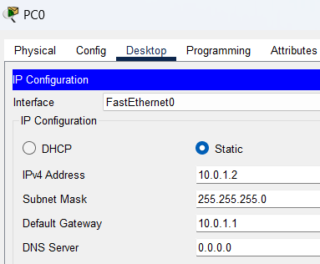

1. Now for Routing using RIP v2, open the CLI in routers and enter the following commands, for Router 0.

* Router>enable
* Router#configure terminal
* Enter configuration commands, one per line. End with CNTL/Z.
* Router(config)#router rip
* Router(config-router)#network 10.0.1.0
* Router(config-router)#network 10.0.2.0
* Router(config-router)#network 30.0.0.0
* Router(config-router)#version 2

1. Connectivity can be confirmed by ping utility, below is an example where we ping PC2 using PC0.

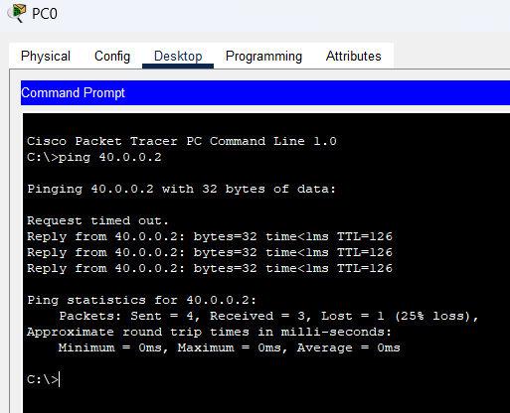

**Conclusion:**

We have successfully configured RIP V1 and RIP V2 on Cisco routers and verified their functionality.