**Exercise – 9 SINGLEAREA OSPF**

**Aim**

To Configuring single area OSPF

**Pre-requisite:**

Open Shortest Path First (OSPF) protocol

**Procedure:**

1. From the Network Devices category, select routers, and from the devices drag 3 routers into the workspace.
2. Select the End Devices sub-category from End Devices, and drag 3 PCs into the workspace.
3. Connect all the devices using crossover cables via switches and connect routers using serial DTE cables.

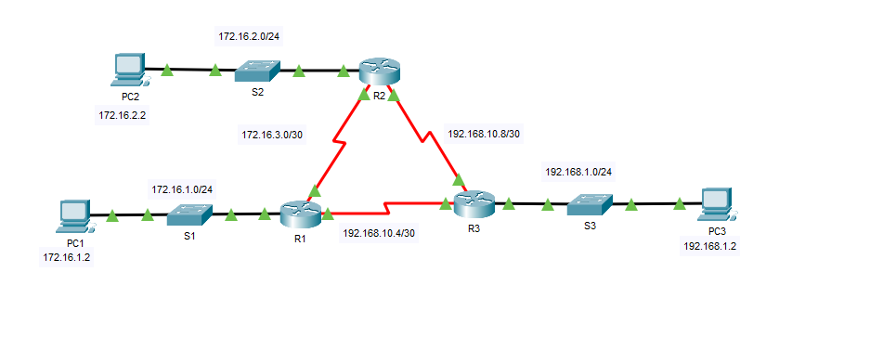

1. Assign the ip-addresses using the address table given below

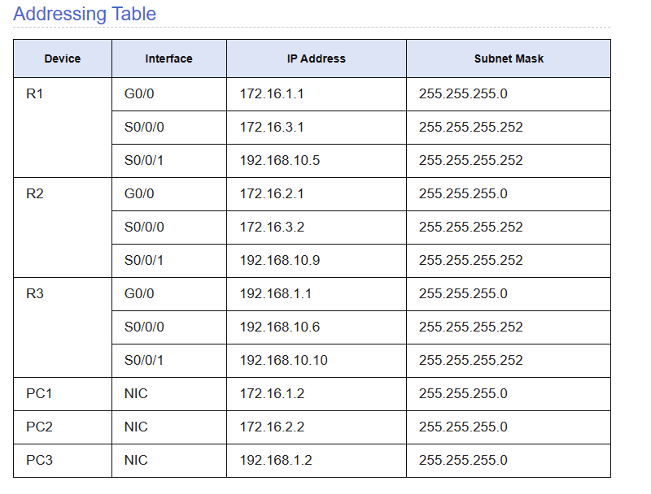

1. Configure the OSPF on the routers R1 using the following commands

* enable
* conf t
* router ospf 10
* router-id 1.1.1.1
* network 172.16.1.0 0.0.0.255 area 0
* network 172.16.3.0 0.0.0.3 area 0
* network 192.168.10.4 0.0.0.3 area 0
* passive-interface GigabitEthernet0/0
* end

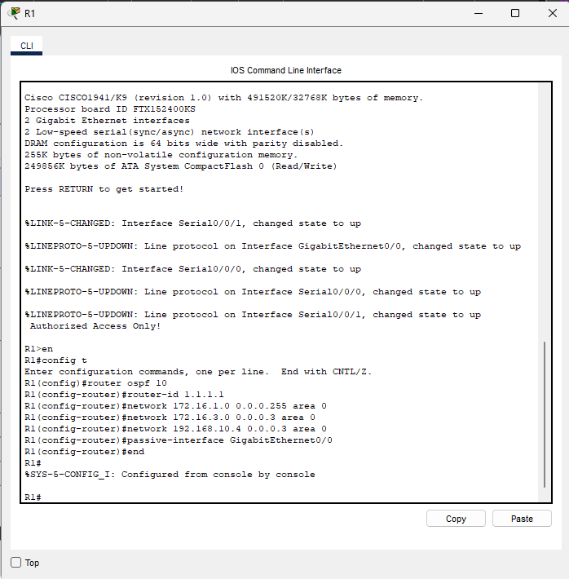

1. Similarly Configure the router R2 with following commands
   * enable
   * conf t
   * router ospf 10
   * router-id 2.2.2.2
   * network 172.16.2.0 0.0.0.255 area 0
   * network 172.16.3.0 0.0.0.3 area 0
   * network 192.168.10.8 0.0.0.3 area 0
   * passive-interface GigabitEthernet0/0
   * end

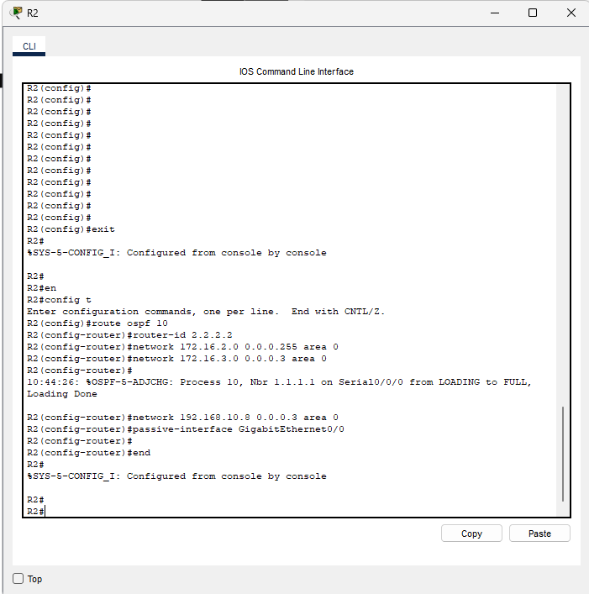

1. Similarly Configure the router R3 with following commands

* enable
* conf t
* router ospf 10
* router-id 3.3.3.3
* network 192.168.1.0 0.0.0.255 area 0
* network 192.168.10.4 0.0.0.3 area 0
* network 192.168.10.8 0.0.0.3 area 0
* passive-interface GigabitEthernet0/0
* end

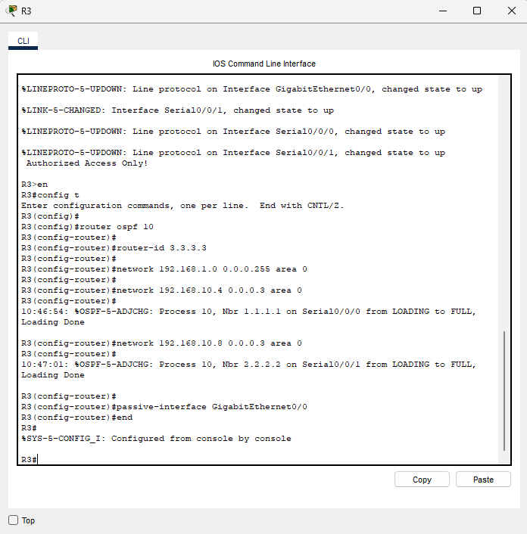

1. Run the ping command from PC1 to check the connection.
   * ping 192.168.1.2
   * ping 172.16.2.2

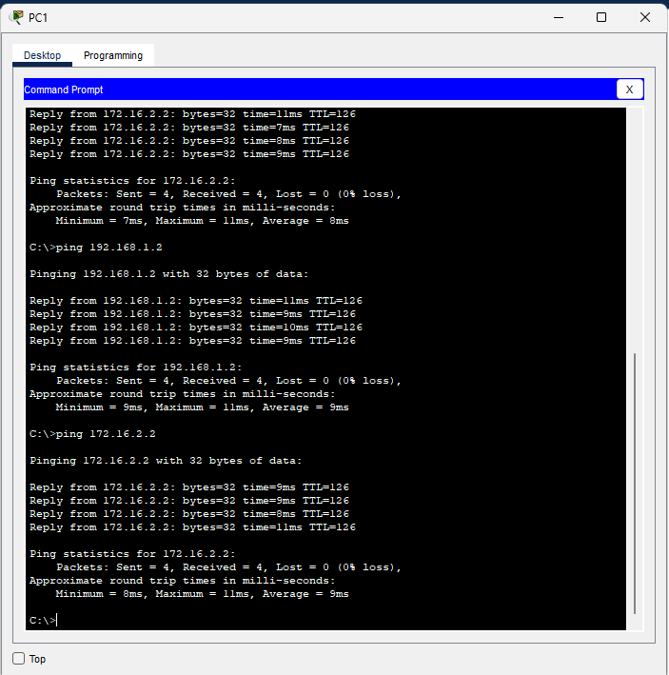

**Conclusion**

We have successfully configured single area OSPF using cisco packet tracer.