**Exercise – 10 MULTIAREA OSPF**

**Aim**

To Configuring multiarea OSPF

**Pre-requisite:**

Open Shortest Path First (OSPF) protocol

**Procedure:**

1. From the Network Devices category, select routers, and from the devices drag 3 routers into the workspace.
2. Select the three PT-cloud from multiarea emulation and connect them to the routers.
3. Connect routers using serial DTE cables.

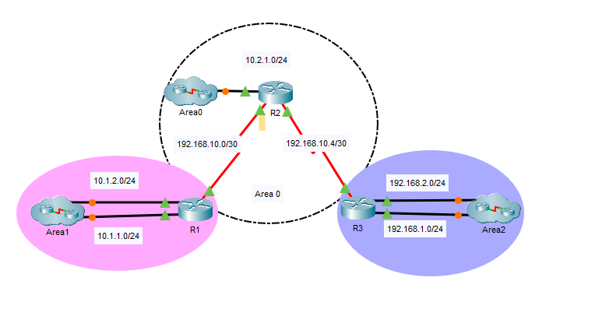

1. 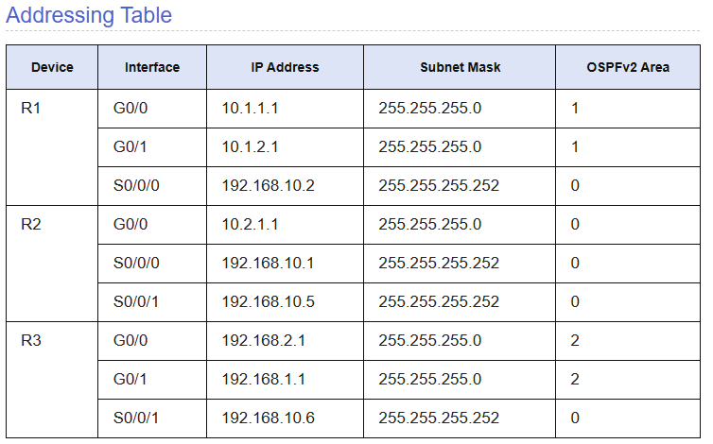Assign the ip addresses from the address table given below

1. Configure the OSPF on router R1

* router ospf 1
* router-id 1.1.1.1
* network 10.1.1.0 0.0.0.255 area 1
* network 10.1.1.0 0.0.0.255 area 1
* network 192.168.10.0 0.0.0.3 area 0

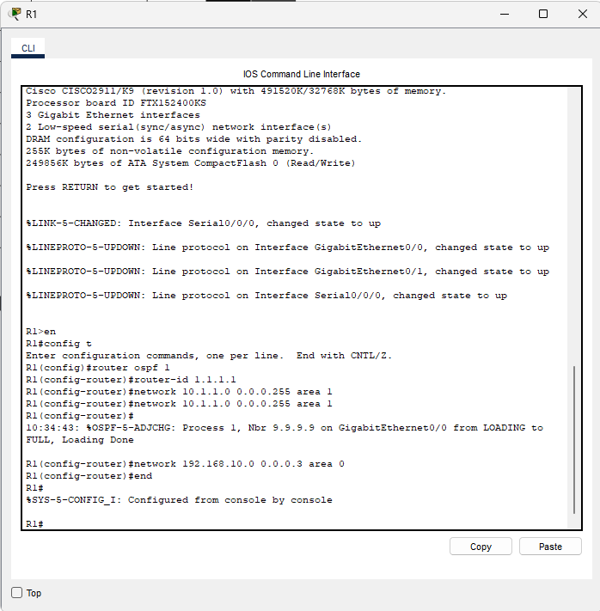

1. Configure the OSPF on router R2 using the following the commands
   * router ospf 1
   * router-id 2.2.2.2
   * network 10.2.1.0 0.0.0.255 area 0
   * network 192.168.10.0 0.0.0.3 area 0
   * network 192.168.10.4 0.0.0.3 area 0

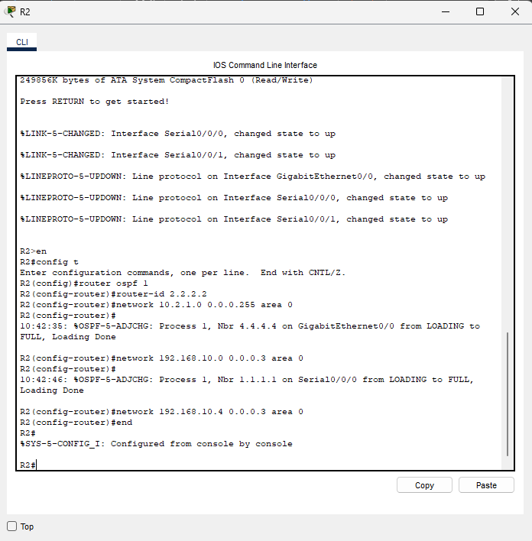

1. Configure the OSPF on router R3 using the following the commands

* router ospf 1
* router-id 3.3.3.3
* network 192.168.2.0 0.0.0.255 area 2
* network 192.168.1.0 0.0.0.255 area 2
* network 192.168.10.4 0.0.0.3 area 0

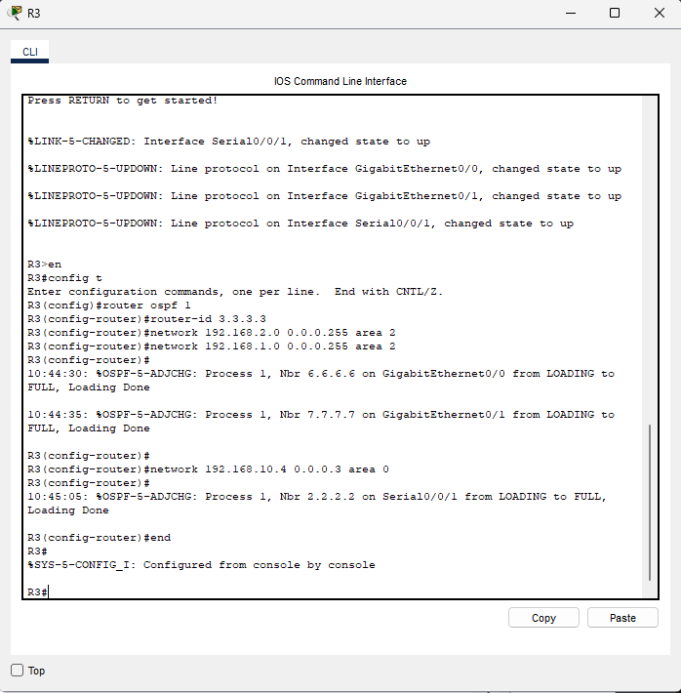

1. Run the ping command from router R1 to check the connection.

* ping 192.168.1.2
* ping 192.168.2.2
* ping 10.2.1.2

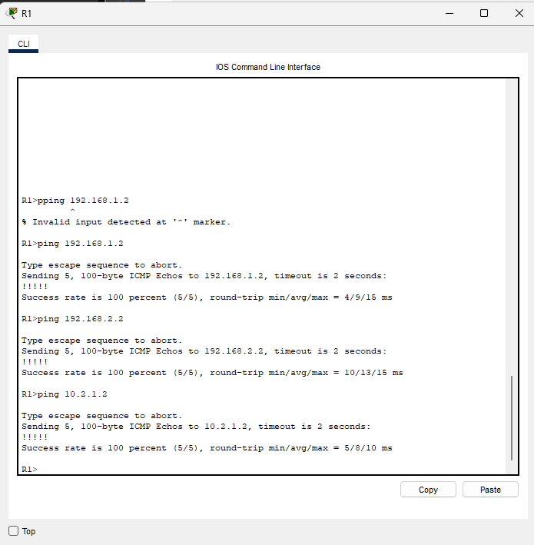

**Conclusion**

We have successfully configured multi area OSPF using cisco packet tracer.