Exercise – 11 HDLC-Configuration

Aim

To Configure HDLC Protocol

Prerequisite:

HDLC Protocol

Procedure:

1. From the Network Devices category, select routers, and from the devices drag 2

routers into the workspace.

1. Connect connect routers using serial DTE cables.
2. To configure Cisco HDLC, firstly we will enable HDLC under the interface and after that, we will configure interface ip addresses. To enable HDLC, we will use “encapsulation hdlc” command under the interface. Here, we will do this under serial 0/0/0 interface.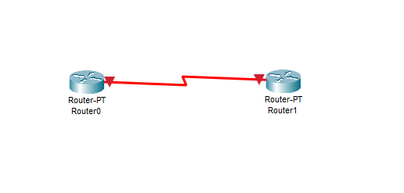
3. Use the following commands to configure the router R1 using CLI

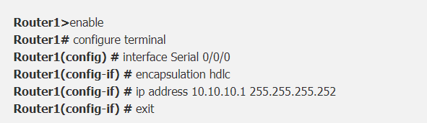

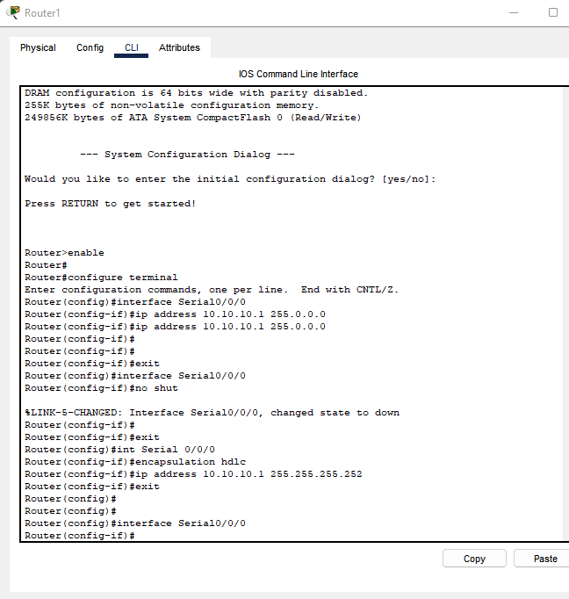

1. Use the following commands to configure the router R2 using CLI

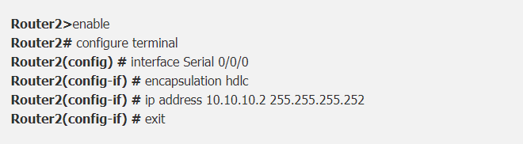

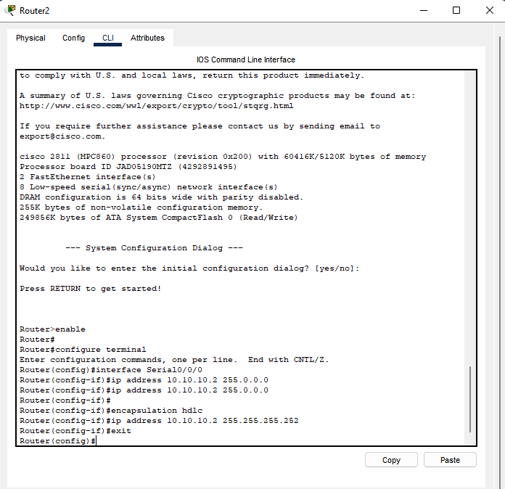

1. To verify Cisco HDLC configuration, on both routers we will use ping command.

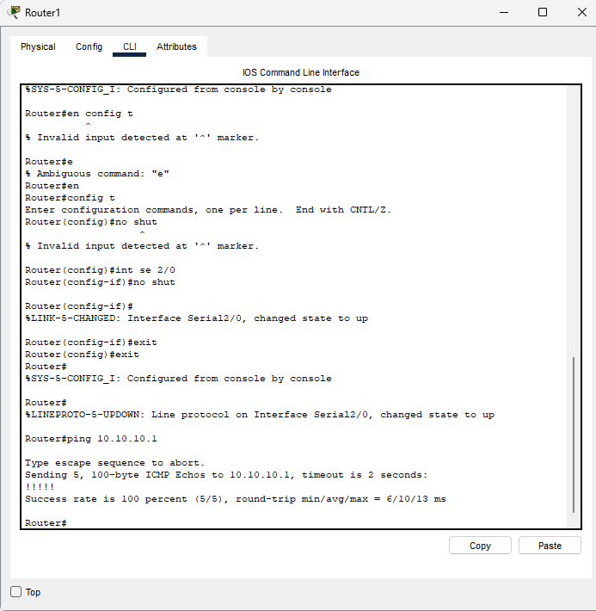

**CONCLUSION**

We have successfully configured HDLC configuration on two router using cisco packet tracer.