Exercise – 12 PPP-Configuration

Aim

To Configure Point to Point Protocol

Prerequisite:

Point to Point Protocol

Procedure:

Procedure:

1. From the Network Devices category, select routers, and from the devices drag 2

routers into the workspace.

1. Connect routers using serial DTE cables.
2. To configure Cisco PPP, firstly we will enable PPP under the interface and after that, we will configure interface ip addresses. To enable PPP, we will use “encapsulation PPP” command under the interface. Here, we will do this under serial 0/0/0 interface.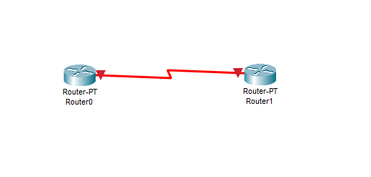
3. Use the following commands to configure the router R1 using CLI 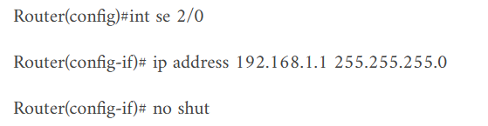

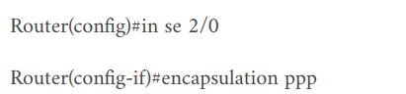 

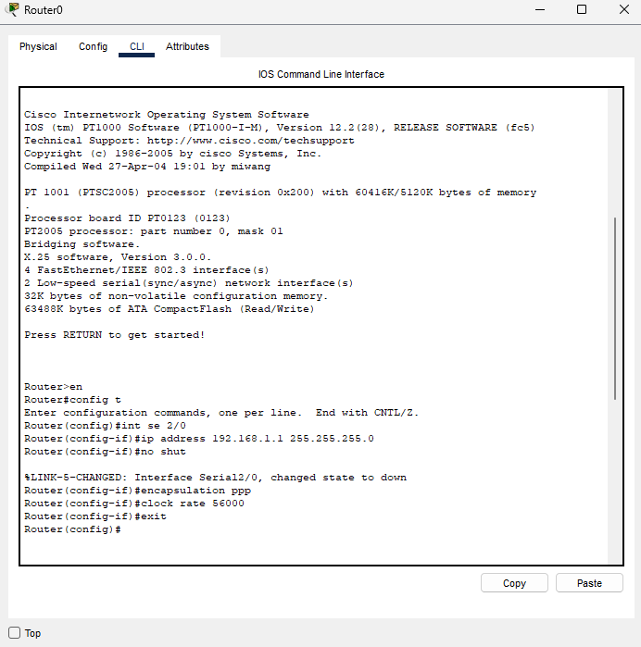

1. Use the following commands to configure the router R2 using CLI

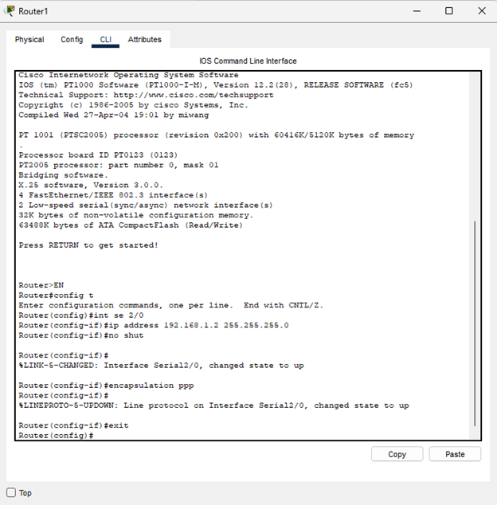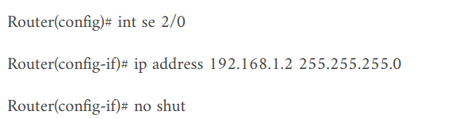 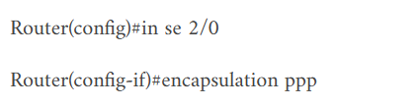

1. To verify Cisco PPP configuration, on both routers we will use ping command.

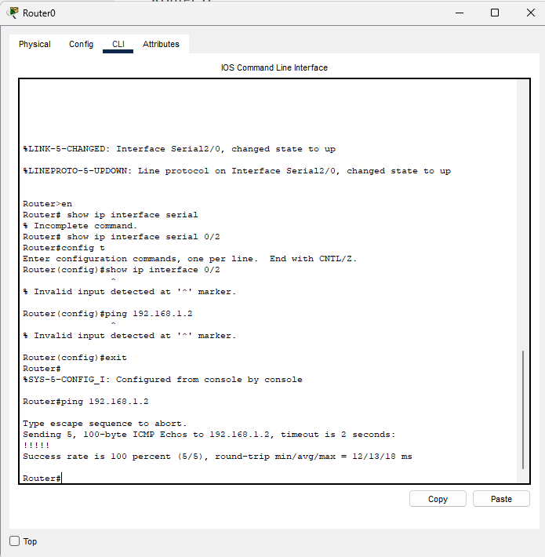

**CONCLUSION**

We have successfully configured PPP configuration on two router using cisco packet tracer.