**Exercise – 13 BGP Protocol**

**Aim**

To Configuring BGP protocol

**Pre-requisite:**

BGP protocol

**Procedure:**

1. From the Network Devices category, select routers, and from the devices drag 2 routers and 2 PC into the workspace.
2. Using the serial DTE cable connect the routers
3. Connect routers using serial DTE cables and connect the PC using copper cross over cables

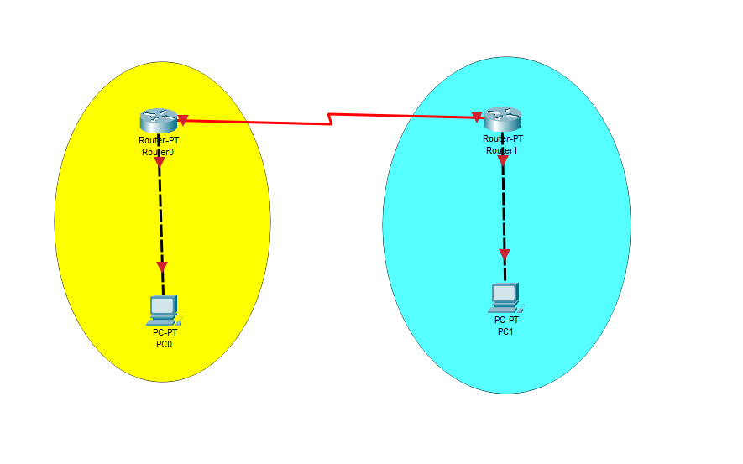

1. Set the IP address of PC0 using ip config

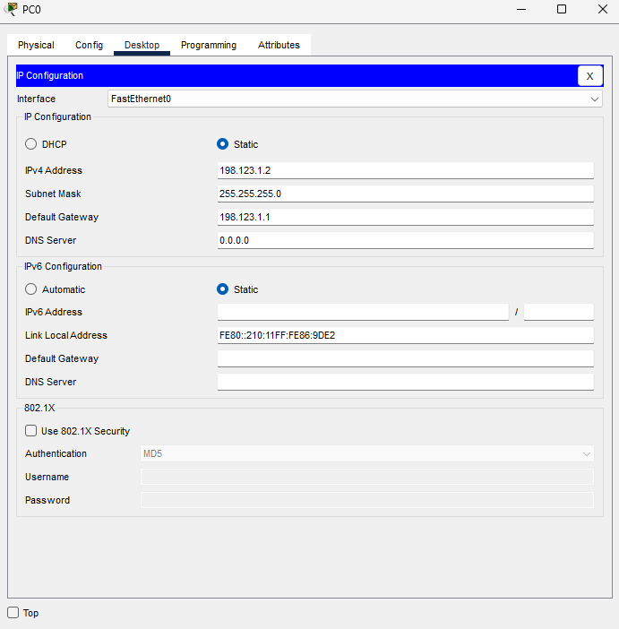

1. Similarly set the Ip address for PC1

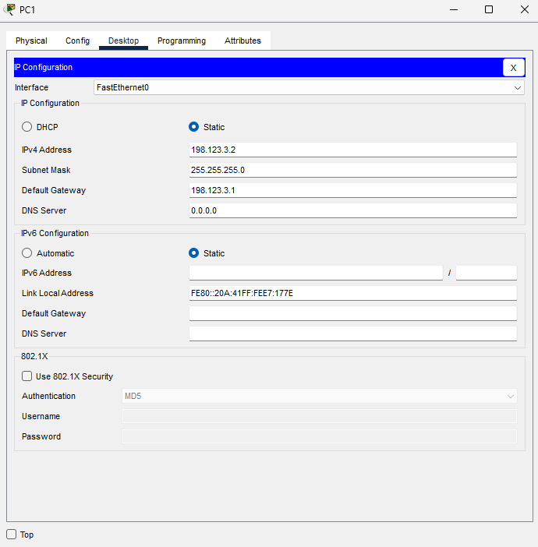

1. Use the following commands to setup router0
   * En
   * Config t
   * interface FastEthernet0/0
   * ip address 198. 123.1.1 255.255.255.0
   * no shut
   * interface Serial2/0
   * ip address 198.123.2.1 255.255.255.0
   * no shutdown
   * clock rate 64000

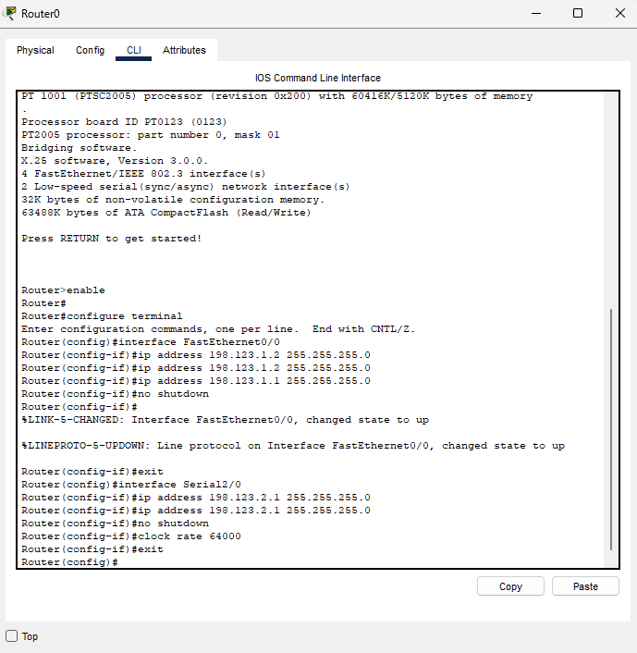

1. Use the following to setup Router R1

* En
* Config t
* interface FastEthernet0/0
* ip address 198.123.3.1 255.255.255.0
* no shut
* interface Serial2/0
* ip address 198.123.2.2 255.255.255.0
* no shutdown
* clock rate 64000

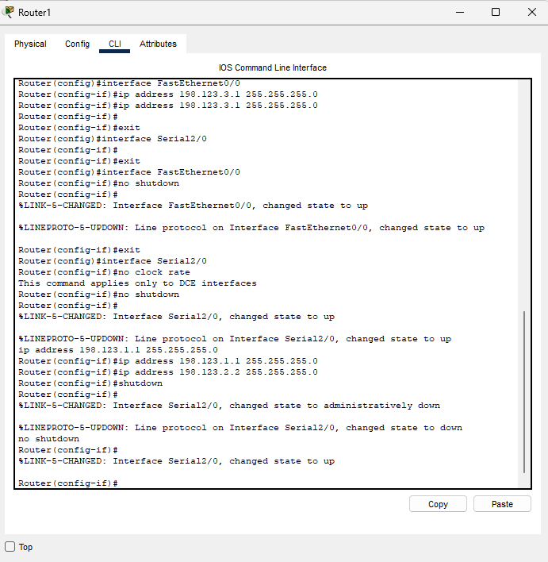

1. To setup BGP protocol use the following commands on Router R0 :--

* Router bgp 100
* Network 198.123.1.0
* Network 198.123.2.0
* Neighbor 198.123.2.2 remote-as 200
* Neighbor 198.123.3.2 remote-as 200
* Exit

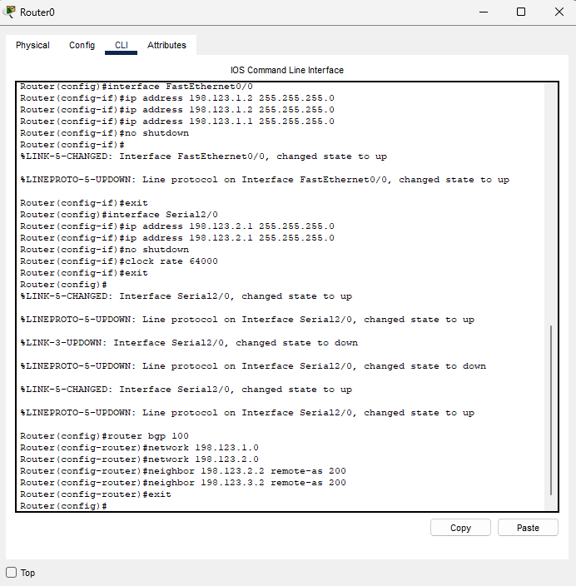

1. To setup BGP protocol use the following commands on Router R2 :--

* Router bgp 200
* Network 198.123.2.0
* Network 198.123.3.0
* Neighbor 198.123.2.1 remote-as 100
* Neighbor 198.123.1.2 remote-as 100
* Exit

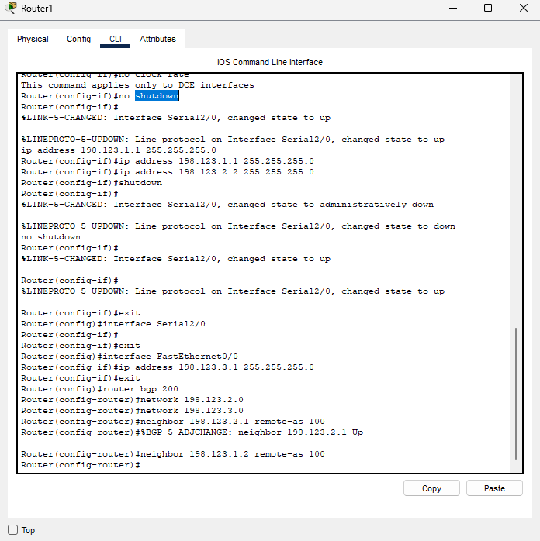

1. To test the connection the between the two pc’s use ping command

* Ping 198.123.3.2 from PC0
* Ping 198.123.1.2 from PC1

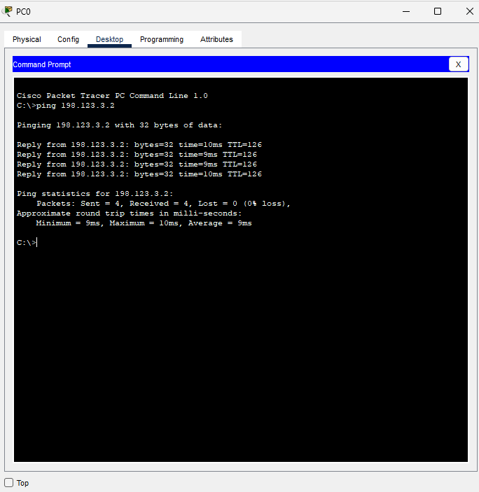 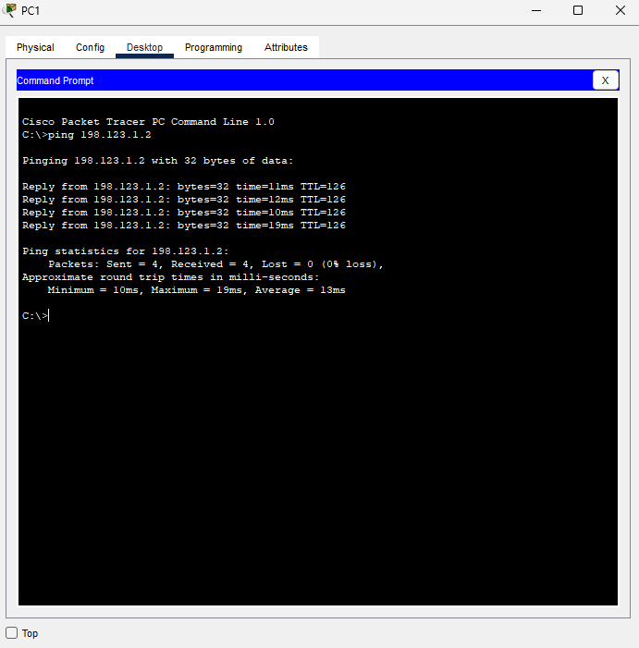

**Conclusion**

We have successfully configured BGP Protocol on two router using cisco packet tracer