**Exercise – 14 EIGRP Protocol**

**Aim**

To Configuring EIGRP protocol

**Pre-requisite:**

EIGRP protocol

**Procedure:**

1. From the Network Devices category, select routers, and from the devices drag 2 routers, 2 switches and 4 PC into the workspace.
2. Using the serial DTE cable connect the routers
3. Use the copper straight cable to connect routers and switches
4. Connect the PC to switches using copper cross straight cable

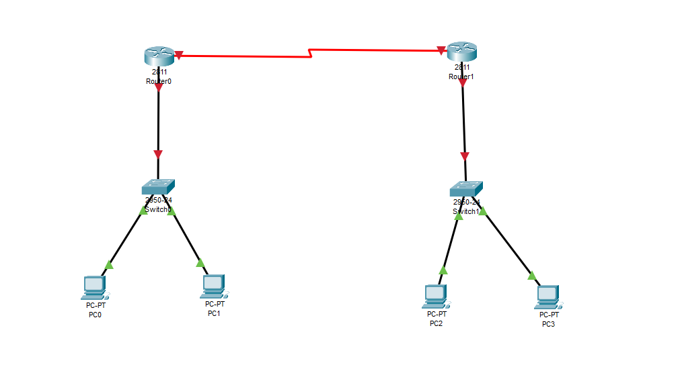

1. Configure the router R0 using following commands

* en
* config t
* int fastethernet 0/0
* ip address 192.168.10.1 255.255.255.0
* no shutdown
* exit
* int serial 0/0/0
* ip address 192.168.20.1 255.255.255.0
* clock rate 128000
* no shutdown
* exit

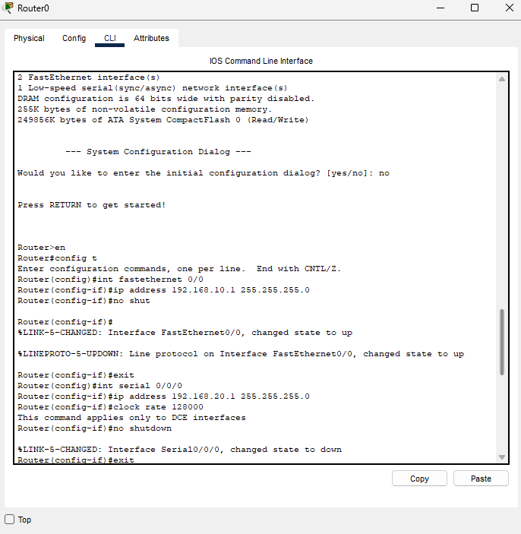

1. Configure the Router R1 using following commands

* en
* config t
* int fastethernet 0/0
* ip address 192.168.30.1 255.255.255.0
* no shutdown
* exit
* int serial 0/0/0
* ip address 192.168.20.2 255.255.255.0
* clock rate 128000
* no shutdown
* exit

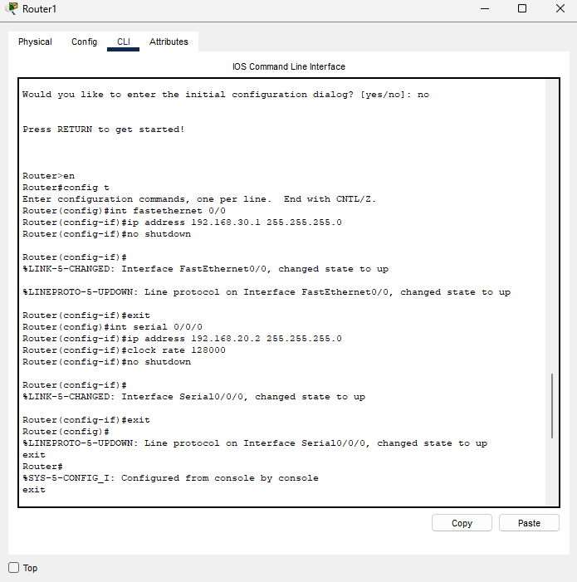

1. To configure the EIGRP protocol use the following commands to configure router R0

* router eigrp 10
* network 192.168.10.0 255.255.255.0
* network 192.168.20.0 255.255.255.0

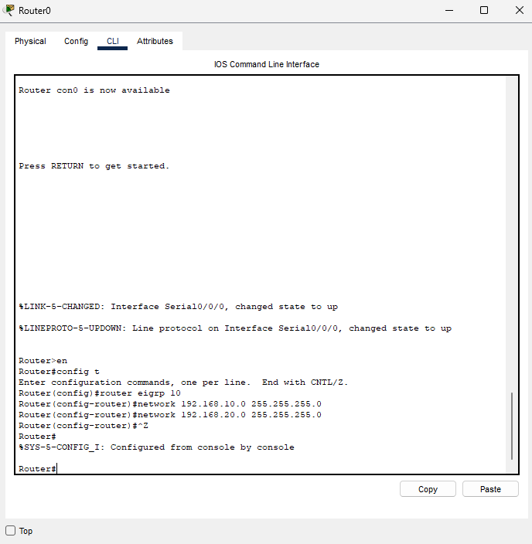

1. Similarly use the following commands to configure the router R1
   * router eigrp 10
   * network 192.168.20.0 255.255.255.0
   * network 192.168.30.0 255.255.255.0

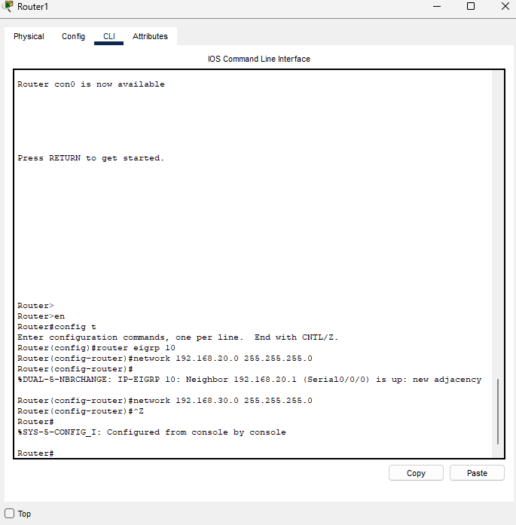

1. Use the ping command to check the connectivity between the pc’s

Ping 192.168.30.2

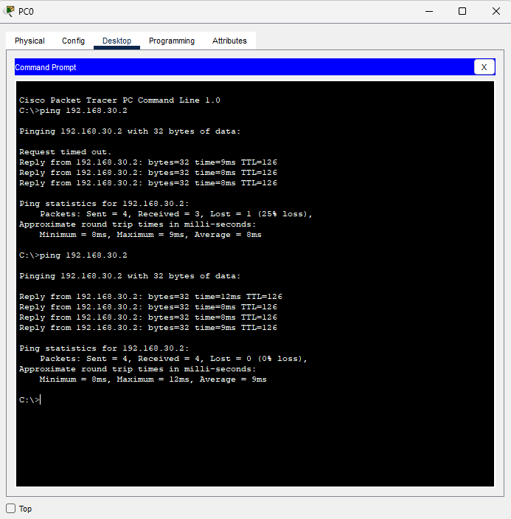

**Conclusion**

We have successfully configured EIGRP Protocol on two router using cisco packet tracer