**Exercise – 15 TELNET**

**Aim**

To Configuring Telnet protocol

**Pre-requisite:**

Telnet Protocol

**Procedure:**

1. From the Network Devices category, select routers, and from the devices drag a router and a PC into the workspace.
2. Connect the PC to router using copper cross straight cable

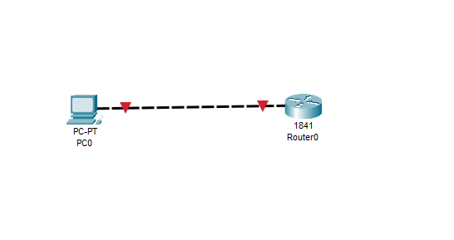

1. Configure the PC0 ip configure

Click on PCO > cllCk on desktop tab > click on ip configuration > set ip address

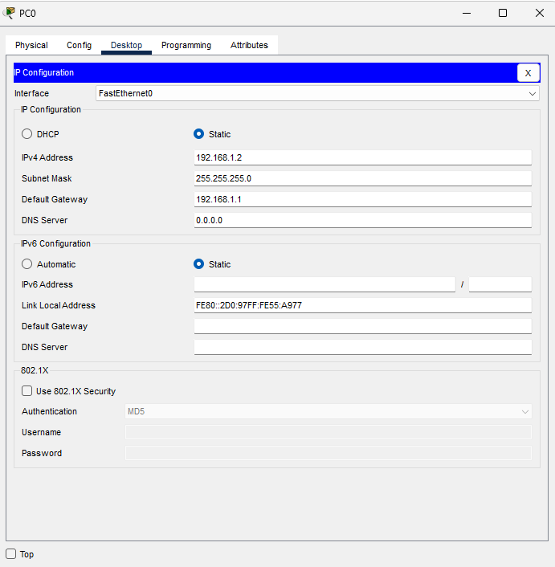

1. Configure the router using the following commands
   * en
   * config t
   * int fastethernet 0/0
   * ip address 192.168.1.1 255.255.255.0
   * no shut
   * exit

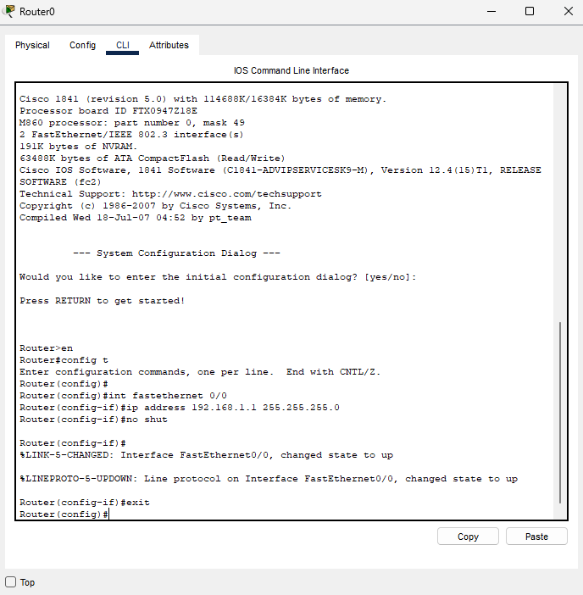

1. Configure the router for telenet using the commands
   * enable password cisco
   * line vty 0 15
   * password cisco
   * login

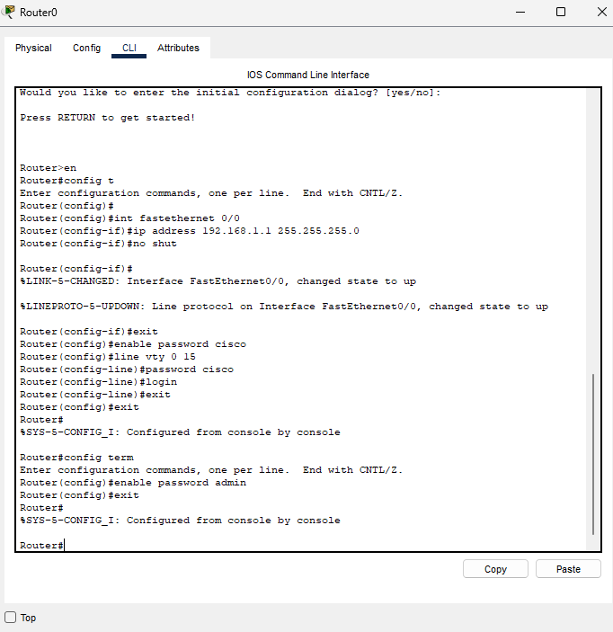

1. Using the PC0, in the command prompt of the admin PC type following the command

* telenet 192.168.1.1

1. Provide Telnet Password (admin) then hit enter. Correct password allows you access the CLI of the router.

**Conclusion**

We have successfully configured Telnet Protocol on two router using cisco packet tracer