**Madhubani Paintings: A Kaleidoscope of Colours and Culture**

Madhubani paintings, also known as Mithila art, are a centuries-old tradition of folk art from the Mithila region of Bihar, India. These exquisite artworks are characterized by their intricate detailing, vibrant colours, and a deep connection to the culture, rituals, and beliefs of the region. Madhubani paintings have a rich history that dates back to ancient times.

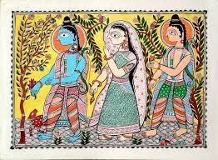 Legend has it that this art form originated during the Ramayana era when King Janak asked his artists to capture the joyous moment of his daughter Sita's marriage to Lord Rama. This tradition of decorating walls with intricate paintings gradually evolved into a vibrant art form, passed down through generations, mainly by women in the community. The hallmark of Madhubani paintings lies in their unique style. Artists primarily use natural pigments and dyes obtained from plants and minerals, resulting in a harmonious blend of earthy colours. The paintings are characterized by bold lines, intricate patterns, and symbolic representations of nature, mythology, and daily life. The central themes often revolve around Hindu deities, scenes from epics like the Ramayana and Mahabharata, and depictions of nature, including birds, animals, and trees.

One striking feature of Madhubani art is its symbolism. Each element in the painting holds a deeper meaning. For instance, fish symbolize fertility and abundance, while the lotus represents purity and enlightenment. The use of geometric patterns and floral designs adds a sense of rhythm and harmony to the compositions. These paintings are not merely decorative but also serve as a form of visual storytelling and convey the cultural values and beliefs of the Mithila region. Madhubani paintings are not confined to canvases or paper, they also adorn the walls of homes in the region. Traditionally, these paintings were created as a form of domestic decoration during festivals, weddings, and other significant occasions. They not only beautify the surroundings but also play a role in preserving and passing down the cultural heritage of the Mithila region.

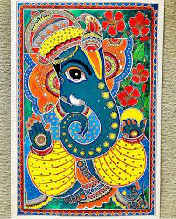 Over time, Madhubani art has transcended regional boundaries and gained international acclaim. It has found its way onto various mediums, including textiles, pottery, and even modern art forms. This expansion has not diluted the essence of Madhubani art but has rather amplified its reach, bringing the beauty of this folk art to a global audience. In conclusion, Madhubani paintings are a testament to the enduring spirit of art and culture in India. They embody the traditions, beliefs, and creativity of the Mithila region, and their exquisite beauty continues to inspire artists and admirers alike. As a student, I find the intricate detailing, vibrant colours, and cultural significance of Madhubani paintings to be a source of inspiration and a testament to the timeless allure of Indian folk art. They are a true kaleidoscope of colours and culture, representing the rich tapestry of India's artistic heritage.