**Ex No: 1**

**UNIVARIATE, BIVARIATE, MULTIVARIATE PROFILING – PYTHON**

**AIM**:

To analyse the dataset, get statistical description and to visualize it in python.

**Dataset Description:**

The dataset contains information on over 2,000 mobile phones from different brands. It includes details such as the storage capacity, RAM, screen size, camera specifications, battery capacity, and price of each device.

The dataset is structured as a CSV file with 7 columns:

* Brand: The brand name of the mobile phone.
* Model: The model name of the mobile phone.
* Storage: The amount of storage space available on the mobile phone in GB.
* RAM: The amount of random access memory available on the mobile phone in GB.
* Screen Size: The size of the mobile phone's screen in inches.
* Camera: The quality of the mobile phone's cameras, measured in megapixels.
* Battery Capacity: The amount of battery life the mobile phone has in mAh.
* Price: The price of the mobile phone in USD.

**Problem Statement**

The mobile phone price prediction problem is to develop a model that can predict the price of a mobile phone given a set of features. The target variable is the price of the mobile phone in USD. The goal of the problem is to develop a model that can accurately predict the price of a mobile phone given its features. This model can be used by a variety of stakeholders, including:

Mobile phone manufacturers: Manufacturers can use the model to develop a pricing strategy for their products. They can also use the model to identify the features that are most important to consumers and to determine how much they should charge for their phones based on those features.

Retailers: Retailers can use the model to set prices for mobile phones in their store. They can also use the model to compare the prices of different phones from different manufacturers and to ensure that they are charging a competitive price.

Consumers: Consumers can use the model to make informed decisions about which mobile phone to buy. They can use the model to compare the prices of different phones with different features and to find the best value for their money.

**PROGRAMS WITH OUTPUT:**

import numpy as np

import pandas as pd

import matplotlib.pyplot as plt

import seaborn as sns

from google.colab import drive

drive.mount('/content/drive')

p1 = '/content/drive/MyDrive/Colab Notebooks/MVT/Mobile.csv'

df = pd.read_csv(p1)

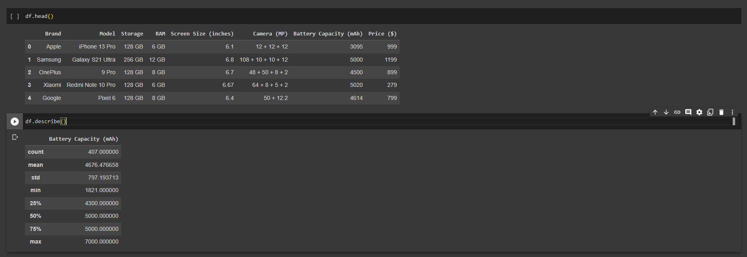

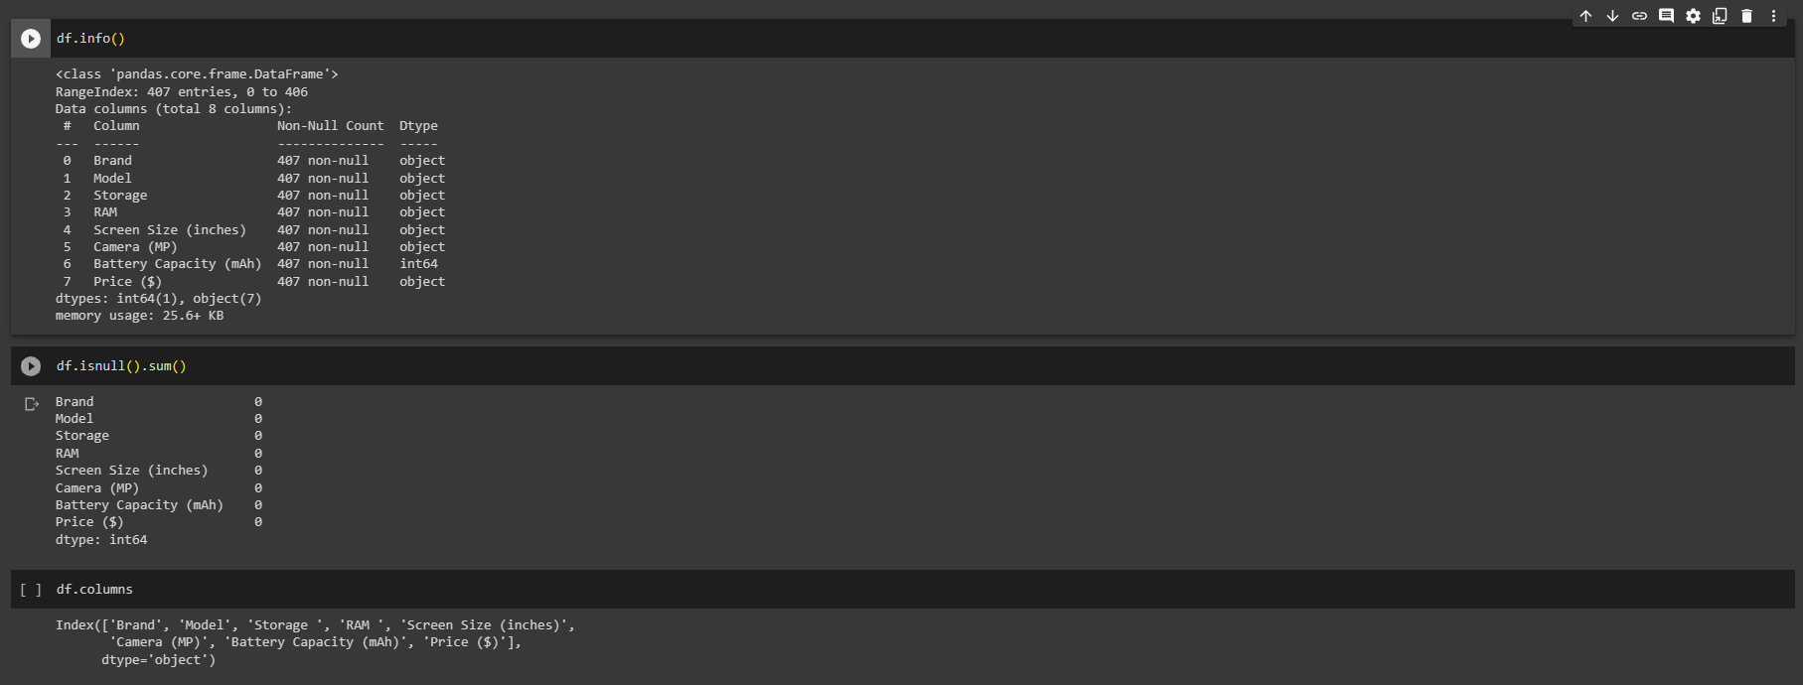

**Univariate Analysis**

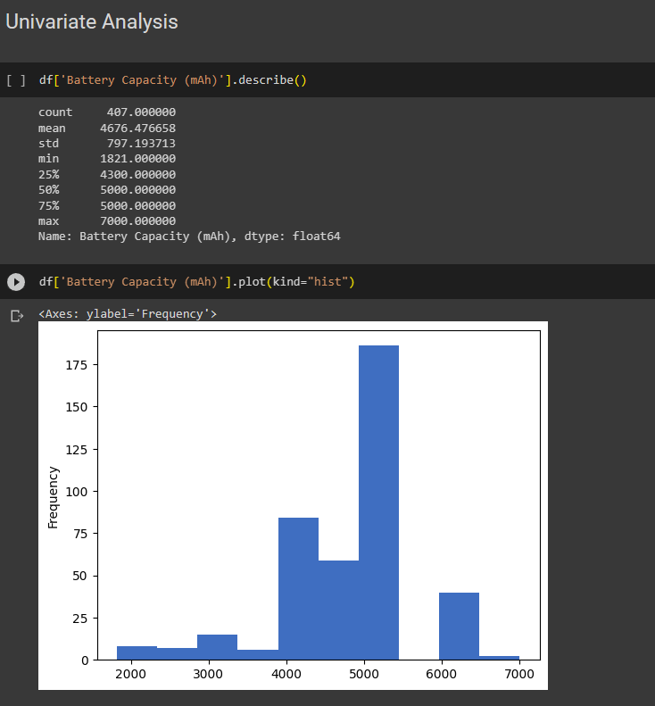

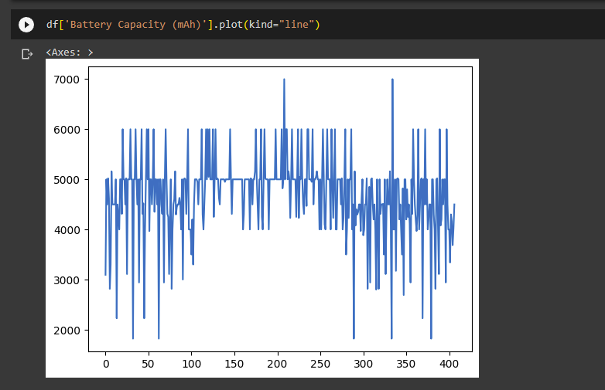

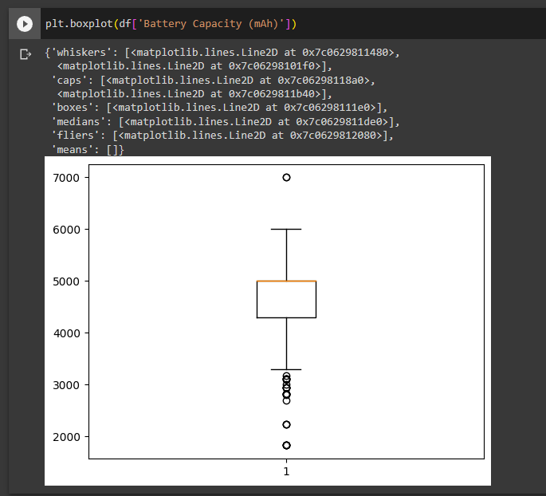

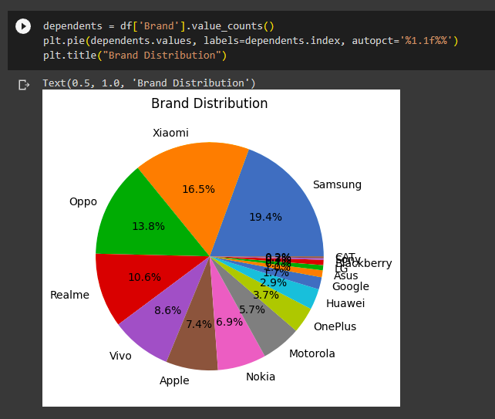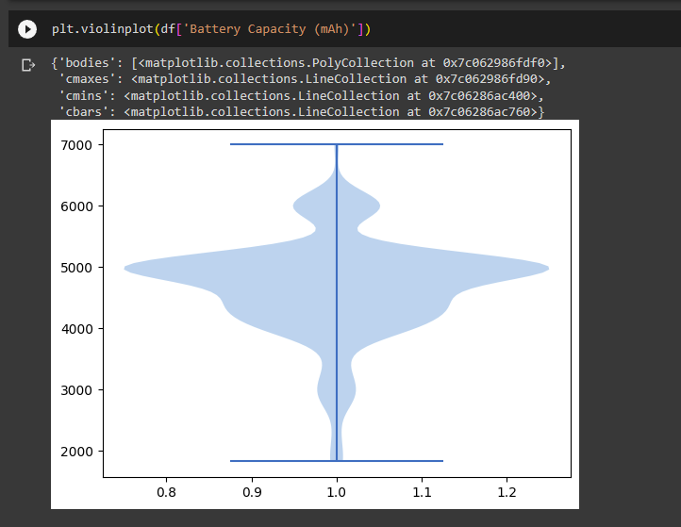

**BIVARIATE ANALYSIS**

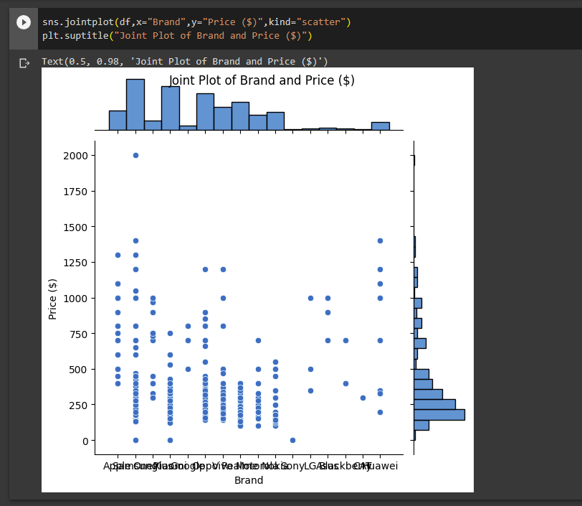

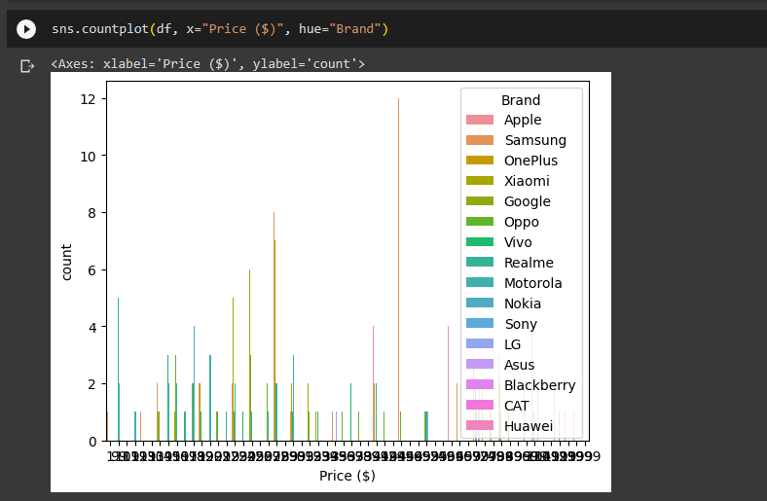

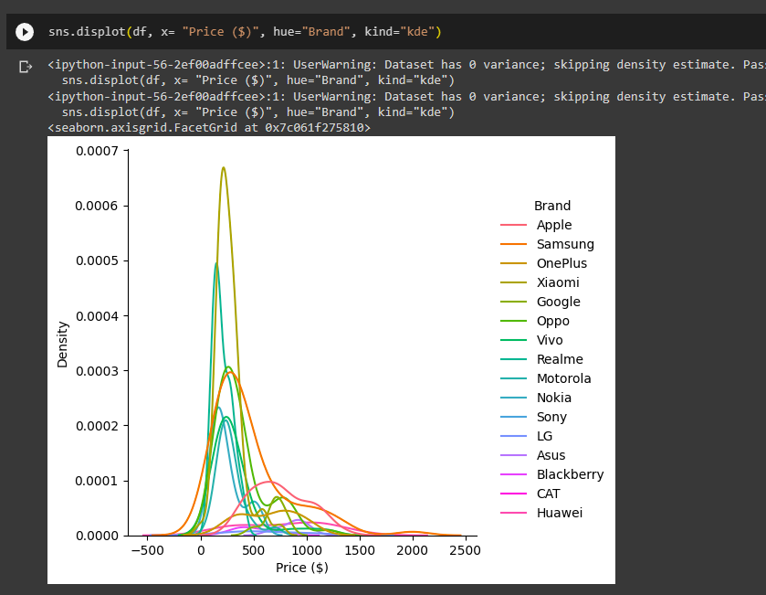

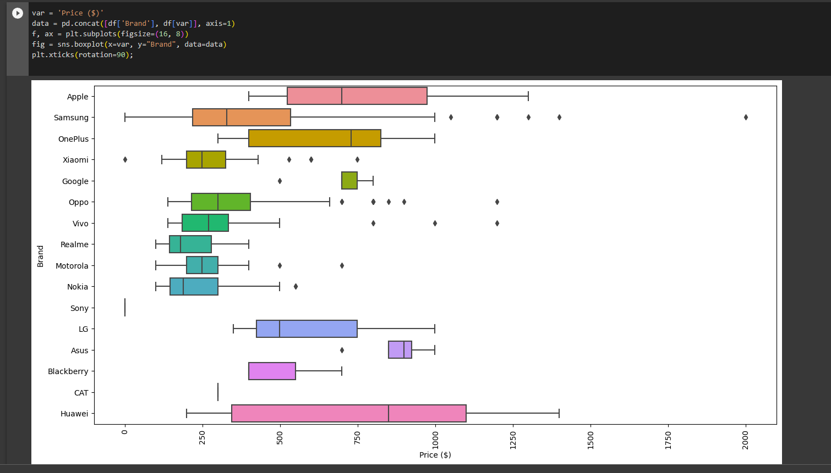

MULTI VARIATE ANALYSIS

s=sns.pairplot(df,hue='Price ($)',size=3,diag_kind='hist')

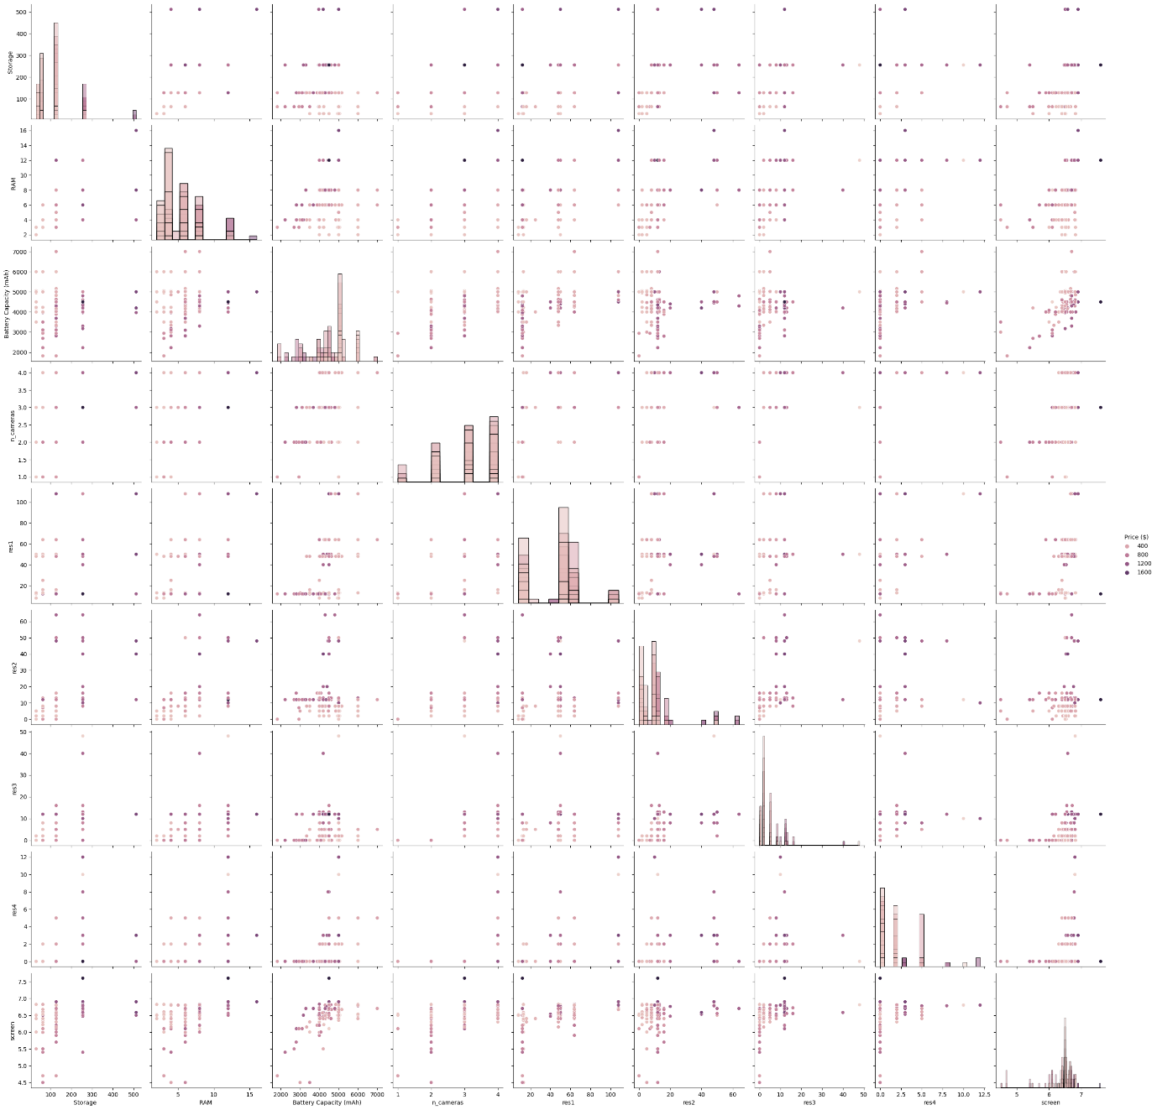

corrmat = df.corr(method='spearman')

f, ax = plt.subplots(figsize=(12, 10))

sns.heatmap(corrmat, ax=ax, cmap="YlGnBu", linewidths=0.1)

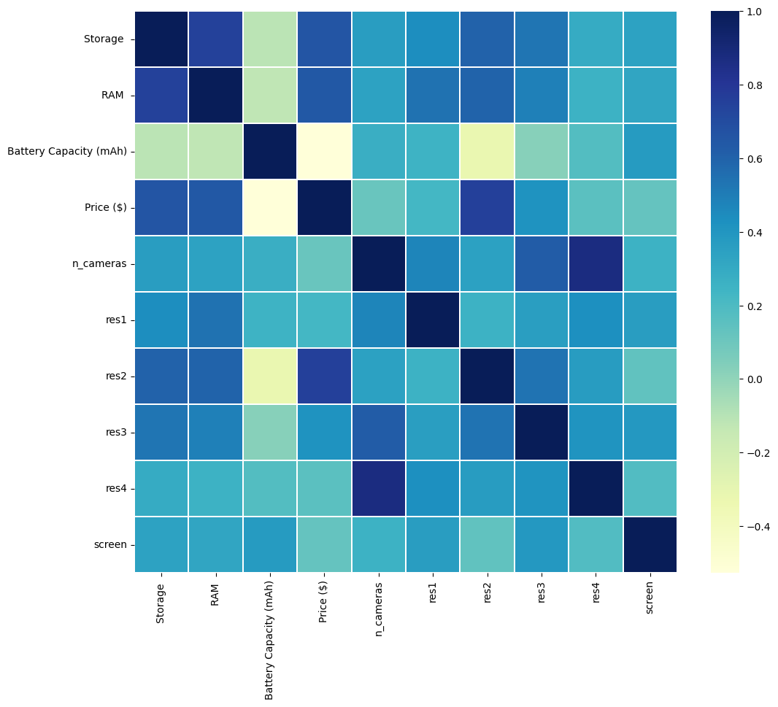

**CONCLUSION:**

The univariate, bivariate and multivariate data analysis has been done using the given dataset and the results have been analyzed using the above visualizations.