**Ex No: 10**

**K-MEANS CLUSTERING**

**AIM**:

To perform Non-hierarchical clustering using K-Means algorithm using given dataset.

**Dataset Description:**

The dataset contains information on over 2,000 mobile phones from different brands. It includes details such as the storage capacity, RAM, screen size, camera specifications, battery capacity, and price of each device.

The dataset is structured as a CSV file with 7 columns:

* Brand: The brand name of the mobile phone.
* Model: The model name of the mobile phone.
* Storage: The amount of storage space available on the mobile phone in GB.
* RAM: The amount of random access memory available on the mobile phone in GB.
* Screen Size: The size of the mobile phone's screen in inches.
* Camera: The quality of the mobile phone's cameras, measured in megapixels.
* Battery Capacity: The amount of battery life the mobile phone has in mAh.
* Price: The price of the mobile phone in USD.

**PROCEDURE:**

1. Import the necessary library functions.
2. Load the required dataset into the dataframe. (Dataset used : Iris dataset)
3. Print the head and shape of the dataset to find the dimensions of the given data.
4. Load the training dataset and fit the data into the K-Means clustering model.
5. Display the scatterplot for the two columns.
6. Using min-maxscaler find the number of cluster required and plot the graph.
7. With the help of the elbow diagram , find the number of clusters needed and do the k-means clustering.

**PROGRAM AND OUTPUT:**

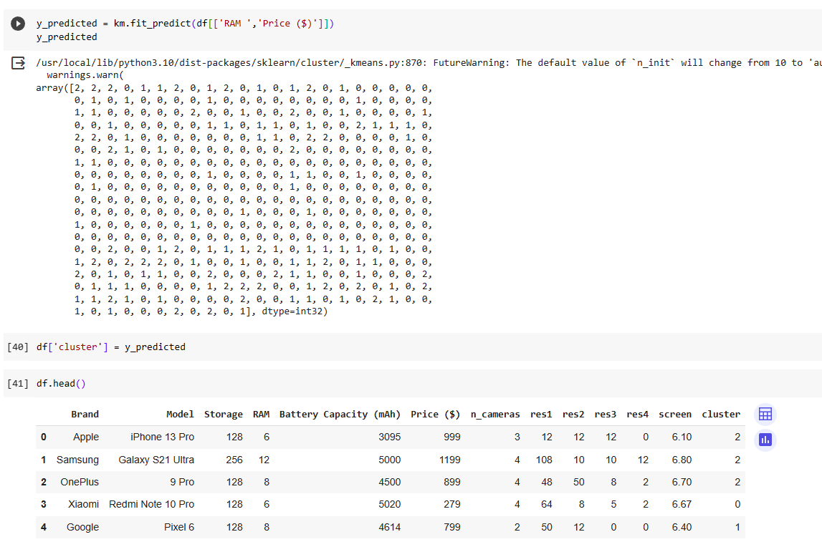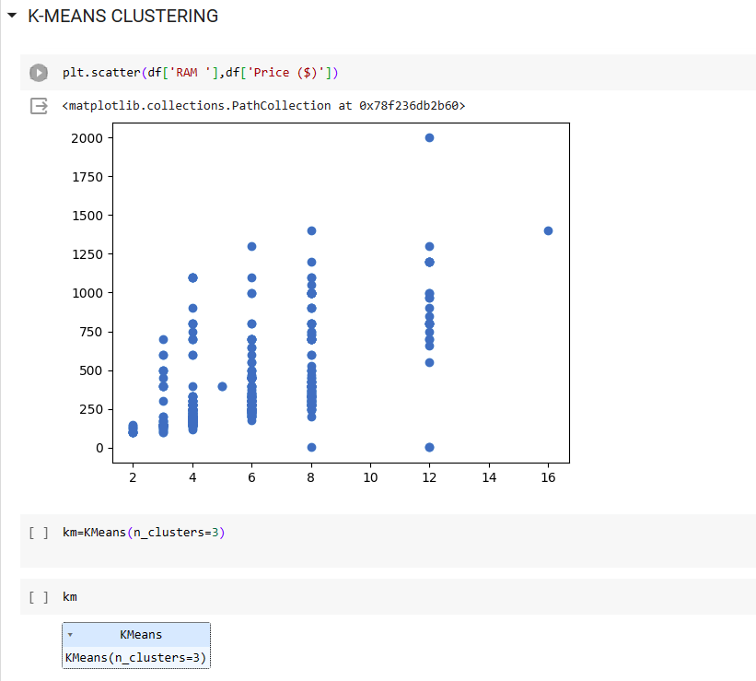

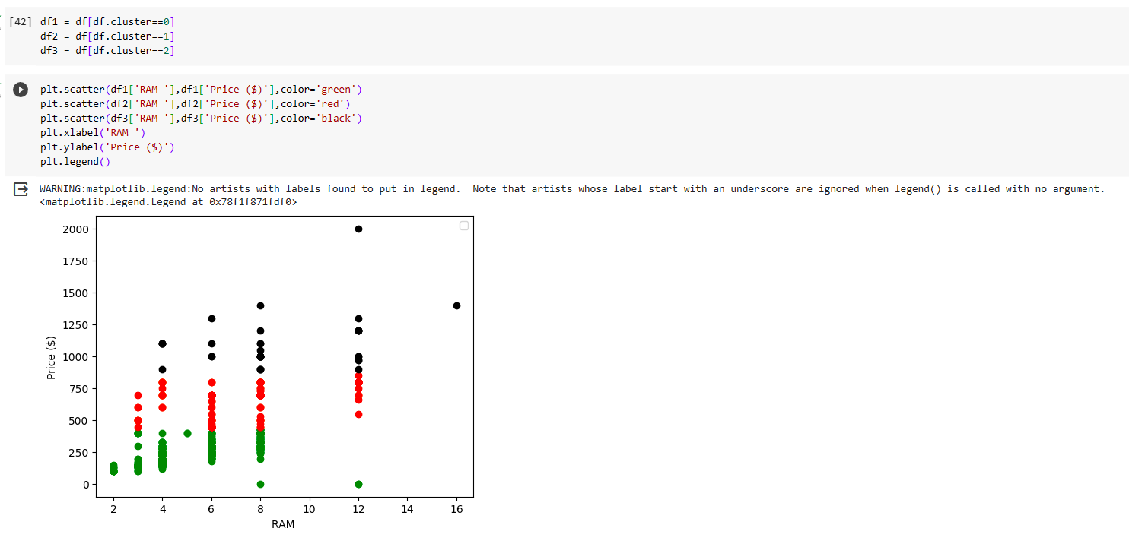

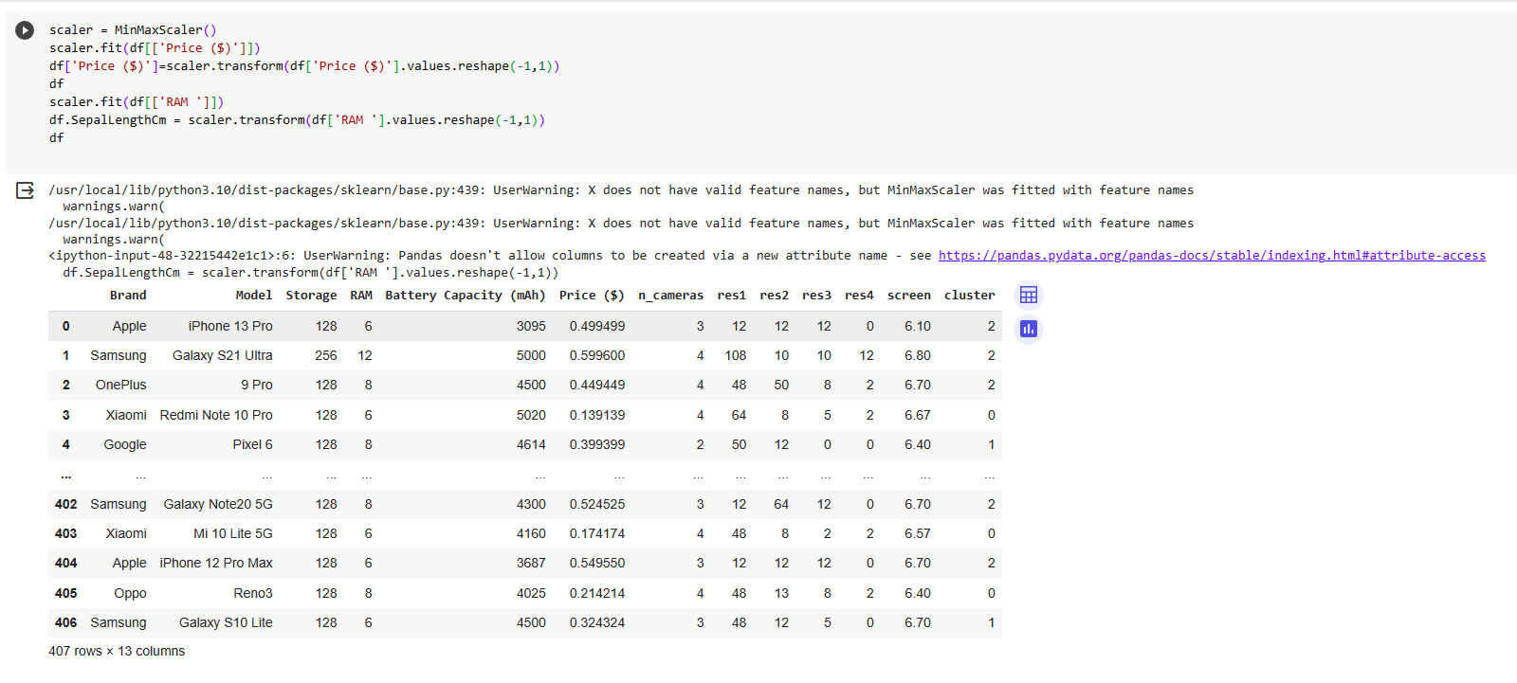

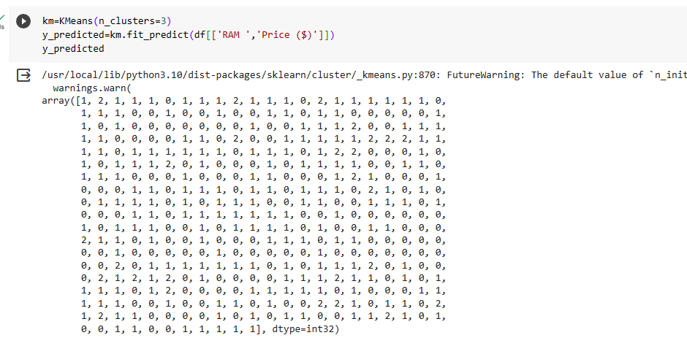

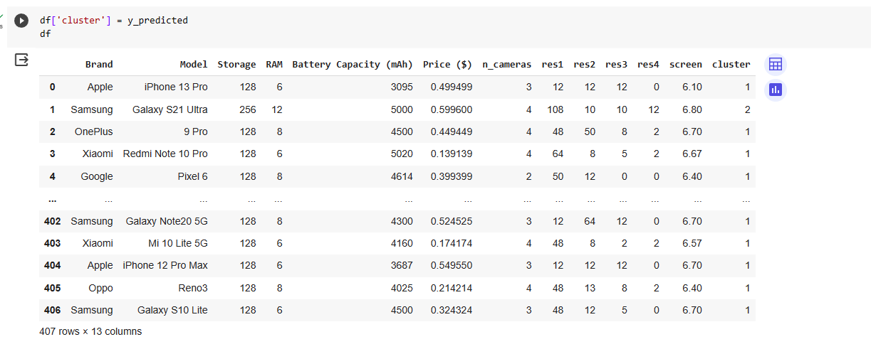 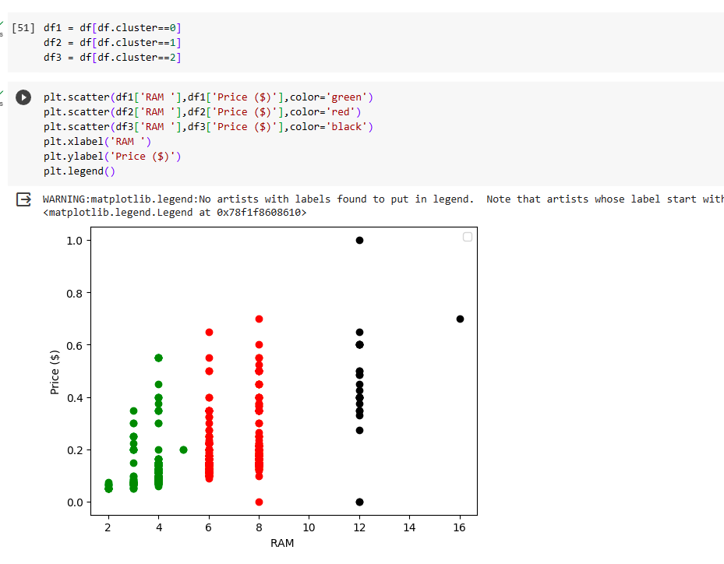 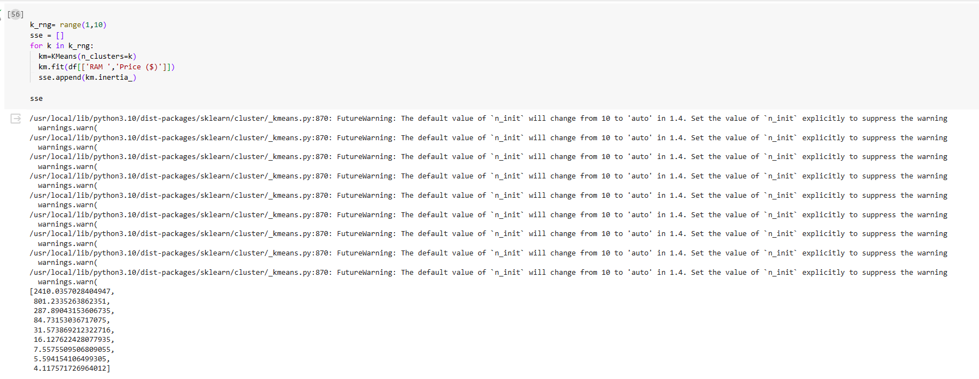

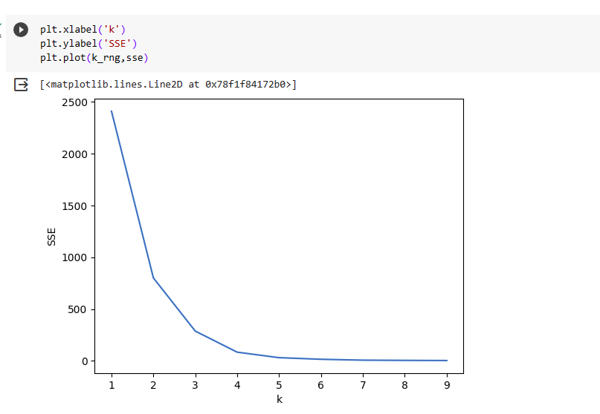

**CONCLUSION:**

Thus the given dataset is clustered using k-means clustering algorithm and 4 clusters has been grouped