**Ex No: 5**

**FACTOR ANALYSIS**

**AIM**:

To perform Factor analysis using Mobile dataset.

**Dataset Description:**

The dataset contains information on over 2,000 mobile phones from different brands. It includes details such as the storage capacity, RAM, screen size, camera specifications, battery capacity, and price of each device.

The dataset is structured as a CSV file with 7 columns:

* Brand: The brand name of the mobile phone.
* Model: The model name of the mobile phone.
* Storage: The amount of storage space available on the mobile phone in GB.
* RAM: The amount of random access memory available on the mobile phone in GB.
* Screen Size: The size of the mobile phone's screen in inches.
* Camera: The quality of the mobile phone's cameras, measured in megapixels.
* Battery Capacity: The amount of battery life the mobile phone has in mAh.
* Price: The price of the mobile phone in USD.

**PROCEDURE:**

1. Import the necessary library functions.
2. Load the required dataset into the dataframe. (Dataset used : Personality data)
3. Print the head and shape of the dataset to find the dimensions of the given data.
4. Load the training dataset and fit the data into the Factor analysis model.
5. Display the scatterplot for the eigenvalues.
6. Load the test dataset and predict the value using the model
7. Display the results of the output predicted from the model.

**PROGRAM AND OUTPUT:**

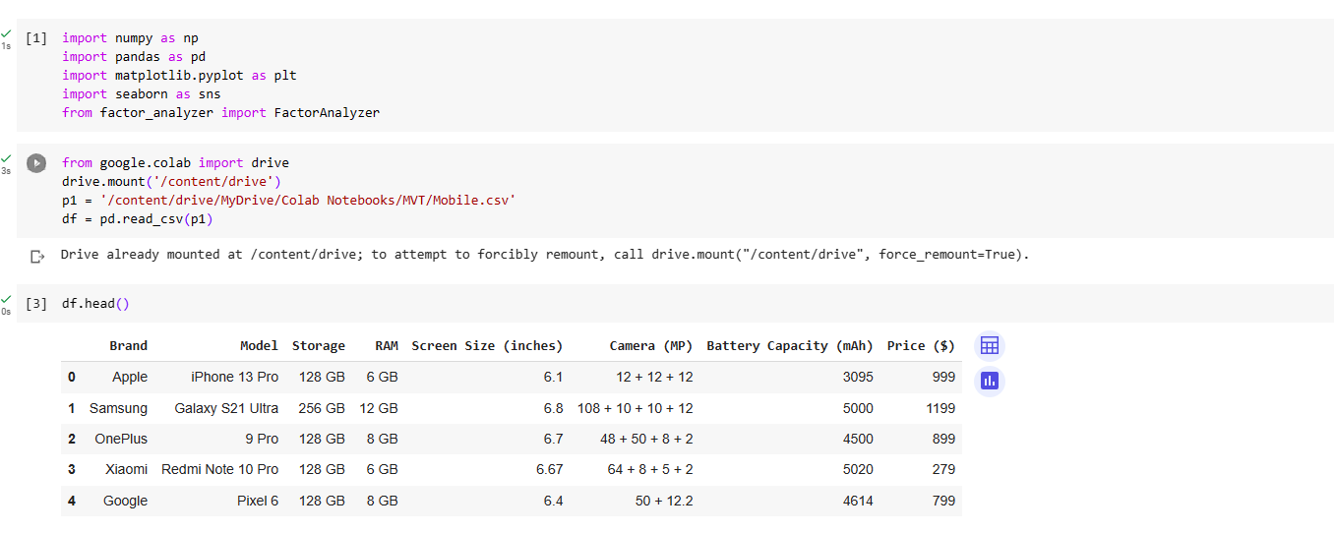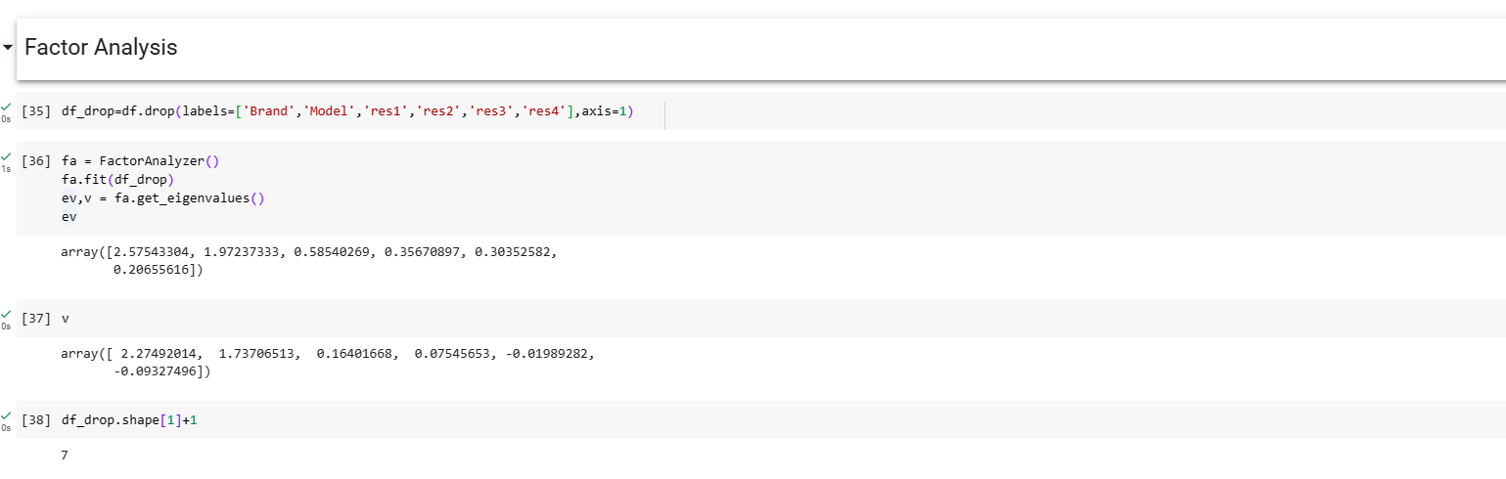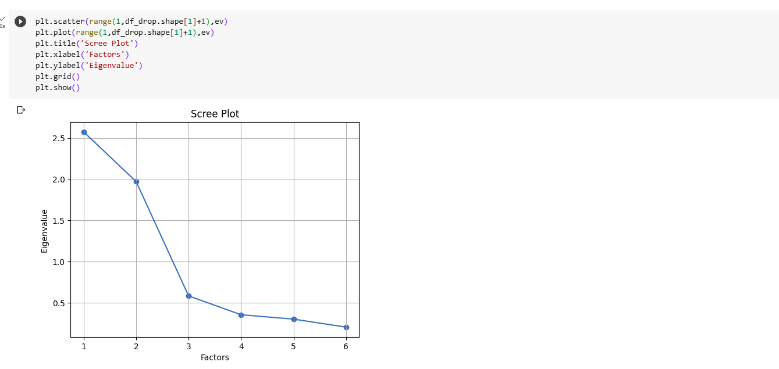

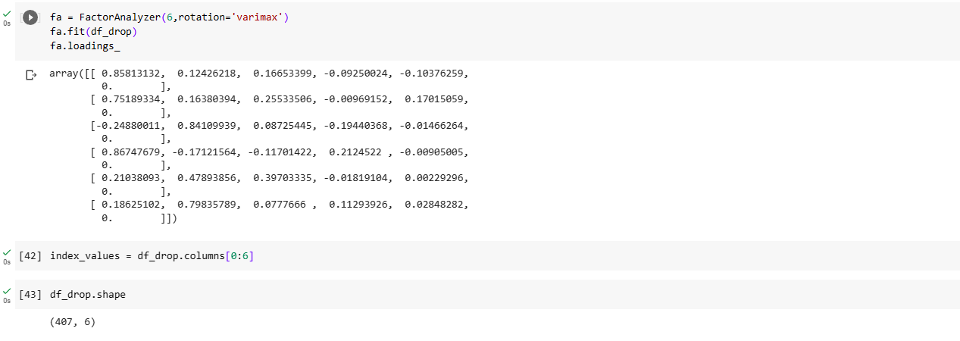

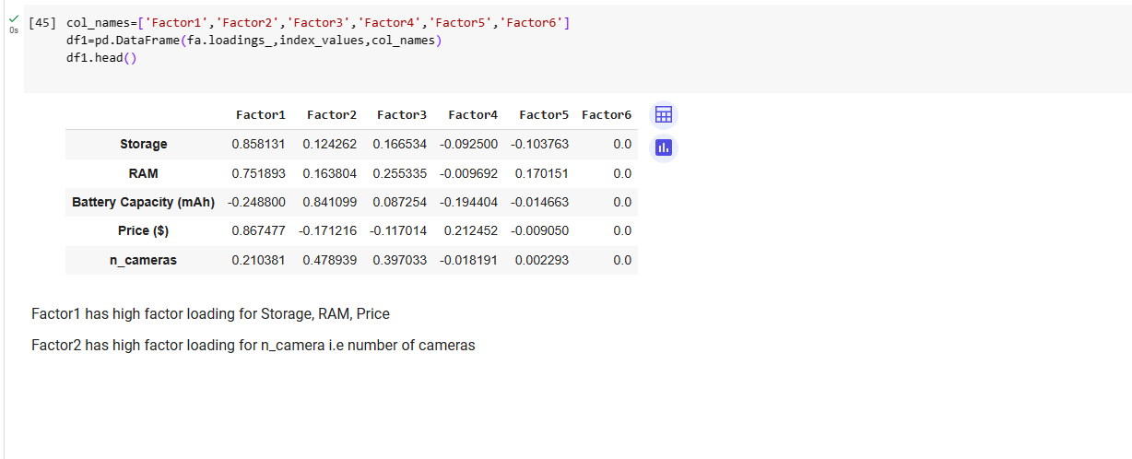

**CONCLUSION:**

The predicted output is displayed using the Factor Analysis model trained with the given dataset and results are verified. Thus the Factor Analysis is used to reduce the dimension of  the dataset by selecting the most important factors in the dataset based on the latent features.