**Ex No: 6**

**LINEAR PROGRAMMING**

**AIM:**

To perform Linear programming in python for the given equations with the constraints and get the optimized values.

**PROCEDURE:**

1. Import the necessary library functions.
2. If pulp is not available use pip install method and install pulp library and import the entire package
3. Give the required constraints and maximization function to the model
4. View the model constraints and verify it.
5. Solve the equations using PULP_CBC_CMD ()
6. View the status of the model
7. Print the results which are calculated by the model
8. Get the optimized values of the given equation and constraints.

**PROGRAM:**

!pip install pulp

from pulp import *

import pandas as pd

import numpy as np

# Create a LP Maximization problem

# LpProblem - Function

# LpMaximize - Objective function is to Maximize

model = LpProblem("Problem", LpMaximize)

# Create problem Variables

x = pulp.LpVariable("x", lowBound = 0) # Create a variable x >= 0

y = pulp.LpVariable("y", lowBound = 0) # Create a variable y >= 0

# Objective Function

model += 2 * x + y

# Constraints:

model += (3 * x + 2 * y <= 12,"Constraint 1")

model += (x + 2.3 * y <= 6.9,"Constraint 2")

model += (x + 1.4 * y <= 4.9,"Constraint 3")

# Display the problem

print(model)

# Model.solve()

model.solve(PULP_CBC_CMD())

status = LpStatus[model.status]

print(status)

print('Optimal value of x : ',pulp.value(x))

print('Optimal value of y : ',pulp.value(y))

print('Optimised Objective Function Value : ',pulp.value(model.objective))

**OUTPUT**

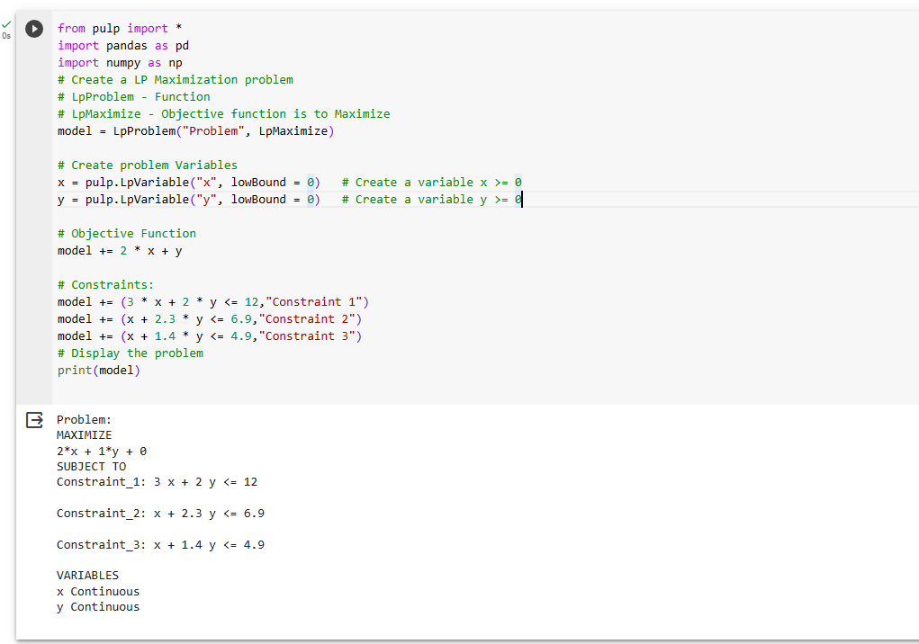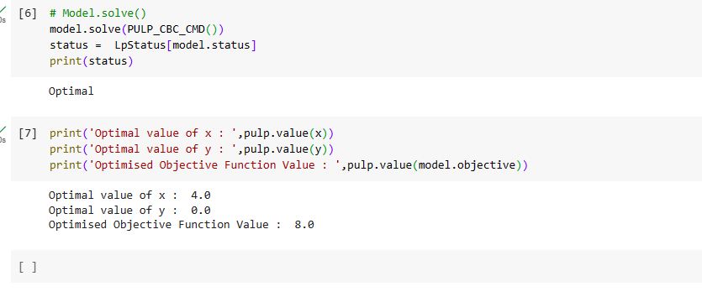

**CONCLUSION:**

Thus the Linear programming method using python was implemented and the results of various equations and optimized values was verified successfully.