**Ex No: 08**

**ASSIGNMENT PROBLEM**

**AIM:**

To perform assignment problem in python for the given cost matrix and get the optimized cost.

**PROCEDURE:**

1. Import the necessary library functions.
2. If scipy is not available use pip install method and install scipy library and import the entire package
3. Create a cost matrix and pass it to function to solve it
4. Solve the equations using linear_sum_assignment ()
5. Extract the optimal assignment values
6. Print the optimal assignment values
7. Calculate the total cost

**PROGRAM:**

import numpy as np

from scipy.optimize import linear_sum_assignment

# Create a cost matrix

cost_matrix = np.array([

[10, 11, 4, 2, 8],

[ 7, 11, 10, 14, 12],

[ 5, 6, 9, 12, 14],

[ 13, 15, 11, 10, 7]

])

# Solve the assignment problem

row_indices, col_indices = linear_sum_assignment(cost_matrix)

# Extract the optimal assignment

assignment = [(row, col) for row, col in zip(row_indices, col_indices)]

print("Optimal Assignment:")

for row, col in assignment:

print(f"Resource {row} assigned to Task {col}")

print("Optimal Cost is = ",2+7+6+7)

**OUTPUT:**

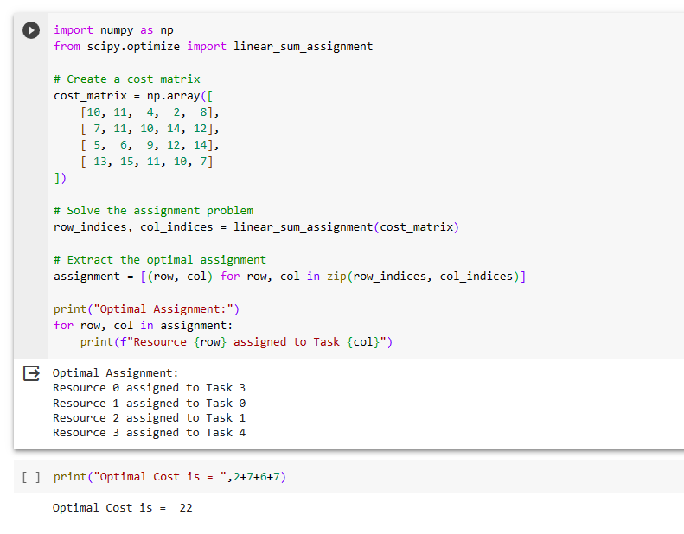

**CONCLUSION:**

Thus the assignment problem method using python was implemented and the results of cost matrix was verified successfully.