**Ex No: 9**

**HIERARCHICAL CLUSTERING**

**AIM**:

To perform Hierarchical Clustering using agglomerative clustering with four types of linkage methods ward ,single ,average ,complete using sklearn make blobs dataset.

**Dataset Description:**

The dataset contains information on over 2,000 mobile phones from different brands. It includes details such as the storage capacity, RAM, screen size, camera specifications, battery capacity, and price of each device.

The dataset is structured as a CSV file with 7 columns:

* Brand: The brand name of the mobile phone.
* Model: The model name of the mobile phone.
* Storage: The amount of storage space available on the mobile phone in GB.
* RAM: The amount of random access memory available on the mobile phone in GB.
* Screen Size: The size of the mobile phone's screen in inches.
* Camera: The quality of the mobile phone's cameras, measured in megapixels.
* Battery Capacity: The amount of battery life the mobile phone has in mAh.
* Price: The price of the mobile phone in USD.

**PROCEDURE:**

1. Import the necessary library functions.
2. Load the required dataset into the dataframe. (Dataset used : sklearn inbuilt makeblob dataset)
3. Load the training dataset and fit the data into the hierarchical clustering ,agglomerative clustering model.
4. Display the scatterplot for the two columns.
5. Display the dendogram using agglomerative model.
6. Fit and predict the point in agglomerative clustering model.
7. Display the scatter plot of the clusters.

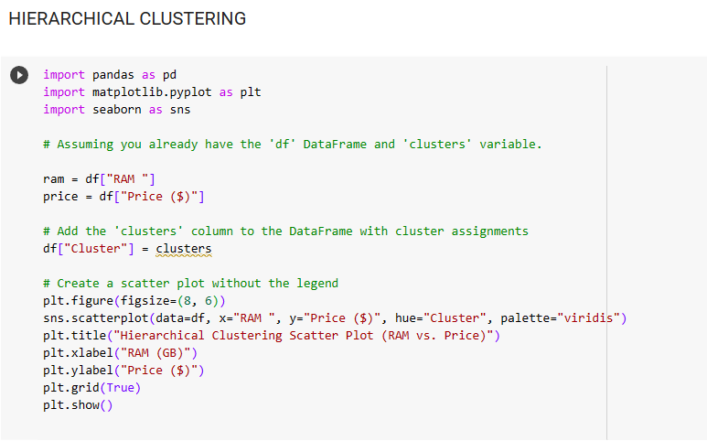**PROGRAM AND OUTPUT;**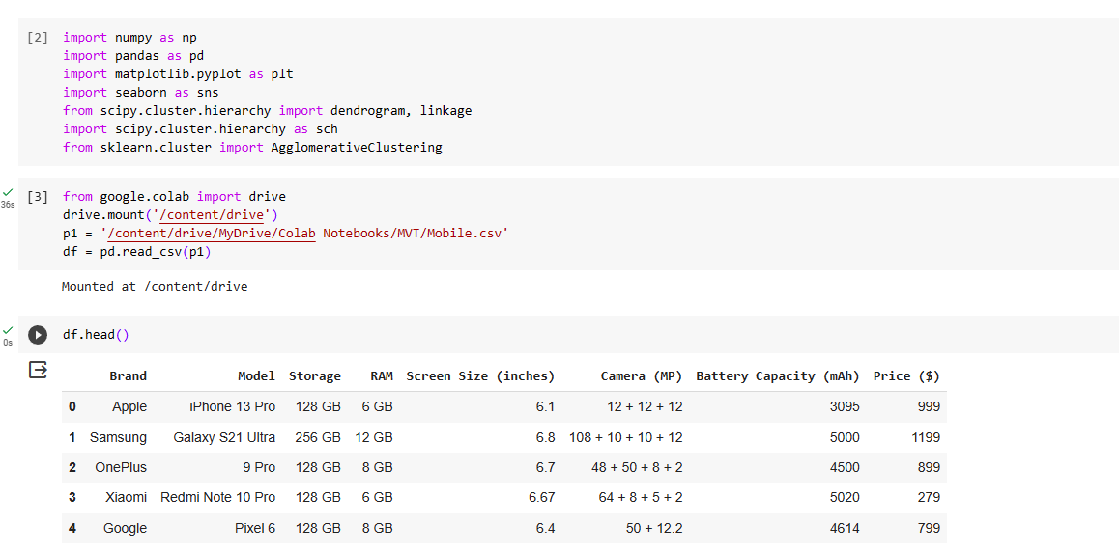 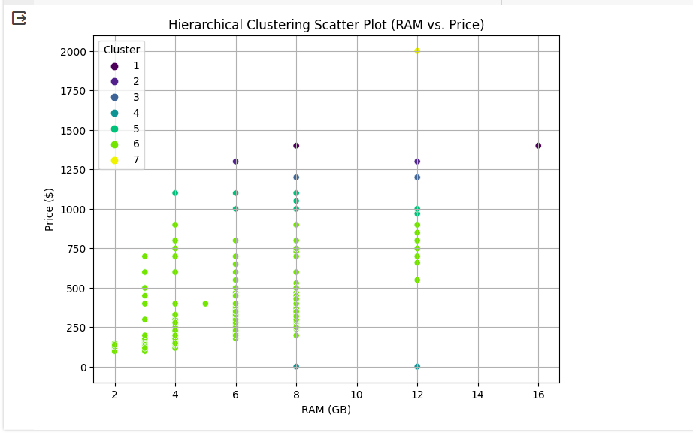

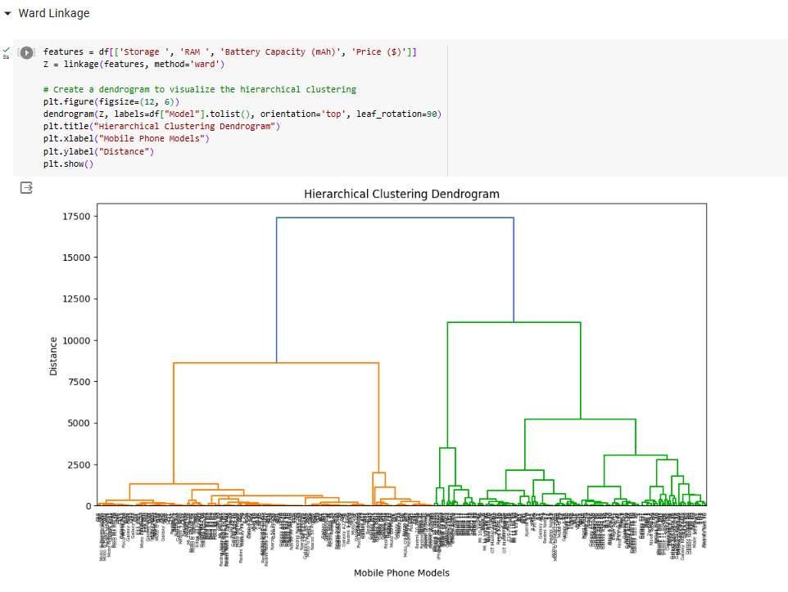

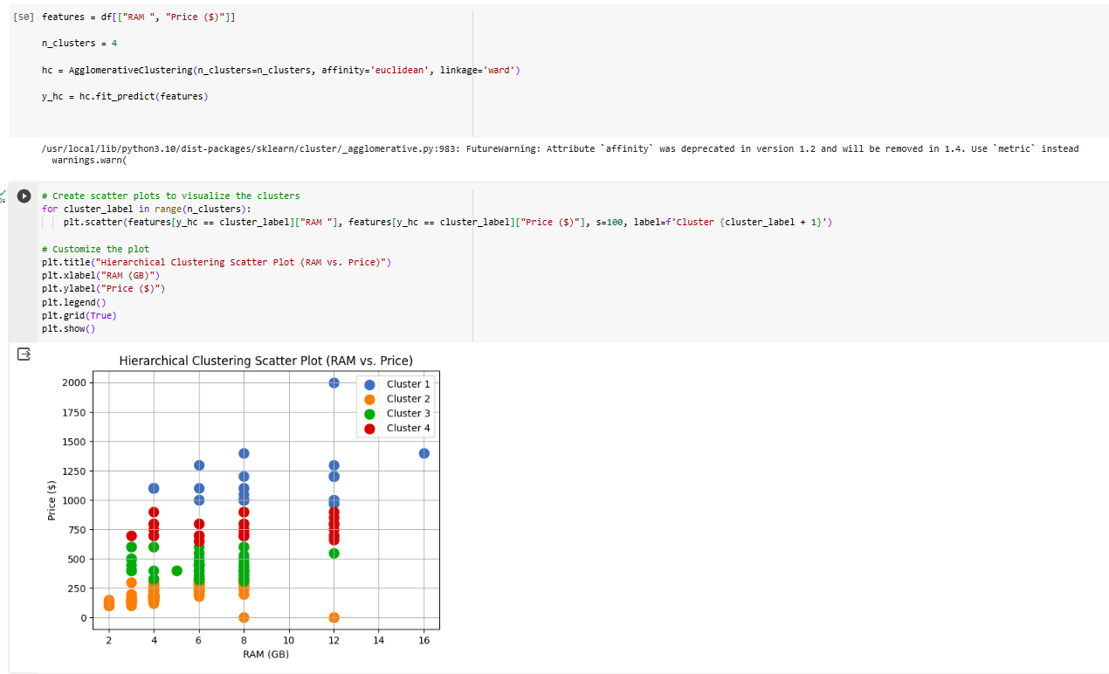 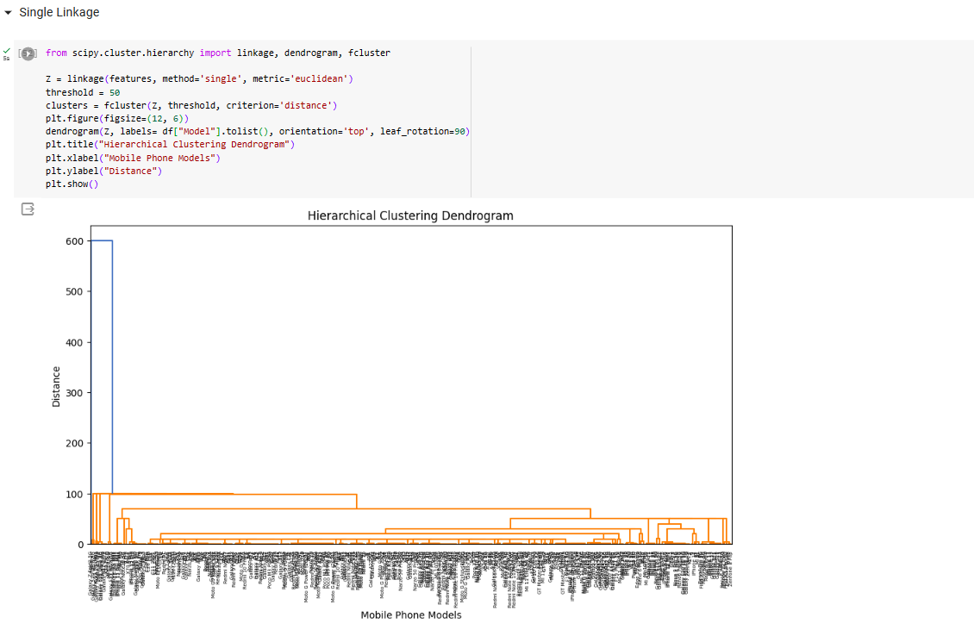 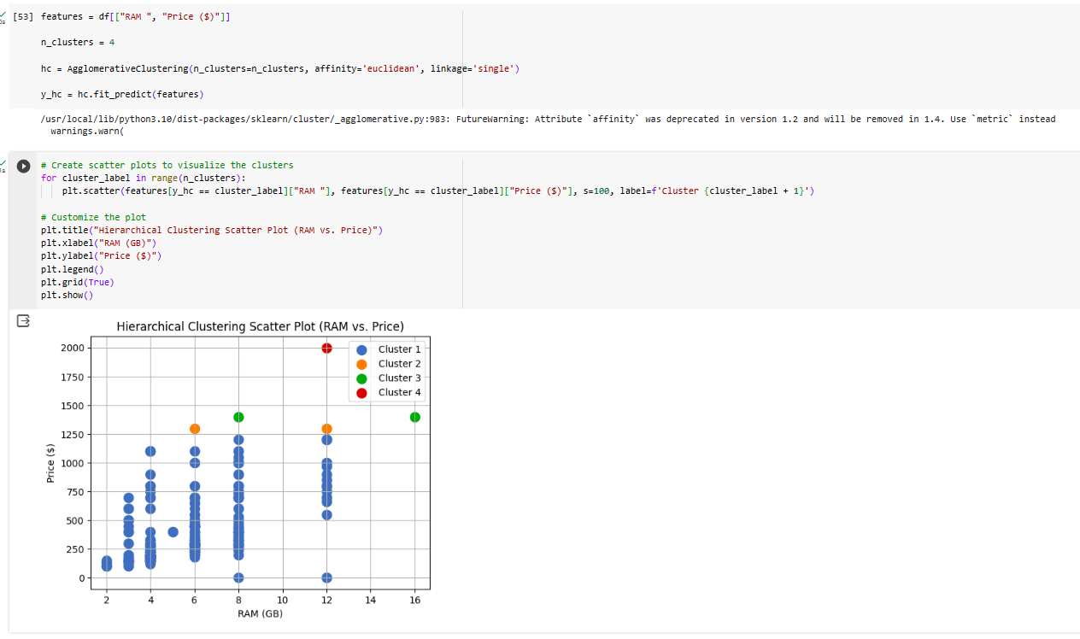 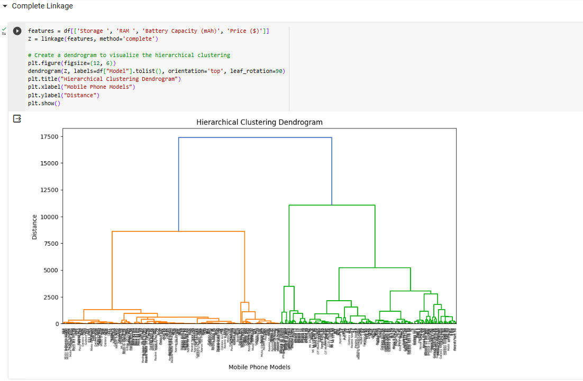

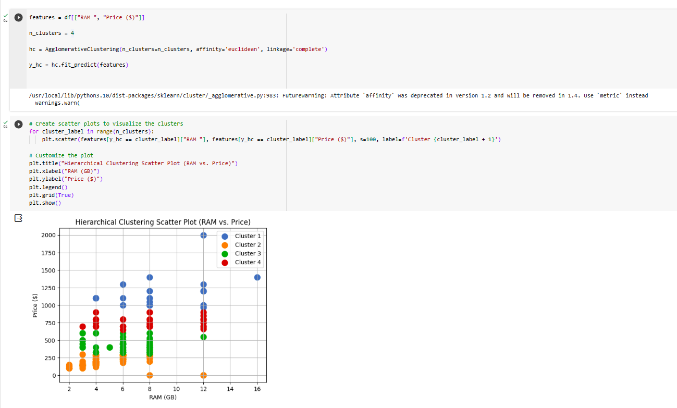

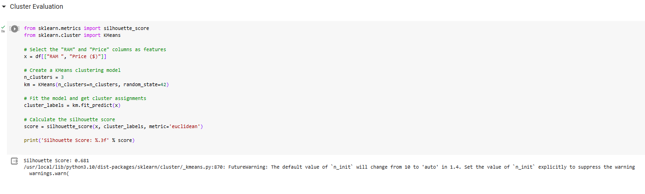

**CONCLUSION:**

Thus the given dataset is clustered using the hierarchical clustering with agglomerative clustering method with 4 different types of linkage methods called as wards, single, complete ,average linkage methods and results were verified.