RAISEC Theory of Career Choice

According to John Holland's theory, most people are one of six personality types: **Realistic, Investigative, Artistic, Social, Enterprising, and Conventional** known collectively as RIASEC. According to Holland, one can classify every person and every profession according to the RIASEC theory. When people choose a profession that specifically suits their personality, they will generally be more successful and satisfied.

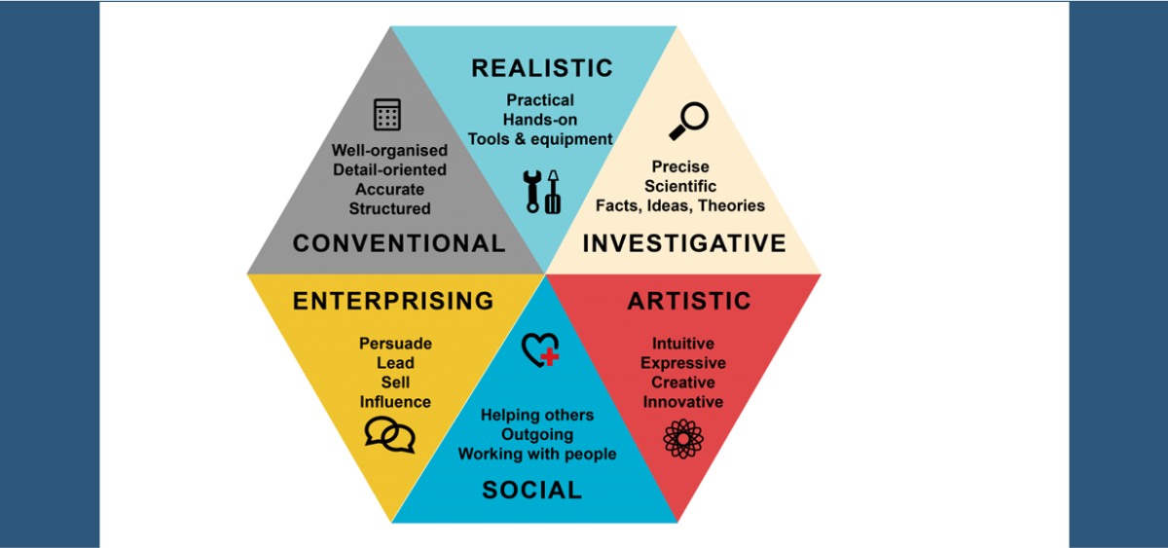

## **REALISTIC**

People who like to work with things. They tend to be assertive and competitive, and are interested in activities requiring motor coordination, skill and strength. They approach problem solving by doing something, rather than talking about it, or sitting and thinking about it. They also prefer concrete approaches to problem solving, rather than abstract theory. Finally, their interests tend to focus on scientific or mechanical rather than cultural and aesthetic areas. Sample majors and careers include:--

* Agriculture
* Engineer

Closest work Environment

* Conventional
* Investigative

Opposite work Environment

* Social

## **INVESTIGATIVE**

People who prefer to work with data. They like to think and observe rather than act, to organize and understand information rather than to persuade. They also prefer individual rather than people-oriented activities. Sample majors and careers include:--

* Professor/Research – PhD
* Lawyer

Closest work Environment

* Realistic
* Artistic

Opposite work Environment

* Enterprising

## **ARTISTIC**

People who like to work with ideas and things. They tend to be creative, open, inventive, original, perceptive, sensitive, independent and emotional. They rebel against structure and rules, but enjoy tasks involving people or physical skills. They tend to be more emotional than the other types. Sample majors and careers include:--

* Photographer
* [Graphic designer](https://en.wikipedia.org/wiki/Graphic_designer)

Closest work Environment

* Investigative
* Social

Opposite work Environment

* Conventional

## **SOCIAL**

People who like to work with people and who seem to satisfy their needs in teaching or helping situations. They tend to be drawn more to seek close relationships with other people and are less apt to want to be really intellectual or physical. Sample majors and careers include:--

* Community Health Workers
* Educational Administration

Closest work Environment

* Enterprising
* Artistic

Opposite work Environment

* Realistic

## **ENTERPRISING**

People who like to work with people and data. They tend to be good talkers, and use this skill to lead or persuade others. They also value reputation, power, money and status. Sample majors and careers include:--

* Entrepreneur
* Agent

Closest work Environment

* Social
* Conventional

Opposite work Environment

* Investigative

## **CONVENTIONAL**

People who prefer to work with data and who like rules and regulations and emphasize self-control. They like structure and order, and dislike unstructured or unclear work and interpersonal situations. They also place value on reputation, power, or status. Sample majors and careers include:--

* Real estate
* financial analyst

Closest work Environment

* Realistic
* Enterprising

Opposite work Environment

* Artistic