***UNIT-II***

***Ontology:***

**Ontology** is the branch of [philosophy](https://en.wikipedia.org/wiki/Philosophy) that studies concepts such as [existence](https://en.wikipedia.org/wiki/Existence), [being](https://en.wikipedia.org/wiki/Being), [becoming](https://en.wikipedia.org/wiki/Becoming_(philosophy)), and [reality](https://en.wikipedia.org/wiki/Reality). It includes the questions of how entities are grouped into [basic categories](https://en.wikipedia.org/wiki/Category_of_being) and which of these entities exist on the most fundamental level. Ontology is sometimes referred to as the *science of being* and belongs to the major branch of philosophy known as [metaphysics](https://en.wikipedia.org/wiki/Metaphysics).

***Reference Ontology and Application Ontology***

**Reference Ontologies**

There appear to be three central characteristics of reference ontologies (ROs). We examine these in turn. Theoretical Focus on representation The first characteristic of ROs is their theoretical focus on representation. ROs are constructed without any particular concerns for computational efficiency. Consequently, ROs avail themselves of (at least) the language of full first-order logic. Specifically, ROs avail themselves of:

• Arbitrary n-place predicates;

• Full classical negation;

• Unbounded, arbitrarily nested quantifiers.

The focus of ROs on representation is most clearly indicated in their generally unapologetic use of full first-order languages. The three features above are particularly noteworthy, as unrestricted use of any of them can render complete deductive procedures intractable, even undecidable. Philosophical inclination toward realism The second feature of ROs is that their inclination toward philosophical realism.

There are generally two elements of this realism:

• Metaphysical realism;

• Epistemological realism.

According to metaphysical realism, the World (Reality, What There Is) exists objectively in itself, independent of any mind. According to epistemological realism, the World is knowable by us. Thus, the philosophical standpoint underlying most ROs is that the World and its properties are there to be discovered. This implies, in turn, that the World, being objective and knowable, puts constraints on what we can say about it. Thus, in our ontologies can get it wrong. An RO is right just insofar as it accurately reflects, as far as it goes, the way the World is. This leads to our third feature of ROs. Methodological emphasis on Truth Because our ROs can be wrong, there is in the construction of an RO a good reason to place a strong methodological emphasis on Truth.

This has two practical implications:

• The central function of an ontology is to represent the World accurately and comprehensively; hence:

• The quality of an ontology a function of its accuracy and comprehensiveness.

ROs are all about getting the world — or some important piece of it — right.

An ontology of time purports to describe its actual nature, to proffer the sober metaphysical truth on such matters as whether time is discrete, continuous, some combination of the two; whether there are timepoints or intervals, or both, and so on. Consequently, the quality of an ontology is judged along two dimensions: its accuracy — i.e.,

whether what it purports to be the case is in fact the case — and its comprehensiveness — i.e., whether it takes in a sufficiently broad spectrum of facts as to be significant.

**Application Ontologies**

Corresponding to our three features of reference ontologies are three salient features of application ontologies (AOs).

**Theoretical Focus on Reasoning**

Unlike ROs, AOs are typically designed with some sort of computational application — and hence its attendant expressive limitations — in mind. Consequently, AOs are usually expressed in the language of some computationally tractable sub logic of full firstorder logic (see, e.g., [6]). Such languages typically support:

• Reasoning about classes and “slots” through the use of unary and (limited) binary predicates;

• Conjunction and disjunction, but not negation;

**Philosophical inclination toward pragmatism/ instrumentalism/constructivism**

Unlike the strong realism underlying ROs, for AOs, take a far more pragmatic view of the world, both metaphysically and epistemologically. Specifically, the metaphysical presumption underlying a typical AO is the falsity, or at least the irrelevance, of metaphysical realism. The objects and structures we encounter in the world — those parts of it that matter to ontology, anyway — are social constructs, products of the evolving interaction between conscious, intelligent human agents and, at best, a substrate of unknowable.

The corresponding epistemological presumption is that, even if metaphysical realism is true and there is an ultimate metaphysical reality to the world, that underlying reality probably unknowable anyway. Hence, what we can be said to know is simply what works.

**Methodological emphasis on fidelity**

Methodologically, the central emphasis of an AO must be on fidelity, i.e., to be a faithful expression of the concepts/intuitions of relevant domain experts or sources. All that matters to an AO is how relevant domain experts conceptualize a given domain. The question of any sort correspondence between that conception and an objective external world is idle philosophical speculation with no bearing on the quality of the ontology, which is determined entirely by the extent of its fidelity.

On the face of it, these two approaches two ontology are profoundly different. However, the starkest differences are philosophical; indeed, those differences are probably irreconcilable. However, important as those differences might be conceptually, at the end of the day what we are engaged in is knowledge engineering. And as engineers, I suggest the following tendentious (not to say controversial) thesis: the only components of the two approaches that ultimately matter are the theoretical and methodological. These, I will argue are compatible, indeed complementary. wide-scope universal quantifiers only)



Ontological Layers

**Reference ontology with regard to application ontology**

Application ontologies contain all the definitions that are needed to model the knowledge required for a particular application. They are not reusable themselves.

“Application ontologies describe concepts depending both on a particular domain and task, which are often specializations of both the related ontologies. These concepts often correspond to roles played by domain entities while performing a certain activity, like replaceable unit or spare component “.

Reference ontology versus Application ontology

|  |  |
| --- | --- |
| **Reference Ontology** | **Application Ontology** |
| theoretical Focus on representing | theoretical Focus on representing |
| establishes consensus about meaning of terms | offers terminological services for semantic access, checking constraints between terms |
| maximal coverage | provides a minimal terminological structure |
| Fits the needs of a large community | fits the needs of a specific community |
| Fits the needs of a large community | lightweight ontologies |
| Can’t be derived from application ontology | can be derived from Reference ontology |
| broad and deep | broad and deep |
| designed according to strict ontological principles | designed according to the viewpoint of an end-user in a particular domain |

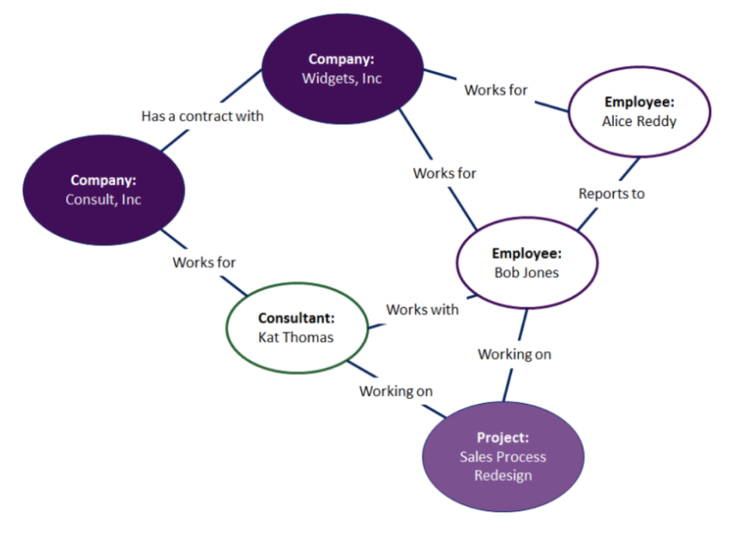

**Ontology example**

**What Is the Product Life Cycle?**

PLC is an assumption that every product goes through that involves the same pattern of introduction into the market, growth, maturity, and decline. As the product spends more time in the market and it makes its way through the cycle, its sales increase. Each product’s PLC is different in the length of scope and duration, and each product is at risk of not making it out of the introduction phase. However, the company strategy should remain consistent throughout each of the phases.

The PLC, in brief, is as follows:

**Stage 1:** Product Development: The new product is introduced; this is when all of the research and development happens.

**Stage 2:**Product Growth: The product is more than an idea or a prototype. At this stage, the product is manufactured, marketed, and released. Distribution increases, demand increases, and competition also increases.

**Stage 3:** Product Maturity: During this stage, the product is widely available, and there are many competitors in the marketplace. You market the product to different segments, but more spending on advertising will have no impact on its demand.

**Stage 4:** Product Decline: The product is losing market share, or becoming obsolete. It is well past its point of highest demand, and the demand decreases.

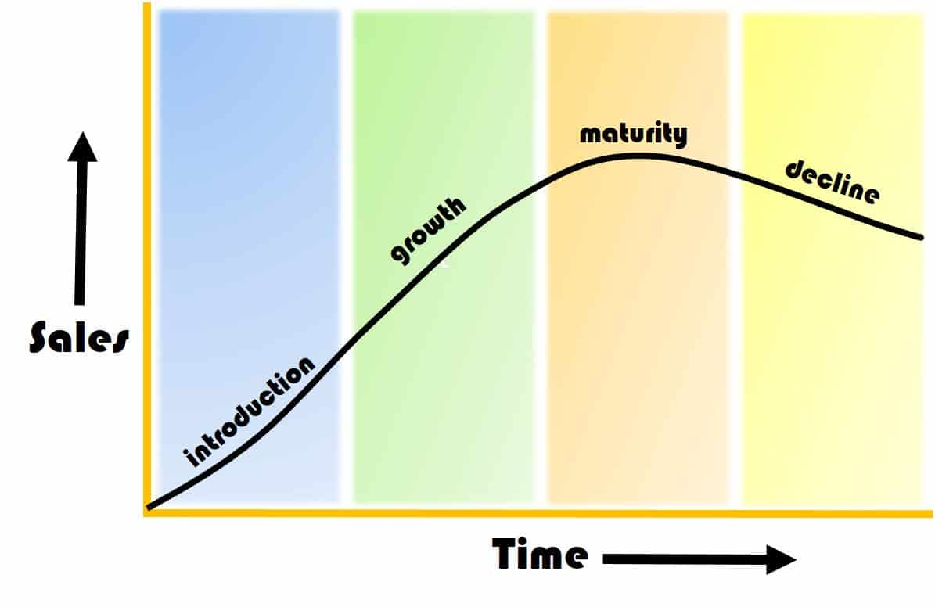

Additionally, the product life cycle affects the average selling price (ASP). The ASP is how much you generally sell your products or services for. When a product has many competitors or it is in the decline stage of its PLC, the ASP will be lower.

Product image also drives the ASP. Products with an image of exclusivity have a higher ASP. For example, Louis Vuitton luggage is considered a luxury brand of products that are made by hand and use the finest materials. There is a limited assortment of products, a long wait time to procure one, and a higher than average price point. The company has even sped up their manufacturing process, but the price point still reflects the exclusivity and time to market of a custom bag. In fact, Louis Vuitton increased its prices in 2013 to attract more high-end consumers because they experienced a decline. This approach is an interesting twist on the PLC since normally the prices would drop with the waning in demand.

**Closed-Loop Manufacturing Cycle**

So far, we have been discussing the typical PLC. It is linear and at each stage has material, labor, and resource inputs. It also has waste outputs that can negatively affect the environment. Researchers assert that the introduction stage where design takes place determines between 70 percent and 90 percent of the life cycle costs. At this stage, manufacturers can also remove excess waste and continue to develop sustainable manufacturing practices. These practices should include products being reused, recycled, and remanufactured. With this, you are developing a closed-loop manufacturing cycle. Instead of a linear PLC, this represents a circular PLC.

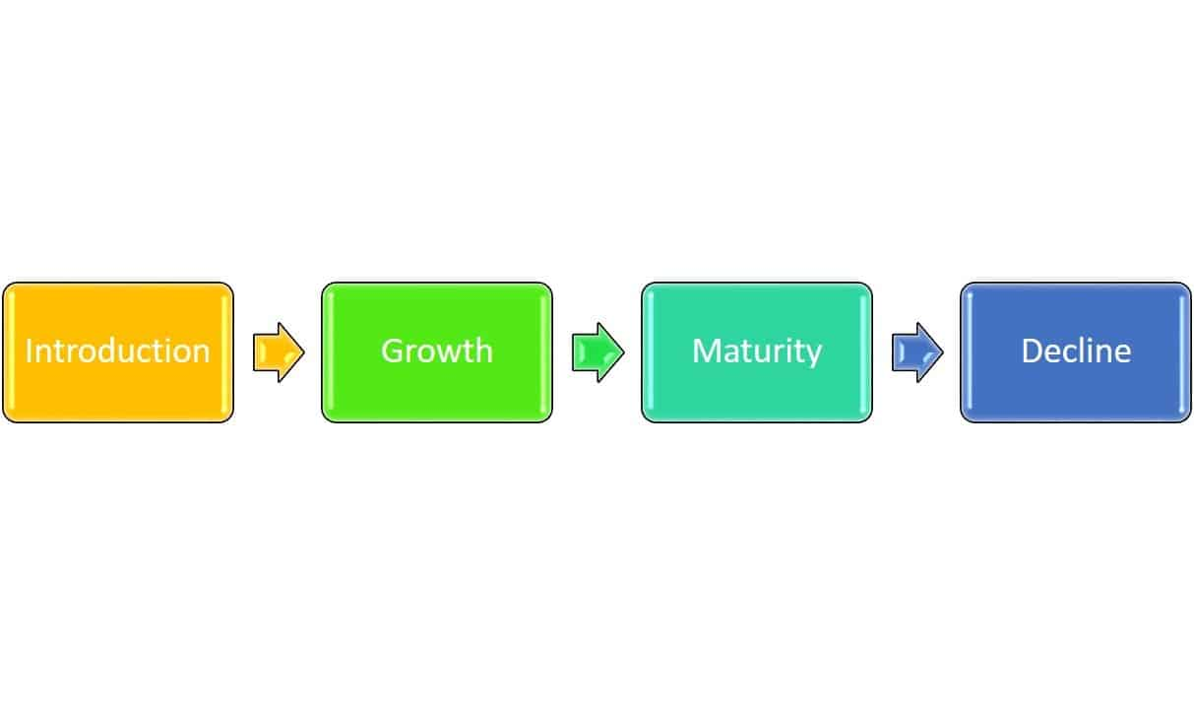

A closed-loop cycle is a natural extension of PLM, and creates a truly full life cycle that takes your obsolete or used products back into raw materials, not just assigning them to waste. Although many of these closed-loop products are down cycled (converted into lesser-quality materials), the products are still recycled and reused repeatedly.

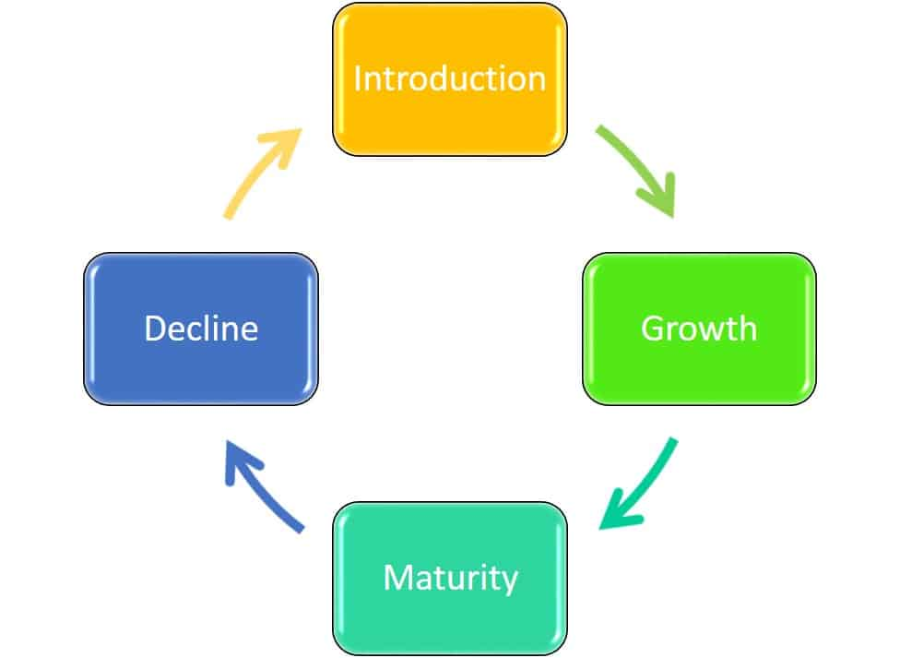

An example of this is Dell’s take-back program, which takes the computers that it manufacturers and turns a majority of them into new computers. Other companies separate out product components and sell them to their partners on the commodities market, as raw materials, who then make them into new products. The benefits of a closed-loop system include:

* Better for the environment
* Does not affect performance or price
* Fewer carbon emissions in manufacturing
* As programs scale, they become cheaper and more effective

Commodities:

Commodities are an important aspect of most American's daily life. A commodity is a basic good used in commerce that is interchangeable with other goods of the same type. Traditional examples of commodities include grains, gold, beef, oil, and natural gas.

For investors, commodities can be an important way to diversify their portfolios beyond traditional securities. Because the prices of commodities tend to move in opposition to stocks, some investors also rely on commodities during periods of market volatility.

In the past, commodities trading required significant amounts of time, money, and expertise, and was primarily limited to professional traders. Today, there are more options for participating in the commodity markets.

* Commodities that are traded are typically sorted into four categories broad categories: metal, energy, livestock and meat, and agricultural.
* For investors, commodities can be an important way to diversify their portfolios beyond traditional securities.
* In the most basic sense, commodities are known to be risky investment propositions because their market (supply and demand) is impacted by uncertainties that are difficult or impossible to predict, such as unusual weather patterns, epidemics, and disasters both natural and human-made.
* There are a number of ways to invest in commodities, such as futures contracts, options, and exchange traded funds (ETFs).