

**School of Computing**

**SRM IST, Kattankulathur – 603 203**

**Course Code: 21CSC303J**

**Course Name: Software Engineering and Project Management**

|  |  |
| --- | --- |
| **Experiment No** | 13 |
| **Title of Experiment** | Provide the details of Architecture Design/Framework/Implementation |
| **Name of the candidate** | Ponnuri Aniruddha |
| **Team Members** | Vamshi Gadde (RA2112704010017)  Y Shabanya Kishore (RA2112704010018) |
| **Register Numbers** | RA2112704010015 |
| **Date of Experiment** | 15/04/2024 |

**Mark Split Up**

|  |  |  |  |
| --- | --- | --- | --- |
| **S. No** | **Description** | **Maximum Mark** | **Mark Obtained** |
| 1 | Exercise | 5 |  |
| 2 | Viva | 5 |  |
| **Total** | | **10** |  |

**Staff Signature with date**

**Aim**

To provide the details of architectural design/framework/implementation

**Team Members:**

|  |  |  |  |
| --- | --- | --- | --- |
| **S No** | **Register No** | **Name** | **Role** |
| **1** | **RA2112704010015** | **Ponnuri Aniruddha** | **Rep/Member** |
| **2** | **RA2112704010018** | **Y Shabanya Kishore** | **Member** |
| **3** | **RA2112704010017** | **Vamshi Gadde** | **Member** |

**Framework and Implementation:**

Frontend: React.js

Backend: Node.js with Express framework

Database: MongoDB

**Architectural Design:**

Frontend: Built with React.js, this layer handles user interactions, rendering dynamic content, and presenting the user interface.

Backend: Implemented using Node.js with Express framework, this layer processes user requests, interacts with the database, and performs core application logic.

Database: MongoDB serves as the NoSQL database, storing research papers, user information, and other application data.

User Management Module:

Description: This module handles user registration, login, profile management, and authorization.

User Registration:

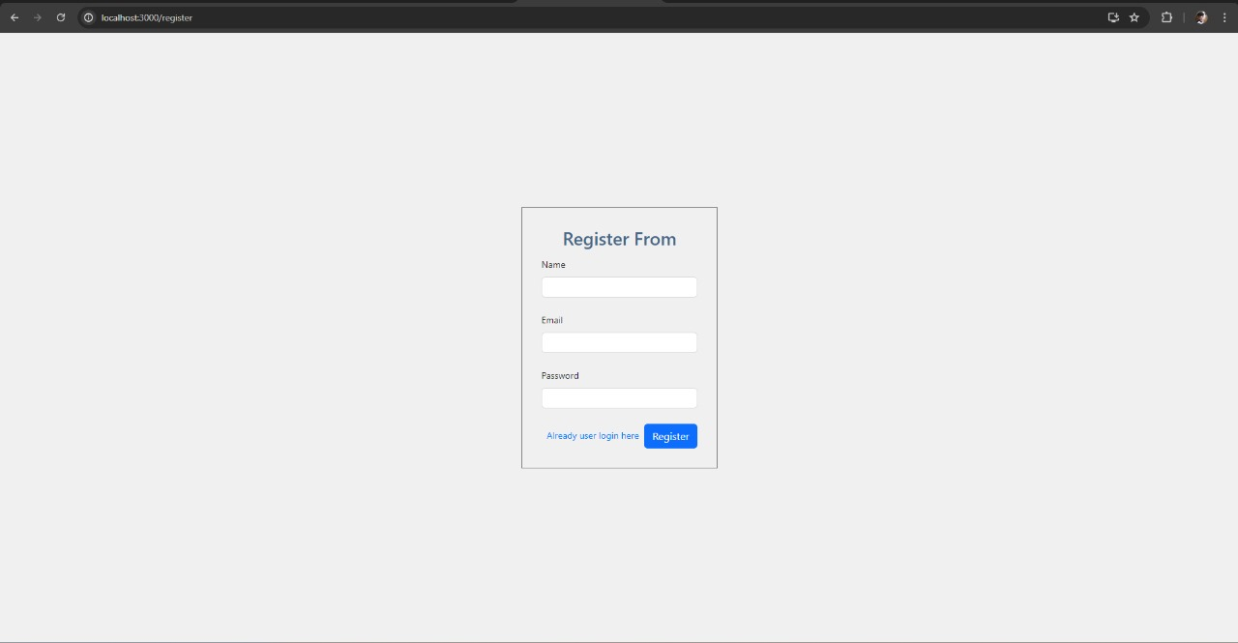

User Login:

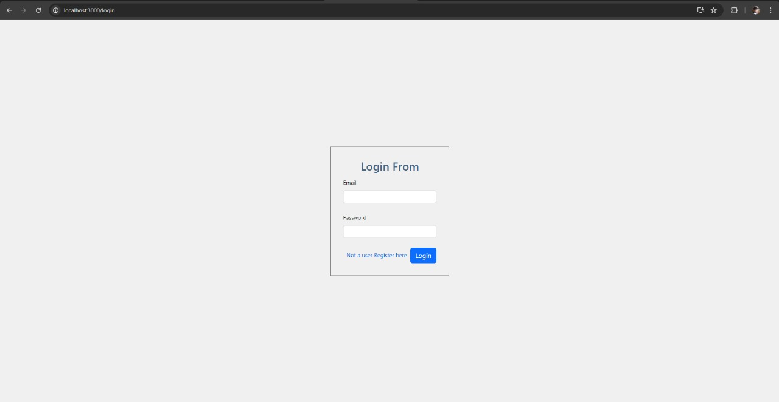

Home Page (Landing Page):

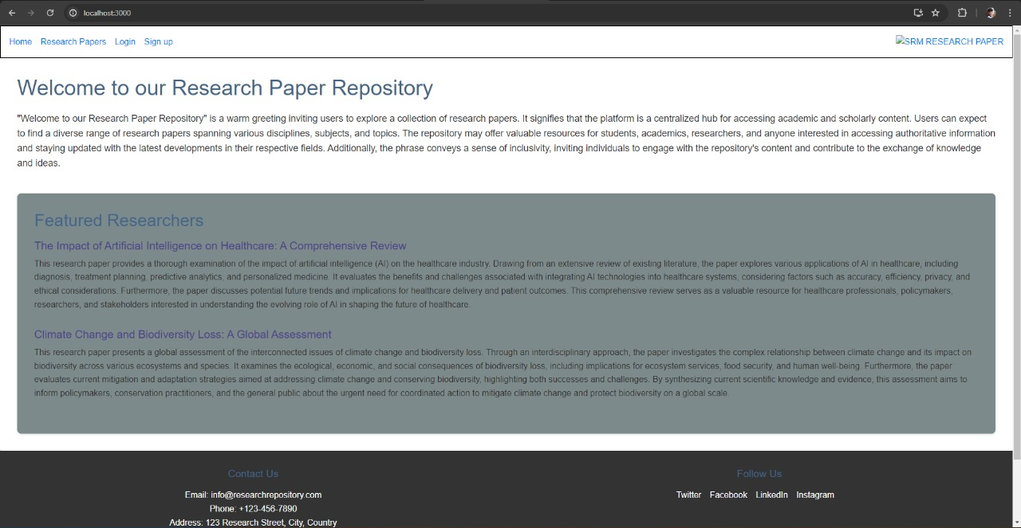

Teacher Dashboard:

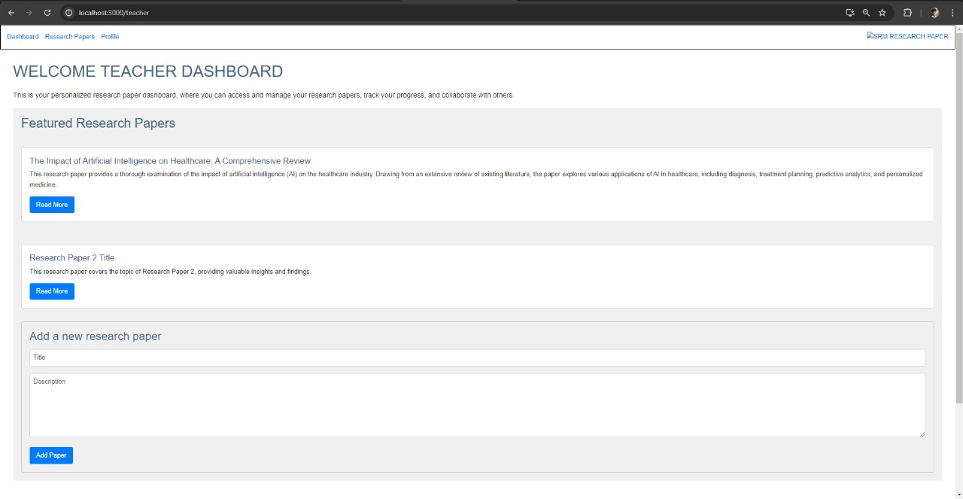

Student dashboard:

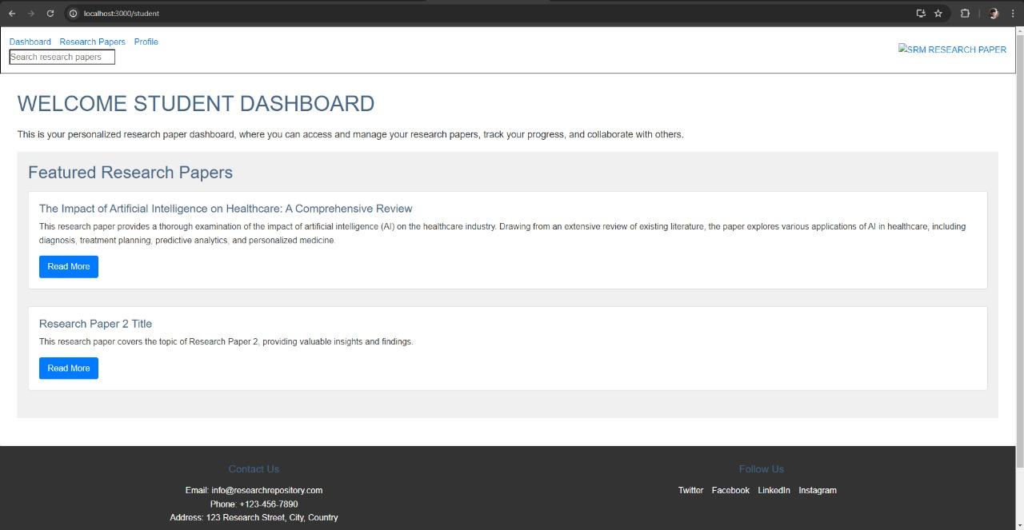

Admin Dashboard:

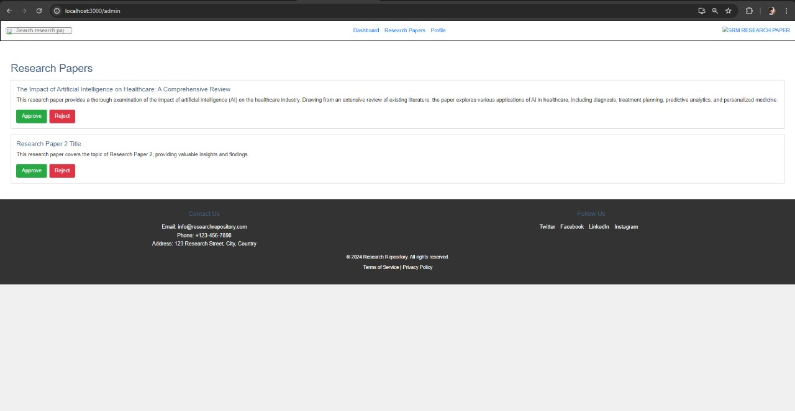

Code: --

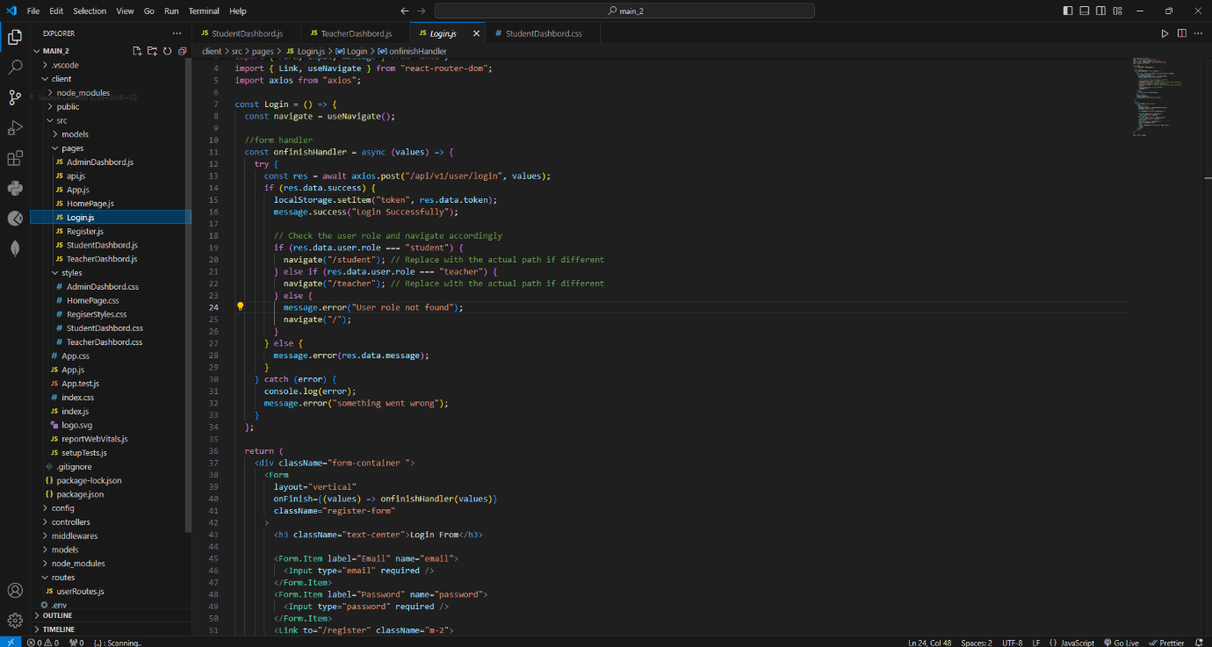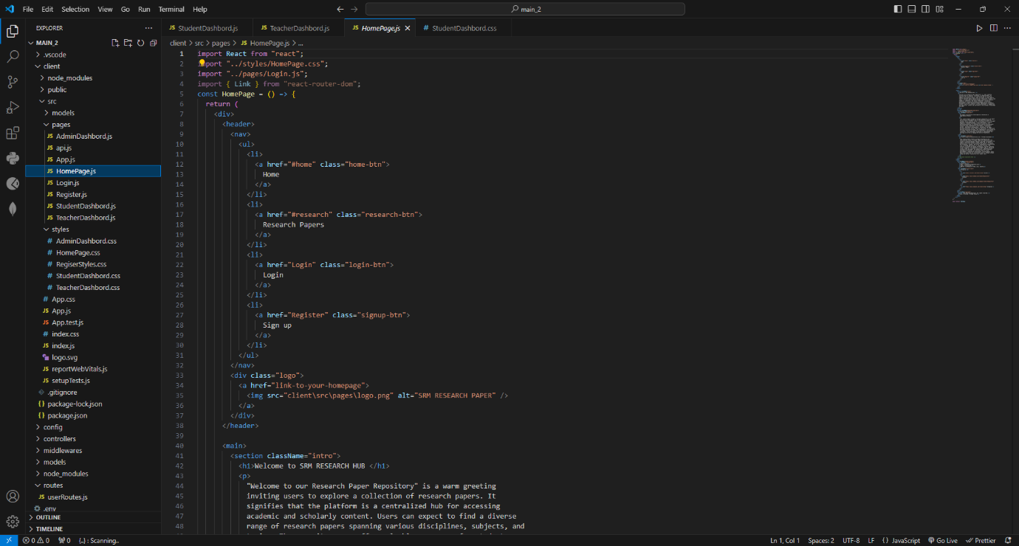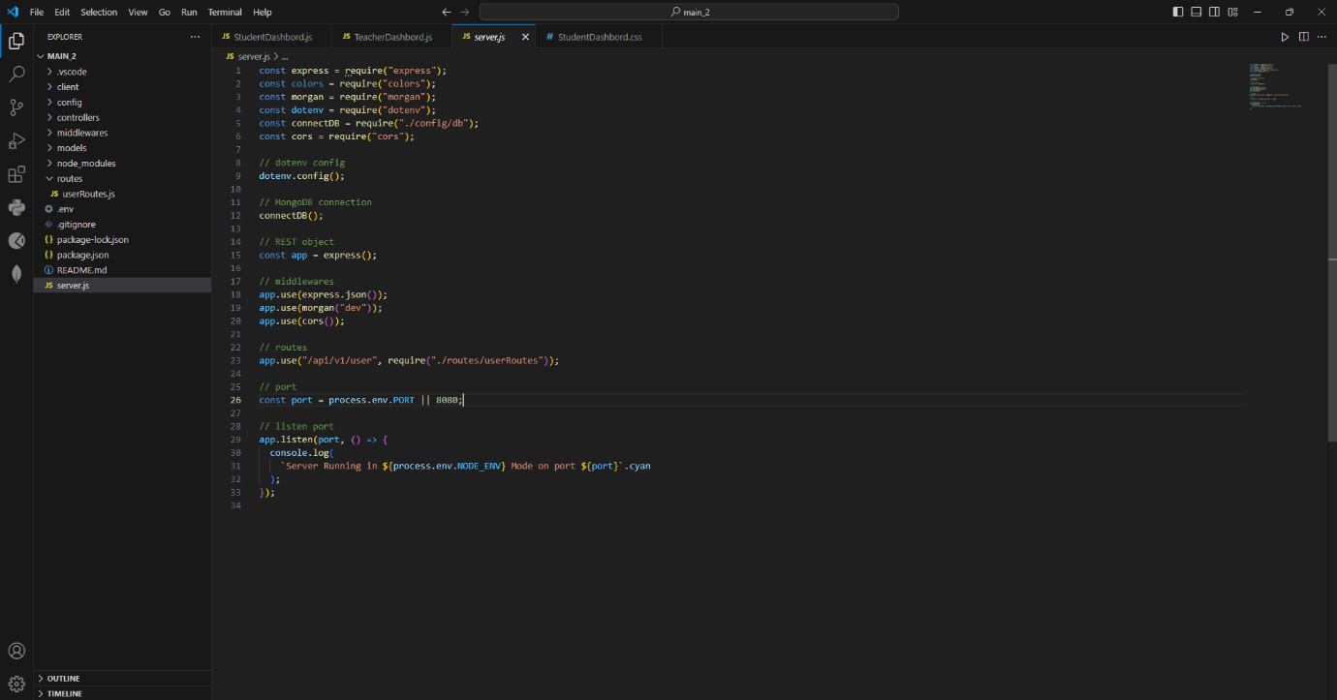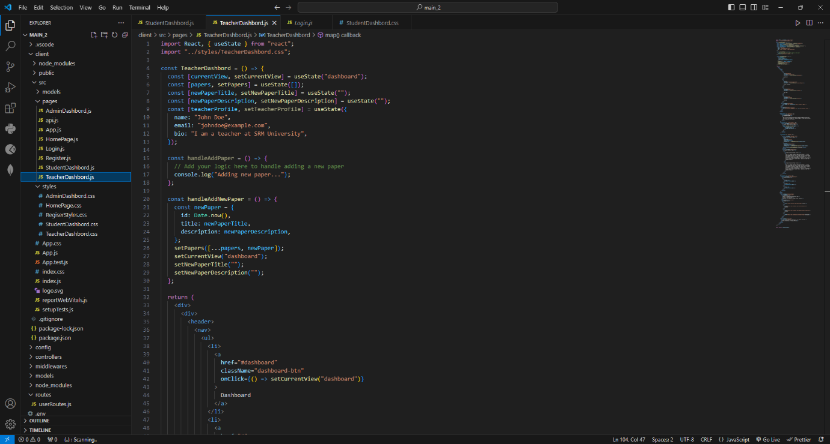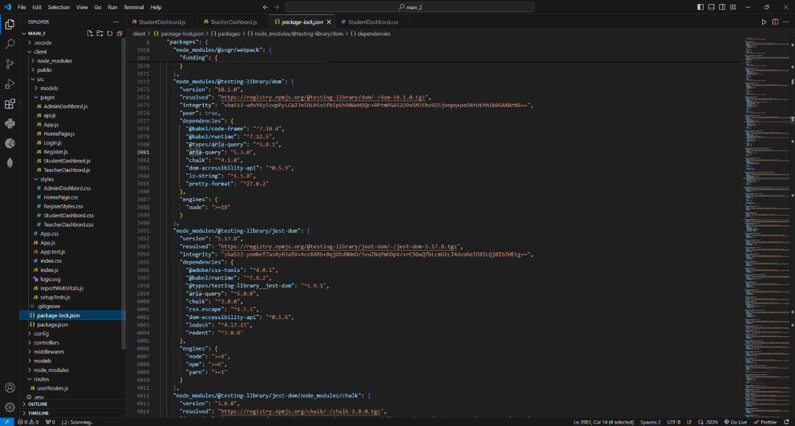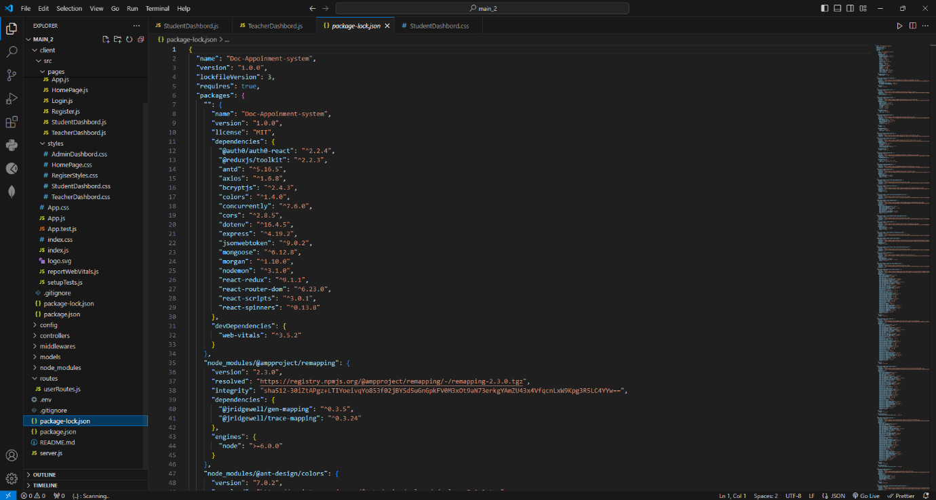

Result:

Thus, the details of architectural design/framework/implementation along with the screenshots were provided.