

**School of Computing**

**SRM IST, Kattankulathur – 603 203**

**Course Code: 21CSC303J**

**Course Name: Software Engineering and Project Management**

|  |  |
| --- | --- |
| **Experiment No** | 5 |
| **Title of Experiment** | Prepare Work breakdown structure, Timeline chart, Risk identification table |
| **Name of the candidate** | Ponnuri Aniruddha |
| **Team Members** | Vamshi Gadde (RA2112704010017)  Y Shabanya Kishore (RA2112704010018) |
| **Register Number** | RA2112704010015 |
| **Date of Experiment** | 17/02/2024 |

**Mark Split Up**

|  |  |  |  |
| --- | --- | --- | --- |
| **S.No** | **Description** | **Maximum Mark** | **Mark Obtained** |
| 1 | Exercise | 5 |  |
| 2 | Viva | 5 |  |
| **Total** | | **10** |  |

**Staff Signature with date**

**Aim**

To Prepare Work breakdown structure, Timeline chart and Risk identification table

**Team Members:**

|  |  |  |  |
| --- | --- | --- | --- |
| **Sl No** | **Register No** | **Name** | **Role** |
| **1** | **RA2112704010015** | Ponnuri Aniruddha | **Rep** |
| **2** | **RA2112704010018** | Y Shabanya Kishore | **Member** |
| **3** | **RA2112704010017** | Vamshi Gadde | **Member** |

**WBS**

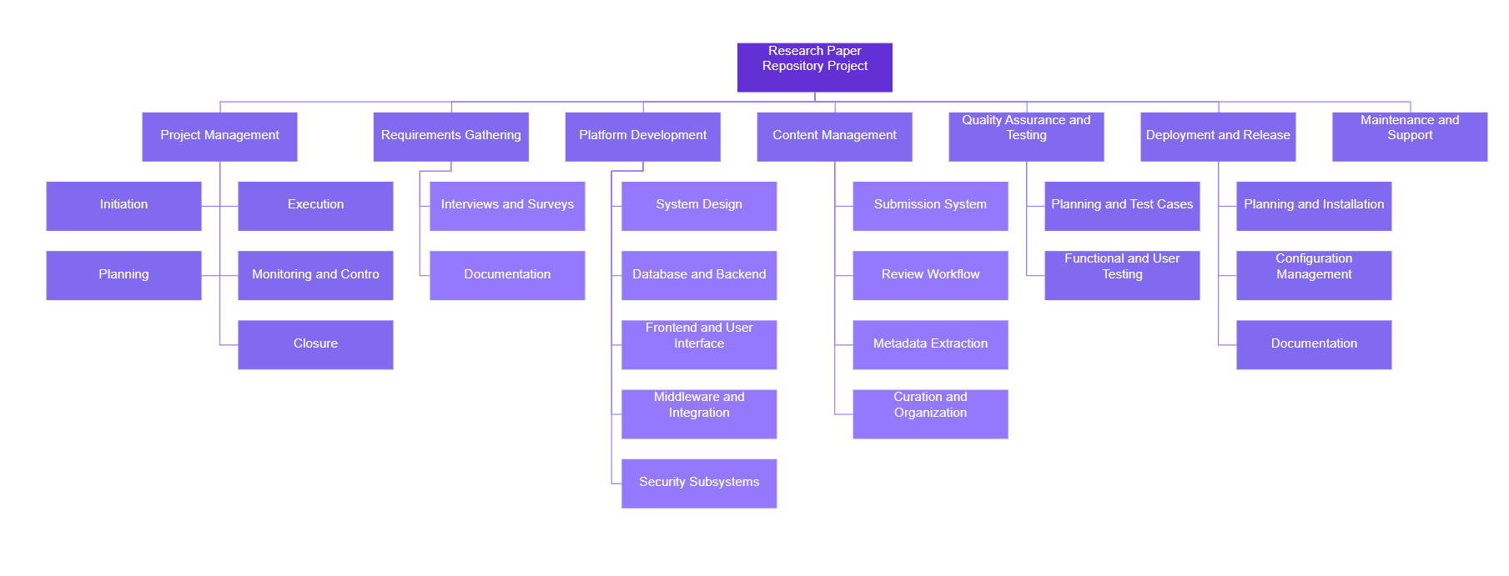

1. **Project Initiation**
   * Define project goals and objectives
   * Establish project team and roles
2. **Requirement Gathering**
   * Conduct stakeholder interviews
   * Gather user requirements and feedback
3. **Platform Design and Development**
   * Design system architecture
   * Develop database structure
   * Design user interface
   * Develop backend functionalities
   * Develop frontend layout and features
   * Integrate middleware components
4. **Content Management**
   * Develop paper submission system
   * Implement review and approval workflow
   * Implement metadata extraction and indexing
   * Organize and curate content
5. **Quality Assurance and Testing**
   * Plan testing activities
   * Develop test cases
   * Conduct functional testing
   * Perform user acceptance testing
6. **Deployment and Release**
   * Plan deployment process
   * Install and configure software
   * Document release notes and procedures
7. **Maintenance and Support**
   * Address bug fixes and updates
   * Provide ongoing user support
8. **Documentation and Training**
   * Create user manuals and documentation
   * Conduct training sessions for users and administrators

**TIMELINE – GANTT CHART**

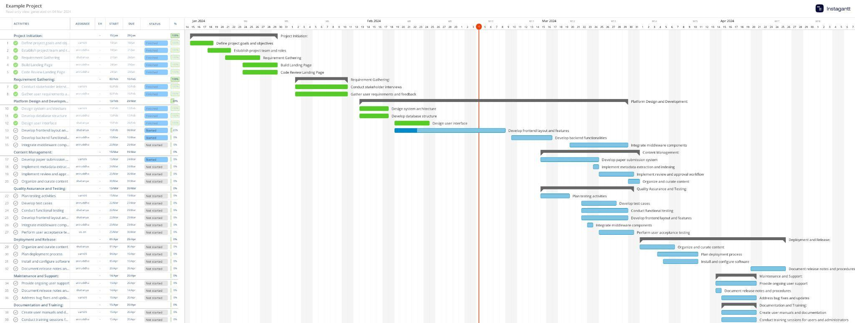

**RISK ANALYSIS – SWOT & RMMM**

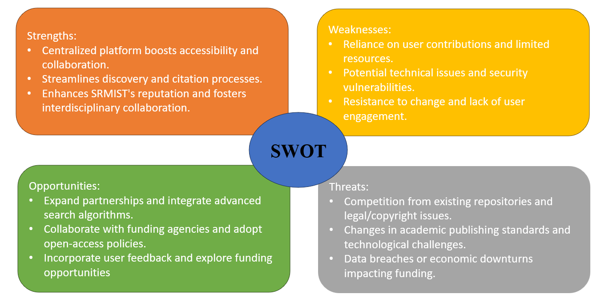

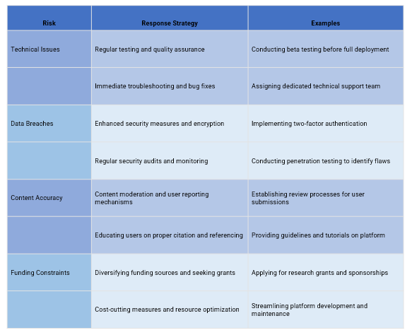

Result:

Thus, the work breakdown structure with timeline chart and risk table were formulated successfully.