

**School of Computing**

**SRM IST, Kattankulathur – 603 203**

**Course Code: 21CSC303J**

**Course Name: Software Engineering and Project Management**

|  |  |
| --- | --- |
| **Experiment No** | 6 |
| **Title of Experiment** | Design a System Architecture, Use Case and Class Diagram |
| **Name of the candidate** | Ponnuri Aniruddha |
| **Team Members** | Vamshi Gadde (RA2112704010017)  Y Shabanya Kishore (RA2112704010018) |
| **Register Number** | RA2112704010015 |
| **Date of Experiment** | 19/02/2024 |

**Mark Split Up**

|  |  |  |  |
| --- | --- | --- | --- |
| **S.No** | **Description** | **Maximum Mark** | **Mark Obtained** |
| 1 | Exercise | 5 |  |
| 2 | Viva | 5 |  |
| **Total** | | **10** |  |

**Staff Signature with date**

**Aim**

To Design a System Architecture, Use case and Class Diagram

**Team Members:**

|  |  |  |  |
| --- | --- | --- | --- |
| **Sl No** | **Register No** | **Name** | **Role** |
| **1** | **RA2112704010015** | **Ponnuri Aniruddha** | **Rep** |
| **2** | **RA2112704010018** | **Y Shabanya Kishore** | **Member** |
| **3** | **RA2112704010017** | **Vamshi Gadde** | **Member** |

**SYSTEM ARCHITECTURE –**

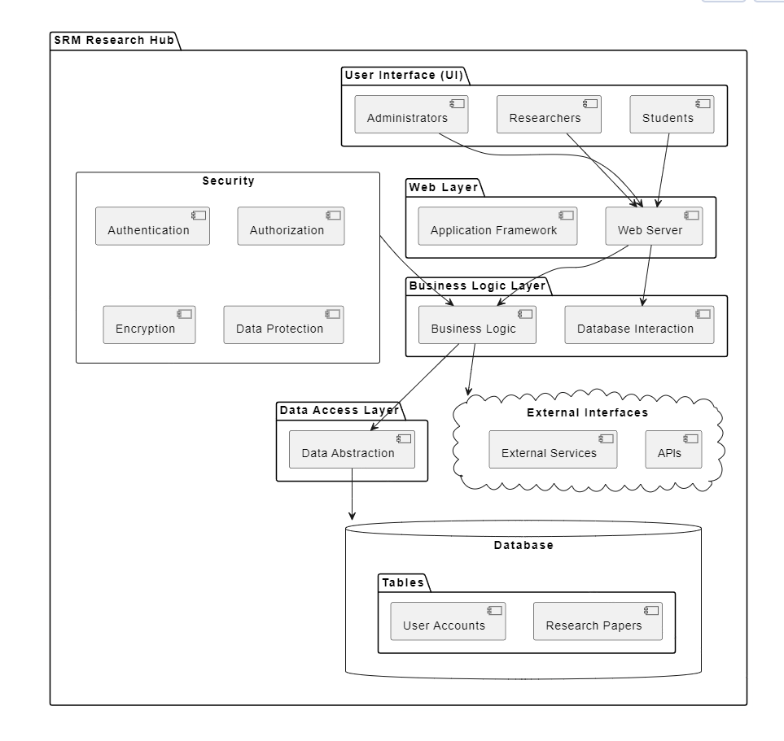

**USE CASE DIAGRAM**

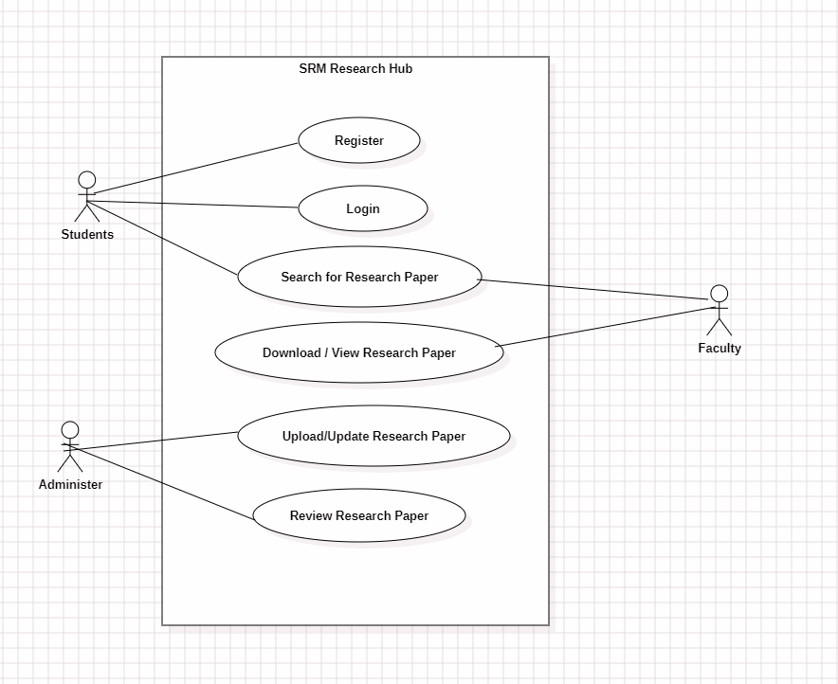

**CLASS DIAGRAM**

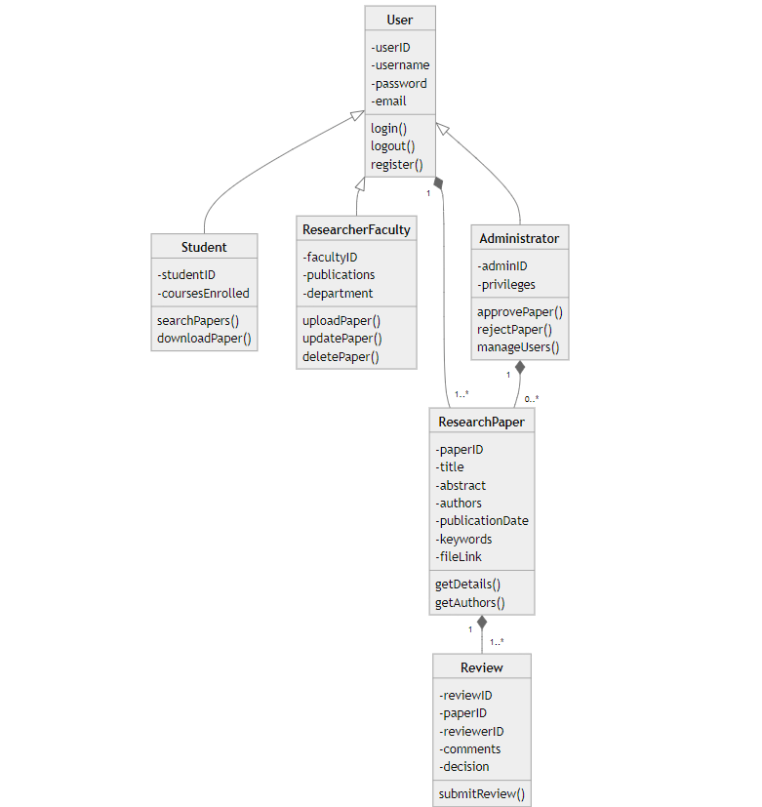

**Result:**

Thus, the system architecture, use case and class diagram created successfully.