

**School of Computing**

**SRM IST, Kattankulathur – 603 203**

**Course Code: 21CSC303J**

**Course Name: Software Engineering and Project Management**

|  |  |
| --- | --- |
| **Experiment No** | 8 |
| **Title of Experiment** | Develop a Data Flow Diagram (Process-Up to Level 1) |
| **Name of the candidate** | Ponnuri Aniruddha |
| **Team Members** | Vamshi Gadde (RA2112704010017)  Y Shabanya Kishore (RA2112704010018) |
| **Register Number** | RA2112704010015 |
| **Date of Experiment** | 04/03/2024 |

**Mark Split Up**

|  |  |  |  |
| --- | --- | --- | --- |
| **S. No** | **Description** | **Maximum Mark** | **Mark Obtained** |
| 1 | Exercise | 5 |  |
| 2 | Viva | 5 |  |
| **Total** | | **10** |  |

**Staff Signature with date**

**Aim**

To develop the data flow diagram up to level 1 for the SRM Research Hub

**Team Members:**

|  |  |  |  |
| --- | --- | --- | --- |
| **S No** | **Register No** | **Name** | **Role** |
| **1** | **RA2112704010015** | **Ponnuri Aniruddha** | **Rep** |
| **2** | **RA2112704010018** | **Y Shabanya Kishore** | **Member** |
| **3** | **RA2112704010017** | **Vamshi Gadde** | **Member** |

DFD Level - 0

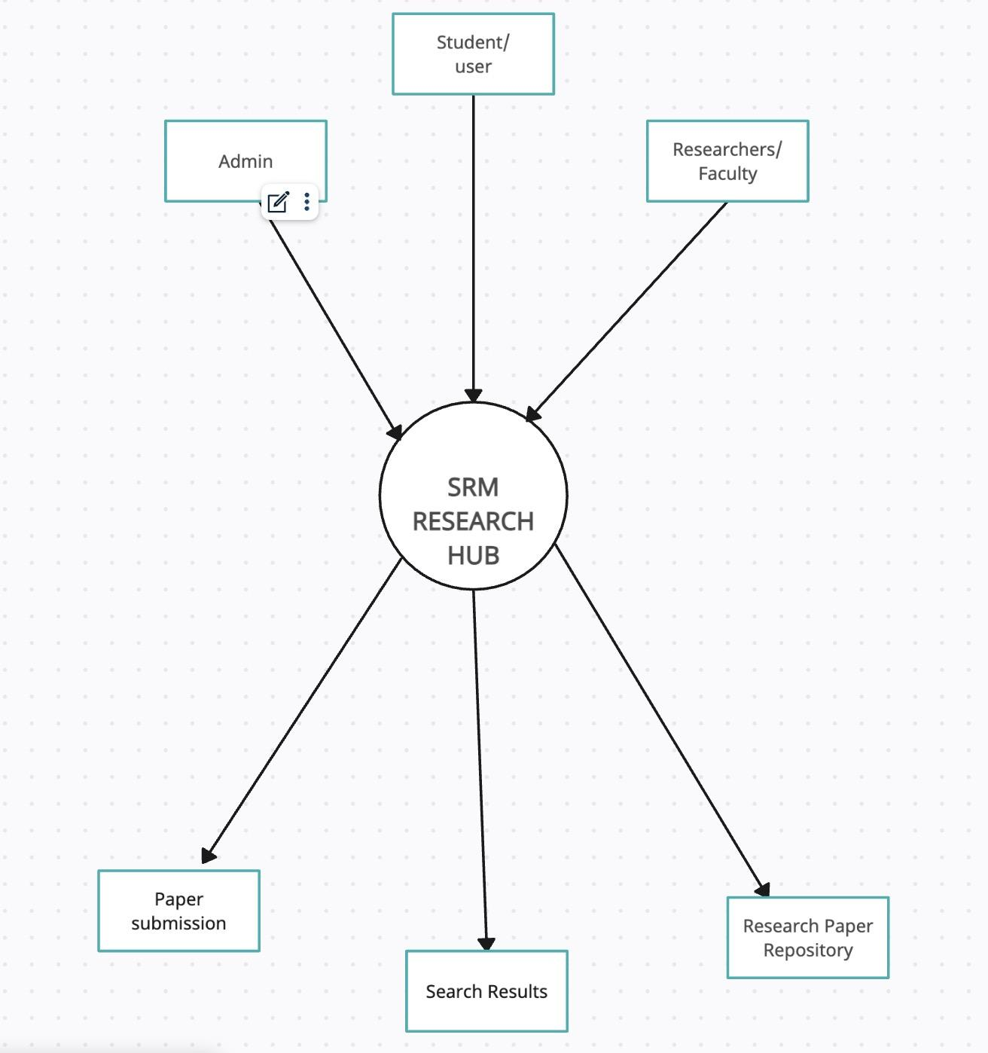

DFD Level - 1

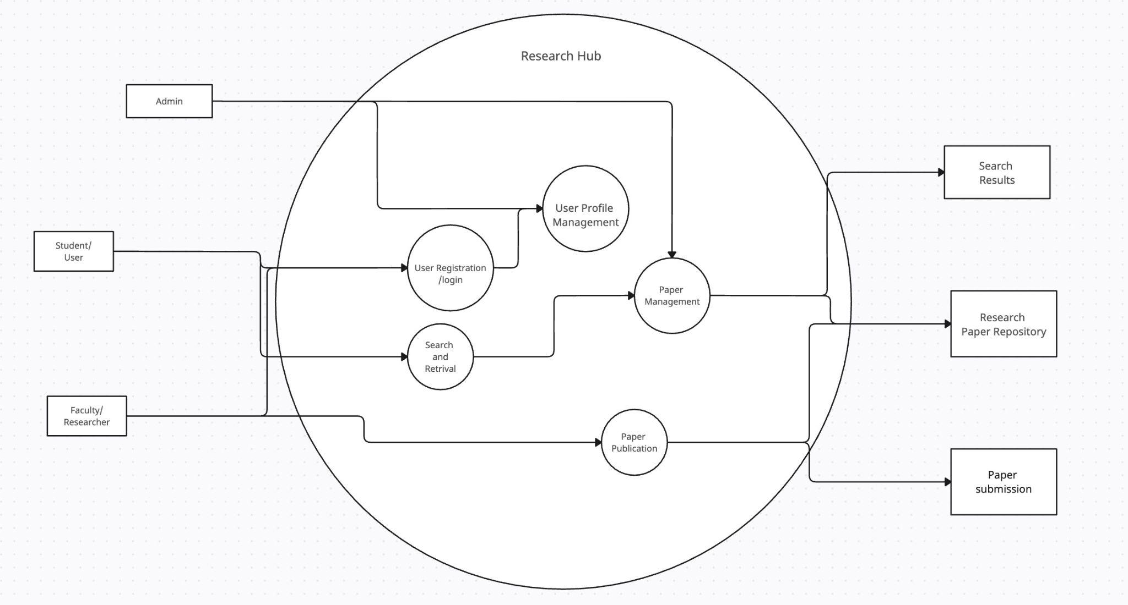

Result:

Thus, the data flow diagrams have been created for the SRM Research Hub.