**LAB RECORD**

**21CSC303J**

**Software Engineering and Project Management**

*Submitted by*

**Ponnuri Aniruddha [RA2112704010015]**

*Under the Guidance of*

**Dr.A.Shanthini**

(Associate Professor, Department of Data Science and Business Systems)

*In partial fulfillment of the Requirements for the Degree*

*of*

**M.TECH (Integrated)**

**COMPUTER SCIENCE WITH SPECIALIZATION IN DATA SCIENCE**



**DEPARTMENT OF DATA SCIENCE AND BUSINESS SYSTEMS**

**FACULTY OF ENGINEERING AND TECHNOLOGY**

**SRM INSTITUTE OF SCIENCE AND TECHNOLOGY**

**MAY 2024**



**School of Computing**

**SRM IST, Kattankulathur – 603 203**

**Course Code: 21CSC303J**

**Course Name: Software Engineering and Project Management**

|  |  |
| --- | --- |
| **Experiment No** | 1 |
| **Title of Experiment** | To identify the Software Project, Create Business Case, Arrive at a Problem Statement |
| **Name of the candidate** | Ponnuri Aniruddha |
| **Team Members** | Vamshi Gadde (RA2112704010017)  Y Shabanya Kishore (RA2112704010018) |
| **Register Number** | RA2112704010015 |
| **Date of Experiment** | 18/01/2024 |

**Mark Split Up**

|  |  |  |  |
| --- | --- | --- | --- |
| **S.No** | **Description** | **Maximum Mark** | **Mark Obtained** |
| 1 | Exercise | 5 |  |
| 2 | Viva | 5 |  |
| **Total** | | **10** |  |

**Staff Signature with date**

**Aim**

To Frame a project team, analyze and identify a Software project. To create a business case and Arrive at a Problem Statement for the SRM RESEARCH HUB

**Team Members:**

|  |  |  |  |
| --- | --- | --- | --- |
| **S. No** | **Register No** | **Name** | **Role** |
| **1** | **RA2112704010015** | Ponnuri Aniruddha | **Lead/Rep** |
| **2** | **RA2112704010018** | Y Shabanya Kishore | **Member** |
| **3** | **RA2112704010017** | Vamshi Gadde | **Member** |

**Project Title:**

**SRM RESEARCH HUB**

**Project Description**

The Research Paper Repository is a web-based platform designed to facilitate the management and access of research papers. It provides users with the ability to explore and contribute to a curated collection of academic publications, with a focus on papers published by SRM Institute of Science and Technology (SRMIST) researchers. The platform aims to streamline the process of discovering, sharing, and collaborating on research within the academic community.

**ONE PAGE BUSINESS CASE TEMPLATE**

|  |  |  |
| --- | --- | --- |
|  | **DATE** | 18/01/2024 |
|  | **SUBMITTED BY** | Ponnuri Aniruddha |
|  | **TITLE / ROLE** | Developer |
| **THE PROJECT**  In bullet points, describe the problem this project aims to solve or the opportunity it aims to develop. | | | |
| * Current academic research papers are scattered across various sources, making it difficult for researchers to discover and access relevant publications. * SRM Institute of Science and Technology (SRMIST) research papers may not receive adequate exposure beyond traditional academic circles, hindering their impact and recognition. * Existing methods for sharing and collaborating on research papers are often cumbersome and lack user-friendly features, leading to inefficiencies in knowledge dissemination and collaboration. * Researchers require a secure and intuitive platform to access, contribute, and collaborate on research papers while ensuring data privacy and integrity. * By providing a centralized repository for research papers, the project aims to facilitate collaboration among researchers, students, and academic professionals, fostering innovation and knowledge exchange within the academic community. | | | |

|  |
| --- |
| **THE HISTORY**  In bullet points, describe the current situation. |
| * Academic research papers from SRM Institute of Science and Technology (SRMIST) are scattered across various sources including academic journals, conference proceedings, and institutional repositories. * Researchers, students, and academic professionals struggle to discover and access relevant SRMIST research papers due to the lack of a centralized platform. * Existing methods for sharing and collaborating on research papers are often inefficient and fragmented, leading to challenges in knowledge dissemination and collaboration. * SRMIST research papers may not receive adequate visibility and recognition beyond traditional academic circles, limiting their impact and contribution to the broader research community. |
| **LIMITATIONS**  List what could prevent the success of the project, such as the need for expensive equipment, bad weather, lack of special training, etc. |
| * Limited access to research papers: The project's success may be hindered if there are restrictions or limitations on accessing SRM Institute of Science and Technology (SRMIST) research papers from official sources. * Technical challenges: Complexities in integrating with SRMIST's official website or obtaining data from various websites may pose technical hurdles to the project's development and functionality. |
| **APPROACH**  List what is needed to complete the project. |
| Research and Analysis:   * Conduct research on existing academic repositories and collaboration platforms. * Analyze user requirements and preferences within the SRM Institute of Science and Technology (SRMIST) community. * Investigate technical feasibility and compatibility with SRMIST's official website and data sources.   Development Resources:   * Determine the technologies and frameworks needed for web application development. * Set up development environments and version control systems for collaborative coding.   Data Integration:   * Establish connections with SRMIST's official website or data sources to fetch research paper metadata. * Develop scripts to retrieve and parse data from external sources.` * Implement a data cleansing process to ensure that the data conforms to the database structure.   Database Management:   * Design and implement a scalable database schema for storing user information, research papers, and metadata. * Optimize database queries and indexing for efficient data retrieval and storage. |

|  |
| --- |
| **BENEFITS**  In bullet points, list the benefits that this project will bring to the organization. |
| * Centralized repository for research papers enhances accessibility and visibility of SRM Institute of Science and Technology (SRMIST) publications. * Facilitates collaboration and knowledge sharing among researchers, students, and academic professionals within the institution. * Streamlines the process of discovering, accessing, and citing relevant research papers, thereby fostering academic excellence and innovation. * Enhances the reputation and recognition of SRMIST as a hub for cutting-edge research and scholarly contributions. * Encourages interdisciplinary collaboration and cross-departmental engagement by providing a platform for interdisciplinary research exploration. * Strengthens the institution's research ecosystem by promoting transparency, accountability, and integrity in scholarly communication. * Empowers researchers and students to showcase their work and contributions to the broader academic community, leading to increased citations and impact. * Establishes SRMIST as a leader in digital innovation and academic excellence by leveraging modern technologies and best practices in research dissemination and collaboration. |

Result:

Thus, the project team formed, the project was described, the business case was prepared and the problem statement was arrived at.



**School of Computing**

**SRM IST, Kattankulathur – 603 203**

**Course Code: 21CSC303J**

**Course Name: Software Engineering and Project Management**

|  |  |
| --- | --- |
| **Experiment No** | 2 |
| **Title of Experiment** | Identification of Process Methodology and Stakeholder Description |
| **Name of the candidate** | Ponnuri Aniruddha |
| **Team Members** | Vamshi Gadde (RA2112704010017)  Y Shabanya Kishore (RA2112704010018) |
| **Register Number** | RA2112704010015 |
| **Date of Experiment** | 29/01/2024 |

**Mark Split Up**

|  |  |  |  |
| --- | --- | --- | --- |
| **S.No** | **Description** | **Maximum Mark** | **Mark Obtained** |
| 1 | Exercise | 5 |  |
| 2 | Viva | 5 |  |
| **Total** | | **10** |  |

**Staff Signature with date**

**Aim**

To identify the appropriate Process Model for the project and prepare Stakeholder and User Description.

**Team Members:**

|  |  |  |  |
| --- | --- | --- | --- |
| **S. No** | **Register No** | **Name** | **Role** |
| **1** | **RA2112704010015** | Ponnuri Aniruddha | **Rep/Member** |
| **2** | **RA2112704010018** | Y Shabanya Kishore | **Member** |
| **3** | **RA2112704010017** | Vamshi Gadde | **Member** |

**Project Title:**

**SRM RESEARCH HUB**

**Selection of Methodology (WaterFall Methodology):--**

* Well-defined Requirements: If the requirements for the SRM Research Hub are clear from the outset, with little expectation of change, the Waterfall model allows for a systematic progression through the stages of development.
* Sequential Phases: The Waterfall model's sequential nature – with distinct phases for requirements gathering, design, implementation, verification, and maintenance – ensures that each phase can be completed and reviewed for quality before moving on to the next.
* Documentation and Rigor: This model emphasizes rigorous documentation and adherence to initial plans, which can be beneficial for aligning with institutional policies and maintaining clarity of purpose throughout the project lifecycle.
* Stakeholder Communications: It can be easier to communicate progress to stakeholders with a Waterfall approach because the project is divided into distinct stages with concrete deliverables at the end of each phase.
* Resource Planning: The Waterfall model allows for more predictable resource allocation and scheduling since each phase is planned in detail at the start of the project.

Incorporate information to below table regarding stakeholders of the project [Make use of below examples]

|  |  |  |  |  |
| --- | --- | --- | --- | --- |
| Stakeholder Name | Activity/ Area /Phase | Interest | Influence | Priority (High/ Medium/ Low) |
| Researchers | Access to latest research papers | High | Low | Medium |
| Students | Access to educational resources | High | High | High |
| Faculty Members | Research dissemination and collaboration | High | High | High |
| External Researchers | Access to SRMIST research papers | High | Low | Low |

Result:

Thus the Project Methodology was identified and the stakeholders were described.



**School of Computing**

**SRM IST, Kattankulathur – 603 203**

**Course Code: 21CSC303J**

**Course Name: Software Engineering and Project Management**

|  |  |
| --- | --- |
| **Experiment No** | 3 |
| **Title of Experiment** | System, Functional and Non-Functional Requirements of the Project |
| **Name of the candidate** | Ponnuri Aniruddha |
| **Team Members** | Vamshi Gadde (RA2112704010017)  Y Shabanya Kishore (RA2112704010018) |
| **Register Number** | RA2112704010015 |
| **Date of Experiment** | 05/02/2024 |

**Mark Split Up**

|  |  |  |  |
| --- | --- | --- | --- |
| **S.No** | **Description** | **Maximum Mark** | **Mark Obtained** |
| 1 | Exercise | 5 |  |
| 2 | Viva | 5 |  |
| **Total** | | **10** |  |

**Staff Signature with date**

**Aim**

To identify the system, functional and non-functional requirements for the project.

**Team Members:**

|  |  |  |  |
| --- | --- | --- | --- |
| **S No** | **Register No** | **Name** | **Role** |
| **1** | **RA2112704010015** | Ponnuri Aniruddha | **Rep/Member** |
| **2** | **RA2112704010018** | Y Shabanya Kishore | **Member** |
| **3** | **RA2112704010017** | Vamshi Gadde | **Member** |

**Project Title: SRM RESEARCH HUB**

**System Requirements:**

Hardware

* Server infrastructure capable of hosting web services, managing databases, and storing sensitive data.
* Scalable storage solutions can handle increasing volumes of research papers and user data.

Software:

* Web server software and a database management system (such as MySQL or PostgreSQL).
* Frameworks and libraries designed for web application development

Compatibility:

* Compatibility with a variety of research paper file formats (for example, PDF and DOCX).

**Functional Requirements**

User Authentication and Authorization:

* Users should be able to register for accounts with a valid email address and password.
* Registered users should be able to log in to the website securely.
* The system should enforce password strength requirements and provide options for password recovery and account management.
* Different user roles (e.g., regular user, administrator) should have different levels of access permissions.

Research Paper Discovery and Search:

* Users should be able to browse and search for research papers by title, authors, publication date, keywords, and categories.
* The search functionality should support advanced filtering options to refine search results.
* Users should be able to view detailed information about each research paper, including abstracts, authors, publication details, and related metadata.

.Research Paper Upload and Submission:

* Registered users should have the ability to upload research papers to the platform.
* The upload process should include fields for entering metadata such as title, authors, abstract, keywords, and publication date.
* The system should validate uploaded papers to ensure they meet specified file format and size requirements.
* Uploaded papers should undergo review by administrators before being made publicly accessible.

User Interaction and Collaboration:

* Users should be able to bookmark or save research papers for later reference.
* Users should have the ability to create personal collections or folders to organize and manage saved papers.
* The system should support user comments, annotations, and discussions on individual research papers.
* Collaboration features such as sharing papers with colleagues or inviting collaborators should be available.

Administrative Tools:

* Administrators should have access to tools for managing user accounts, reviewing uploaded papers, and moderating user interactions.
* The system should provide administrative dashboards and reporting tools for monitoring platform usage and performance

**Non-Functional Requirements**

Usability:

* The website should have a clean and intuitive user interface, with consistent navigation and layout across pages.
* Content should be organized logically, with clear labels and descriptive headings to aid user comprehension.
* The website should be responsive and mobile-friendly, adapting to different screen sizes and devices

Reliability:

* The system should be reliable and resilient, with mechanisms in place to detect and recover from failures automatically.
* Error handling and logging should be implemented to track system errors and provide useful feedback to users and administrators.
* Backup and recovery procedures should be documented and tested regularly to ensure data integrity and availability.

**Result**

Thus the requirements were identified and accordingly described.



**School of Computing**

**SRM IST, Kattankulathur – 603 203**

**Course Code: 21CSC303J**

**Course Name: Software Engineering and Project Management**

|  |  |
| --- | --- |
| **Experiment No** | 4 |
| **Title of Experiment** | Prepare Project Plan based on scope, Calculate Project effort based on resources and Job roles and responsibilities |
| **Name of the candidate** | Ponnuri Aniruddha |
| **Team Members** | Vamshi Gadde (RA2112704010017)  Y Shabanya Kishore (RA2112704010018) |
| **Register Number** | RA2112704010015 |
| **Date of Experiment** | 12/02/2024 |

**Mark Split Up**

|  |  |  |  |
| --- | --- | --- | --- |
| **S.No** | **Description** | **Maximum Mark** | **Mark Obtained** |
| 1 | Exercise | 5 |  |
| 2 | Viva | 5 |  |
| **Total** | | **10** |  |

**Staff Signature with date**

**Aim**

To Prepare Project Plan based on scope, Calculate Project effort based on resources, Find Job roles and responsibilities

**Team Members:**

|  |  |  |  |
| --- | --- | --- | --- |
| **Sl No** | **Register No** | **Name** | **Role** |
| **1** | **RA2112704010015** | Ponnuri Aniruddha | **Lead** |
| **2** | **RA2112704010018** | Y Shabanya Kishore | **Member** |
| **3** | **RA2112704010017** | Vamshi Gadde | **Member** |

# Project Management Plan

Describe the key issues driving the project. **[Min 3 Focus Areas]**

|  |  |
| --- | --- |
| **Focus Area** | **Details** |
| Integration Management | Governance Framework  Project Team Structure  Roles & Responsibilities of Team  Change Management  (Change Control, Issue Management)  Project Closure |
| Scope Management | Scope Statement  Requirement Management (Gathering, Control, Assumption, Constraint Stakeholder)  Define Deliverable  Requirement Change Control  Activities and Sub-Tasks |
| Schedule Management | Define Milestones  Schedule Control |
| Cost Management | Estimate Effort  Assign Team  Budget Control |
| Quality Management | Quality Assurance: Quality assurance will be managed including governance, roles and responsibilities, tools and techniques and reporting  Quality Control: Specify the mechanisms to be used to measure and control the quality of the work products |
| Resource Management | Estimate and Manage the need  People: People & Skills Required  Finance: Budget Required  Physical: Facilities, IT Infrastructure |
| Stakeholder | Identifying, Analyzing, Engaging Stakeholders |
| Communication Management | Determine communication requirements, roles and responsibilities, tools and techniques. [Type of Communication, Schedule, Mechanism Recipient] |
| Risk Management | Identifying, analysing, and prioritizing project risks |
| Procurement Management | Adhering to organization procurement process |

# Estimation

# Effort and Cost Estimation

|  |  |  |  |  |
| --- | --- | --- | --- | --- |
| **Activity Description** | **Sub-Task** | **Sub-Task Description** | **Effort (in hours)** | **Cost in INR** |
| Design the user screen | E1R1A1T1 (Effort-Requirement-Activity-Task) | Designing the User  Login page | 5 | 10,000 |
| E1R1A1T2 | Designing the Home  Page | 7 | 14,000 |
| E1R1A1T4 | Designing the student dashboard | 8 | 10,000 |
| E1R1A1T4 | Designing the teacher dashboard | 8 | 10,000 |
| E1R1A1T3 | Designing the Back End | 10 | 24,000 |
| Identify Data Source for displaying units of Energy Consumption |  | Go through Interface contract (Application Data Exchange) documents | 5 | 10,000 |
|  | Document | 3 | 6,0000 |
|  |  | Software testing | 8 | 16,000 |

|  |  |
| --- | --- |
| **Effort (hr)** | **Cost (INR)** |
| 1 | 5,000 |

# Infrastructure/Resource Cost [CapEx]

|  |  |  |  |
| --- | --- | --- | --- |
| **Infrastructure Requirement** | **Qty** | **Cost per qty** | **Cost per item** |
| IR1 | PC’s | 4 | 70,000 |
| IR2 | Wi-Fi | 1 | 4,000 |
|  | Hosting Server | 1 | 6,000 |
|  | Backup Server | 1 | 6,000 |
|  | Tie-Up with all Department | NA | NA |

# 

# Maintenance and Support Cost [OpEx]

|  |  |  |  |  |
| --- | --- | --- | --- | --- |
| **Category** | **Details** | **Qty** | **Cost per qty per annum** | **Cost per item** |
| People | Network, System, Middleware and DB admin  Developer , Support Consultant | 3 | 2,000,000 | 60,00,000 |
| License | Operating System  Database  Middleware  IDE | 10 | 10000 | 1,00,000 |
| Infrastructures | Server, Storage and Network | 20 | 20000 | 4,00,000 |

# Project Team Formation

# Identification Team members

|  |  |  |
| --- | --- | --- |
| **Name** | **Role** | **Responsibilities** |
| vamshi | Key Business User (Product Owner) | Provide clear business and user requirements |
| vamshi,aniruddha | Project Manager | Manage the project |
| shabanya | Business Analyst | Discuss and Document Requirements |
| aniruddha | Technical Lead | Design the end-to-end architecture |
| vamshi | UX Designer | Design the user experience |
| vamshi | Frontend Developer | Develop user interface |
| aniruddha | Backend Developer | Design, Develop and Unit Test Services/API/DB |
| shabanya | Cloud Architect | Design the cost effective, highly available and scalable architecture |
| shabanya | Cloud Operations | Provision required Services |
| vamshi | Tester | Define Test Cases and Perform Testing |

# Responsibility Assignment Matrix

|  |  |  |  |  |
| --- | --- | --- | --- | --- |
| **RACI Matrix** | **Team Members** | | | |
|  | Activity Tharun  (Designer) | Praveen  (Developer) | Chidvilas  (Project Manager & BA) | Chidvilas -  Key Business User |
| User Requirement  Documentation | - | C/I | A | R |
| Advertisement | C | C | R |  |
| Development | C | R | I |  |
| Website Design | R | A | I |  |
| Testing /  Deployment | - | A | C |  |
| Bug Fixes | A | R | I |  |
| Update & Upgrade | - | C | A |  |

|  |  |
| --- | --- |
| A | Accountable |
| R | Responsible |
| C | Consult |
| I | Inform |

Result:

Thus, the Project Plan was documented successfully.



**School of Computing**

**SRM IST, Kattankulathur – 603 203**

**Course Code: 21CSC303J**

**Course Name: Software Engineering and Project Management**

|  |  |
| --- | --- |
| **Experiment No** | 5 |
| **Title of Experiment** | Prepare Work breakdown structure, Timeline chart, Risk identification table |
| **Name of the candidate** | Ponnuri Aniruddha |
| **Team Members** | Vamshi Gadde (RA2112704010017)  Y Shabanya Kishore (RA2112704010018) |
| **Register Number** | RA2112704010015 |
| **Date of Experiment** | 17/02/2024 |

**Mark Split Up**

|  |  |  |  |
| --- | --- | --- | --- |
| **S.No** | **Description** | **Maximum Mark** | **Mark Obtained** |
| 1 | Exercise | 5 |  |
| 2 | Viva | 5 |  |
| **Total** | | **10** |  |

**Staff Signature with date**

**Aim**

To Prepare Work breakdown structure, Timeline chart and Risk identification table

**Team Members:**

|  |  |  |  |
| --- | --- | --- | --- |
| **Sl No** | **Register No** | **Name** | **Role** |
| **1** | **RA2112704010015** | Ponnuri Aniruddha | **Rep** |
| **2** | **RA2112704010018** | Y Shabanya Kishore | **Member** |
| **3** | **RA2112704010017** | Vamshi Gadde | **Member** |

**WBS**

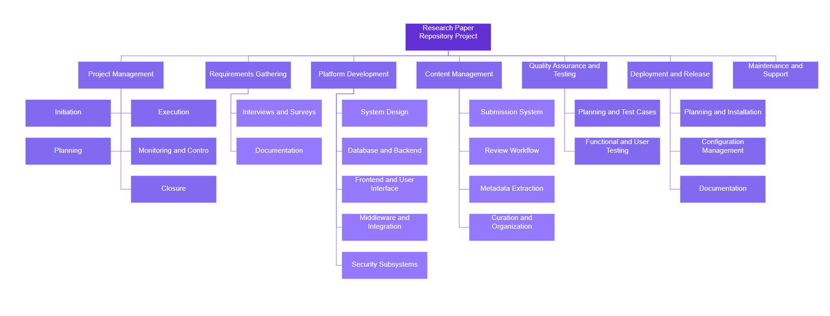

1. **Project Initiation**
   * Define project goals and objectives
   * Establish project team and roles
2. **Requirement Gathering**
   * Conduct stakeholder interviews
   * Gather user requirements and feedback
3. **Platform Design and Development**
   * Design system architecture
   * Develop database structure
   * Design user interface
   * Develop backend functionalities
   * Develop frontend layout and features
   * Integrate middleware components
4. **Content Management**
   * Develop paper submission system
   * Implement review and approval workflow
   * Implement metadata extraction and indexing
   * Organize and curate content
5. **Quality Assurance and Testing**
   * Plan testing activities
   * Develop test cases
   * Conduct functional testing
   * Perform user acceptance testing
6. **Deployment and Release**
   * Plan deployment process
   * Install and configure software
   * Document release notes and procedures
7. **Maintenance and Support**
   * Address bug fixes and updates
   * Provide ongoing user support
8. **Documentation and Training**
   * Create user manuals and documentation
   * Conduct training sessions for users and administrators

**TIMELINE – GANTT CHART**

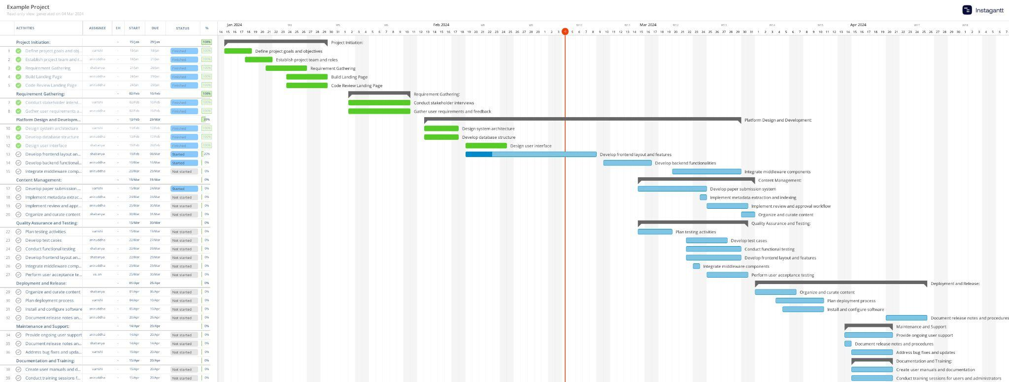

**RISK ANALYSIS – SWOT & RMMM**

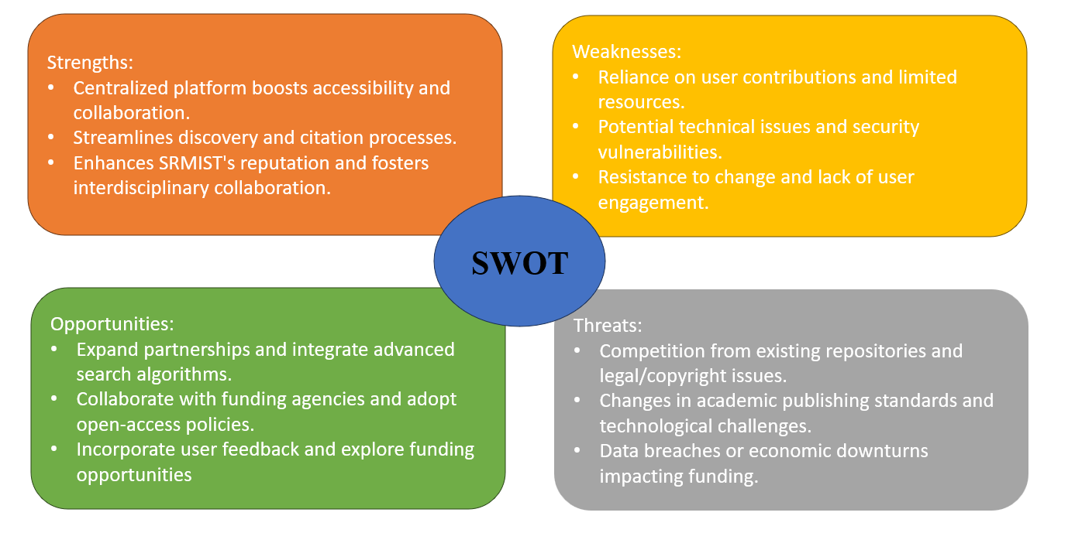

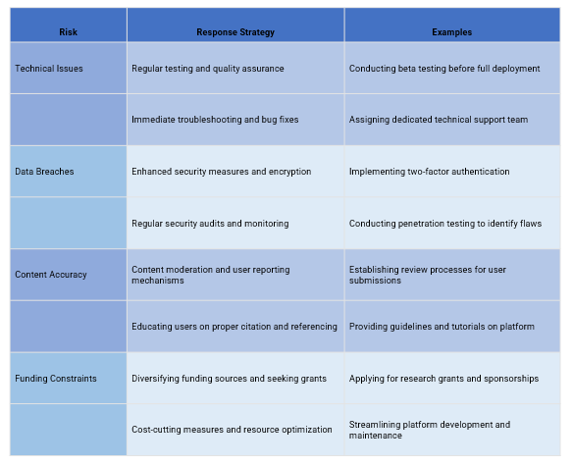

Result:

Thus, the work breakdown structure with timeline chart and risk table were formulated successfully.



**School of Computing**

**SRM IST, Kattankulathur – 603 203**

**Course Code: 21CSC303J**

**Course Name: Software Engineering and Project Management**

|  |  |
| --- | --- |
| **Experiment No** | 6 |
| **Title of Experiment** | Design a System Architecture, Use Case and Class Diagram |
| **Name of the candidate** | Ponnuri Aniruddha |
| **Team Members** | Vamshi Gadde (RA2112704010017)  Y Shabanya Kishore (RA2112704010018) |
| **Register Number** | RA2112704010015 |
| **Date of Experiment** | 19/02/2024 |

**Mark Split Up**

|  |  |  |  |
| --- | --- | --- | --- |
| **S.No** | **Description** | **Maximum Mark** | **Mark Obtained** |
| 1 | Exercise | 5 |  |
| 2 | Viva | 5 |  |
| **Total** | | **10** |  |

**Staff Signature with date**

**Aim**

To Design a System Architecture, Use case and Class Diagram

**Team Members:**

|  |  |  |  |
| --- | --- | --- | --- |
| **Sl No** | **Register No** | **Name** | **Role** |
| **1** | **RA2112704010015** | **Ponnuri Aniruddha** | **Rep** |
| **2** | **RA2112704010018** | **Y Shabanya Kishore** | **Member** |
| **3** | **RA2112704010017** | **Vamshi Gadde** | **Member** |

**SYSTEM ARCHITECTURE –**

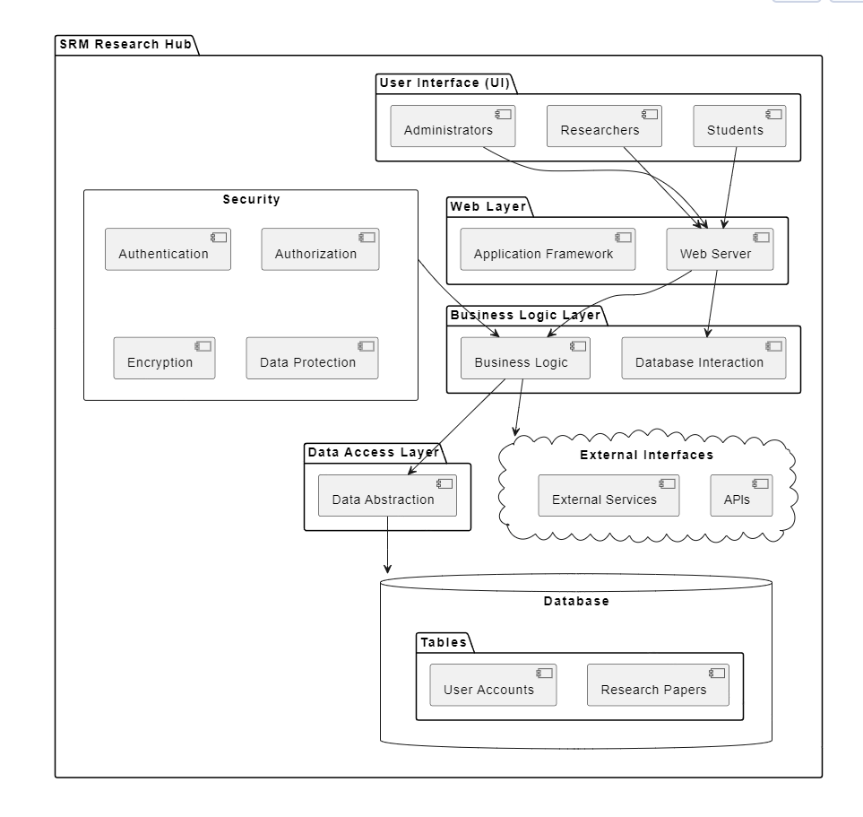

**USE CASE DIAGRAM**

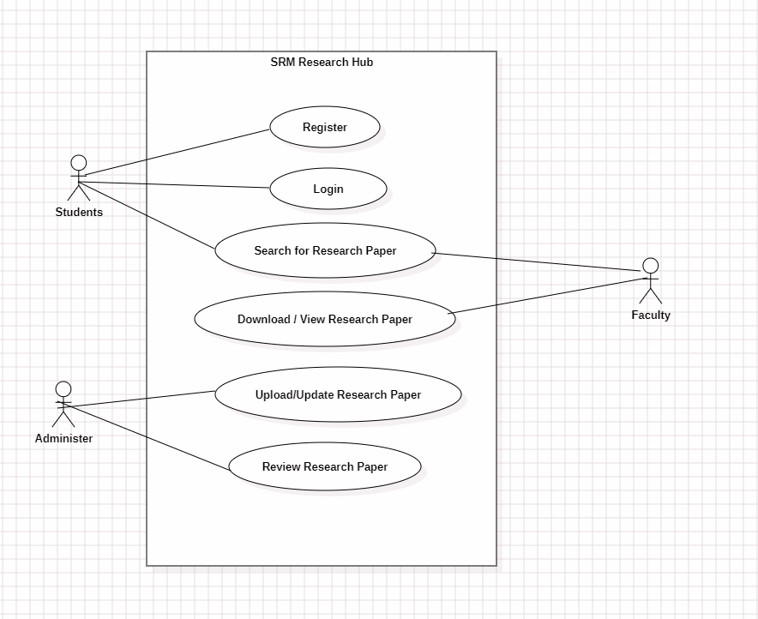

**CLASS DIAGRAM**

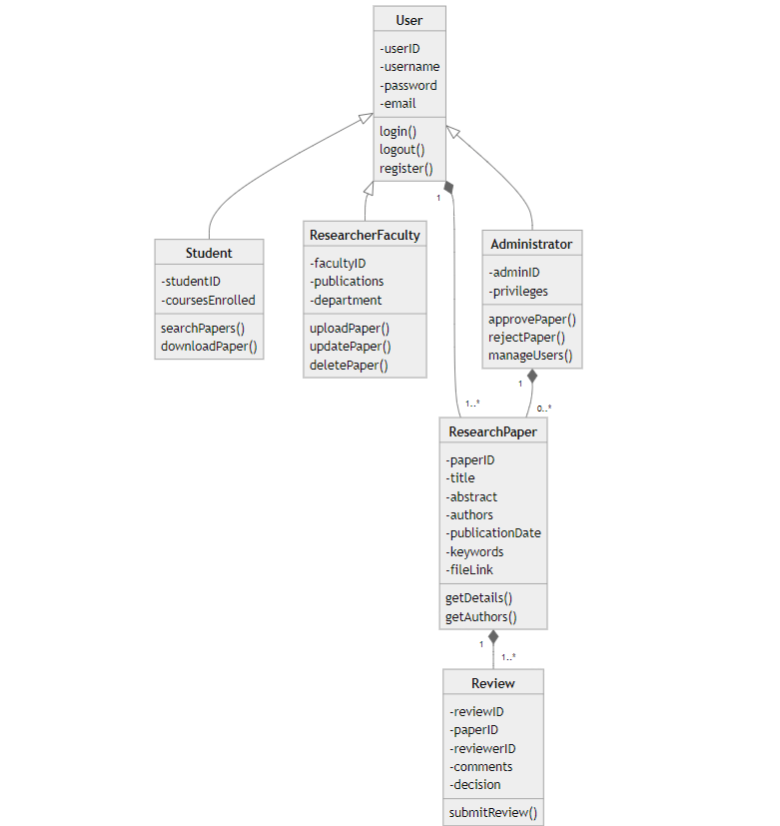

**Result:**

Thus, the system architecture, use case and class diagram created successfully.



**School of Computing**

**SRM IST, Kattankulathur – 603 203**

**Course Code: 21CSC303J**

**Course Name: Software Engineering and Project Management**

|  |  |
| --- | --- |
| **Experiment No** | 7 |
| **Title of Experiment** | Design a Entity relationship diagram |
| **Name of the candidate** | Ponnuri Aniruddha |
| **Team Members** | Vamshi Gadde (RA2112704010017)  Y Shabanya Kishore (RA2112704010018) |
| **Register Number** | RA2112704010015 |
| **Date of Experiment** | 26/02/2024 |

**Mark Split Up**

|  |  |  |  |
| --- | --- | --- | --- |
| **S. No** | **Description** | **Maximum Mark** | **Mark Obtained** |
| 1 | Exercise | 5 |  |
| 2 | Viva | 5 |  |
| **Total** | | **10** |  |

**Staff Signature with date**

**Aim**

To create the Entity Relationship Diagram

**Team Members:**

|  |  |  |  |
| --- | --- | --- | --- |
| **S No** | **Register No** | **Name** | **Role** |
| **1** | **RA2112704010015** | **Ponnuri Aniruddha** | **Rep** |
| **2** | **RA2112704010018** | **Y Shabanya Kishore** | **Member** |
| **3** | **RA2112704010017** | **Vamshi Gadde** | **Member** |

**ER Diagram**

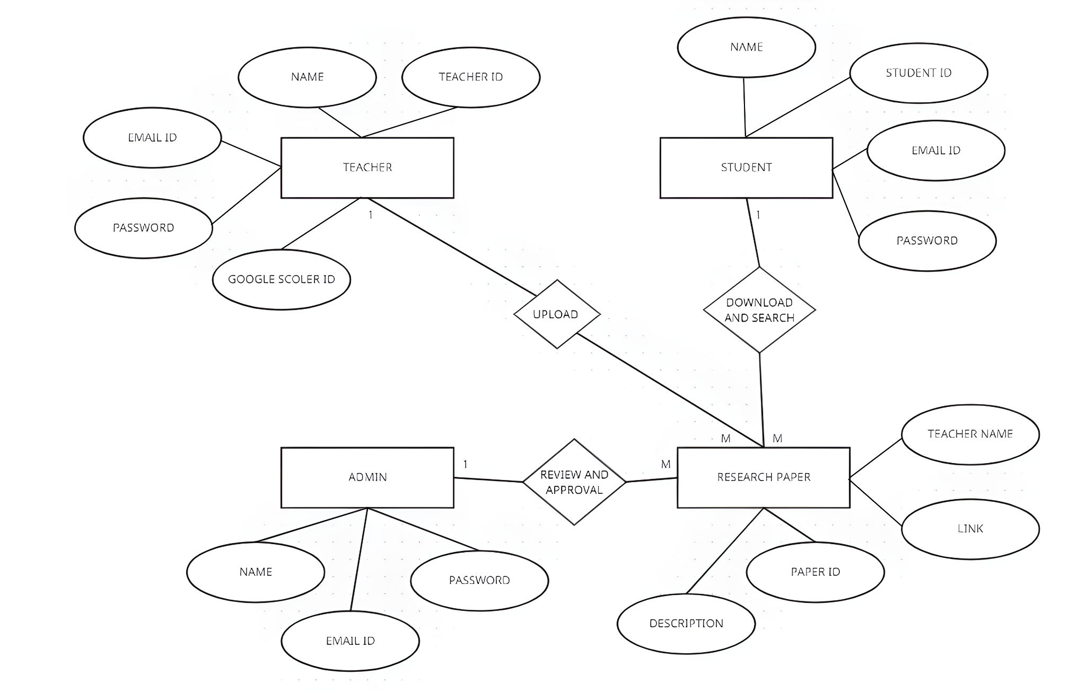

**Result:**

Thus, the entity relationship diagram was created successfully.



**School of Computing**

**SRM IST, Kattankulathur – 603 203**

**Course Code: 21CSC303J**

**Course Name: Software Engineering and Project Management**

|  |  |
| --- | --- |
| **Experiment No** | 8 |
| **Title of Experiment** | Develop a Data Flow Diagram (Process-Up to Level 1) |
| **Name of the candidate** | Ponnuri Aniruddha |
| **Team Members** | Vamshi Gadde (RA2112704010017)  Y Shabanya Kishore (RA2112704010018) |
| **Register Number** | RA2112704010015 |
| **Date of Experiment** | 04/03/2024 |

**Mark Split Up**

|  |  |  |  |
| --- | --- | --- | --- |
| **S. No** | **Description** | **Maximum Mark** | **Mark Obtained** |
| 1 | Exercise | 5 |  |
| 2 | Viva | 5 |  |
| **Total** | | **10** |  |

**Staff Signature with date**

**Aim**

To develop the data flow diagram up to level 1 for the SRM Research Hub

**Team Members:**

|  |  |  |  |
| --- | --- | --- | --- |
| **S No** | **Register No** | **Name** | **Role** |
| **1** | **RA2112704010015** | **Ponnuri Aniruddha** | **Rep** |
| **2** | **RA2112704010018** | **Y Shabanya Kishore** | **Member** |
| **3** | **RA2112704010017** | **Vamshi Gadde** | **Member** |

DFD Level - 0

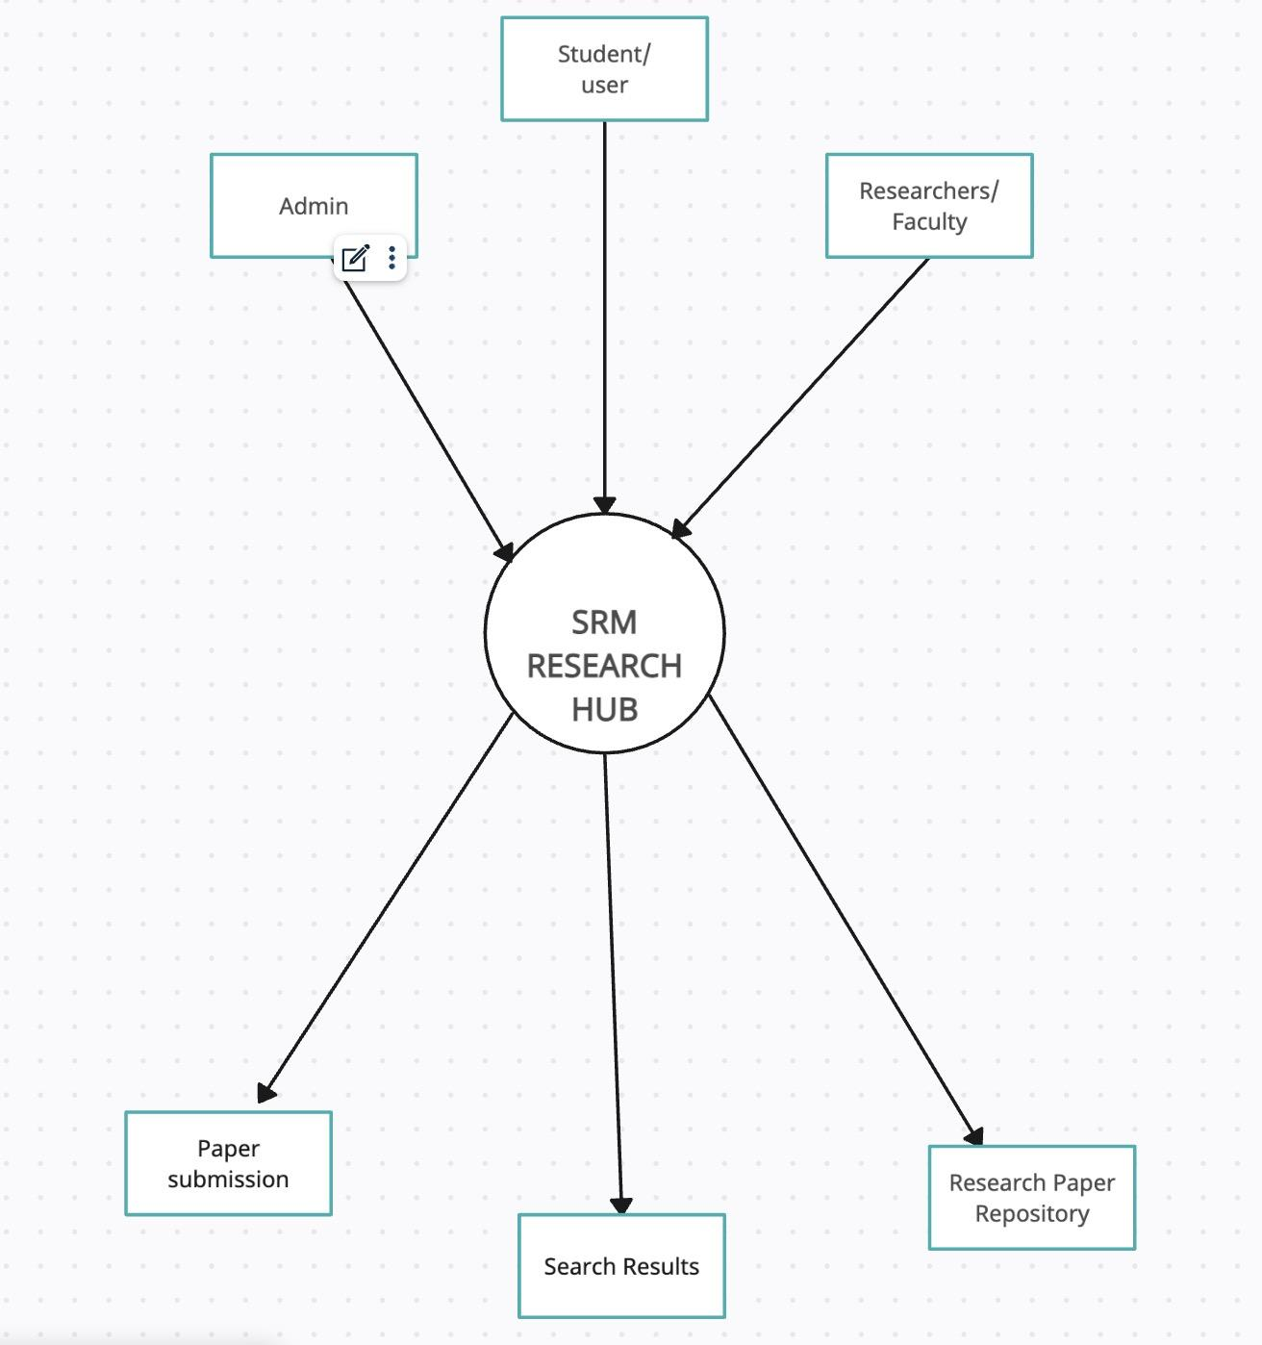

DFD Level - 1

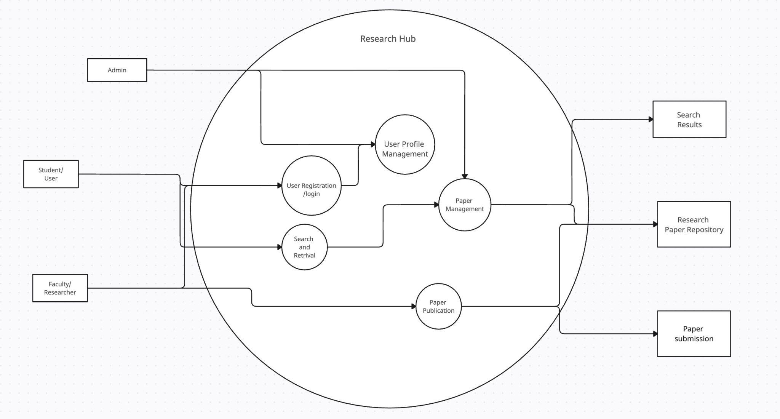

Result:

Thus, the data flow diagrams have been created for the SRM Research Hub.



**School of Computing**

**SRM IST, Kattankulathur – 603 203**

**Course Code: 21CSC303J**

**Course Name: Software Engineering and Project Management**

|  |  |
| --- | --- |
| **Experiment No** | 9 |
| **Title of Experiment** | Design a Sequence and Collaboration Diagram |
| **Name of the candidate** | Ponnuri Aniruddha |
| **Team Members** | Vamshi Gadde (RA2112704010017)  Y Shabanya Kishore (RA2112704010018) |
| **Register Number** | RA2112704010015 |
| **Date of Experiment** | 11/03/2024 |

**Mark Split Up**

|  |  |  |  |
| --- | --- | --- | --- |
| **S. No** | **Description** | **Maximum Mark** | **Mark Obtained** |
| 1 | Exercise | 5 |  |
| 2 | Viva | 5 |  |
| **Total** | | **10** |  |

**Staff Signature with date**

**Aim**

To create the sequence and collaboration diagram for the SRM RESEARCH HUB

**Team Members:**

|  |  |  |  |
| --- | --- | --- | --- |
| **S No** | **Register No** | **Name** | **Role** |
| **1** | **RA2112704010015** | **Ponnuri Aniruddha** | **Rep/Member** |
| **2** | **RA2112704010018** | **Y Shabanya Kishore** | **Member** |
| **3** | **RA2112704010017** | **Vamshi Gadde** | **Member** |

**Sequence Diagram**

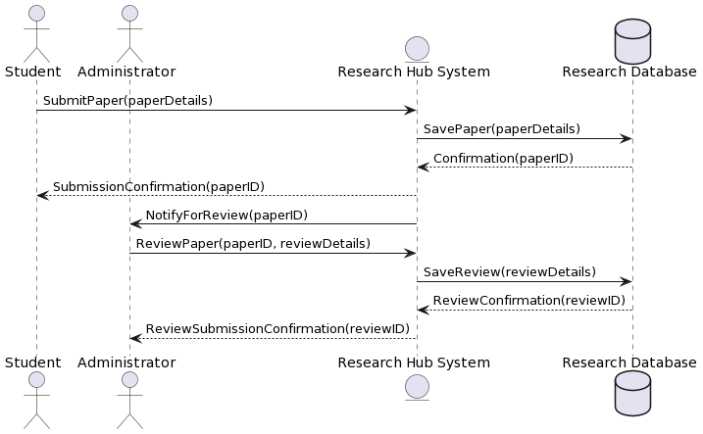

**Collaboration Diagram**

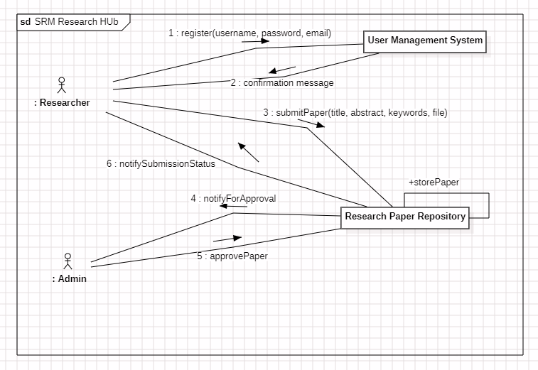

Result:

Thus, the sequence and collaboration diagrams were created for the SRM RESEARCH HUB.



**School of Computing**

**SRM IST, Kattankulathur – 603 203**

**Course Code: 21CSC303J**

**Course Name: Software Engineering and Project Management**

|  |  |
| --- | --- |
| **Experiment No** | 10 |
| **Title of Experiment** | Develop a Testing Framework/User Interface |
| **Name of the candidate** | Ponnuri Aniruddha |
| **Team Members** | Vamshi Gadde (RA2112704010017)  Y Shabanya Kishore (RA2112704010018) |
| **Register Number** | RA2112704010015 |
| **Date of Experiment** | 18/03/2024 |

**Mark Split Up**

|  |  |  |  |
| --- | --- | --- | --- |
| **S. No** | **Description** | **Maximum Mark** | **Mark Obtained** |
| 1 | Exercise | 5 |  |
| 2 | Viva | 5 |  |
| **Total** | | **10** |  |

**Staff Signature with date**

**Aim**

To develop the testing framework and/or user interface framework for the SRM Research Hub

**Team Members:**

|  |  |  |  |
| --- | --- | --- | --- |
| **S No** | **Register No** | **Name** | **Role** |
| **1** | **RA2112704010015** | Ponnuri Aniruddha | **Rep/Member** |
| **2** | **RA2112704010018** | Y Shabanya Kishore | **Member** |
| **3** | **RA2112704010017** | Vamshi Gadde | **Member** |

Executive Summary

The primary objective is to ensure the application functions as intended, meets user requirements, and delivers a high-quality user experience. We will employ a combination of manual and automated testing methodologies to achieve comprehensive coverage of both functional and non-functional aspects.

Test Plan

Scope of Testing:

* Functional Testing:
  + All application modules will be covered, with a focus on core functionalities like user registration, login, research paper management (upload, download, edit, delete), search and filtering, user profiles, and integration with SRMIST sources.
  + Automation will cover critical functionalities and regression testing of core user flows.
  + Manual testing will address specific test cases and edge cases that are less suitable for automation.
* Non-Functional Testing:
  + Performance testing will assess response times, load capacity, and scalability under varying user loads.
  + Usability testing will involve user feedback to evaluate the interface's intuitiveness, learnability, and overall user experience.
  + Security testing will ensure data security, role-based access control, and protection against vulnerabilities.

|  |  |  |  |
| --- | --- | --- | --- |
| Category | Methodology | Tools Required | Description |
| Functional Requirements | Manual & Automated | Test case management tool Automation framework | Manual testing will cover user interaction, user interface elements, and various test cases. Automated testing will focus on critical functionalities, regression testing, and API interactions. |
| Non-Functional Requirements | Manual & Automated | Performance testing tool (e.g., JMeter, LoadRunner) Usability testing platform (e.g., UserTesting, Lookback)  Security scanning tools (e.g., OWASP ZAP, Nessus) | Performance testing will assess response times, load capacity, and scalability using automated tools.  Usability testing will involve user recruitment and observation through online platforms.  Security testing will employ automated tools for vulnerability scanning and manual penetration testing (if resources permit). |

Result:

Thus, the testing framework/user interface framework has been created for the SRM Research Hub.



**School of Computing**

**SRM IST, Kattankulathur – 603 203**

**Course Code: 21CSC303J**

**Course Name: Software Engineering and Project Management**

|  |  |
| --- | --- |
| **Experiment No** | 11 |
| **Title of Experiment** | Test Cases |
| **Name of the candidate** | Ponnuri Aniruddha |
| **Team Members** | Vamshi Gadde (RA2112704010017)  Y Shabanya Kishore (RA2112704010018) |
| **Register Number** | RA2112704010015 |
| **Date of Experiment** | 26/03/2024 |

**Mark Split Up**

|  |  |  |  |
| --- | --- | --- | --- |
| **S. No** | **Description** | **Maximum Mark** | **Mark Obtained** |
| 1 | Exercise | 5 |  |
| 2 | Viva | 5 |  |
| **Total** | | **10** |  |

**Staff Signature with date**

**Aim**

To develop the test cases manual for the SRM Research Hub

**Team Members:**

|  |  |  |  |
| --- | --- | --- | --- |
| **S No** | **Register No** | **Name** | **Role** |
| **1** | **RA2112704010015** | **Ponnuri Aniruddha** | **Rep** |
| **2** | **RA2112704010018** | **Y Shabanya Kishore** | **Member** |
| **3** | **RA2112704010017** | **Vamshi Gadde** | **Member** |

**Functional Test Case**

|  |  |  |  |  |  |  |  |
| --- | --- | --- | --- | --- | --- | --- | --- |
| Test ID | Test Scenario | Test Case | Execution Steps | Expected Outcome | Actual Outcome | Status | Remarks |
| 1 | Verify User Registration | Accept Valid SRM Registration Number | 1. User clicks on "User Registration" link.  2. Enter a valid SRM registration number (e.g., RA2112704010015).  3. Click "Register" button. | User should be directed to the next page for entering more user details. |  |  |  |
| 2 | Verify User Registration | Don't Accept Invalid Registration Number | 1. User clicks on "User Registration" link.  2. Enter an invalid registration number (e.g., incorrect format or non-existent number).  3. Click "Register" button. | An error message should be displayed indicating invalid registration number format. |  |  |  |
| 3 | Verify User Login | Successful Login with Valid Credentials | 1. Enter a registered email address in the username field.  2. Enter the corresponding password in the password field.  3. Click "Login" button. | User should be successfully logged in and directed to the user dashboard. |  |  |  |
| 4 | Verify User Login | Failed Login with Invalid Username | 1. Enter an unregistered email address in the username field.  2. Enter a valid password. 3. Click "Login" button. | An error message should be displayed indicating invalid username or password. |  |  |  |
| 5 | Verify User Login | Failed Login with Incorrect Password | 1. Enter a registered email address in the username field. <br> 2. Enter an incorrect password. <br> 3. Click "Login" button. | An error message should be displayed indicating invalid username or password. |  |  |  |
| 6 | Verify Research Paper Upload | Upload a Valid PDF Document | 1. Navigate to the "Upload Research Paper" section.  2. Select a valid PDF document from the local storage.  3. Click "Upload" button. | The document should be uploaded successfully, and a confirmation message displayed. |  |  |  |
| 7 | Verify Research Paper Upload | Upload an Unsupported File Format | 1. Navigate to the "Upload Research Paper" section.  2. Select a file with an unsupported format (e.g., .docx).  3. Click "Upload" button. | An error message should be displayed indicating invalid file format. |  |  |  |

**Non-Functional Test Cases**

|  |  |  |  |  |  |  |  |
| --- | --- | --- | --- | --- | --- | --- | --- |
| Test ID | Test Scenario | Test Case | Execution Steps | Expected Outcome | Actual Outcome | Status | Remarks |
| 1 | Performance Testing | Load Capacity | 1. Simulate concurrent user logins with increasing load. <br> 2. Monitor response times and system performance. | The application should maintain acceptable response times and functionality under increasing load. |  |  |  |
| 2 | Usability Testing | User Interface Clarity | 1. Recruit users from the target audience (students, faculty, researchers). <br> 2. Observe users interacting with the application and record their feedback. | Users should find the interface intuitive and easy to navigate. |  |  |  |
| 3 | Security Testing | Data Encryption | 1. Use security testing tools to scan for vulnerabilities related to data encryption. | All user data and research papers should be encrypted in transit and at rest. |  |  |  |

Result:

Thus, the test case manual has been created for the SRM Research Hub.



**School of Computing**

**SRM IST, Kattankulathur – 603 203**

**Course Code: 21CSC303J**

**Course Name: Software Engineering and Project Management**

|  |  |
| --- | --- |
| **Experiment No** | 12 |
| **Title of Experiment** | Manual Test Case Reporting |
| **Name of the candidate** | Ponnuri Aniruddha |
| **Team Members** | Vamshi Gadde (RA2112704010017)  Y Shabanya Kishore (RA2112704010018) |
| **Register Number** | RA2112704010015 |
| **Date of Experiment** | 04/04/2024 |

**Mark Split Up**

|  |  |  |  |
| --- | --- | --- | --- |
| **S. No** | **Description** | **Maximum Mark** | **Mark Obtained** |
| 1 | Exercise | 5 |  |
| 2 | Viva | 5 |  |
| **Total** | | **10** |  |

**Staff Signature with date**

**Aim**

To prepare the manual test case report for the SRM RESEARCH HUB.

**Team Members:**

|  |  |  |  |
| --- | --- | --- | --- |
| **S No** | **Register No** | **Name** | **Role** |
| **1** | **RA2112704010015** | **Ponnuri Aniruddha** | **Rep/Member** |
| **2** | **RA2112704010018** | **Y Shabanya Kishore** | **Member** |
| **3** | **RA2112704010017** | **Vamshi Gadde** | **Member** |

**Current Status of the Testing:**

The testing of the SRM Research Hub application is currently progressing well, with an overall Amber status. We've made significant headway in functional testing of both User Management (Admin, Student, Teacher) and Paper Repository modules, achieving an overall coverage of 85%. User Login functionality is fully tested (100%), while other areas like User Registration, Profile Management, and Access Control are in progress (update percentages based on your project). Similarly, Paper Repository functionalities like Upload, Search & Filtering, and Download & Viewing are under development with progress (update percentages). Integration testing across modules is the next focus area to ensure a seamless user experience.

Non-functional testing has not yet begun. We'll prioritize completing remaining test cases for the core functionalities and establish a test data management plan to streamline the process. Open communication with stakeholders remains crucial to address any resource limitations and ensure alignment with project goals. By taking these steps, we can achieve a successful testing phase and launch a high-quality SRM Research Hub application.

**Present obstacles to proceed further**

While the SRM Research Hub testing is progressing well, there are a few obstacles to achieving a complete green status. Integration testing, which ensures smooth interaction between User Management and Paper Repository modules, requires additional focus. Furthermore, a comprehensive test data management plan needs to be established to streamline testing across various user roles and functionalities. Resource limitations might also come into play, potentially slowing down progress.

To address these challenges, scheduling collaborative sessions between functional and development teams will be crucial for seamless integration. Additionally, developing a test data plan outlining data requirements for different test scenarios will optimize testing efficiency. If resource limitations become a bottleneck, expanding the testing team or prioritizing critical functionalities might be necessary. By proactively addressing these obstacles, we can ensure a successful testing phase and deliver a high-quality application.

**Engaging Stakeholders:**

* Continuous communication with stakeholders will be crucial for addressing these challenges and ensuring project success.
* Stakeholders can provide valuable feedback on user needs and system priorities.
* Collaboration will help maintain alignment with project goals and secure necessary resources for a smooth testing completion.

**Next Steps:**

* Prioritize completion of remaining test cases for User Management and Paper Repository modules.
* Conduct comprehensive integration testing to ensure seamless user experience across modules.
* Finalize a test data management plan to streamline test execution.
* Address resource limitations through collaboration or prioritization strategies.
* Maintain open communication with stakeholders to ensure project goals are met.

|  |  |  |
| --- | --- | --- |
| **Category** | **Progress Against Plan** | **Status** |
| Functional Testing | Amber | ICompleted |
| Non-Functional Testing | Amber | In-Progress |

|  |  |  |
| --- | --- | --- |
| **Functional** | **Test Case Coverage (%)** | **Status** |
| User Login | 100 | Completed |
| Student page | 70 | In-Progress |
| Teacher Page | 65 | In-Progress |
| Admin Page | 70 | In-Progress |
| Research Paper Database | 75 | In-Progress |

Result:

Thus, the test case report has been created for the SRM RESEARCH HUB.



**School of Computing**

**SRM IST, Kattankulathur – 603 203**

**Course Code: 21CSC303J**

**Course Name: Software Engineering and Project Management**

|  |  |
| --- | --- |
| **Experiment No** | 13 |
| **Title of Experiment** | Provide the details of Architecture Design/Framework/Implementation |
| **Name of the candidate** | Ponnuri Aniruddha |
| **Team Members** | Vamshi Gadde (RA2112704010017)  Y Shabanya Kishore (RA2112704010018) |
| **Register Numbers** | RA2112704010015 |
| **Date of Experiment** | 15/04/2024 |

**Mark Split Up**

|  |  |  |  |
| --- | --- | --- | --- |
| **S. No** | **Description** | **Maximum Mark** | **Mark Obtained** |
| 1 | Exercise | 5 |  |
| 2 | Viva | 5 |  |
| **Total** | | **10** |  |

**Staff Signature with date**

**Aim**

To provide the details of architectural design/framework/implementation

**Team Members:**

|  |  |  |  |
| --- | --- | --- | --- |
| **S No** | **Register No** | **Name** | **Role** |
| **1** | **RA2112704010015** | **Ponnuri Aniruddha** | **Rep/Member** |
| **2** | **RA2112704010018** | **Y Shabanya Kishore** | **Member** |
| **3** | **RA2112704010017** | **Vamshi Gadde** | **Member** |

**Framework and Implementation:**

Frontend: React.js

Backend: Node.js with Express framework

Database: MongoDB

**Architectural Design:**

Frontend: Built with React.js, this layer handles user interactions, rendering dynamic content, and presenting the user interface.

Backend: Implemented using Node.js with Express framework, this layer processes user requests, interacts with the database, and performs core application logic.

Database: MongoDB serves as the NoSQL database, storing research papers, user information, and other application data.

User Management Module:

Description: This module handles user registration, login, profile management, and authorization.

User Registration:

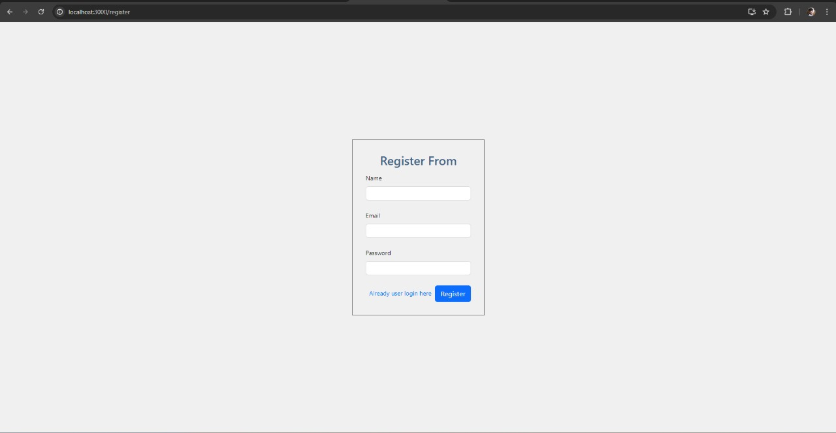

User Login:

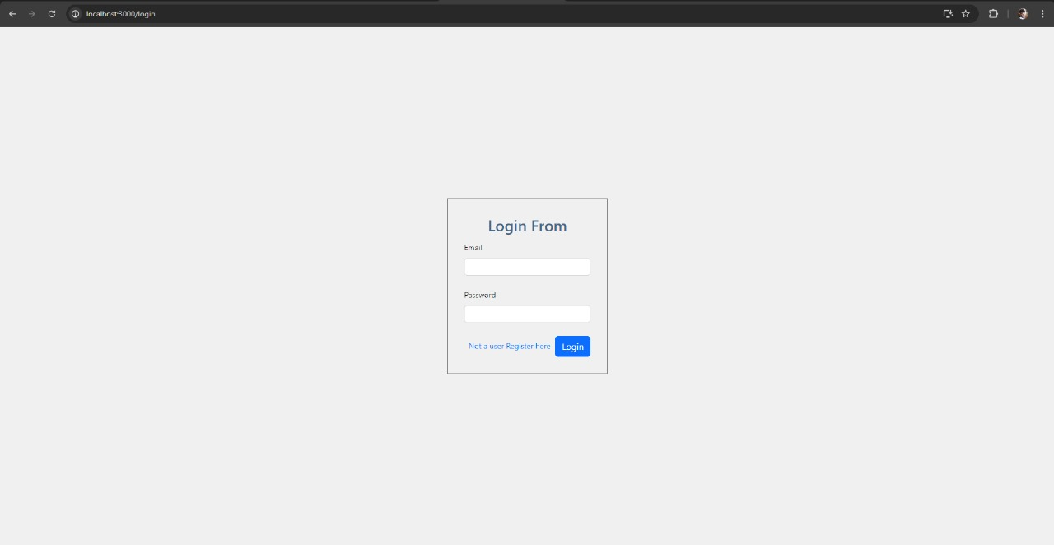

Home Page (Landing Page):

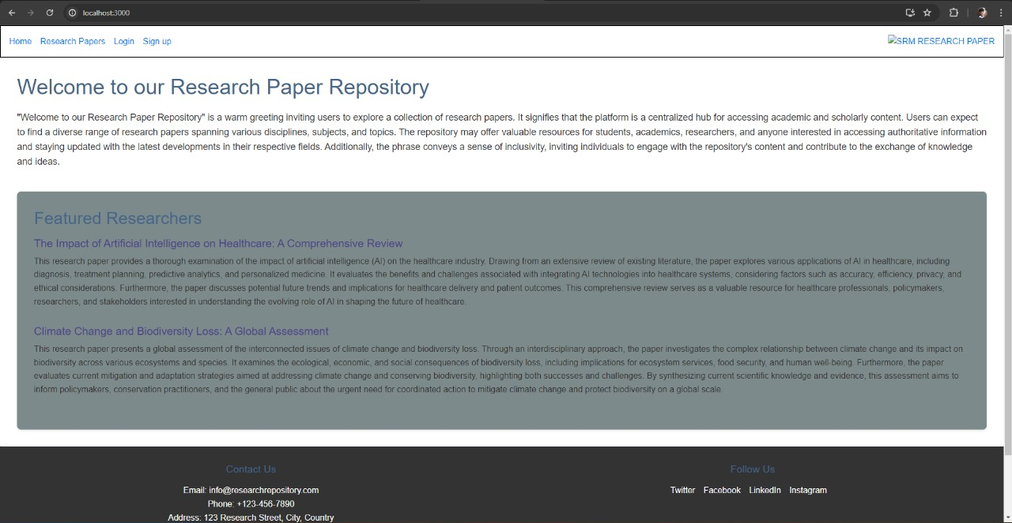

Teacher Dashboard:

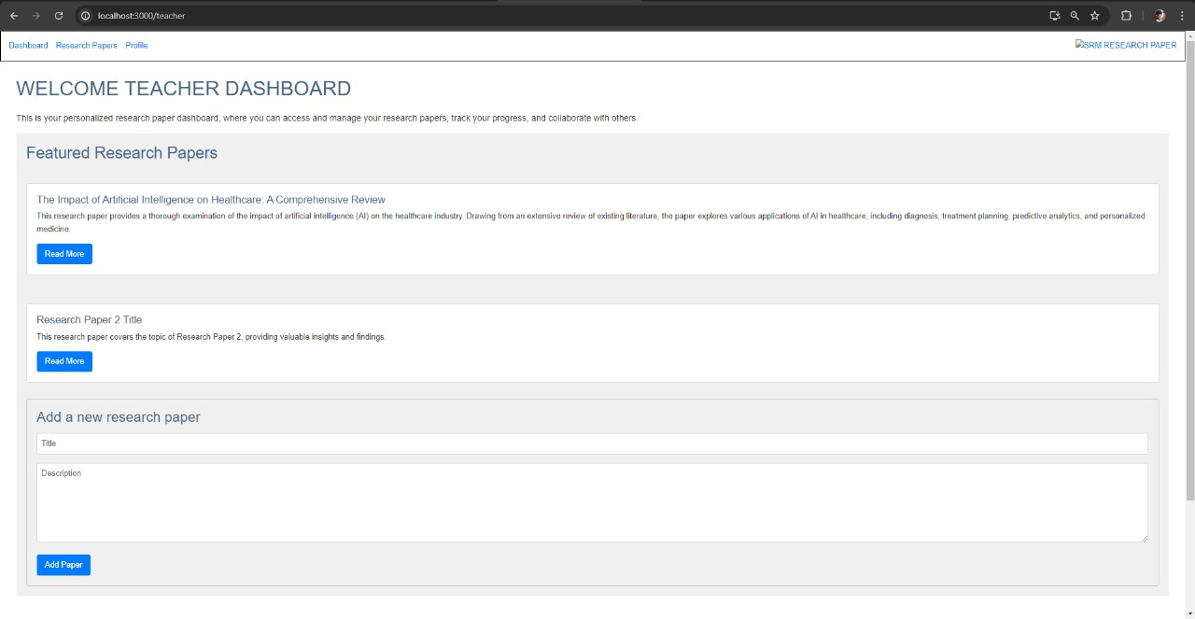

Student dashboard:

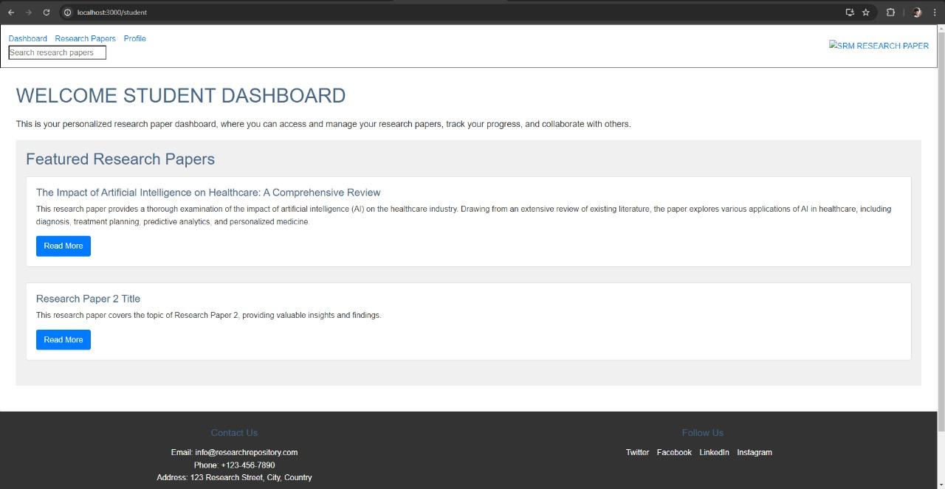

Admin Dashboard:

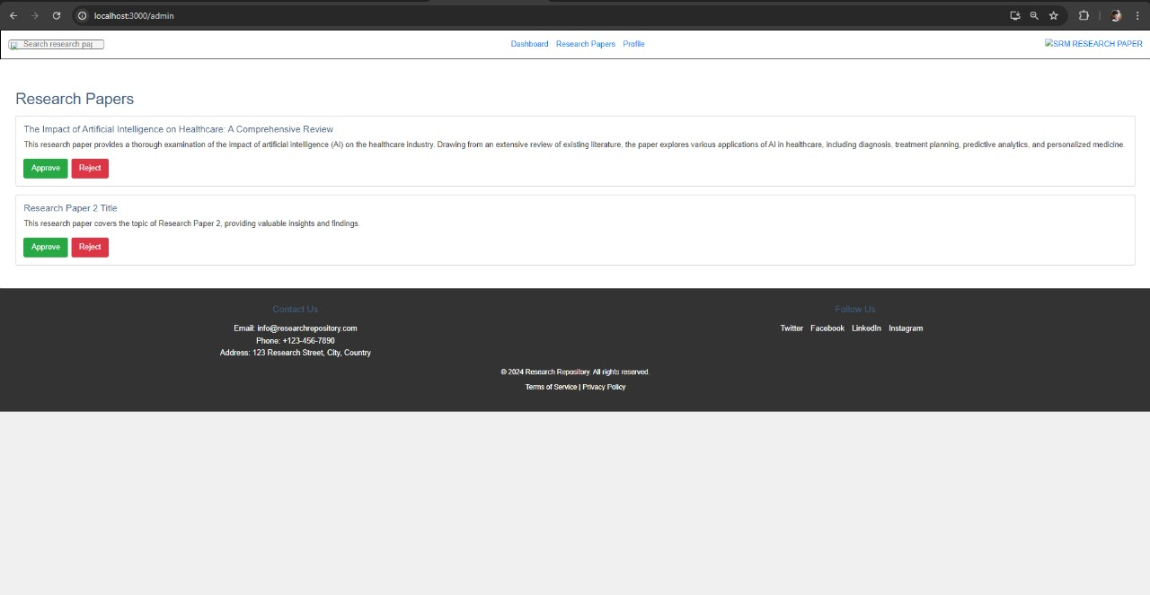

Code: --

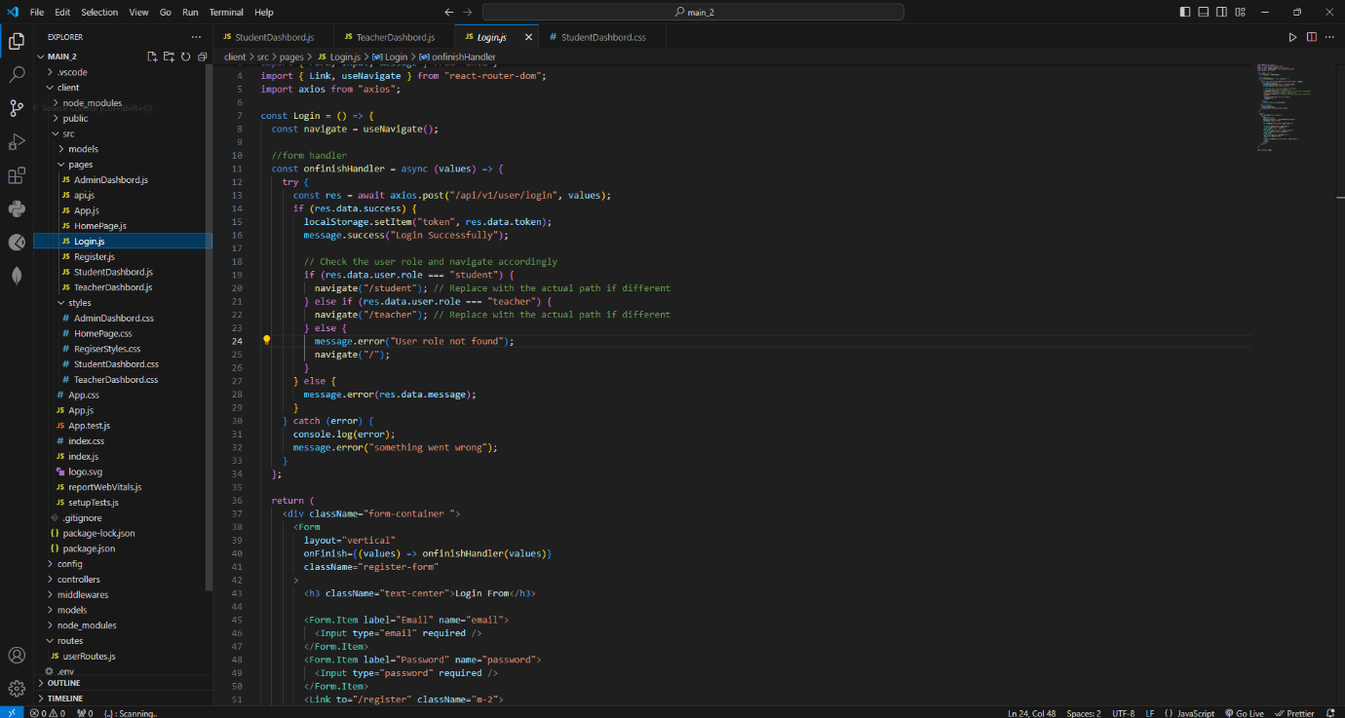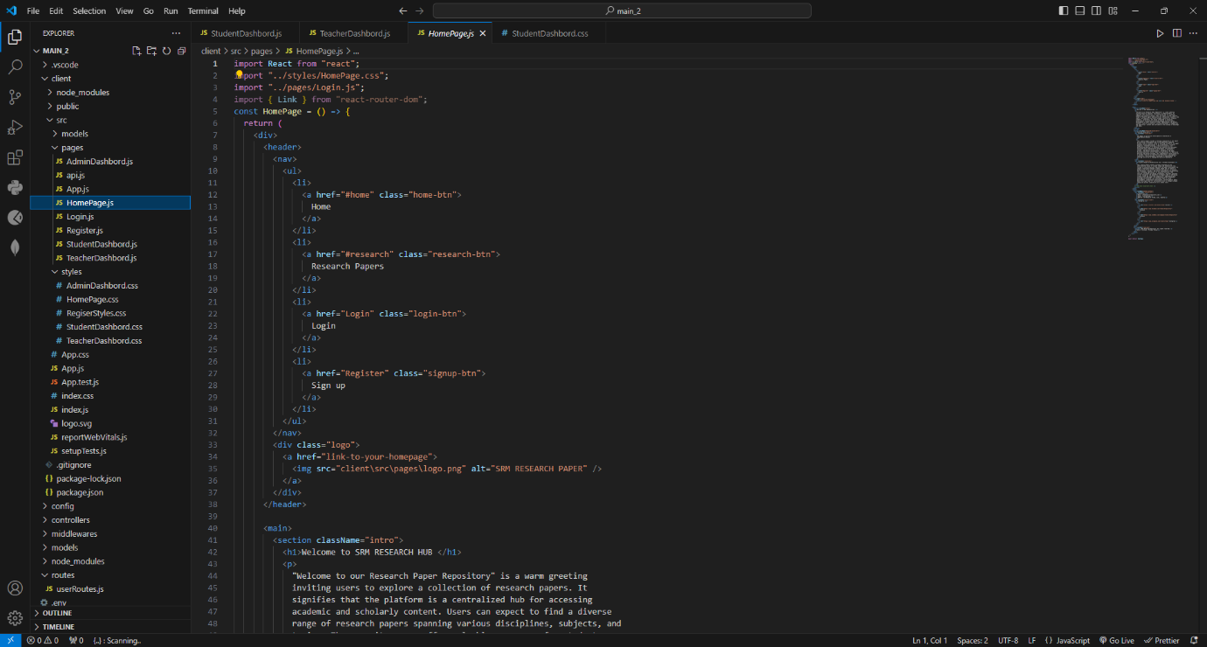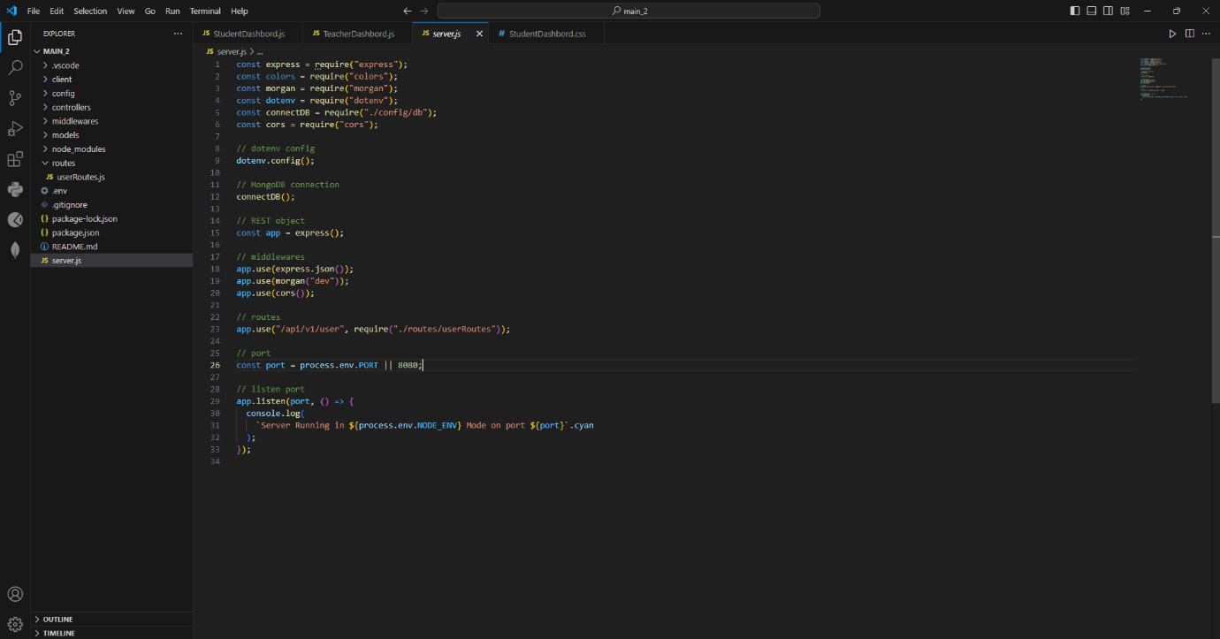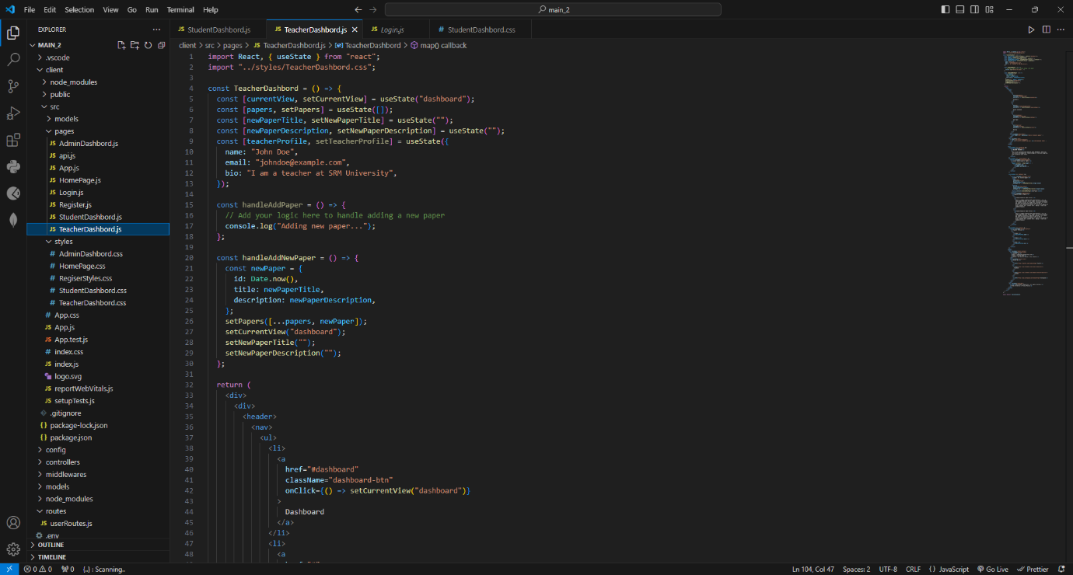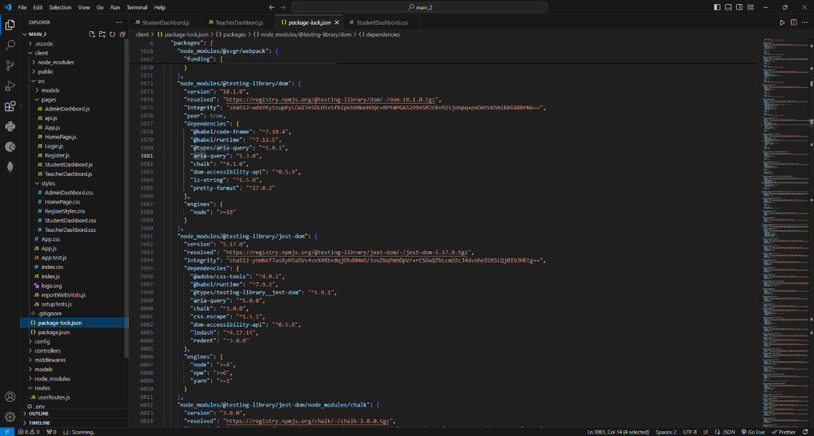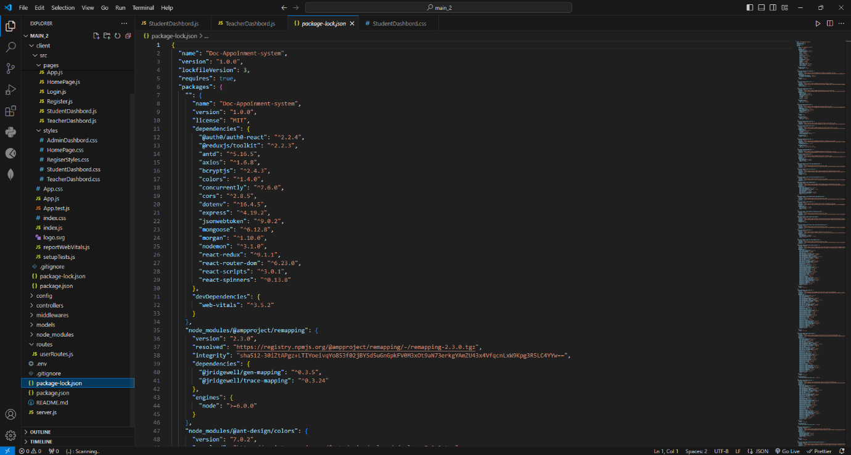

Result:

Thus, the details of architectural design/framework/implementation along with the screenshots were provided.