
SRM Institute of Science and Technology
College of Engineering and Technology
School of Computing
SRM Nagar, Kattankulathur – 603203, Chengalpattu District, Tamilnadu
Academic Year: 2023-24 (Even)
Test: CLA-T1 Date: 20-02-2024
Course Code & Title: 21CSE356T & NATURAL LANGUAGE PROCESSING Duration: 2 Hours
Year & Sem: III Year / VI Sem Max. Marks: 50

Course Articulation Matrix: (to be placed)
S.No. | Course Outcome | PO1 | PO2 | PO3 | PO4 | PO5 | PO6 | PO7 | PO8 | PO9 | PO10 | PO11 | PO12
1 | CO1 | 3 | 3 | 2 | - | - | - | - | - | - | - | - | -
2 | CO2 | 3 | 3 | 2 | - | - | - | - | - | - | - | - | -
3 | CO3 | 3 | 3 | 2 | - | - | - | - | - | - | - | - | -
4 | CO4 | 3 |  | - | 3 | 3 | - | - | - | - | - | - | -
5 | CO5 | - |  | 2 | 3 | 3 | - | - | - | - | - | - | -

Part - A
(5 x 1 = 5 Marks)
Instructions: Answer all
Q. No | Question | Marks | BL | CO | PO | PI Code
1 | Which of the following accurately describes an application of Natural Language Processing (NLP)?  a) Predicting stock market trends using sentiment analysis of news articles.  b) Generating random text using Markov chains.  c) Sorting a list of words alphabetically.  d) Converting images into text. | 1 | L2 | 1 | 1 | 1.6.1
2 | Which level of NLP involves understanding the meaning behind words and their relationships in a sentence?  a) Morphological level  b) Syntactic level  c) Semantic level  d) Pragmatic level | 1 | L1 | 1 | 2 | 2.6.3
3 | Which NLP task involves assigning grammatical categories such as noun, verb, or adjective to words in a sentence?  a) Parts of Speech Tagging  b) Named Entity Recognition  c) N-grams  d) Morphological Analysis | 1 | L1 | 1 | 2 | 2.6.3
4 | In the context of NLP, what does the term "frame" refer to?  a) A linguistic structure representing a single word.  b) A data structure used for storing text data.  c) A model for capturing syntactic relationships in a sentence.  d) A conceptual structure used for representing knowledge in a specific domain. | 1 | L1 | 1 | 2 | 2.6.3
5 | In linguistic morphology _____________ is the process for reducing inflected words to their root form.  a) Rooting  b) Stemming  c) Text-Proofing  d) Both Rooting & Stemming | 1 | L1 | 1 | 2 | 2.6.3
Part – A ( 5 x 5 = 25 marks)
4 | What is Natural Language Processing? Discuss with some applications. | 2 | L2 | 1 | 2 | 2.6.3
5 | What is meant by the semantics of a natural language, and how this differs from the pragmatics? | 2 | L1 | 1 | 2 | 2.6.1
6 | Identify the head and morphological type (Noun Phrase, Verb Phrase, Adjective Phrase, Adverbial Phrase) of the following sentence segments.  i. The president of the company  ii. Looked up the chimney  iii. Angry as a hippo  iv. Rapidly like a bat | 2 | L4 | 1 | 2 | 2.6.1
7 | Identify and describe the ambiguities in the following sentences.  i. The man kept the dog in the house.  ii. Book that flight. | 2 | L2 | 1 | 5 | 5.4.1
8 | Explain the different levels of language analysis.
Part – B (2 x 10 = 20 marks)
Instructions: Randomly selected five questions. Answer all Five Questions
9 | Consider a corpus consisting of two documents:  "The quick brown fox jumps over the lazy dog."  "A quick brown dog outpaces a quick fox."  Perform the following tasks using TF-IDF:  a) Compute the Term Frequency (TF) for each term in each document.  b) Compute the Inverse Document Frequency (IDF) for each term.  c) Compute the TF-IDF scores for each term in each document.  d) Interpret the results and discuss the significance of TF-IDF in natural language processing. | 10 | L3 | 1 | 1 | 1.6.1
10 | Consider the following corpus consisting of three documents:  1. "The cat sat on the mat."  2. "The dog ate my homework."  3. "I love cats and dogs."  a) Explain the concept of Bag of Words (BoW) representation in Natural Language Processing (NLP). How does it convert text data into numerical feature vectors? Provide a brief explanation. (3 marks)  b) Perform tokenization on each document in the given corpus. Show the tokenized form of each document. (4 marks)  c) Build the vocabulary from the given corpus. List all unique words in the vocabulary.  (4 marks)  d) Create the Bag of Words representation for each document in the corpus. Represent each document as a numerical vector based on word frequencies. Provide the Bag of Words representation for each document. (4 marks) | 10 | L3 | 1 | 1 | 1.6.1

*Program Indicators are available separately for Computer Science and Engineering in AICTE examination reforms policy.

Course Outcome (CO) and Bloom’s level (BL) Coverage in Questions

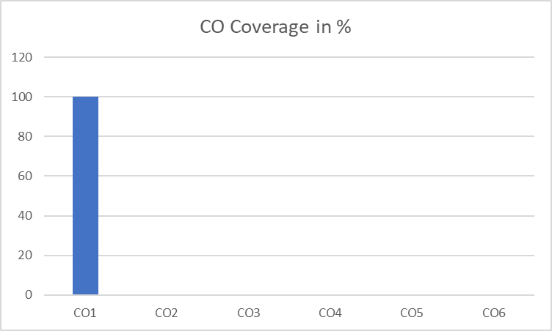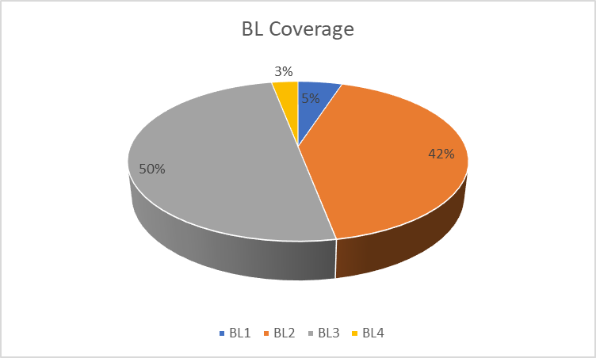

Approved by the Audit Professor/Course Coordinator

