**Name** – Aniruddha Dhawad FY-IT-H

**Roll No.** – 1914079

**PINBALL GAME**

1. Component name – **Teleportation Region**

Component image –

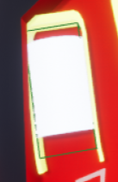

Approach:

* For the teleporting of the ball I used a Trigger Box.
* As soon as the ball overlaps the trigger box, teleport function is called which teleports the ball to the desired location.
* For the destination location I have used another actor to get its location and teleport the ball there.
* This whole thing was set in level blueprint.
* I also attached a sound for teleportation. As soon as the ball enters the teleportation region a sound can be heard.

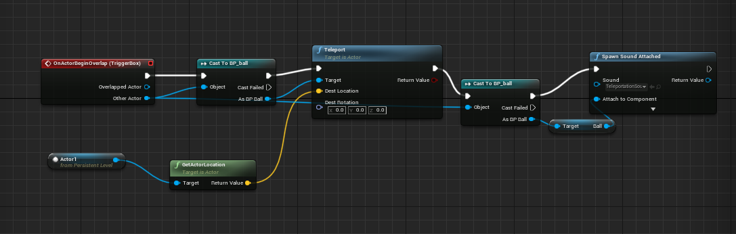

Difficulties faced:

Did not know about Teleport function and how to use the box trigger I had to search it online.

1. Component name – **Second Plunger**

Component image –

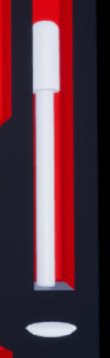

Approach:

* As there are two plungers in the scene now, I converted the plunger from normal variable to an array.
* While detecting them foreach loop was used to get both the plungers and the same was done while setting up input action for charging and stopping the plungers.
* In the spawn function for spawning the ball again foreach loop was required so that the ball spawns for both the plungers.
* Also attached a sound as soon as plunger launches the ball.

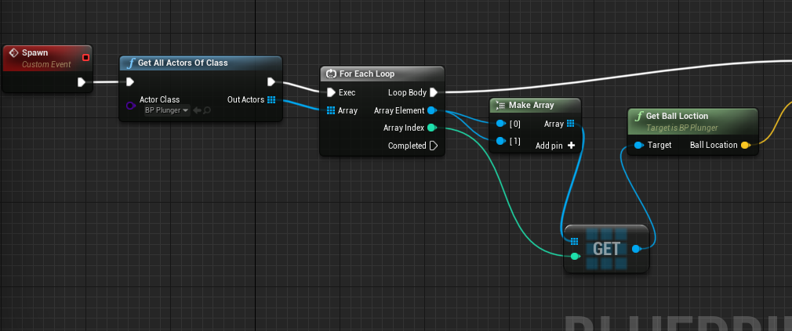

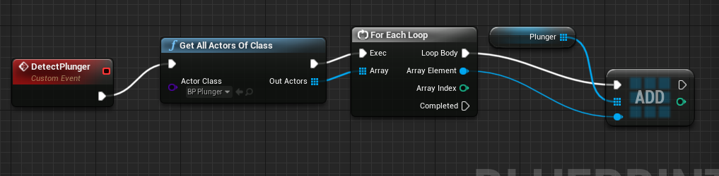

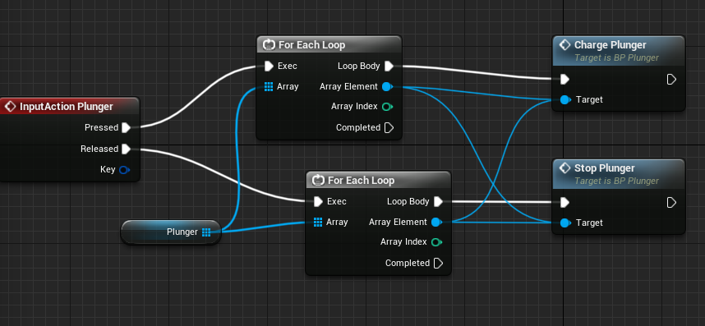

Difficulties faced:

* It took me a while to figure out that there is a need to convert the plunger from a normal variable to an array.
* Even after figuring this out I was confused while setting up the Detect Plunger function and then I took the reference of Detect Flipper function and got it fixed.

1. Component name – **Cannon**

Component image –

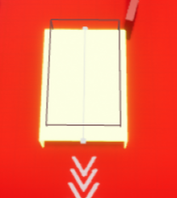

Approach:

* For making the cannon I simply added a box collision to the cannon and on the event begin overlap added an impulse of -6000 in the Y direction so that the velocity of ball increases suddenly thus giving it a functionality of cannon.
* Also attached a sound to it.

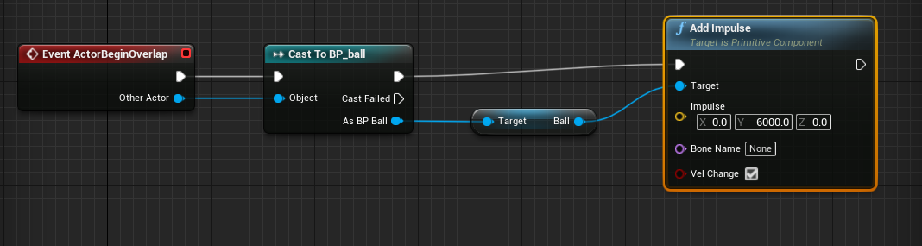

Difficulties faced:

I had to think for a while about adding the box collision after that it was quite simple.

1. Component name – **Center Region**

Component image –

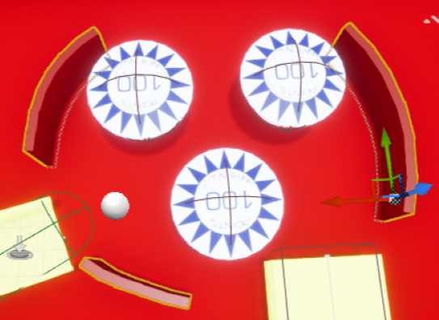

Approach:-

* I used normal box from geometry class for creating each section of this structure.
* The boxes were placed next to each other at an angle of 5 degrees to each other.
* Finally I selected all the boxes and created a static mesh for the whole structure so that it becomes a single component.
* The center region also consists of the actor which is the destination for the ball after teleportation.

Difficulties faced:-

A lot of time was required in order to set up all the boxes so that it looks like this.

1. Component name – **Bonus Region**

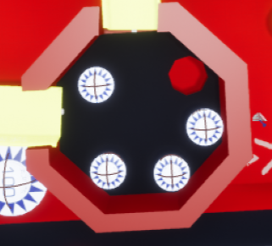Component image –

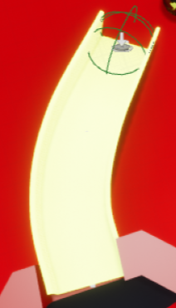 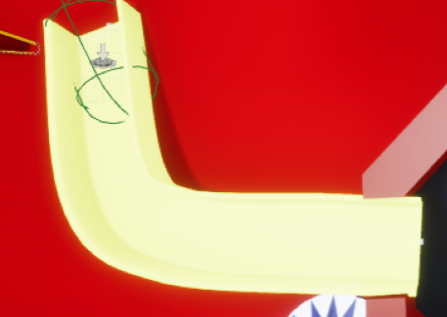

1. ii) iii)

Approach:-

* Bonus region consists of three major components – the main region(i) and two entrances(ii and iii).
* The main region was made with two cylinders, first is the outer one and the other is the inner one which is subtractive in order to create space for the bumpers. A small hole is also made for the ball to exit after entering this region.
* There are two entrances which let the ball go only in upwards direction into the bonus region.
* For this functionality I used a capsule trigger which adds an impulse to the ball in upward direction and do not let the ball fall backwards.

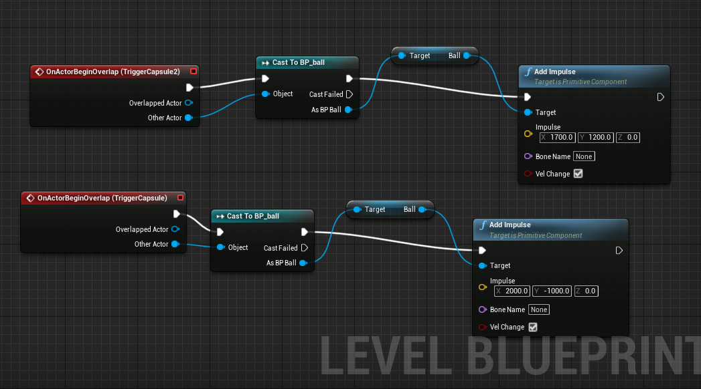

Difficulties faced:-

* I don’t really think adding a trigger capsule for preventing the ball from falling backwards is the best way but I searched a lot and I could not find any better way.
* Still sometimes ball doesn’t go upwards and just stick to the entrance or in between when on ramp.

**Miscellaneous issues:-**

* Still sometimes ball flies off when it is hit by plunger.
* Ball gets stuck sometimes in unwanted places.
* Ball might fly off when it is hit by a bumper or sling band.
* If both the ball flies of the scene the game will never get reset.