Drupal implementation

Why Drupal ?

Drupal is an “out of the box” web content management tool as well as a customizable platform -- to help you build the right tool to serve your content management strategy. Business and technology leaders use Drupal to create real-world enterprise solutions that empower web innovation. When assessing Drupal, it’s important to envision your goals and ask “Can Drupal be used to build this?” The answer nearly always is “yes”. Drupal offers limitless potential with native features and module extensions -- it’s a platform for the next disruptive technology, without disruption to your business.

**Highly Scalable**

Drupal’s scalability means it can manage the largest, most high-traffic sites in the world. Sites that experience daily high traffic, like Weather.com, and sites that see periodic spikes in traffic, like Grammy.com and the publications of Time, Inc. (like SI.com) all use Drupal to ensure scalability as traffic and content grows

**Mobile-First**

Build responsive sites and also create web applications that deliver optimal visitor experiences, no matter what device they’re on. Drupal supports responsive design best practices and ensures your users get a seamless content experience every time, on every device.

**Security**

Drupal’s community provide countless eyes and ears to help keep Drupal sites secure. Rely on your team, but also on the open source community to identify vulnerabilities and create/deliver patches automatically to protect your sites and your business. And never lose a night’s sleep.

Hosted in <https://cloud.acquia.com>

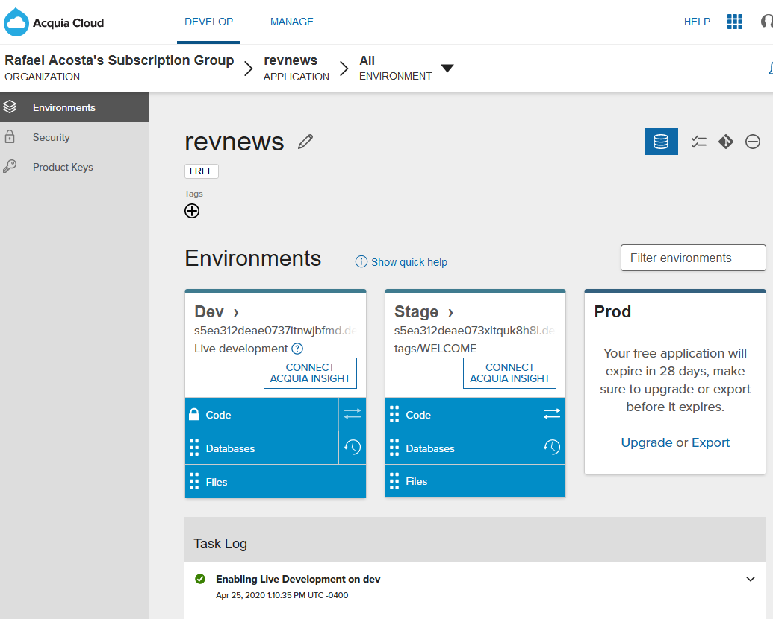

How we can do the backend integration ?

Using a database connection via [Acquia Dev Studio](https://docs.acquia.com/dev-studio/):

Acquia Developer Studio integrates many of the tools developers need to build better digital experiences, and to also be more productive. With Acquia Developer Studio, you can focus on building the best Drupal websites by using the tools you already know.

Web interface for database setup:

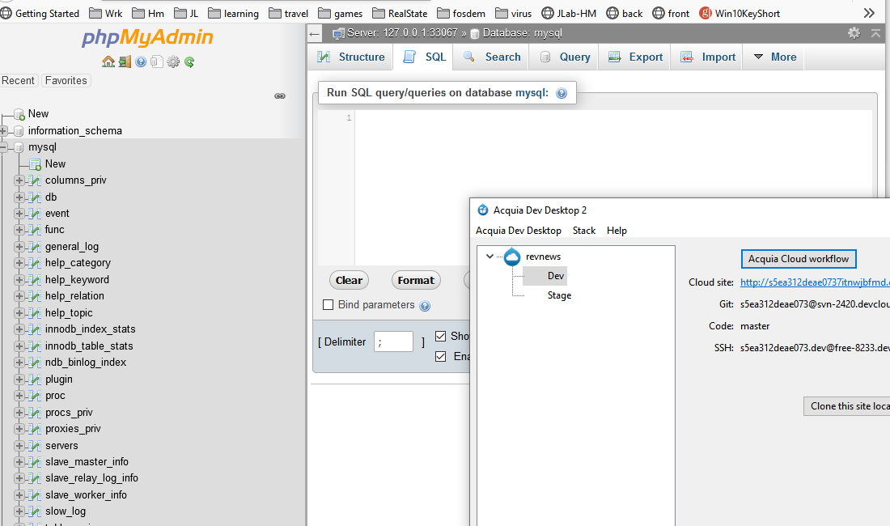

We can integrate the backend database creating table via SQL using this interface (phpmyAdmin) provided by Acquia Dev Studio or via linux terminal (tcp/ip) connection. After the tables and realation betwen tables is created, we can add python scripts (or php scripts) to run the backend system for new/reviewers rankings and other logic algorithms.

Web site (Dev version)

<http://s5ea312deae0737itnwjbfmd.devcloud.acquia-sites.com/>

temporary (home page broken)

<http://s5ea312deae0737itnwjbfmd.devcloud.acquia-sites.com/node/16>

