Drupal implementation

Hosted in <https://cloud.acquia.com>

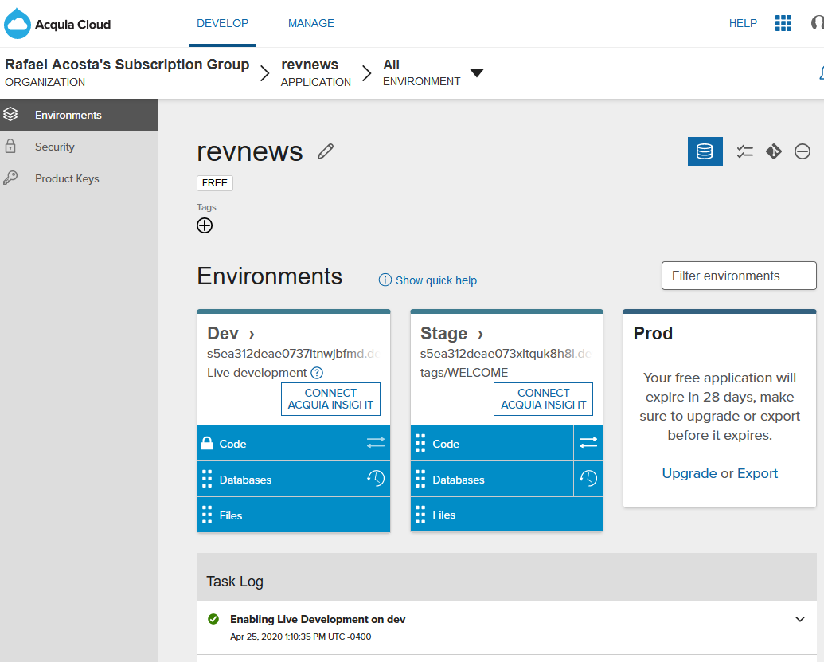

Database connection via Acquia Dev Studio

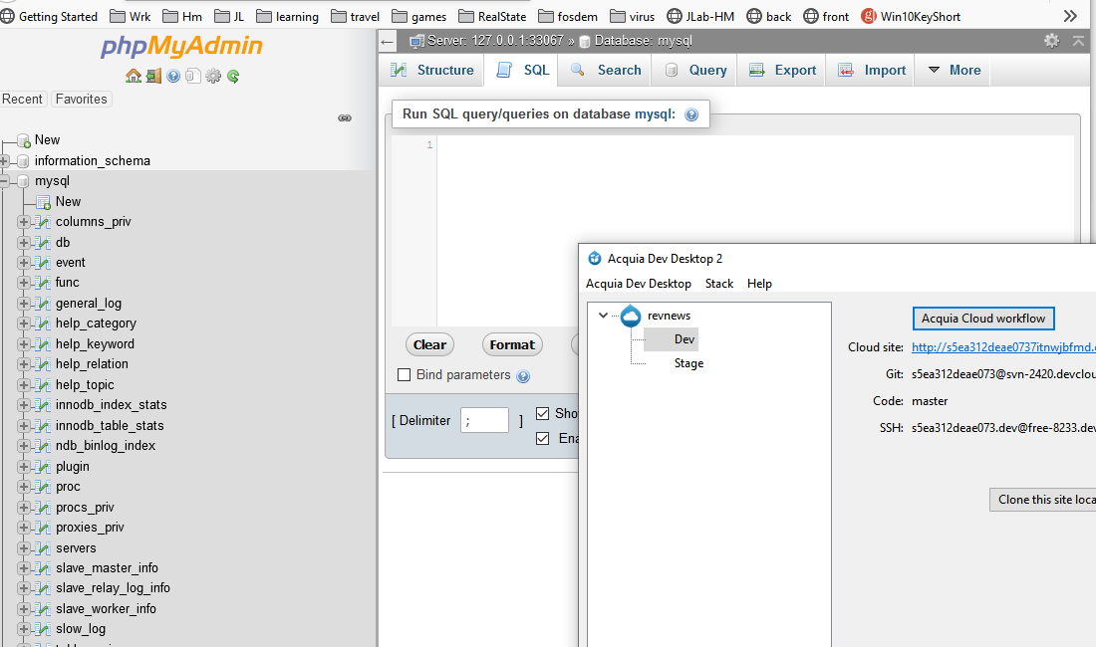

Web stie (Dev version)

<http://s5ea312deae0737itnwjbfmd.devcloud.acquia-sites.com/>

