Assignment 4

Topology:
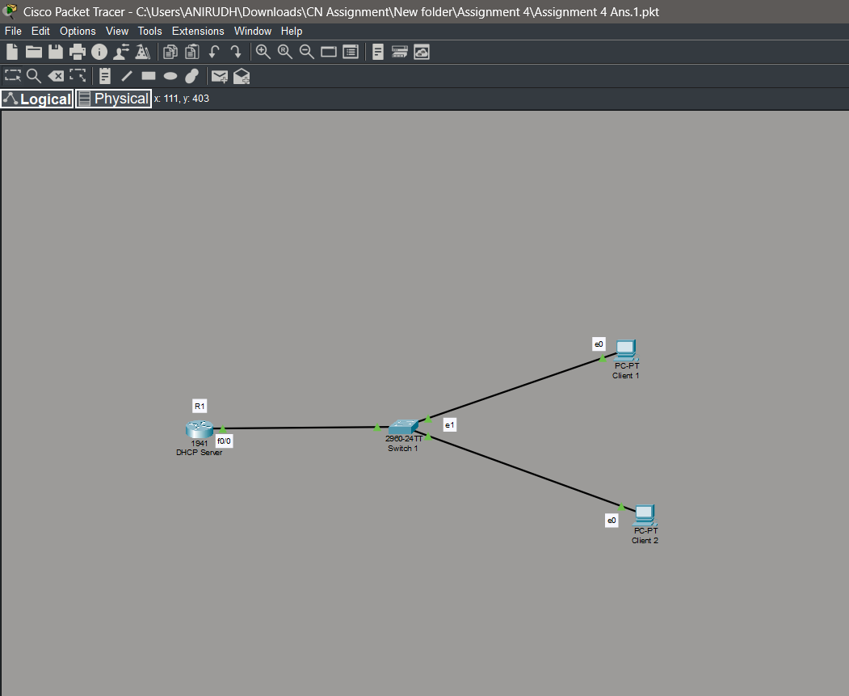

- Commands used to configure Router Interface:
enable
configure terminal
interface f0/0
ip address 192.168.10.1 255.255.255.0
no shutdown
exit

- Create DHCP Pool
ip dhcp pool xyz
network 192.168.10.0 255.255.255.0
default-router 192.168.10.1
dns-server 1.2.3.4
lease 0 3
exit

- Disable BOOTP
no ip bootp server

