ASSIGNMENT 1
- To capture live network packets using Wireshark and identify basic network protocols such as TCP, UDP, IP, and DNS.

Step 1: Launch Wireshark
- Open Wireshark
- You will see a list of network interfaces
  - Wi-Fi
  - Ethernet

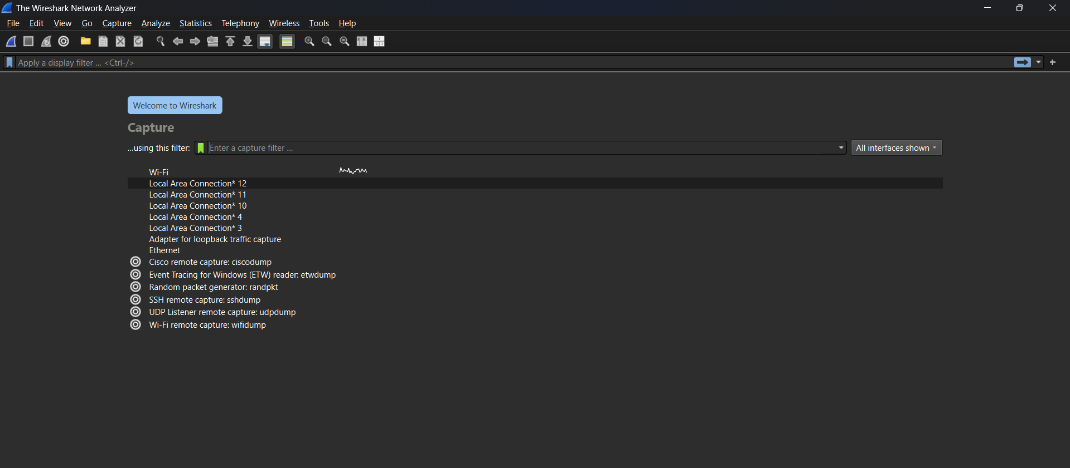

Step 2: Start Packet Capture
- Double-click on Wi-Fi (or active interface)
- Packet capture will start immediately
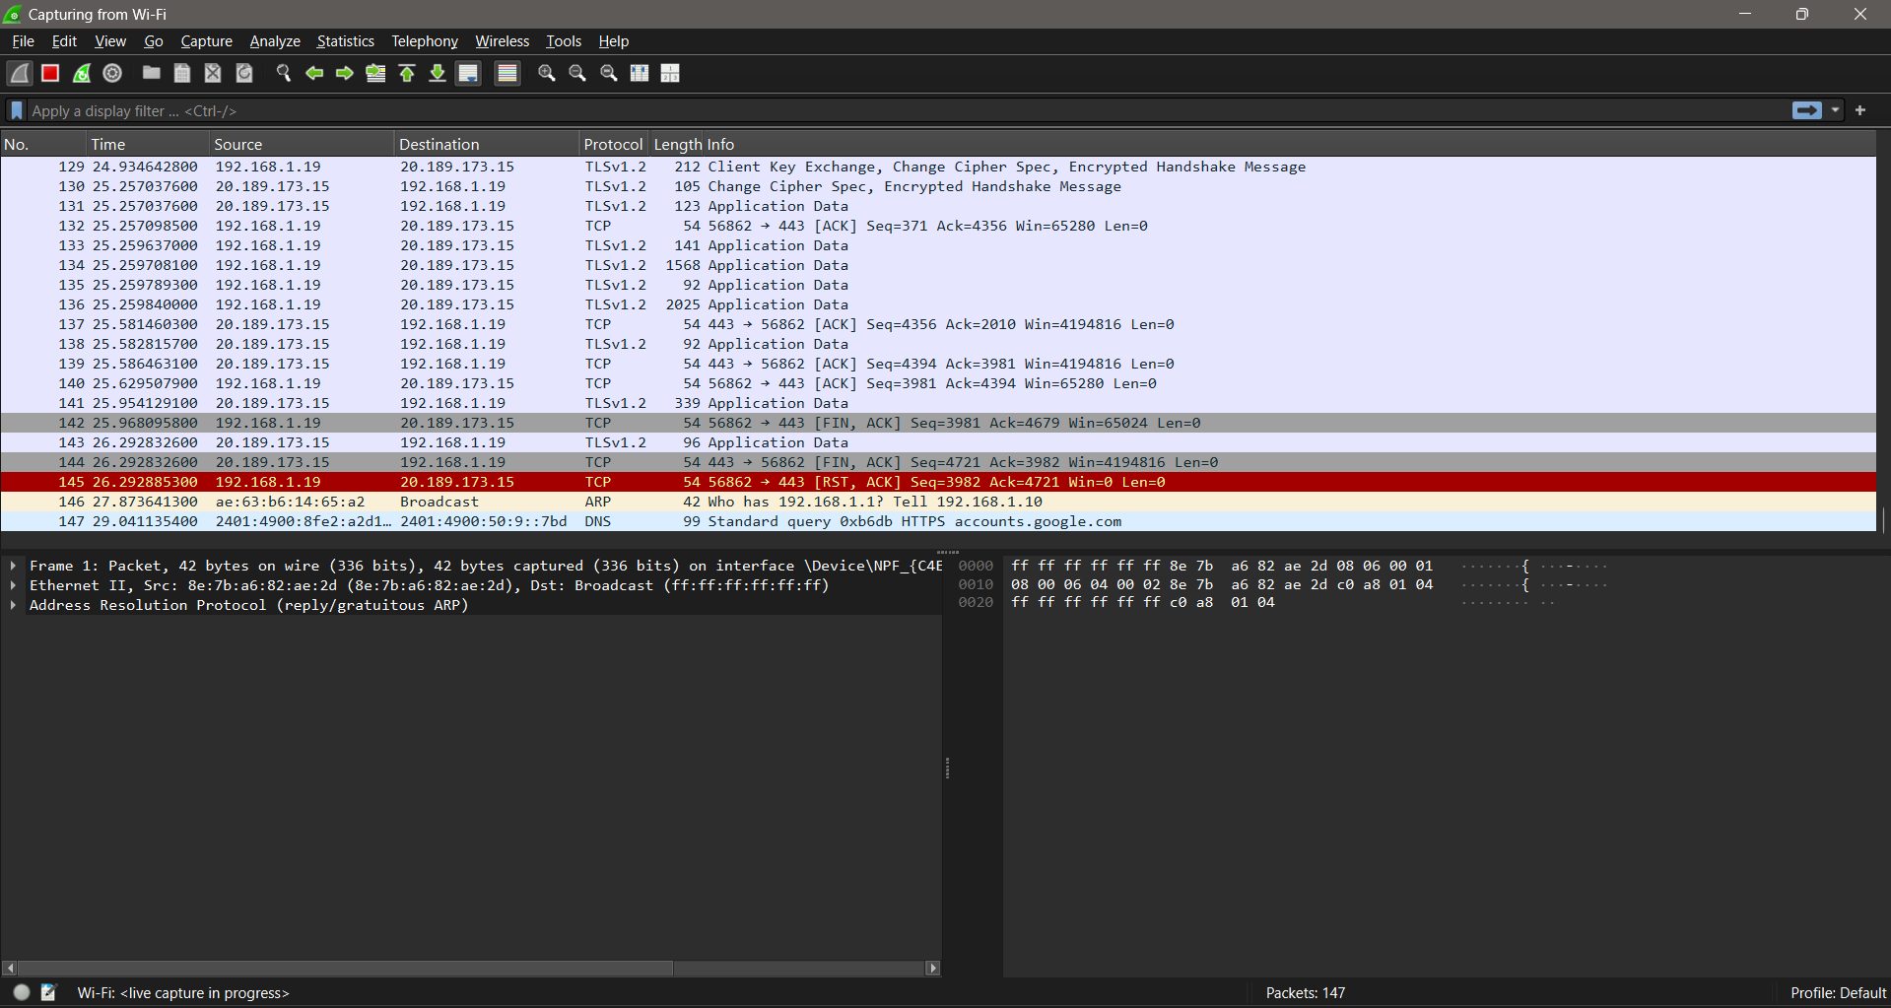

Step 3: Generate Network Traffic
Perform any of the following:
- Open a web browser
- Visit any website (e.g., google.com)
- Open Command Prompt and run:
- ping google.com

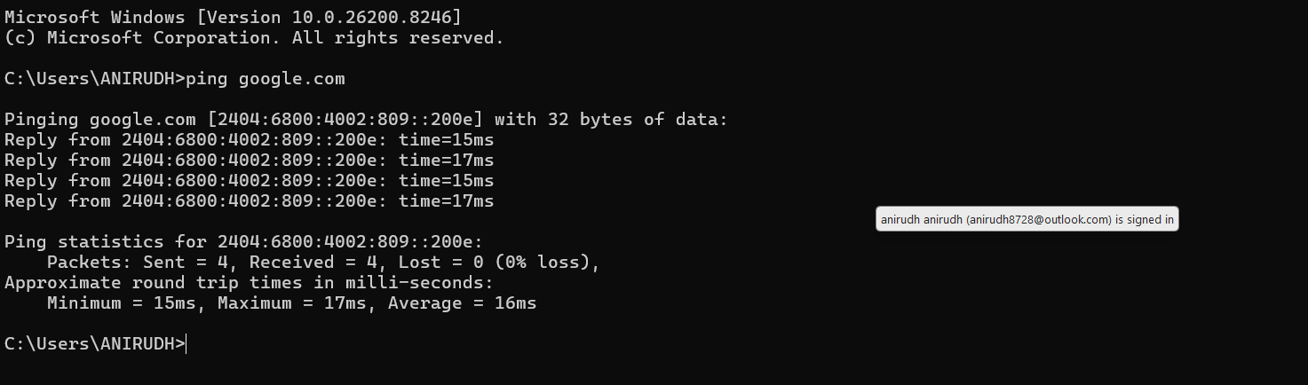

Step 4: Stop Capture
- Click the red Stop button
- Captured packets will remain on the screen

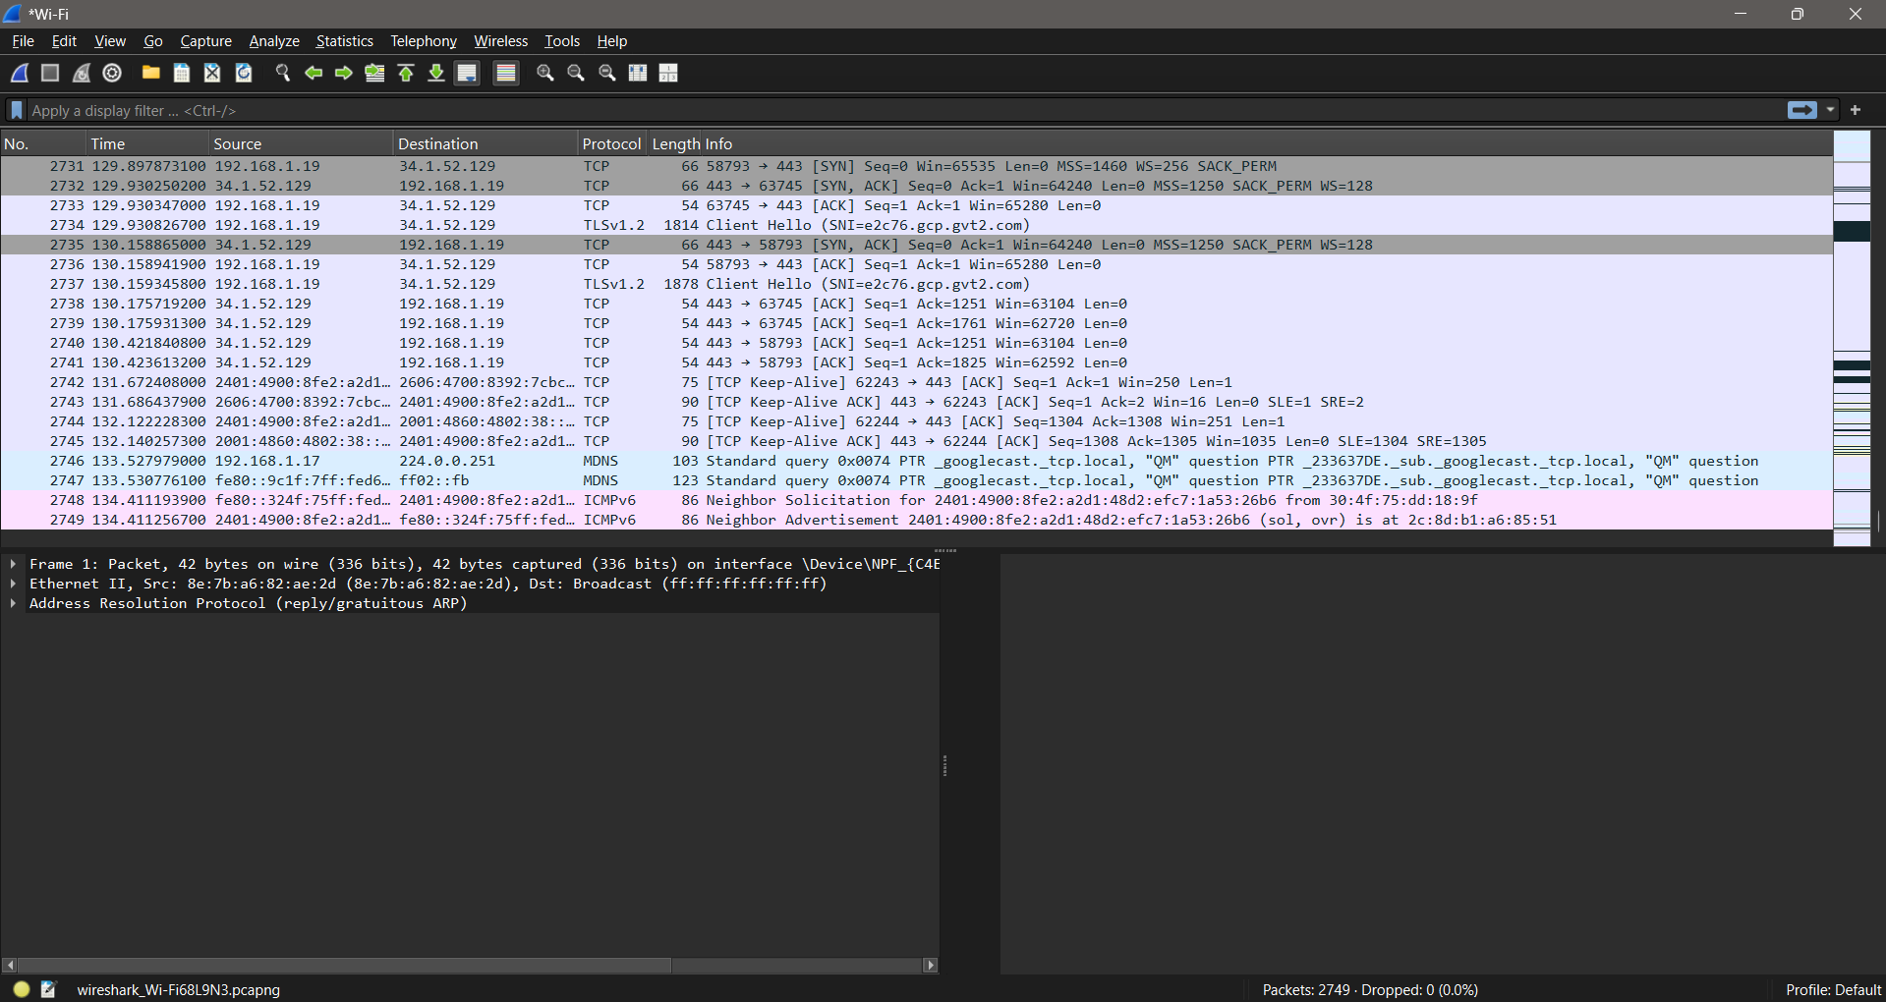

Step 5: Apply Basic Filters
- Use the Display Filter bar:
Filter | Purpose
ip | Show IP packets
tcp | Show TCP packets
udp | Show UDP packets
dns | Show DNS packets
icmp | Show ping packets

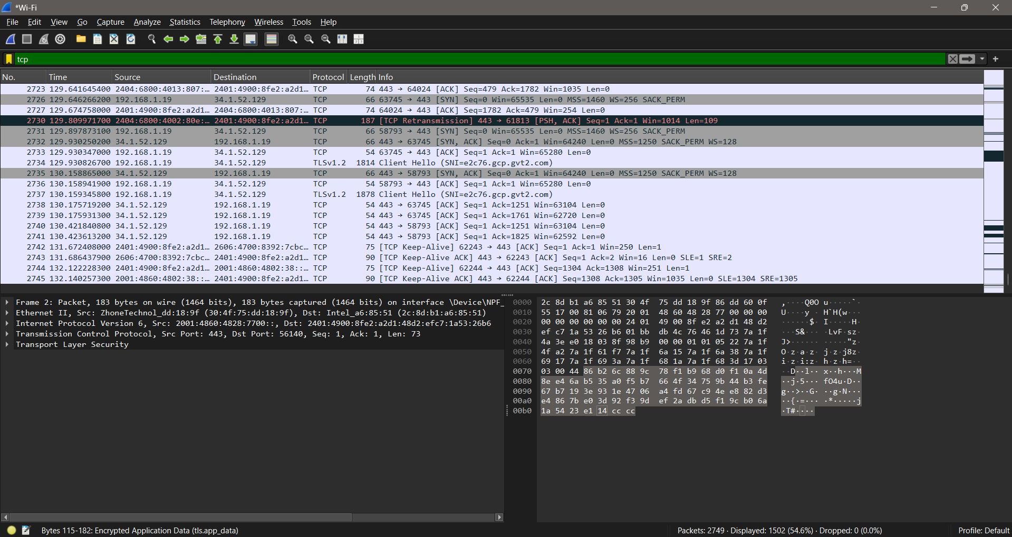

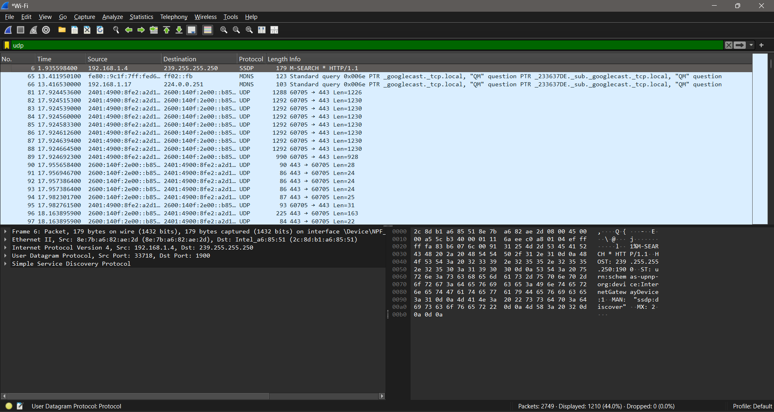

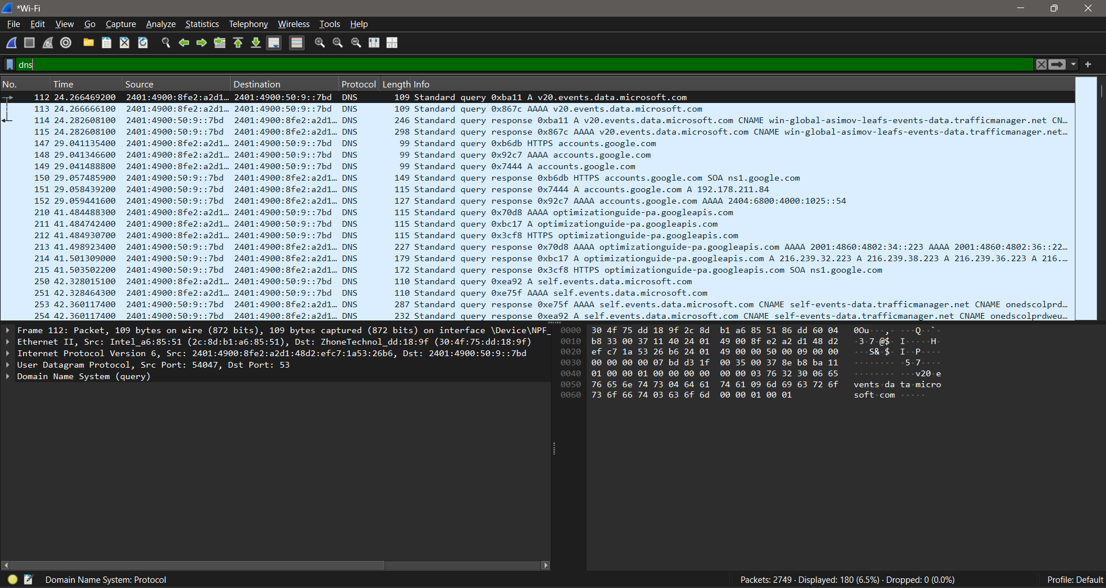
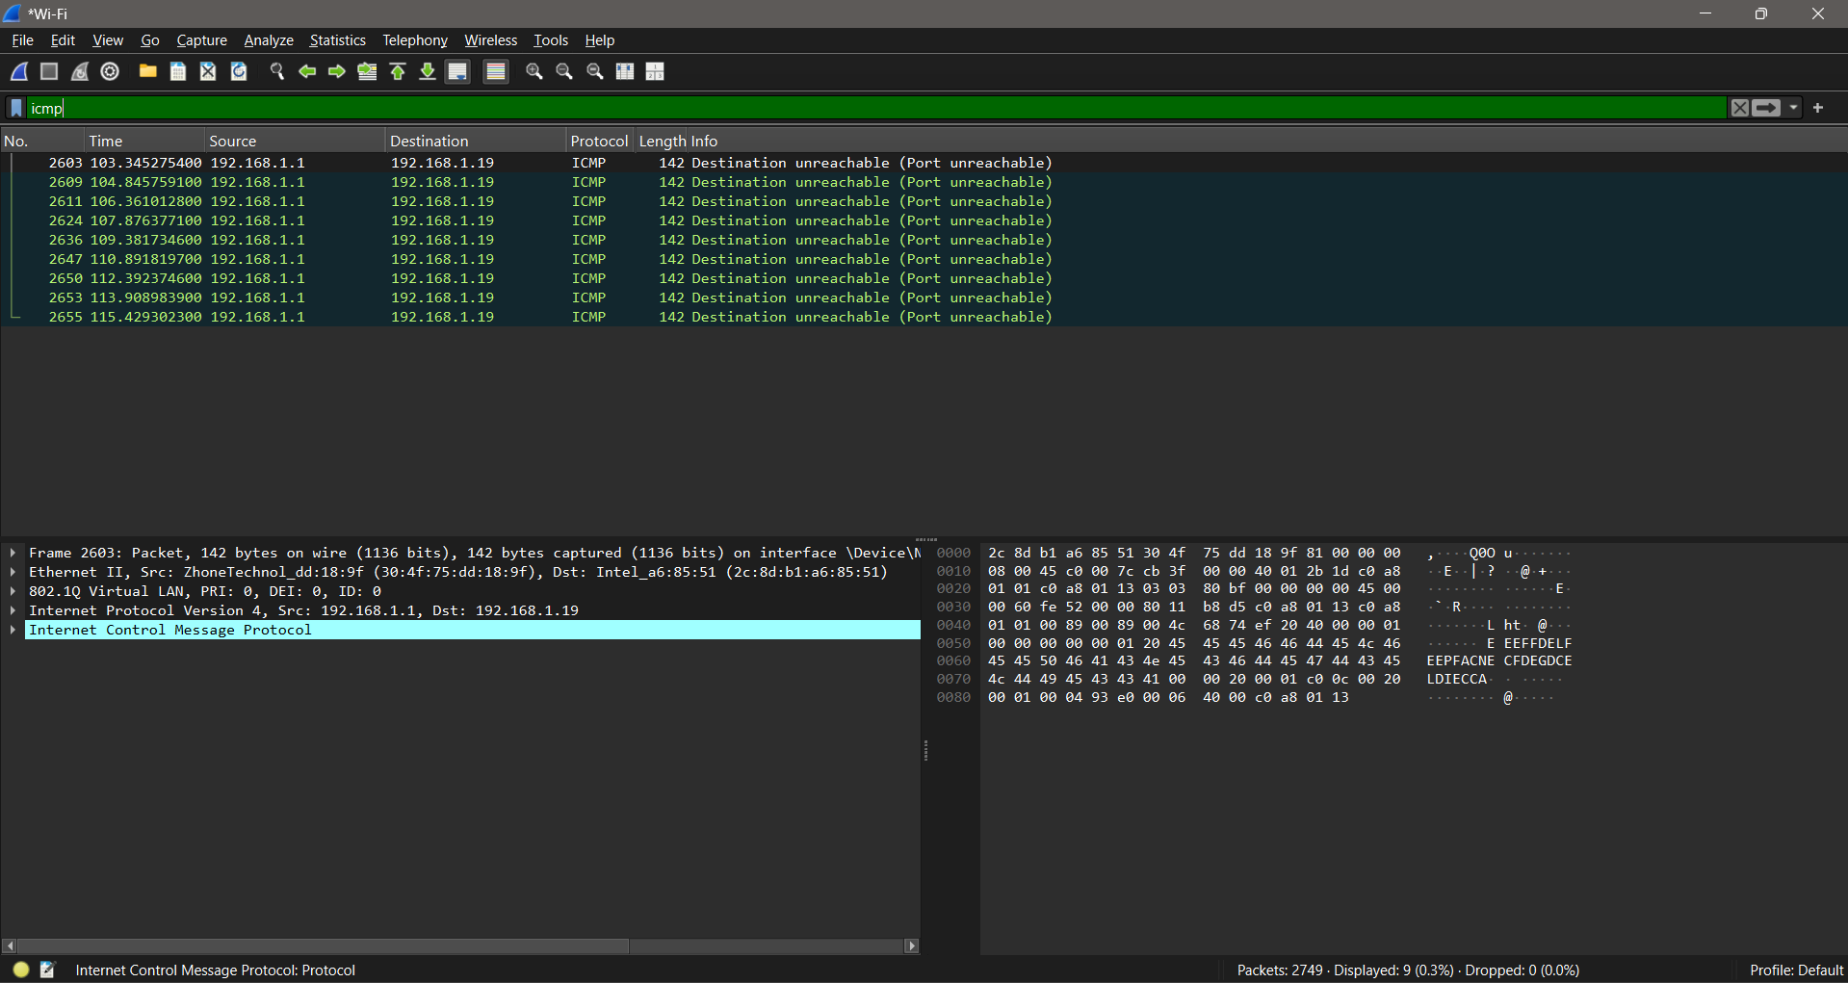

Step 6: Analyze a Packet
- Click on any packet
- Observe:
  - Ethernet header
  - IP header
  - TCP/UDP header
  - Payload data

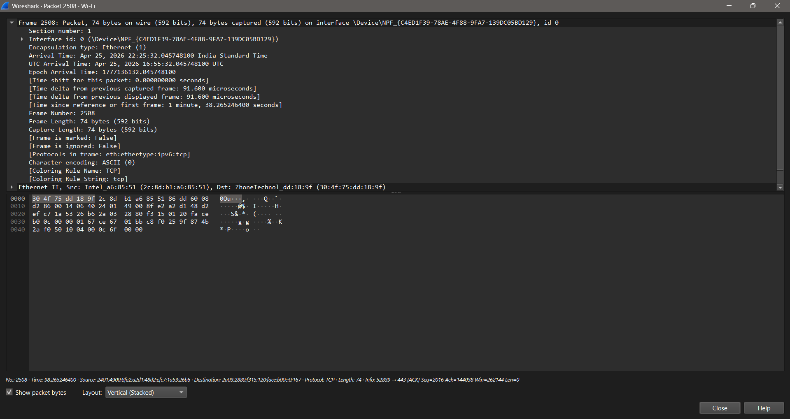

Obesrvation:
Interface used:
- Protocols observed:
- Source and destination IP addresses
- Packet length

Result
Live network packets were successfully captured using Wireshark, and basic network protocols were identified and analyzed.

