NAME: ANIRUDH NAGARAJAN

SECTION: B

REQUIREMENTS TABLE:
Req ID | Type | Description | Priority | Acceptance Criteria | Rationale | Comments
FR-001 | Functional | The system shall parse uploaded student resumes (PDF format), extract skill tags, and match profiles against active company eligibility rules. | High | Pass: Ineligible applicants are filtered out with clear discrepancy reasons; Fail: Applicant with active backlog bypasses eligibility filter. | To ensure only eligible applicants are filtered through to the further rounds of evaluation
FR-002 | Functional | The system shall analyze and display all relevant evaluation criteria in a neat and concise format for each student | High | Pass: Each applicant’s information and relevant data is displayed in a neat format and is easy to understand | To make criteria analysis easier and less time consuming
FR-003 | Functional | The system shall allow for grouping the applicants by some specified criteria, and also allow further filtering | Medium | Pass: Allows for filtering and grouping the students by CGPA, Attendance, etc. | To make grouping and splitting into categories easily
FR-004 | Functional | The system must have a tab or interface where the applicant can view their current placement round and all interview details | High | Pass: Any applicant can view their interview details including the company/business, timing and date, venue, etc. | To ensure students have a way to access their interview details
FR-005 | Functional | The system must be able to store and process multiple offer letters from different businesses | High | Pass: Any offer letter to an applicant is stored in a database which can be accessed by the student and processed. | To manage offer letters for applicants
NFR-001 | Non-Functional | The system shall encrypt all student academic records and offer documents at rest using AES256. | High | Pass: Benchmarking tests confirm target latency and security standards under simulated peak load.
NFR-002 | Non-Functional | The system must operate at a latency of less then 3s and must be available 24/7 | High | Pass: The system is functional and responsive when accessed during the whole day

USE CASE DIAGRAM:
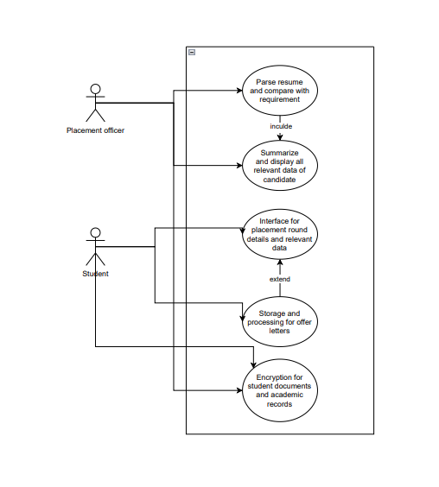

USE CASE FLOW (parsing resume):
- Login through valid credentials (placement officer)
- Open the parser interface, which accesses the database with the student resumes
- Apply relevant qualifications and requirements for candidates onto the parser
- The parser goes through the resumes and filters out only valid/qualified candidates
Alternate flow 1.1
  - Login credentials invalid
  - Attempt to login again 3 times
  - If fail, then locked out for 1 hour

