NAME: ANIRUDH NAGARAJAN

SECTION: B

Backlog screen with all user stories before sprint 1:
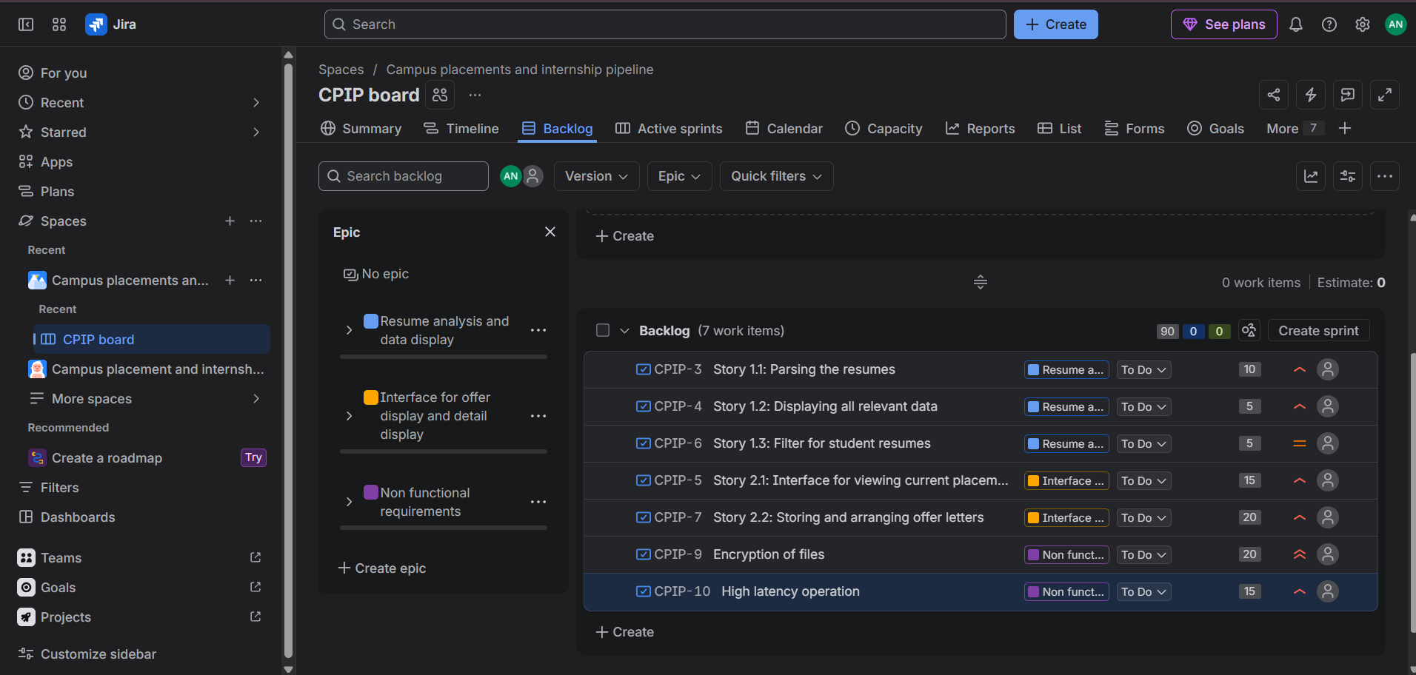

Backlog screen during sprint 1:
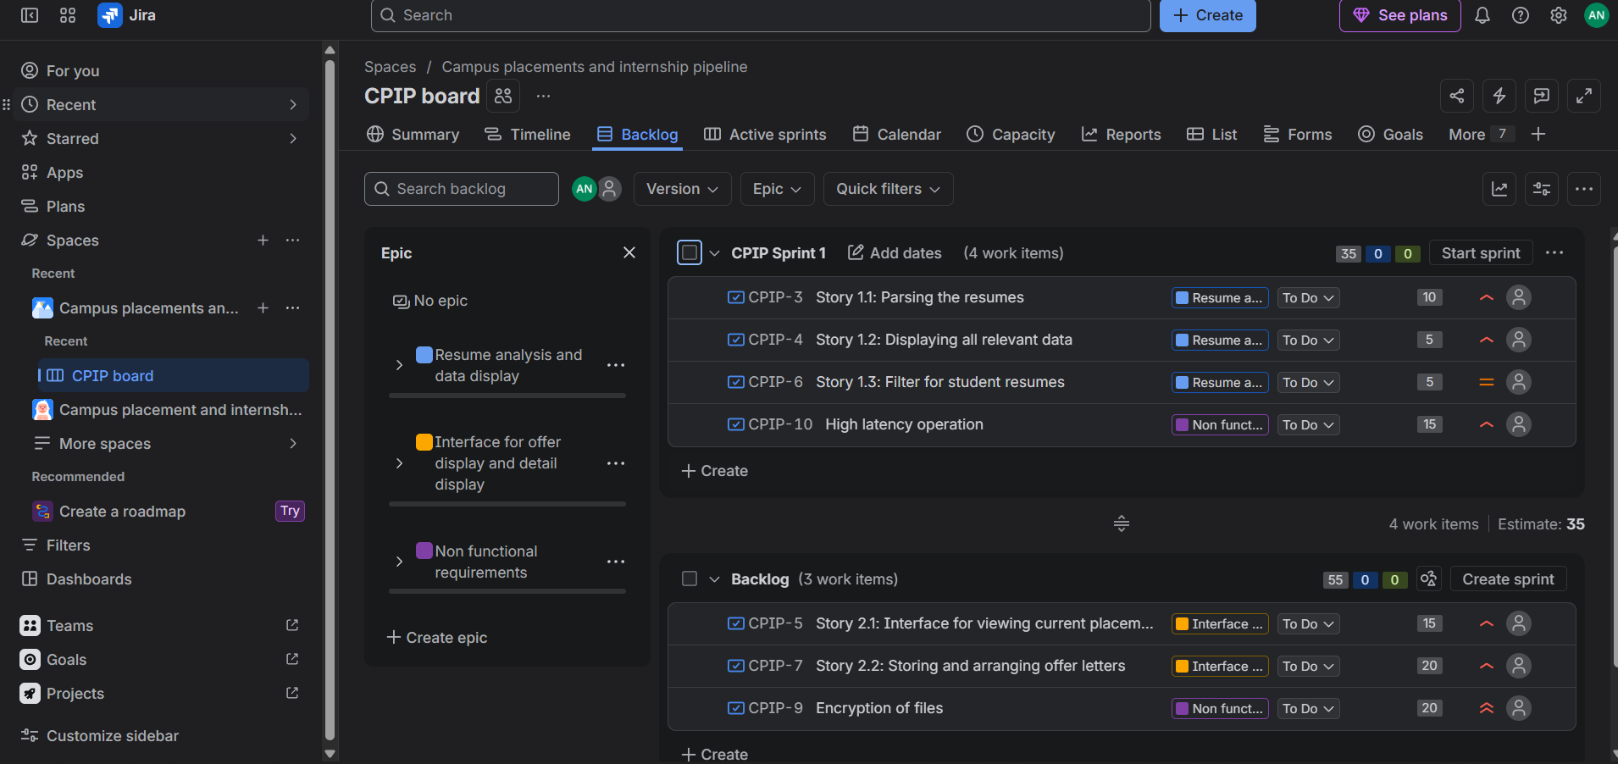

Backlog screen with all user stories after sprint 1:
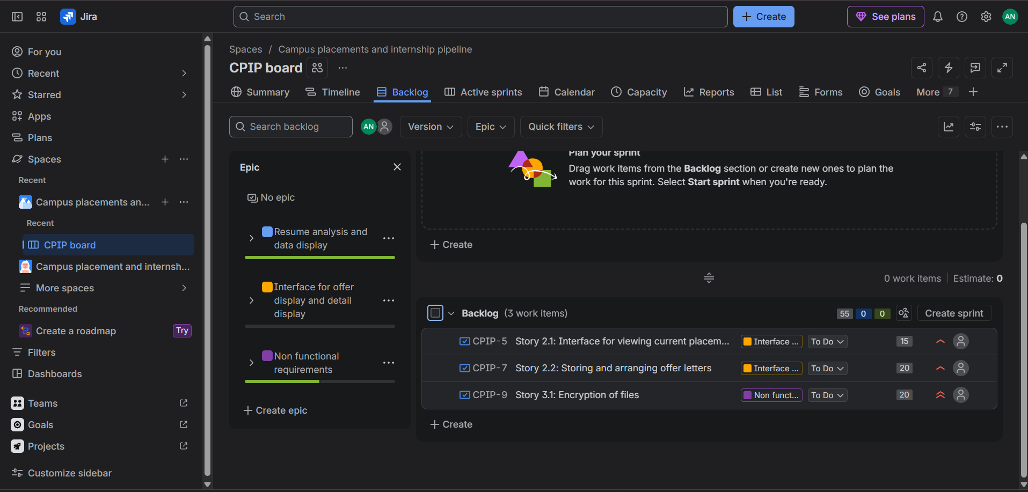

Backlog screen during sprint 2:
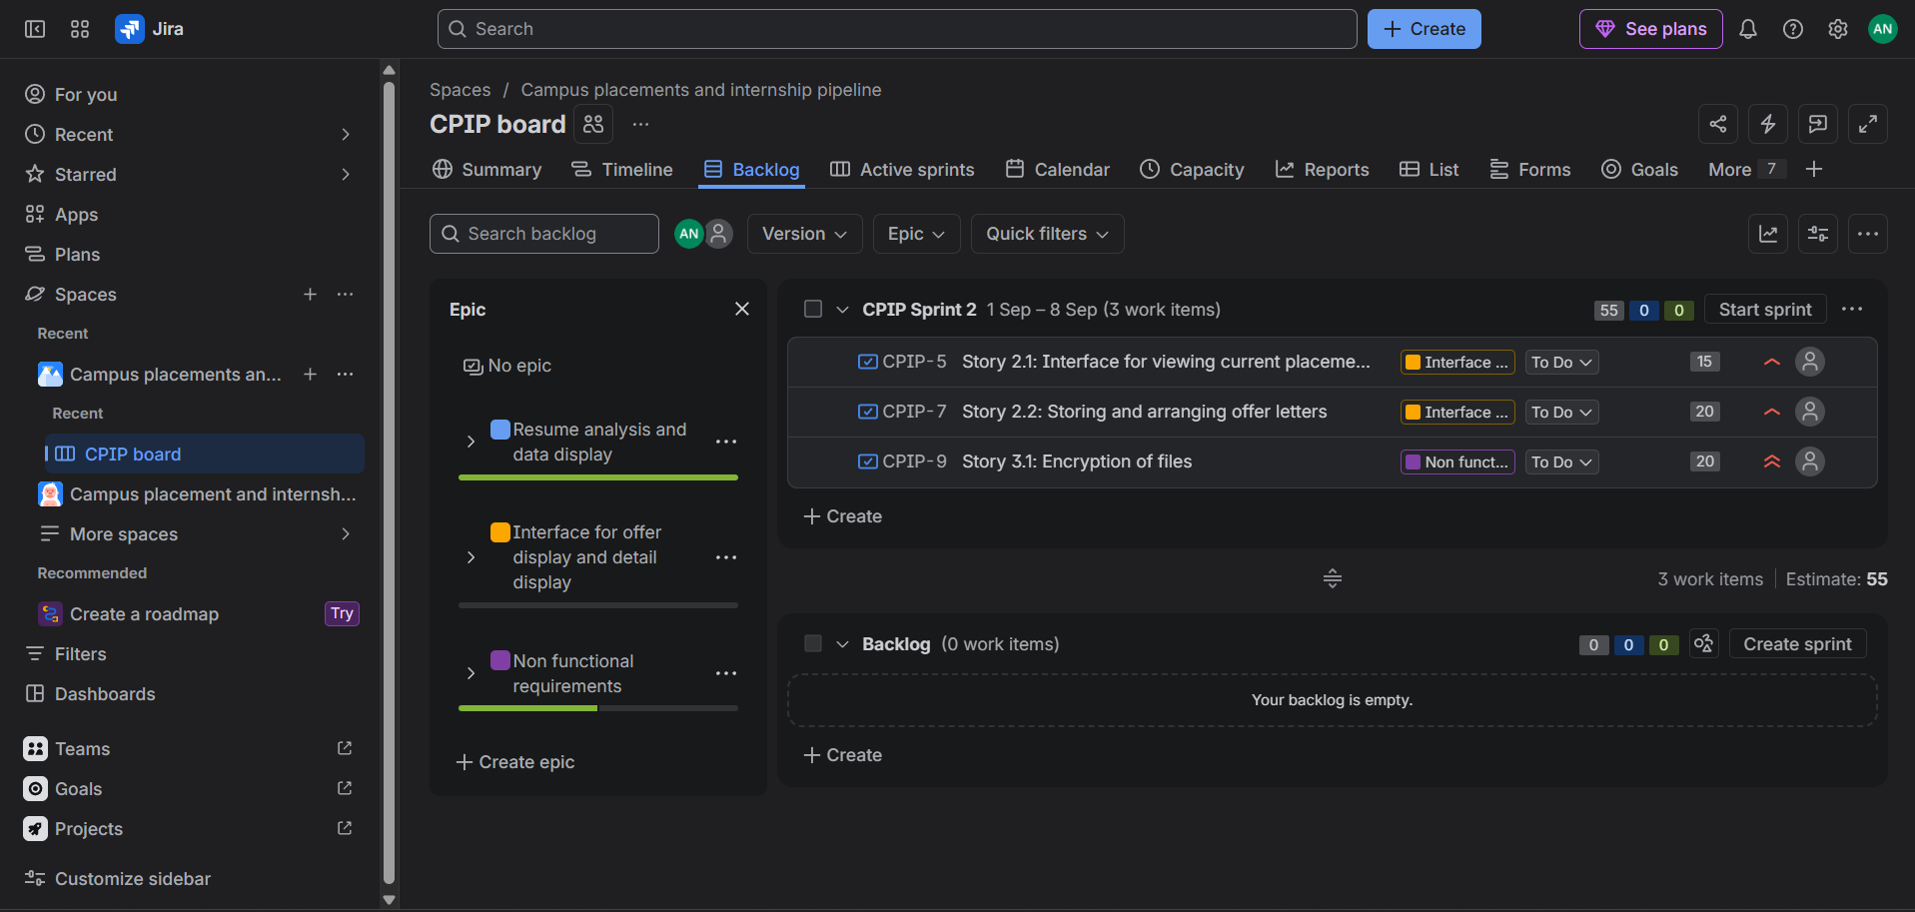

Backlog screen with all user stories after sprint 2:
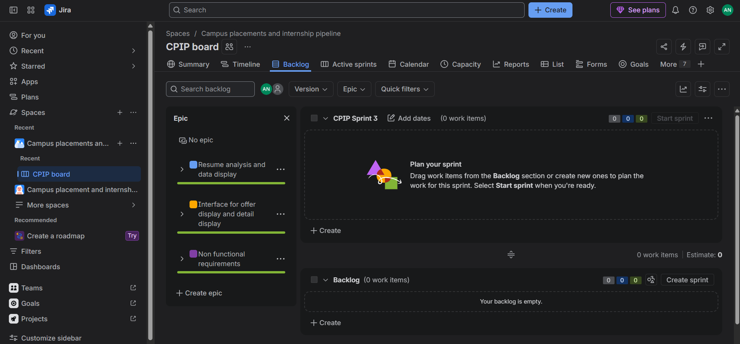

Burndown charts:

SPRINT 1
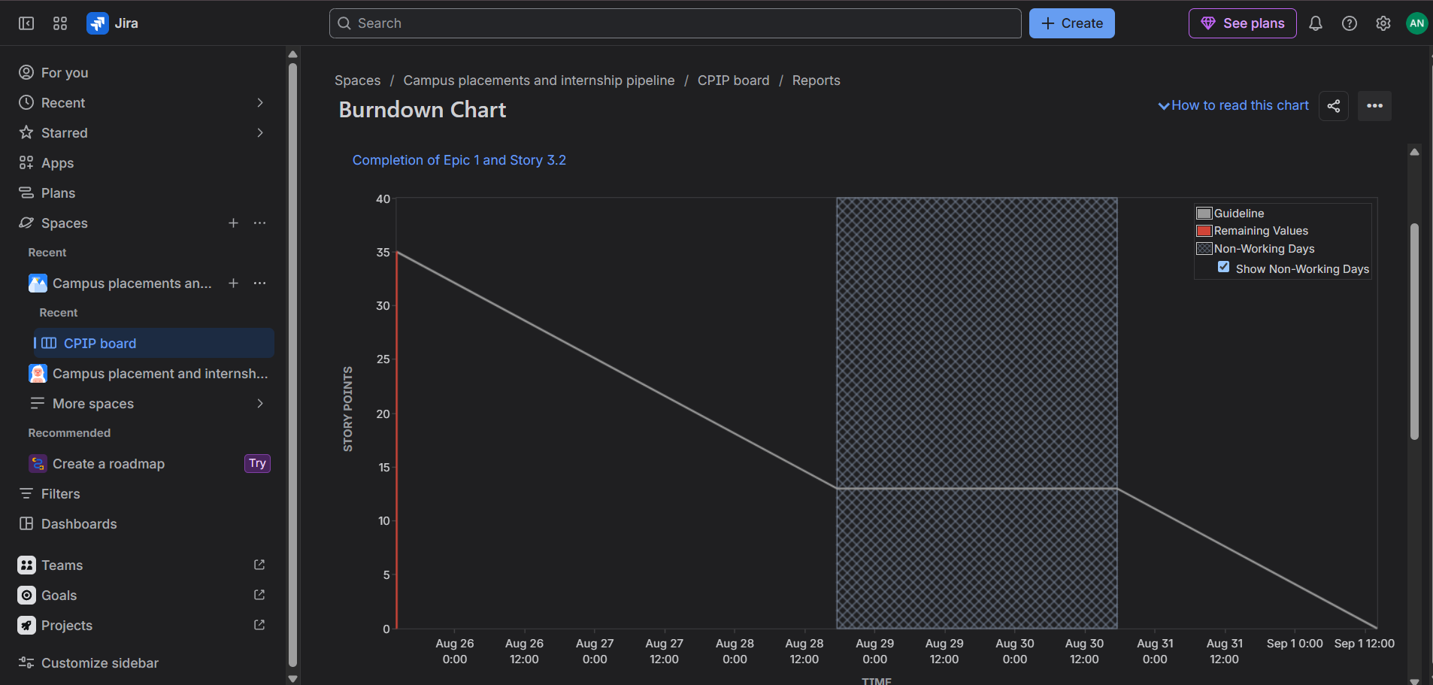

SPRINT 2
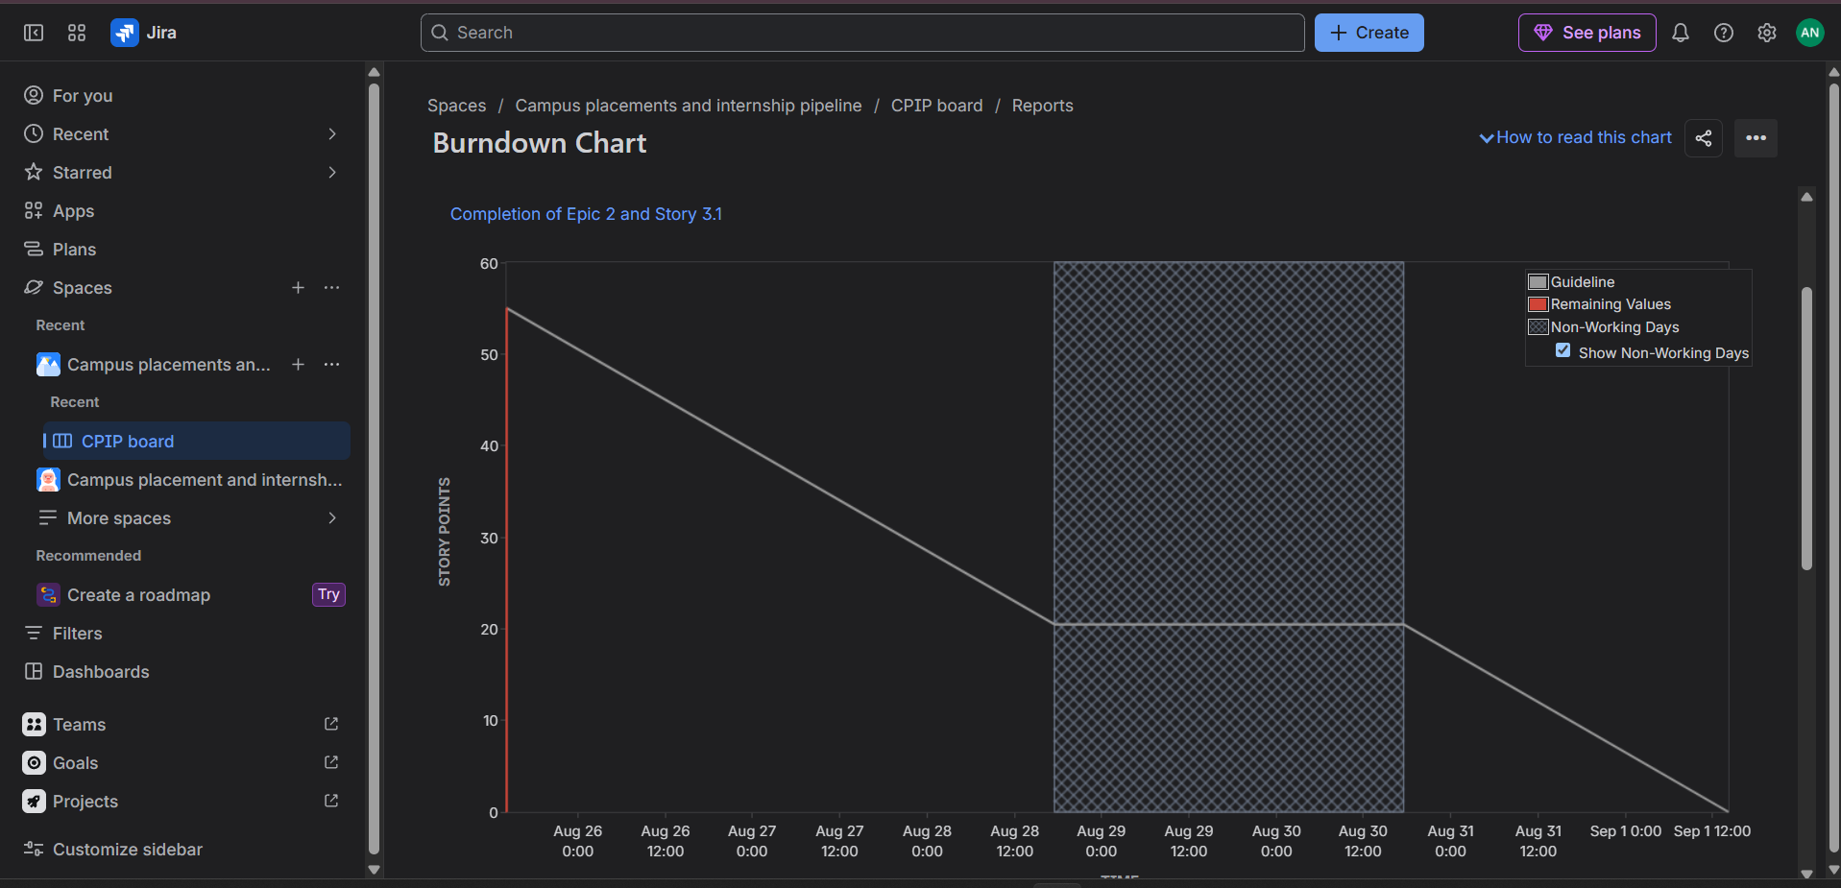

REFLECTION QUESTIONS:
- Since in this simulated sprint, I moved the tasks/stories from to-do to in progress to done very fast, the estimations are actually far higher than what actually happened. Hence the estimations do not reflect effort here.

- Yes, I assigned each story appropriate story points, and also added them to the sprints accordingly to evenly distribute workload.

- The simulated sprint was completed extremely fast, meanwhile the plan was that the sprint would last for a week. Hence the work was completed much faster than expected.

- In this simulation, the burndown charts suggest that the team is highly capable as it completed the tasks extremely fast, and no task remained incomplete.

