NAME: ANIRUDH NAGARAJAN

SECTION: B

COMPONENT DIAGRAM:
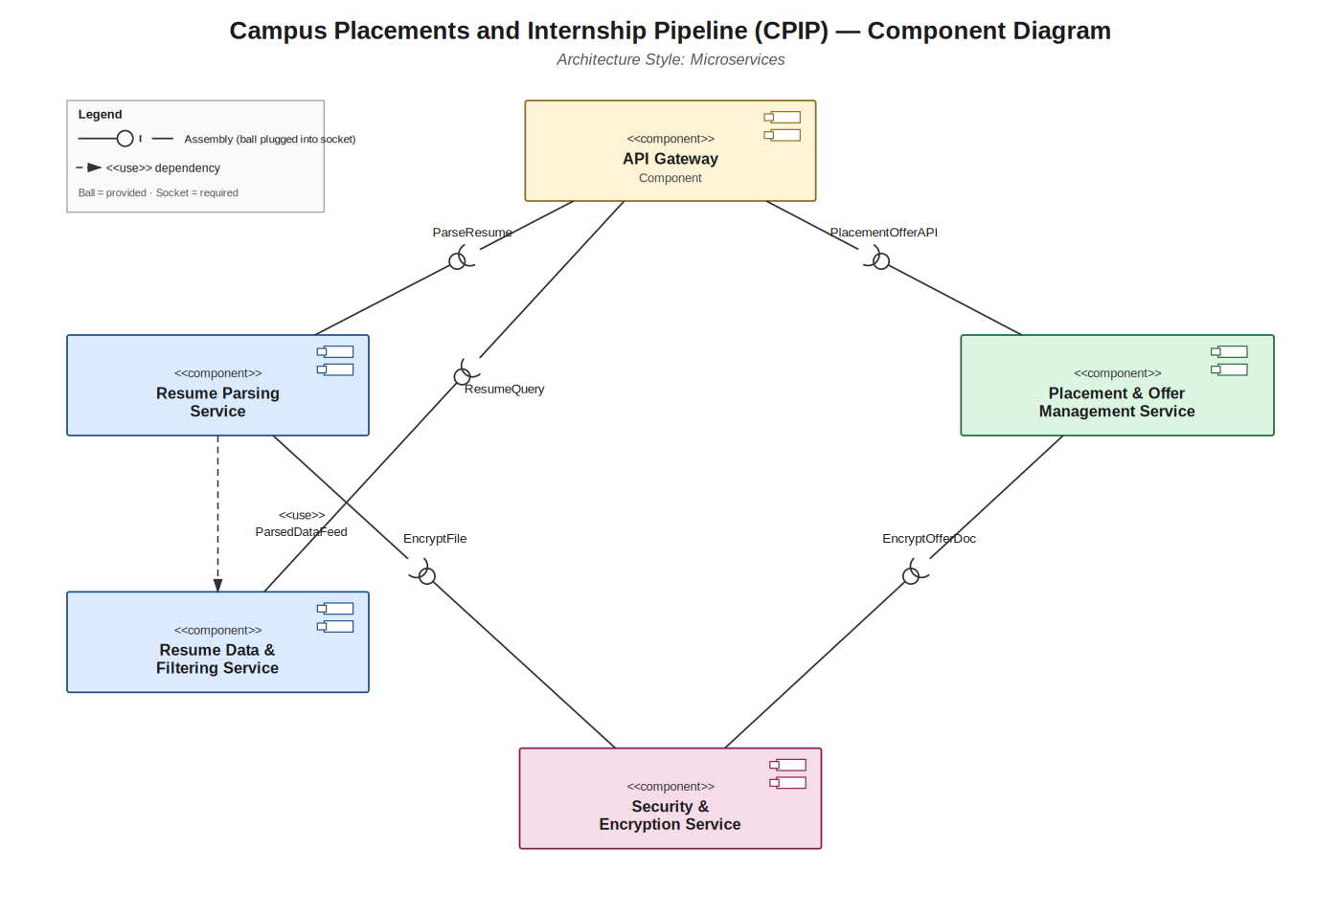

ANALYSIS AND REASONING:
Architecture Selection: I chose Microservices Architecture for the Campus Placements and Internship Pipeline (CPIP) System.
Reason 1 — Independently modules
The requirements are already organised around distinct capability areas — resume analysis and data display, and the offer/placement viewing interface — each owned and iterated on separately across sprints. Microservices let the Resume Parsing Service, Resume Data & Filtering Service, and Placement & Offer Management Service be built, tested, and deployed independently, matching how the team is already planning and delivering work without one team's change risking another module.
Reason 2 — Uneven load across functions
Resume parsing is CPU-heavy and highly bursty during application windows and placement drives, while browsing current placements or offers is lightweight and constant. A microservices split lets the Resume Parsing Service be scaled horizontally on demand, without over-provisioning the rest of the system — a flexibility a single monolithic layer cannot offer as cleanly.
Security Advantage
Isolating a dedicated Security & Encryption Service gives the system one auditable boundary for encrypting sensitive artefacts — student resumes and offer letters — instead of scattering encryption logic across modules. Every other service must go through this service's provided interface to read or write protected files, so a vulnerability in, say, the Placement & Offer Management Service does not automatically expose the encryption keys or raw file contents, containing the area of a compromise.
Performance Benefit
The system's technical constraints flag high-latency operation as a risk. Because the API Gateway routes requests to independently deployed services, only the Resume Parsing Service — the heaviest, highest-latency component — needs extra instances; lightweight services like Resume Data & Filtering keep responding quickly and are not slowed down by the parsing backlog. This targeted scaling reduces average response time far more efficiently than scaling an entire layered monolith would.

