NAME: ANIRUDH NAGARAJAN

SECTION: B

Bandit_report.txt
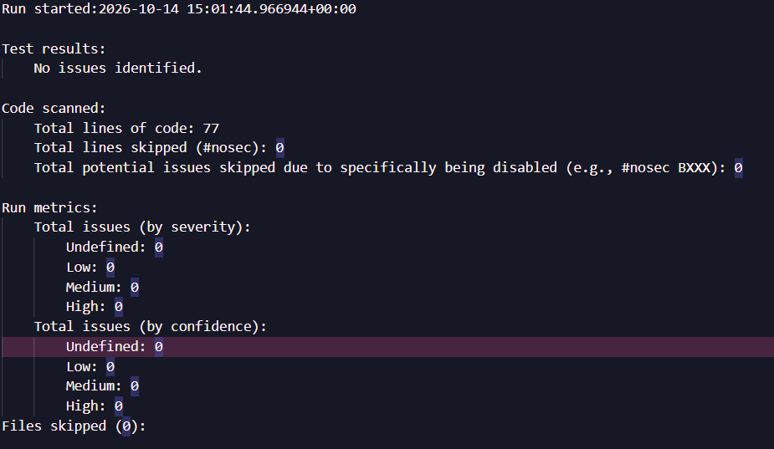

pylint_report.txt
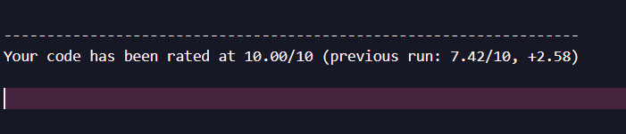

Flake8 output is empty

