Name: Anirudh G Achar
SRN: PES1UG24AM342
Subject: SE LAB 1
Topic: Internal Microservice Catalog & Health Portal

Requirement Table:
Req ID | Type | Description | Priority | Acceptance Criteria | Rationale | Comments
FR-001 | Functional | The system shall ping microservice health endpoints at 30-second intervals and compute rolling 24-hour service availability percentages. | High | Pass: Downtime recorded and alert dispatched on 3 consecutive failed health probes; Fail: Unreachable service marked healthy. | Core health monitoring loop.
FR-002 | Functional | The system shall aggregate and display API documentation for all registered microservices in a centralized portal. | Medium | Pass: Viewing a service page displays its associated API endpoints and payload schemas; Fail: Documentation is missing or fails to load. | Enables developers to easily discover API specs. | specify if it supports Swagger/OpenAPI
FR-003 | Functional | The system shall allow a System Architect to manually register a new microservice by providing its endpoint URL and listing its dependencies. | High | Pass: New service appears in the catalog and dependency graph after submission; Fail: System rejects valid registration. | Required to build the dependency map. | Does system validate the endpoint URL format before accepting the registration?
FR-004 | Functional | The system shall dispatch downtime alerts to the DevOps Engineer when a service fails its health check. | High | Pass: Email/SMS notification sent to DevOps engineer upon failure criteria met; Fail: No alert is sent. | Ensures quick response to system outages. | specify the exact notification channels
FR-005 | Functional | The system shall display a unified dashboard showing the real-time status (Healthy/Down) and 24-hour availability percentage of all mapped services. | Medium | Pass: Dashboard loads all services with correct statuses and % metrics; Fail: Dashboard displays stale or incorrect data. | Provides a high-level operational overview. | What is default display if newly added service has < 24 hours of data?
NFR-001 | Performance & Security | The service catalog dependency graph viewer must render interactive node architectures containing up to 200 services smoothly. | High | Pass: Benchmarking tests confirm target latency and security standards under simulated peak load. | Ensures usability of the UI at enterprise scale.
NFR-002 | Performance | The system shall dispatch downtime alerts within 5 seconds of the 3rd consecutive failed health probe. | High | Pass: System logs show alert dispatch timestamp is < 5s after the final probe failure; Fail: Alert takes longer than 5s. | Immediate notification is critical for DevOps. | Make sure network latency is factored out of that 5-second measurement

UML Use-Case Diagram:
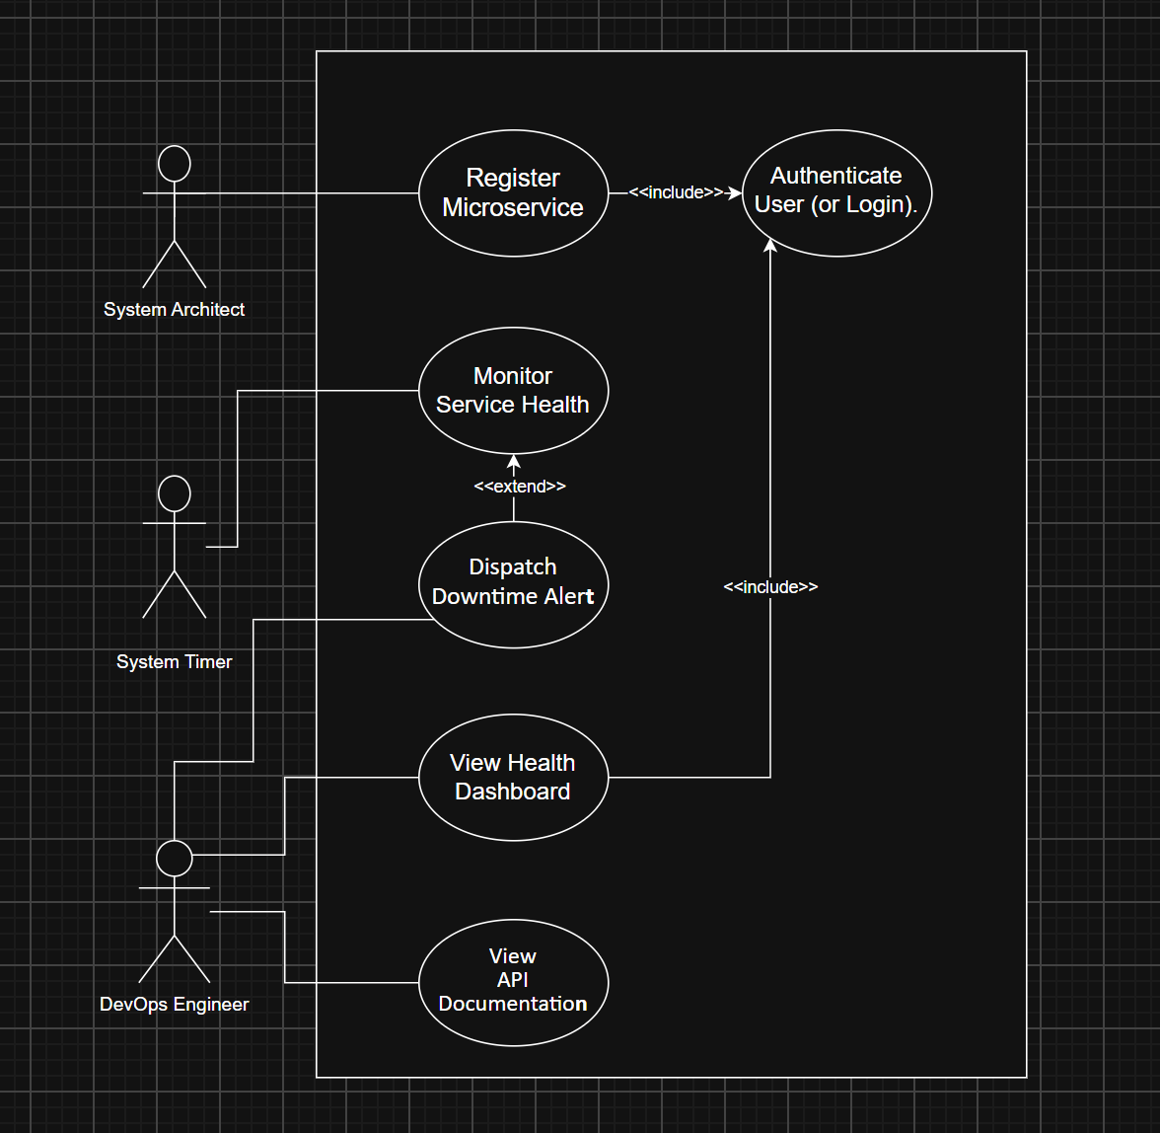

Use-Case Flow Document:
Use Case Name: Monitor Service Health
Primary Actor: System Timer
Secondary Actor: DevOps Engineer
Preconditions:
- The target microservice is actively registered in the internal catalog.
- The automated scheduling service is configured to run at 30-second intervals.
Main Success Scenario:
- The System Timer initiates the scheduled health check process.
- The system sends a ping request to the registered microservice health endpoint.
- The microservice processes the request and responds with a successful status code.
- The system logs the successful probe alongside the current timestamp.
- The system computes the updated rolling 24-hour service availability percentage.
- The system refreshes the internal health dashboard with the latest metrics.
- The use case ends successfully.
Alternate Flow: Health Probe Failure
- The system sends a ping request to the registered microservice health endpoint.
- The microservice fails to respond within the timeout window or returns a server error.
- The system logs the failed health probe.
- The system evaluates the recent ping history for this specific microservice.
- The system detects a threshold of 3 consecutive failed health probes.
- The system triggers the extended use case to dispatch a downtime alert to the DevOps Engineer.
- The system updates the dashboard to mark the service as unreachable and unhealthy.
- The use case ends.
Postconditions:
- The backend database accurately reflects the latest health status, probe history, and availability percentage for the queried microservice.

