1ST RECEIPT ACTIVITY SHOULD BE ACCORDING TO UNIT (MRT), RECEIPT TYPE MISC, BANK ORIGINAL
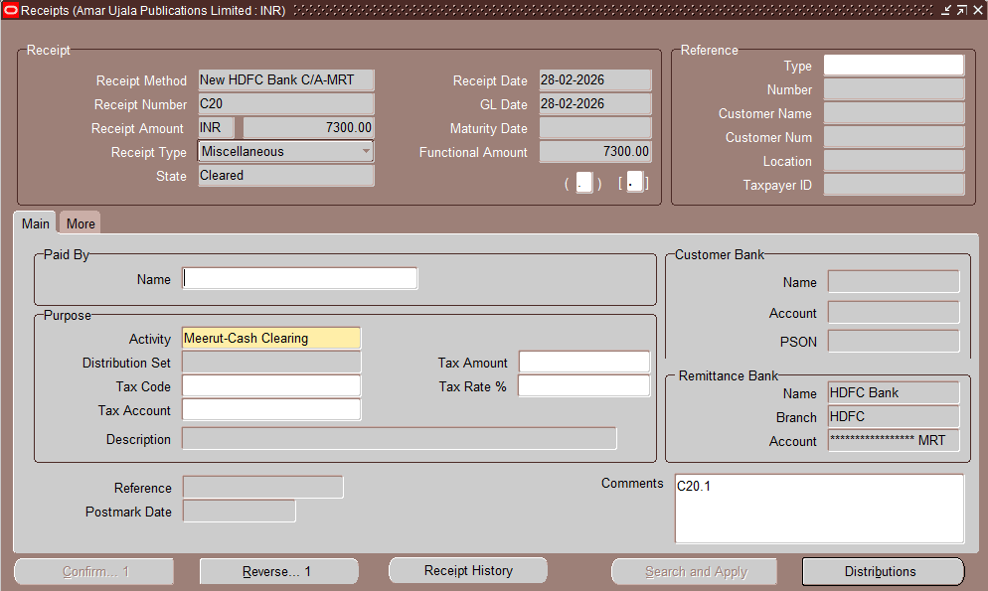
2ND RECEIPT DUMMY BANK, RECEIPT TYPE STANDARD
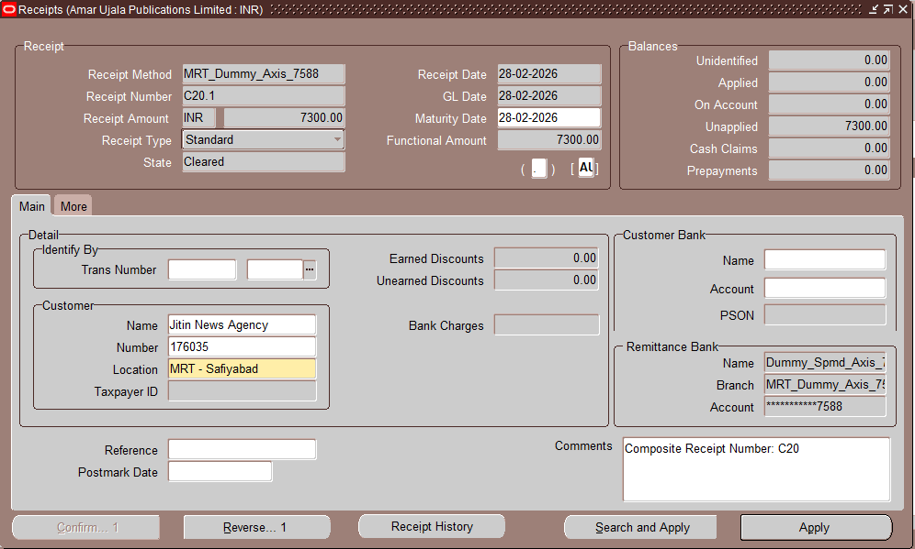
3RD RECEIPT WITH DUMMY BANK AND ACTIVITY ACCORDING TO UNIT, RECEIPT TYPE MISC
