Anirudh R
Reg No.: 210905318
LAB 2

1)List all the files under the given input directory, whose extension has
only one character

echo "Enter path to directory"
read dirname
find "$dirname" -type f -name '*.?'


2)Write a shell script that accepts two command line parameters. First
parameter indicates the directory and the second parameter indicates a
regular expression. The script should display all the files and directories
in the directory specified in the first argument matching the format
specified in the second argument.

if [ $# != 2 ]; then
echo "Usage: $0 <directory> <regular expression>"
exit 1
fi

ls $1 | grep -E "$2"

3)Count the number of users logged on to the system. Display the output
as Number of users logged into the system.

echo "Number of users logged in: " && who | wc -l

4)Count only the number of files in the current directory.

ls -l | grep "^-" | wc -l
5)Write a shell script that takes two sorted numeric files as input and
produces a single sorted numeric file without any duplicate contents.

if [ $# != 2 ]; then
echo "Usage: $0 <file> <file>"
exit 1
fi

if [ ! -f "$1" ] || [ ! -f "$2" ]; then
echo "Error: Input files do not exist."
exit 1
fi

sort -n "$1" "$2" | uniq > merged.txt

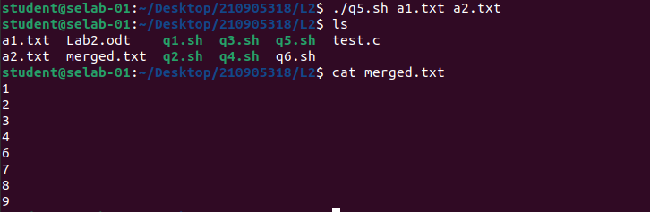
6)Write a shell script that accepts two command line arguments. First
argument indicates format of file and the second argument indicates the
destination directory. The script should copy all the files as specified in
the first argument to the location indicated by the second argument.
Also, try the script where the destination directory name has space in it.

if [ "$#" -ne 2 ]; then
echo "Usage: $0 <file_format> <destination_directory>"
exit 1
fi

if [ ! -d "$2" ]; then
mkdir -p "$2"
fi

cp *."$1" "$2"

