Anirudh R
Reg No.: 210905318
LAB 3

1)Find whether the given number is even or odd.

echo "Enter a number"
read number
rem=`expr $number % 2`
[ $rem -eq 0 ] && echo "The number entered is even" || echo "The number entered is odd"

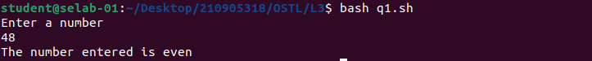
2)Print the first ‘n’ odd numbers.

echo "Enter a number "
read n
i=1
c=0
while [ $c -lt $n ]
do
echo $i
i=`expr $i + 2`
c=`expr $c + 1`
done

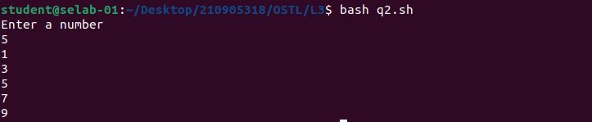
3)Find all the possible quadratic equation roots using case.

echo "This file is $0"
echo "Enter 'a'"
read a
echo "Enter 'b'"
read b
echo "Enter 'c'"
read c
d=$(echo "scale=3; $b*$b - 4*$a*$c" | bc -l )
x="0"
if [ $d -eq 0 ]
then
x="1"
elif [ $d -gt 0 ]
then
x="2"
else
x="3"
fi
echo $a,$b,$c,$d
b=`expr $b \* -1`
echo $b
tmp=$(echo "scale=3; $b/(2*$a)" | bc -l )
t1=$(echo "scale=3; sqrt($d)/(2*$a)" | bc -l )

case $x in
"1")
echo "Both roots are: $tmp"
;;
"2")
r1=$(echo "scale=3; $tmp + $t1" | bc -l )
r2=$(echo "scale=3; $tmp - $t1" | bc -l )
echo "The roots are: $r1 and $r2"
;;
"3")
echo "First root is: $tmp + $t1 i"
echo "Second root is: $tmp - $t1 i"
esac

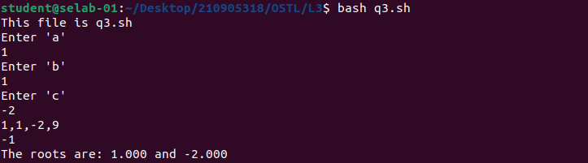
4)Find the factorial of a given number.

echo "Enter a number"
read n
f=1
i=1
while [ $i -lt $n ]
do
f=$(($f*$i))
i=$(($i+1))
done
f=$(($f*$n))
echo "Factorial is" $f

