CivicLink 2.0 - Smart Citizen Complaint & Grievance Reporting System

Developed By:
Anirudh Sharma
B.Tech - Computer Engineering
NIMIS, Navi Mumbai
Under the appreciation of:
Dr. Preeti Gupta, Associate Dean, NIMIS

Project Overview
CivicLink 2.0 is an innovative mobile and web-based system designed to simplify the process of reporting and managing civic issues within a city. Citizens can report local problems like potholes, garbage collection delays, streetlight faults, and water leaks directly through a mobile app. Each report includes a photo, description, and GPS location, which is instantly sent to the concerned municipal department via a centralized web dashboard.

Objectives
- To enable quick and transparent communication between citizens and municipal authorities.
- To automate issue tracking and monitoring through a digital dashboard.
- To encourage civic participation and accountability in public service management.

System Architecture
[ Citizen App ] ⇄ [ Node.js Server ] ⇄ [ MySQL Database ] ⇄ [ Admin Website ]

Modules
- User Authentication - Login via Email or OTP (Phone-based).
- Issue Reporting - Add issue with photo, category, description, and GPS coordinates.
- My Reports - View user submitted issues and their current status.
- Leaderboard - Displays top contributors to encourage engagement.
- Admin Dashboard - Web portal for viewing, managing, and resolving complaints.

Technologies Used
Programming Language: Java, JavaScript
Frontend (Mobile): Android XML, Material Design
Backend: Node.js, Express.js
Database: MySQL
Libraries / Frameworks: Retrofit, Multer, Bcrypt.js, MySQL2, dotenv
Tools: Android Studio, VS Code, Postman, MySQL Workbench
Frontend (Web): HTML, CSS, JavaScript

Key Features
- OTP-based secure user authentication
- Real-time issue reporting with image and GPS data
- Centralized database for all complaints
- Interactive leaderboard to promote civic engagement
- Web-based admin panel for authorities to monitor issues

App Interface
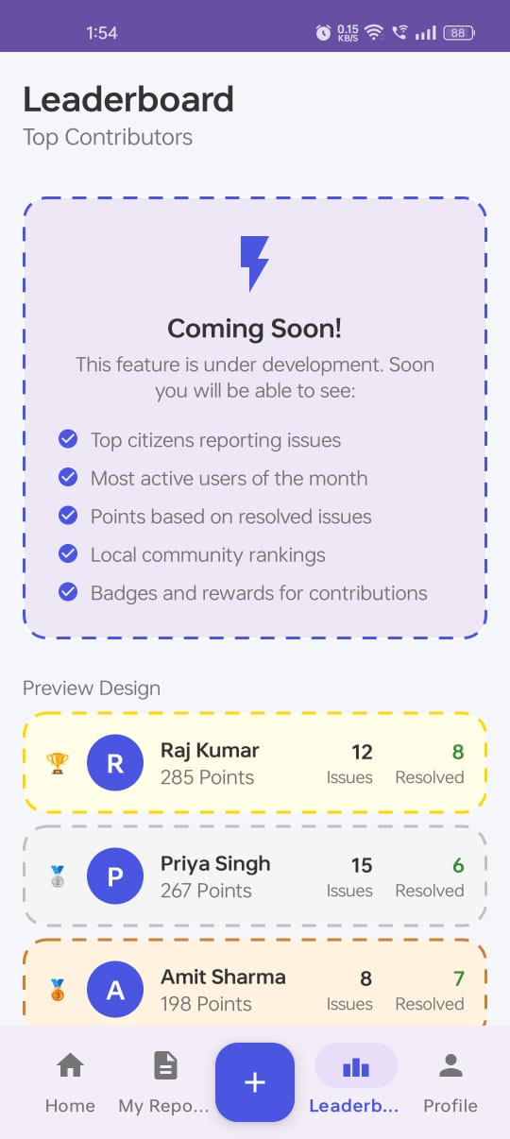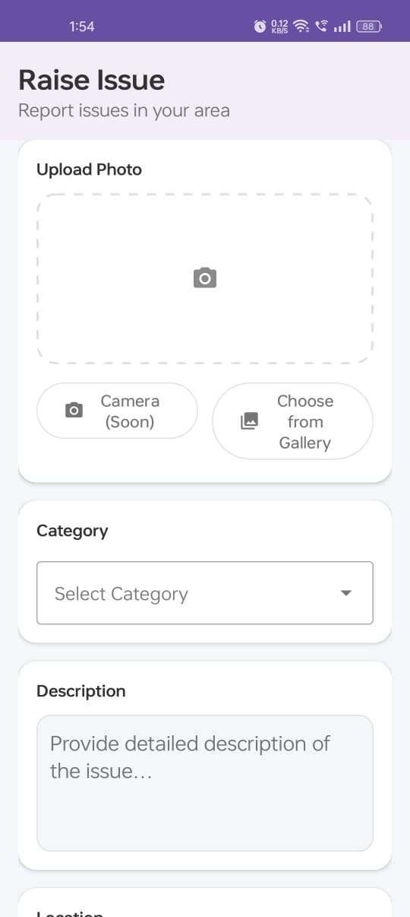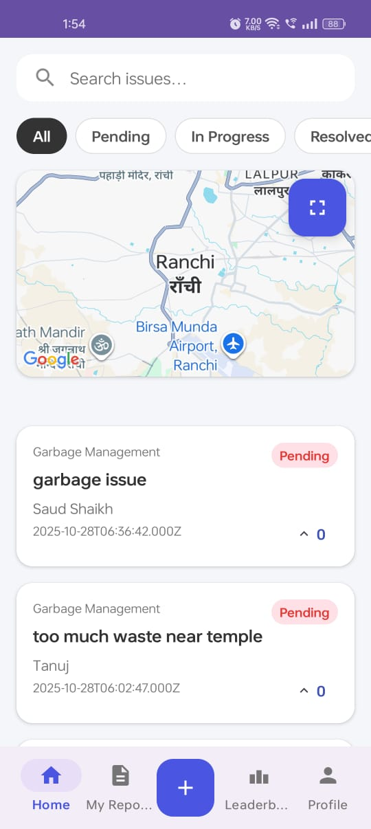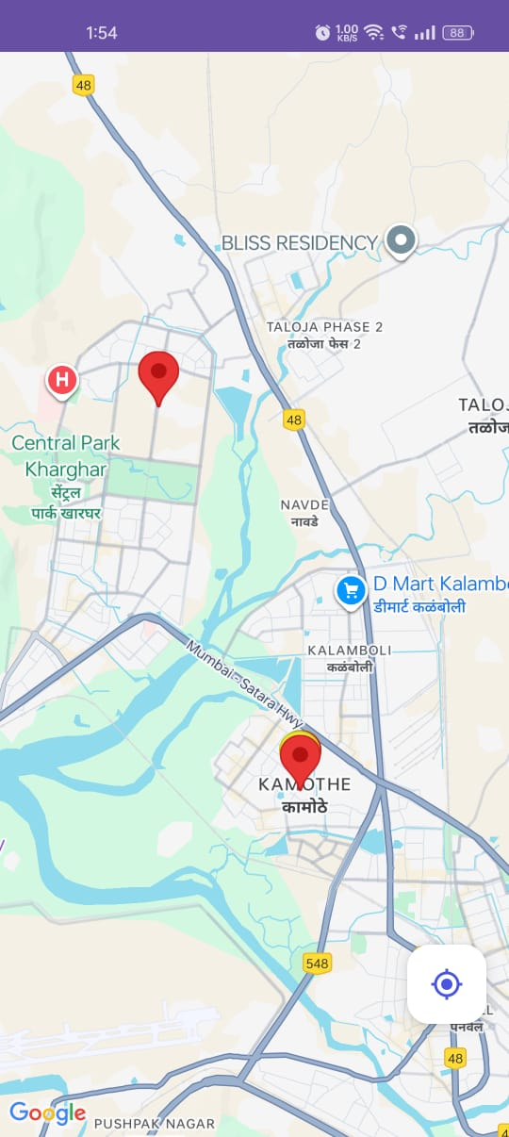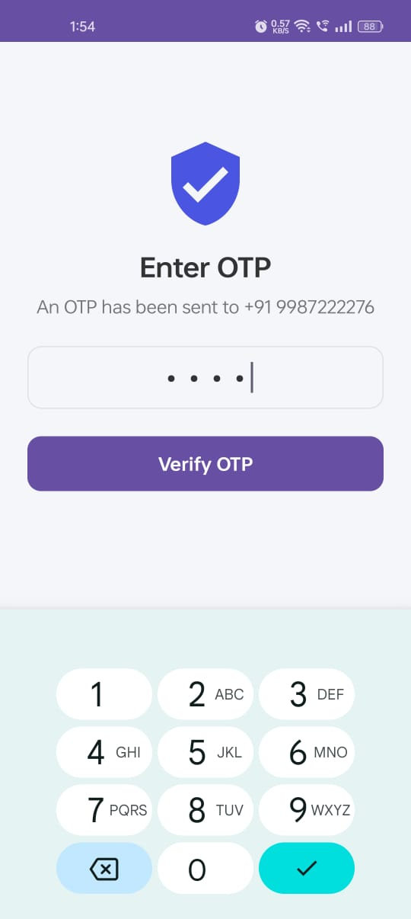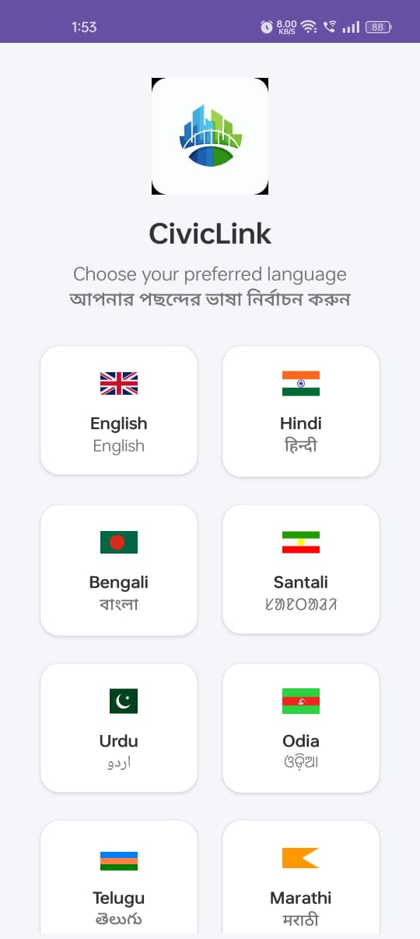

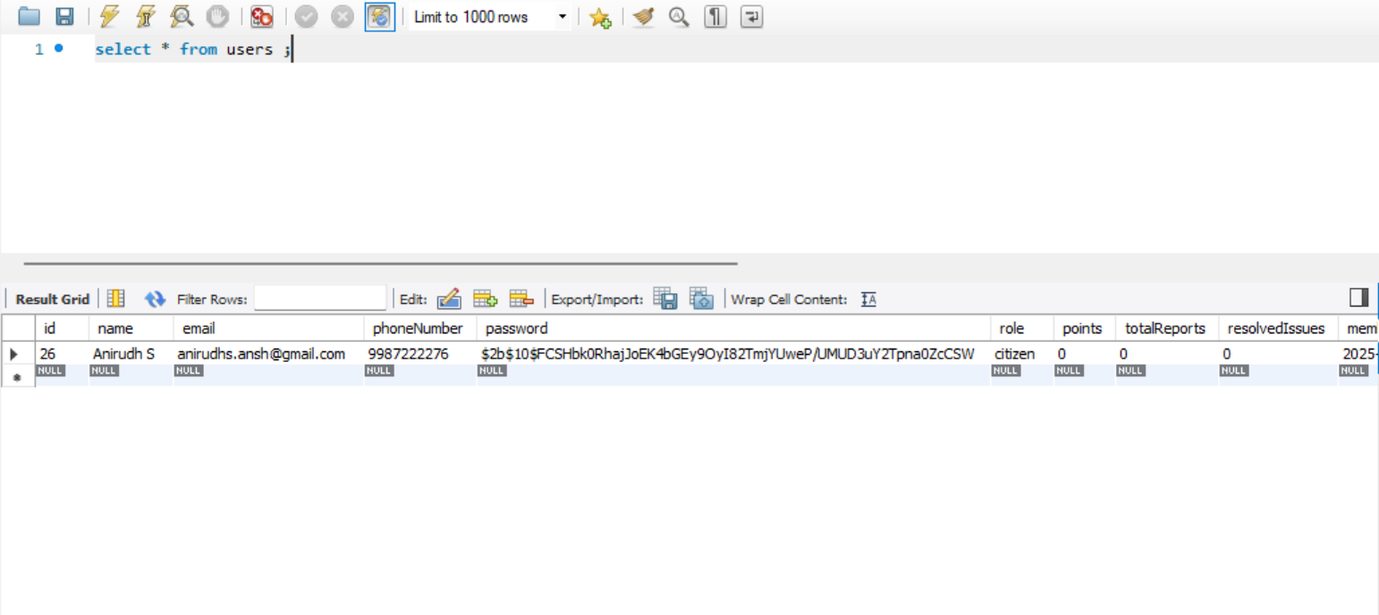
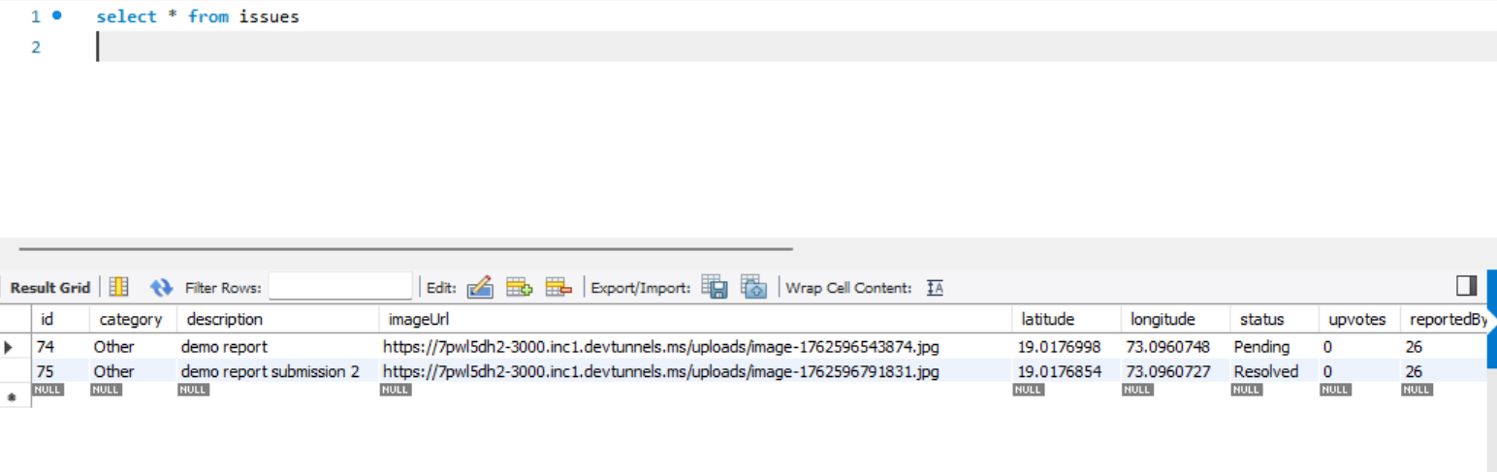

Contact
Anirudh Sharma
B.Tech - Computer Engineering
NIMIS, Navi Mumbai
Email: anirudhs.ansh@gmail.com
Phone: 9987222276

"CivicLink 2.0 demonstrates a creative and impactful approach to digital governance. I appreciate Anirudh's initiative in developing a scalable solution for civic issue management."
- Dr. Preeti Gupta, Associate Dean, NIMIS

