ADS-1 FINAL SUBMISSION.docx

--- Anirudh chevva

Submission date: 10-Nov-2023

Submission ID: 22101110

File name: ADS-1FINAL-SUBMISSION

Word count:205, Character count:2251

Data Visualization

Data source: <http://data.un.org/Data.aspx?d=ComTrade&f=_l1Code%3a51>

# Export Trend Comparison

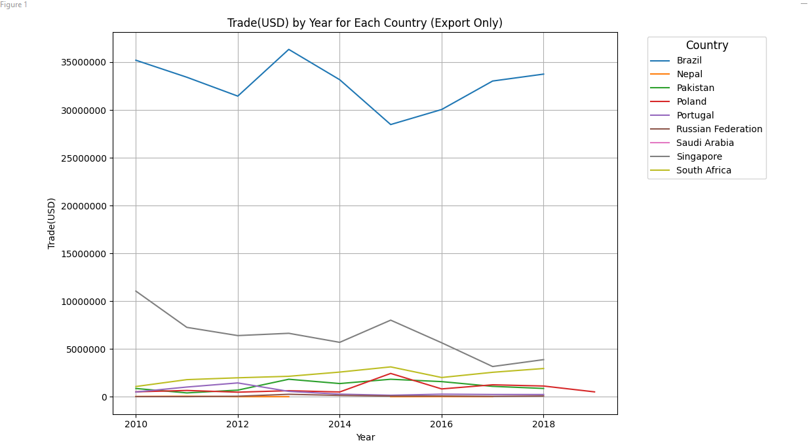

The graph clearly shows that the remaining nations—South Africa, Pakistan, and Russia, among others—maintain comparatively low export levels that vary from 0 to 5000000. A fascinating story emerges as Brazil sees a notable uptick after 2016, indicating a spike in silk export activities. On the other hand, Singapore's line declined within the same time frame, indicating a decline in its performance related to silk exports.

The capacity of the line chart to condense complicated information into an understandable narrative makes it a valuable tool for displaying trading data. The data's historical arrangement enables stakeholders to see trends, including Singapore's decline and Brazil's post-2016 increase, providing vital information for analysts, corporations, and governments. When a line chart tells a story, it helps decision-makers recognize critical points, link events to changes in the market, and create well-thought-out plans of action.

# Quantity Based Grouped Comparison

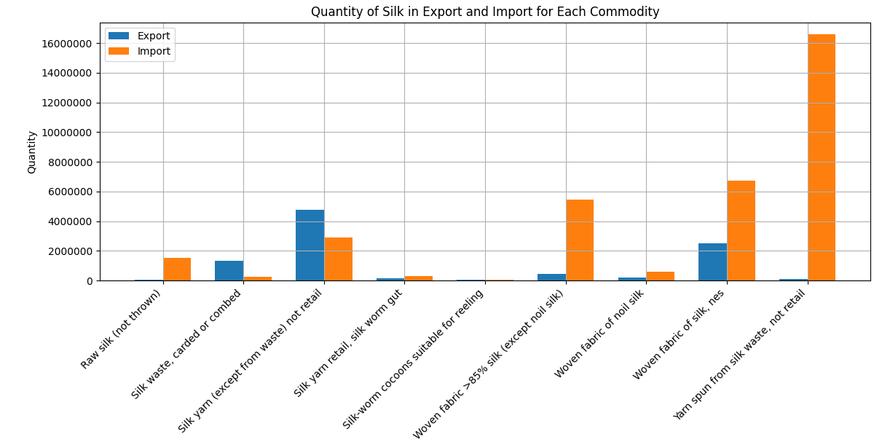

With its ability to compare import and export volumes for different types of silk commodities side by side, the grouped bar chart proves to be an effective tool for analyzing the dynamics of the silk trade. The large differences between import and export amounts are instantly seen in this graphic story. Silk yarn takes the lead and stands out as the most imported good, while silk yarn ranks first in terms of the amount exported.

The graph reveals a complex tale of market needs and trade imbalances. Yarn spun from silk, with its tall import bar, indicates a strong demand for this specific good on the international scene. In the meanwhile, the popularity of silk yarn in export amounts highlights exporters' strength in the market and competitive edge with regard to this particular silk product.

Because it makes direct comparisons easier, the grouped bar chart is invaluable in this situation. The placement of the bars side by side enables decision-makers to spot trends, recognize anomalies, and make well-informed choices. The analytical procedure is streamlined by the visual depiction, which provides a rapid reference for comprehending the relative magnitudes of import and export volumes across various silk commodities.

# Brazil's Top 3 Exports

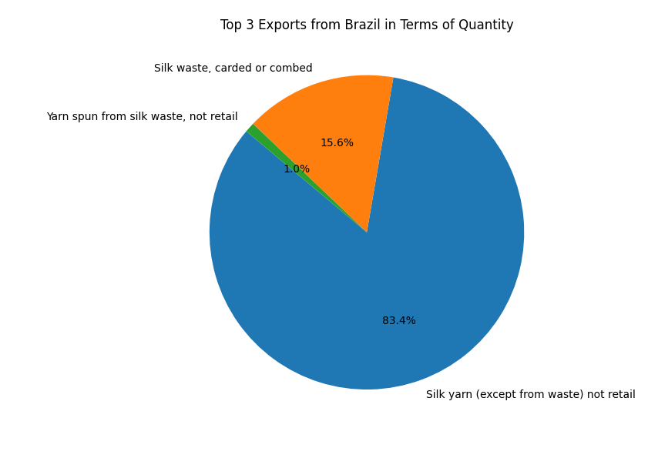The pie chart illustrates the proportionate distribution of Brazil's silk exports across different commodities and provides an engaging visual story. With an astounding 85% of the export market share, Silk Yarn Non-Retail is clearly in the lead in this case. This product has become the mainstay of Brazil's silk export industry. Yarn Spun, on the other hand, makes up a significantly lower portion, highlighting its comparatively smaller importance in the export portfolio as a whole. Pie charts are powerful tools for proportional analysis because they can clearly show the relative sizes of various components within a whole. Each commodity's significance may be quickly understood by stakeholders since each slice's size corresponds to its percentage of the export market. In this instance, the pie chart provides a clear and succinct summary of Brazil's export goals in the silk sector by illuminating the dominant position of Silk Yarn Non-Retail.

Summing it up the pie chart is a valuable tool in proportional analysis because it provides a concise representation of how quantities are distributed within a whole. Its significance stems from its ability to condense complex data into a visually simple manner, enabling stakeholders to make defensible judgments grounded in a clear grasp of proportionate relationships.