CSI-471/571: Introduction to Computer Vision
Homework 1 — Basic Image Processing
Name: Anirudh Amuda
ID: 001674734
Collaborators: None
All code written in Python 3 using numpy, scikit-image (skimage), and matplotlib.
Note on dolphins.jpg: this file was not included in the homework data and was not available, so Problem 6a's first sub-part (window copy, 180-degree rotation, and re-insertion) is instead demonstrated on quart.jpg, which is large enough to contain the same [135,135]->[220,180] window. The algorithm itself (region copy -> 180-degree rotation -> paste back) is identical and would run unchanged on the real dolphins.jpg (see the DOLPHINS_FILE variable at the top of hw1_solution.py) if it becomes available. Problem 7b uses two personal photos (photo1.png, photo2.png) in place of new digital-camera photos, which satisfies the assignment's intent of using two of the student's own pictures.

Problem 1 — Thresholding (5 pts)
quart.jpg was thresholded pixel-by-pixel: for each pixel, if its intensity is greater than a threshold TH it is set to 0 (black), otherwise it is set to 255 (white). Looking at the image histogram, the background paper forms a very strong peak around 215-255 while the four coins span a broad range from about 60 to 210 (with a few bright specular highlights on the metal). This gives a clean separation point around TH = 210, which cleanly turns the background black and the coins white.
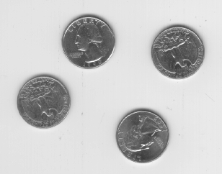  Original quart.jpg | 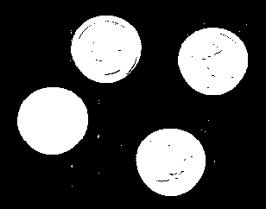  Thresholded, TH = 210 (chosen value)
Effect of TH — lower thresholds keep more of the coin (including darker shadow/engraved regions), higher thresholds erode the coin silhouette:
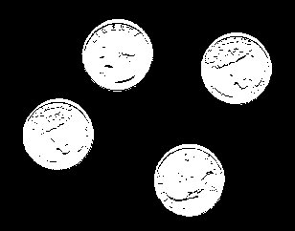  TH = 150 (too low — loses shadow detail) | 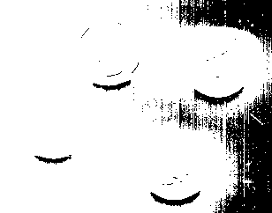  TH = 230 (too high — erodes coin edges)
Modules/functions used: skimage.io.imread/imsave, numpy (array indexing), an explicit nested for-loop over every pixel as specified in the handout.

Problem 2 — Bi-level Thresholding (5 pts)
snowman.jpg's pixel histogram has three clusters: the black floor (~0-30), Bob the snowman's body (~150-170), and the light-gray background/title text region (~200-230). Setting I0 = 130 and I1 = 190 keeps only the snowman band as white (255) and sends everything else to black (0).
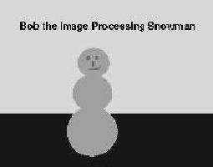  Original snowman.jpg | 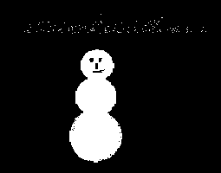  Bi-level threshold, I0=130, I1=190
Observation: a thin, faint outline of the title text ("Bob the Image Processing Snowman") also appears in the result. This is because the text is anti-aliased against the light background, so a ring of pixels along each letter's edge takes on intermediate gray values that happen to fall inside the same [I0, I1] band as the snowman's body. Global intensity-based thresholding cannot distinguish these two unrelated regions when their intensities coincide; a connected-component / region-growing step (keeping only the largest connected blob) would remove this artifact if a perfectly clean mask were required.
Modules/functions used: skimage.io.imread/imsave, numpy.where.

Problem 3 — Pixel-wise Operations (5 pts)
Inversion: out = 255 - I. Because I is always within [0,255], 255-I is also always within [0,255], so no clipping/shifting was needed here. Brightness changes were tried two ways: multiplicatively (x1.10 / x0.90, i.e. ±10%) and additively (±I0, with I0 = 25); both were computed in a signed/float buffer first and then clipped to [0,255] before casting back to uint8, so bright pixels don't wrap around (overflow) and dark pixels don't go negative.
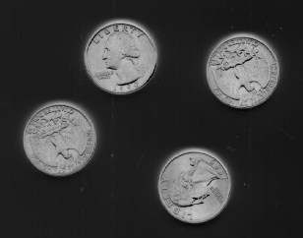  Inverted (255 - I) | 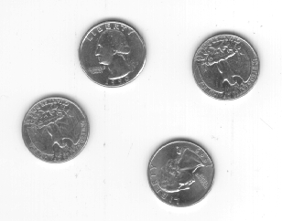  +10% brighter (x1.10) | 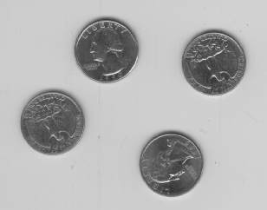  -10% darker (x0.90)
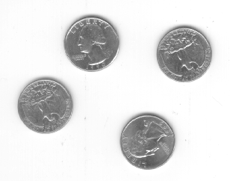  +25 brighter (additive, I0=25) | 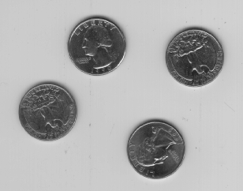  -25 darker (additive, I0=25)
The additive version (±I0) shifts every pixel by the same fixed amount, so it visibly brightens/darkens flat regions (the background) more noticeably in absolute terms, while the multiplicative version scales bright pixels more than dark ones, preserving black (0) exactly. Both required clipping to keep values in [0,255]; without it, bright highlight pixels near 255 would overflow past 255 (wrap to a small number in uint8 arithmetic) when adding I0.
Modules/functions used: numpy (astype, clip, arithmetic on int16 buffers), skimage.io.

Problem 4 — Quantization (5 pts)
Each pixel's 256 possible intensities were grouped into equal-width bins and mapped to the bin's midpoint (e.g. for 8 levels: 0-31 -> 16, 32-63 -> 48, ..., 224-255 -> 240).
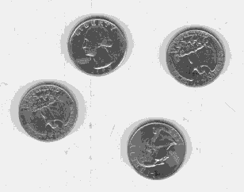  8 levels | 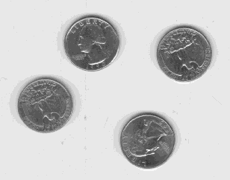  16 levels
Observation: with only 8 levels, false contouring (banding) is clearly visible on the coins' curved, smoothly-shaded surfaces — the smooth gradient breaks into visible discrete rings. At 16 levels the banding is much less noticeable because each step is only 16 gray levels instead of 32, so it takes a much larger discontinuity for the eye to detect a boundary between adjacent bins. This demonstrates the classic quantization/false-contouring trade-off between file size (fewer levels = fewer bits/pixel) and perceived image quality.
Modules/functions used: numpy (integer division //, minimum, astype).

Problem 5 — Subsampling & Resampling (15 pts)

5a. Image Subsampling (skip every other pixel)
Original, 308x242 | 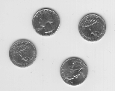  Subsampled, 154x121 (1/4 area)
Taking every other row and column exactly halves each dimension, giving an output image with 1/4 the pixel count/area of the original, as expected. No interpolation/averaging is performed, so this is prone to aliasing on fine, high-frequency detail (visible as slight jaggedness on the coin edges and lettering).

5b. Image Re-sampling with Bilinear Interpolation
A bilinear-interpolation resize function was implemented from scratch (not skimage.transform.resize): for every destination pixel, the corresponding continuous source coordinate is computed, and the output value is a weighted average of the 4 nearest source pixels. quart.jpg (308x242) was resized to an arbitrary non-power-of-two resolution of 1000x500, and again to 600x400 to show a different aspect ratio (non-uniform horizontal/vertical scale factors).
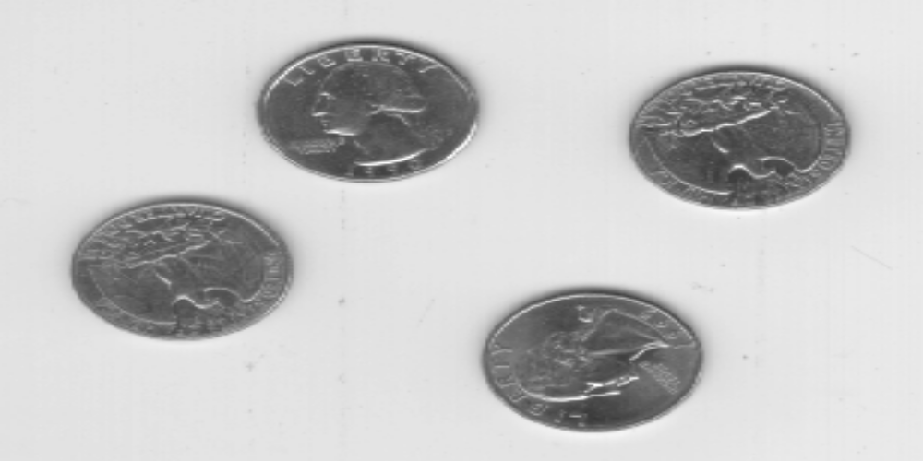
Resized to 1000x500 (bilinear)
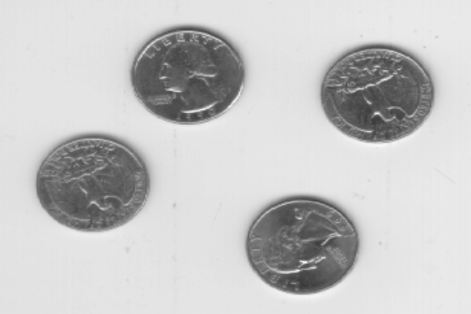
Resized to 600x400 (bilinear, different aspect ratio)
Modules/functions used: numpy (floor, clipping, weighted sums), skimage.io; bilinear_resize() is a hand-written function (see hw1_solution.py).

Problem 6 — Rotation (41 pts)

6a. Region Copy, 180-degree Rotation & Mirror (dolphins.jpg)
dolphins.jpg was not available, so this sub-part uses quart.jpg as a substitute image (same algorithm: copy the window, rotate it 180 degrees, paste it back).
The window [135,135] -> [220,180] (x0,y0 -> x1,y1) was copied out of the image, rotated 180 degrees (equivalent to reversing both the row and column order of the patch — the simplified form of the rotation-matrix formula when theta = 180), and pasted back into the same location in the original.
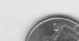  Original patch | 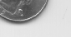  Patch rotated 180deg | 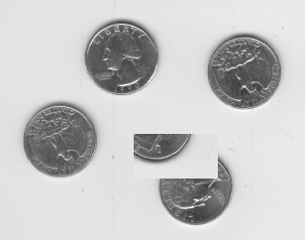  Re-inserted into image (quart.jpg substitute)

6a (cont.) — 90-degree Rotation to Patch rotate.jpg
The window [44,95] -> [104,125] from rotate.jpg (the light-gray rectangle) was copied, rotated 90 degrees clockwise (the simplified rotation-matrix formula for theta=90, implemented as a transpose followed by a column flip), and moved into the black rectangular hole in the top-right corner of the same image (the target location was located automatically by detecting the near-black region, since it matches the rotated patch's footprint exactly).
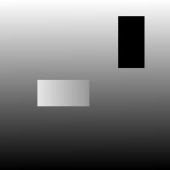  Original rotate.jpg | Extracted patch, rotated 90deg CW | 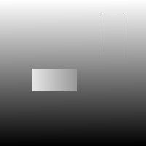  Hole filled seamlessly

6b. Forward Rotation with Rounding
lenag.png (512x512) was rotated 35 degrees CCW using FORWARD mapping: for every source pixel, its destination location is computed with the rotation matrix about the image center and rounded to the nearest integer pixel. The output canvas was padded to 714x714 (ceil(W|cos 35|+H|sin 35|) on each side) so the entire rotated image fits without cropping.
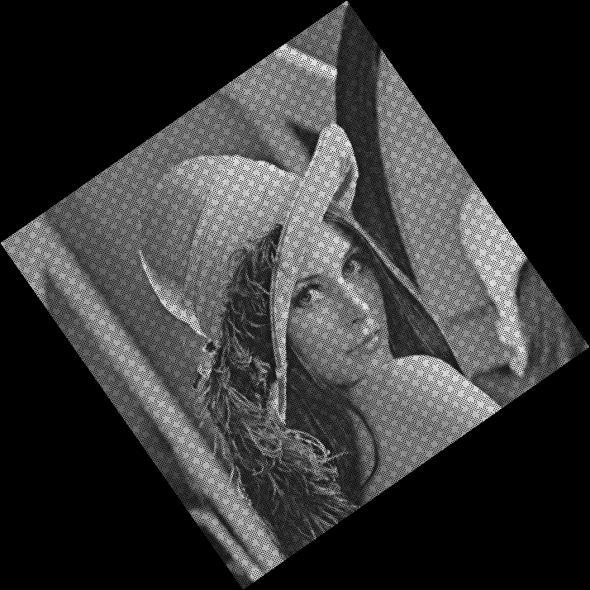
lenagr.png — forward-mapped, rounded, 35deg CCW
Because forward mapping only visits each of the 262,144 source pixels once and several source pixels can round to the same destination pixel (or none at all, since the rotated image has more destination positions per unit area near its center than a 1-to-1 mapping can fill), roughly 56% of the destination canvas is left unfilled (black). Around 48% of that is unavoidable background outside the rotated square's silhouette (present in any correct rotation, forward or backward); the remaining ~8% shows up as the visible speckled/pinhole pattern inside the rotated Lena silhouette itself — the classic artifact of forward/nearest rounding.

6c. Rotation with Bilinear Interpolation (Backward Mapping)
The same 35-degree CCW rotation was repeated using BACKWARD mapping instead: for every destination pixel, the inverse rotation is used to back-project into the source image, and the value is bilinearly interpolated from the 4 nearest source pixels. This visits every destination pixel exactly once, so there are no holes.
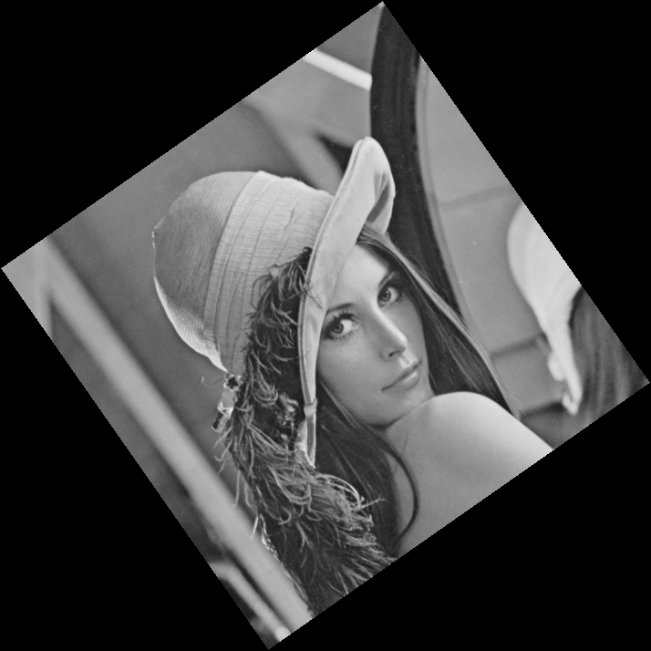
Backward-mapped + bilinear interpolation, 35deg CCW

6d. Residual Examination
The 35deg-CCW bilinear result (6c) was rotated back 35 degrees CW with the same backward+bilinear method and center-cropped back to the original 512x512 footprint (lenag2.png), then differenced against the original lenag.png.
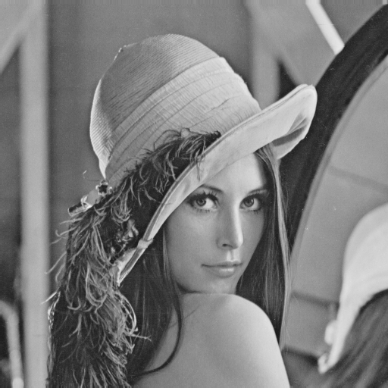  Original lenag.png | 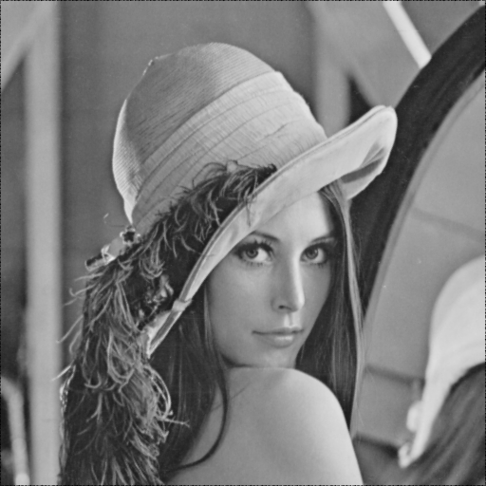  lenag2.png (rotated CCW then back CW) | 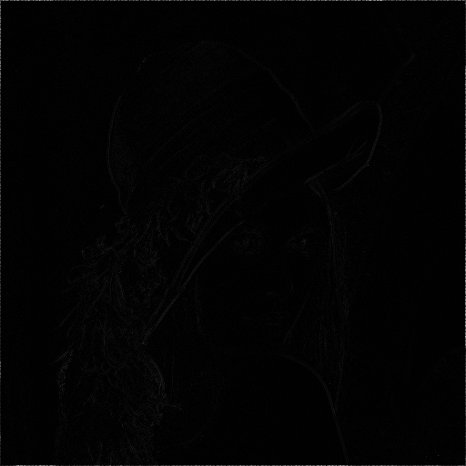  |difference| (contrast-stretched: mean=2.56, max=197)
The two align well: the mean absolute residual is only 2.56 gray levels (out of 255), confirming the round trip is nearly lossless. The residual is not exactly zero because two successive bilinear interpolation passes each introduce a small amount of low-pass blurring, and pixels near the border of the (now twice-rotated) square are the most affected, which is where the max error of 197 occurs. For comparison, repeating the same round trip using the forward/rounded (6b) result instead gives a much worse mean residual of 41.0, since the holes from forward mapping compound across the two rotations — concrete evidence that backward-mapping + bilinear interpolation is the correct approach for image resampling/rotation.
Modules/functions used: numpy (trig functions, floor, clipping), skimage.io; rotate_forward_nearest() and rotate_backward_bilinear() are hand-written (see hw1_solution.py).

Problem 7 — Logical & Arithmetic Operations (24 pts)

7a. Logical Operations on Binary Images
things1.png and things2.png were binarized (threshold at 128) with the drawn objects mapped to 255 (foreground/True) and the white paper background mapped to 0 (background/False) -- note this is the opposite of the images' raw pixel brightness (ink is dark, paper is bright), so this inversion is necessary for AND/OR/XOR to mean "is there an object here" rather than "is there white paper here". AND, OR and XOR were then applied with numpy's bitwise operators.
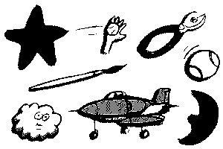  things1.png (orig) | 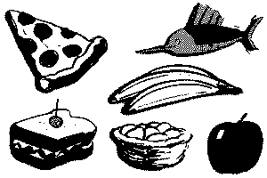  things2.png (orig)
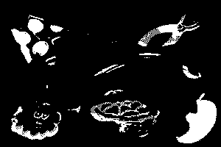  AND (object overlap) | 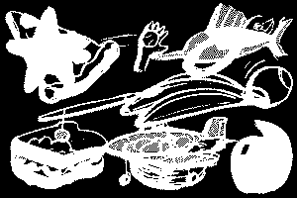  OR (union of all objects) |   XOR (objects in exactly one image)
AND keeps only pixels where both images' line-art coincide (10.2% of the frame -- less than either image alone, as expected for an intersection). OR shows the union of every object outline from both images. XOR looks almost identical to OR here because the two drawings barely overlap, so nearly every "object" pixel belongs to exactly one image; the small areas that differ between OR and XOR are exactly the AND region, which XOR removes.

7b. Pixel Arithmetic on Two Personal Photos
Two personal photos were converted to grayscale (skimage.color.rgb2gray, then rescaled from [0,1] float to [0,255] uint8, matching the conversion shown in color_image.py) and used for ADDITION, SUBTRACTION, MULTIPLICATION and DIVISION. Both were already the same pixel dimensions (532x945), so no resizing was required. All four operations were computed with a single vectorized numpy expression over the whole array (not a per-pixel Python for-loop), which is dramatically faster.
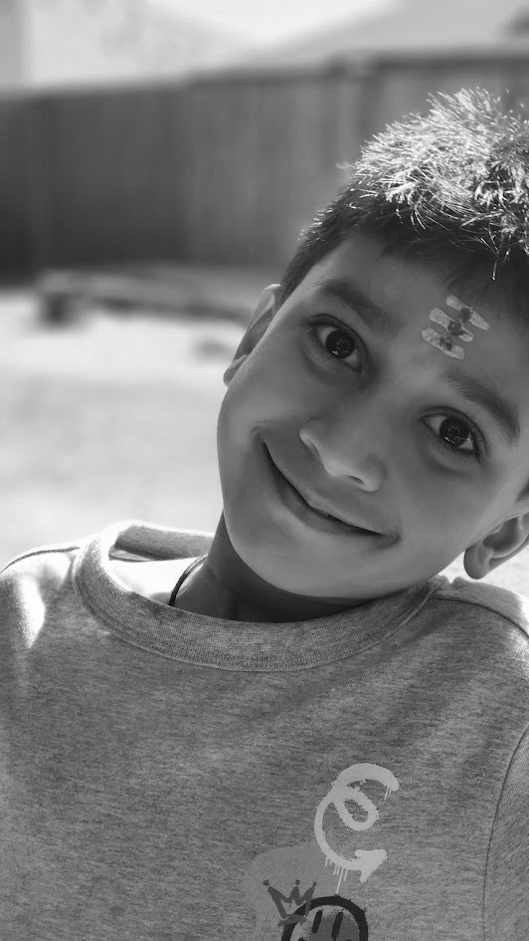  Image A (grayscale) | 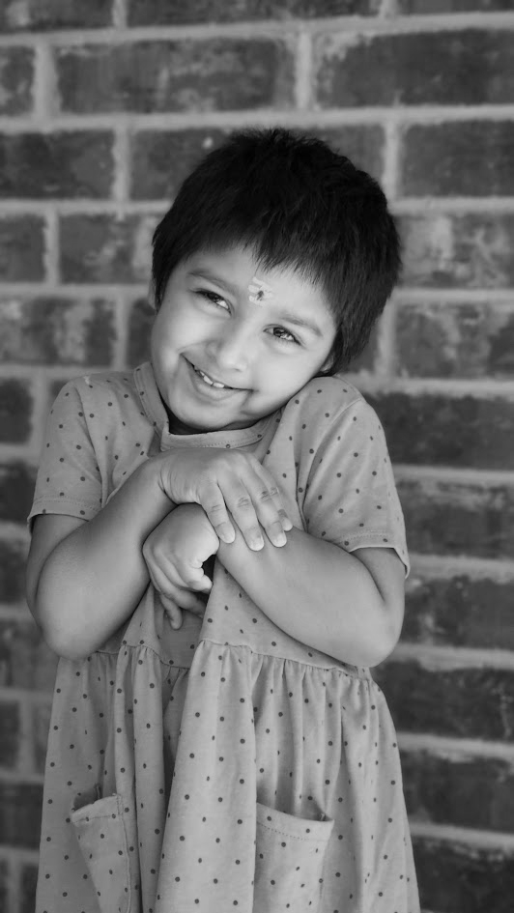  Image B (grayscale)
For addition and subtraction, C = A ± k*B with k = 0.5 was used to control B's contribution and avoid the blend being dominated by one image. Pixel values were first promoted to float32 before the arithmetic (to avoid uint8 overflow/wraparound, e.g. 200+150 would overflow and wrap to 94 in raw uint8 arithmetic) and the final result was clipped to [0,255] before casting back to uint8. Multiplication was rescaled by dividing by 255 after the product (since two uint8 values as large as 255x255=65025 would otherwise far exceed the valid range) and division used B+1 in the denominator to avoid divide-by-zero, with the result rescaled by its own max value into the full [0,255] display range.
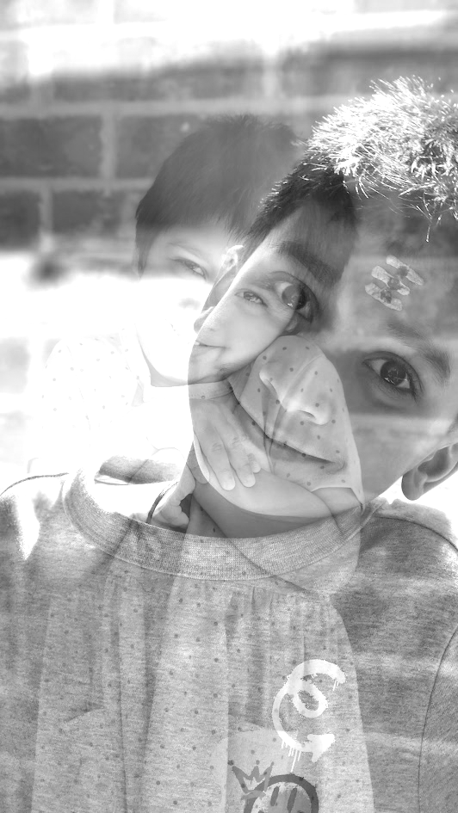  ADD: C = A + 0.5*B | 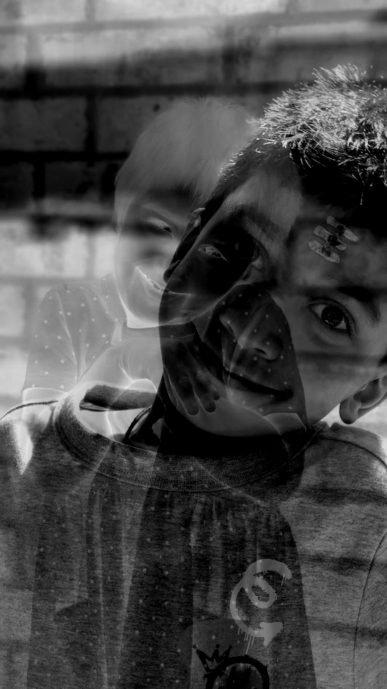  SUB: C = A - 0.5*B
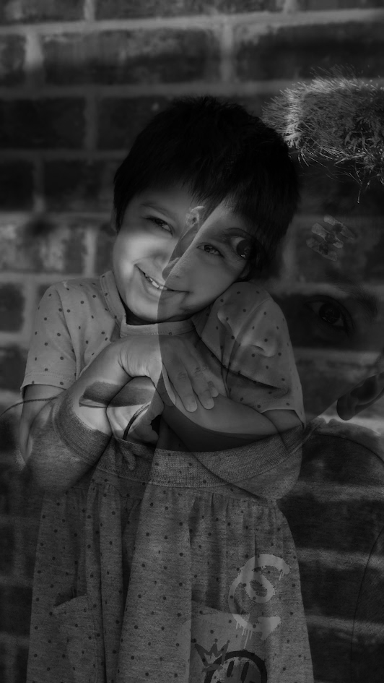  MULTIPLY: C = A*B / 255 | 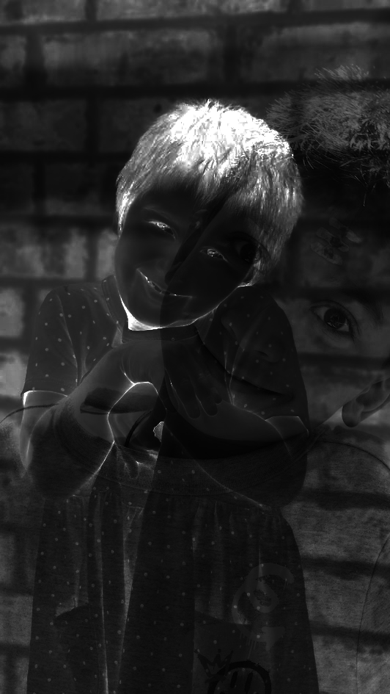  DIVIDE: C = A / (B+1), rescaled
Modules/functions used: skimage.io, skimage.color.rgb2gray, numpy (astype float32, clip, vectorized arithmetic).

