**INTRODUCTION TO ELECTRICAL AND ELECTRONICS ENGINEERING**

### A THESIS

### Submitted by

Anirudh S Varrier (CB.SC.U4AIE23113)

Nitin Krishna (CB.SC.U4AIE23156)

Abhay Rohit (CB.SC.U4AIE23173)

Gaurav Mahesh (CB.SC.U4AIE23176)

### *in partial fulfillment for the award of the degree of*

### **BACHELOR OF TECHNOLOGY**

### **IN**

### **CSE(AI)**



**Centre for Computational Engineering and Networking**

**AMRITA SCHOOL OF ARTIFICIAL INTELLIGENCE**

## **AMRITA VISHWA VIDYAPEETHAM**

COIMBATORE - 641 112 (INDIA)

**JUNE - 2024**

## **AMRITA SCHOOL OF ARTIFICIAL INTELLIGENCE**

## **AMRITA VISHWA VIDYAPEETHAM**

## **COIMBATORE - 641 112**



# **BONAFIDE CERTIFICATE**

# This is to certify that the thesis entitled “EEG Signal Analysis and Classification” submitted by Anirudh S Varrier (CB.SC.U4AIE23113), Nitin Krishna (CB.SC.U4AIE23156), Abhay Rohit (CB.SC.U4AIE23173), Gaurav Mahesh (CB.SC.U4AIE23176), for the award of the Degree of Bachelor of Technology in the “CSE(AI)” is a Bonafide record of the work carried out by her under our guidance and supervision at Amrita School of Artificial Intelligence, Coimbatore.

# **Ms. Ambika PS**

# Project Guide

# **Dr. K.P.Soman**

# Professor and Head CEN

# *Submitted for the university examination held on ______*

# 

## **AMRITA SCHOOL OF ARTIFICIAL INTELLIGENCE**

## **AMRITA VISHWA VIDYAPEETHAM**

## **COIMBATORE - 641 112**

### **DECLARATION**

I, Anirudh S Varrier (CB.SC.U4AIE23113), Nitin Krishna (CB.SC.U4AIE23156), Abhay Rohit (CB.SC.U4AIE23173), Gaurav Mahesh (CB.SC.U4AIE23176), hereby declare that this thesis entitled “EEG Signal Classification and Analysis”, is the record of the original work done by me under the guidance of Ms. Ambika PS, Assistant Professor, Centre for Computational Engineering and Networking, Amrita School of Artificial Intelligence, Coimbatore. To the best of my knowledge this work has not formed the basis for the award of any degree/diploma/ associate ship/fellowship/or a similar award to any candidate in any University.

**Place: Coimbatore**

**Date:04-06-2024**  **Signature of the Student**

## CONTENT

Acknowledgement

Abstract

Introduction

Dataset

Proposed Methodology

Methodology

Inference

Result

Conclusion

Future Work

Bibliography

## **ACKNOWLEDGMENT**

We would like to express our special thanks of gratitude to our teacher (MS. Ambika P S ma’am), who gave us the golden opportunity to do this wonderful project on the topic (EEG Signal Classification and Analysis ), which also helped us in doing a lot of Research and we came to know about so many new things. We are thankful for the opportunity given.

We would also like to thank our group members, as without their cooperation, we would not have been able to complete the project within the prescribed time.

ABSTRACT

The project explores the signals that are given out by the brain and what we can understand from them. The signals can be comprehended in the form of FMRI scans or EEG signals. The objective of this project is to analyze EEG signals and decode the movements the body is doing.

The project can be done by first getting the required dataset. Deep analysis of the dataset must be carried out before attempting to start with the coding of the project. Then, the data must be gotten into a form which the machine can understand (Preprocessing). A machine learning algorithm will be made which will analyze the data and predict / classify which type of muscle motion it is.

The results of the project will include how well the algorithm can understand the data and predict the possible movement.

This project will be helpful in making BCI, which can help people with disabilities perform motions which they usually cannot. This project will also contribute to a deeper understanding of the signals the brain produces.

Introduction

Part I - The brain

The brain is one of the most complex organs in the entire human body. Even after a lot of technological advancements, we still do not know how it functions, how it stores information and how it thinks. We now know that the brain sends instructions to all parts of the body through electrical impulses through neurons which are cells specific to the neural system of the body.

Part II – Signals from the Brain

The brain produces electrical pulses which help in transmitting signal / commands to all parts of the body. The signals which are sent out can be recorded with the help of sophisticated equipment. The recordings are of diverse types such as FMRI signals, EEG signals etc. These signals help in analyzing the function of the brain and what parts of it are being active.

Part III – EEG Signals

EEG signals are a measurement of potentials that reflect the electrical activities of a human brain. The EEG is widely used by scientists and doctors to diagnose neurological disorders. During the EEG test, several electrodes are placed on the surface of the scalp and each electrode is connected to an amplifier. In the EEG measurement, the cerebral cortex is the most relevant structure as it is responsible for higher order cognitive tasks, such as problem solving, language comprehension, movement, and processing of complex visual information. Due to its surface position, the electrical activity of the cerebral cortex has the greatest influence on EEG recordings.

The Dataset

The BCI Competition IV Dataset 2a is a dataset that collected EEG signals from 22 electrodes and recorded the locations of three electrooculogram (EOG) scalp electrodes for nine subjects. During the experiment, the subjects were asked to perform four different motor imagery tasks involving the left hand, right hand, foot, and tongue. Subjects sat in a comfortable chair and completed sessions consisting of six runs, with 48 motor imagery trials per run. In total, each session had 288 trials, with 72 trials performed for each type of motor imagery task.

In the experiment, a total of 22 scalp electrodes based on the international 10–20 system were used, including Fz, FC3, FC1, FCz, FC2, FC4, C5, C3, C1, Cz, C2, C4, C6, CP3, CP1, CPz, CP2, CP4, P1, Pz, P2, and POz, left mastoid reference, right mastoid grounding,

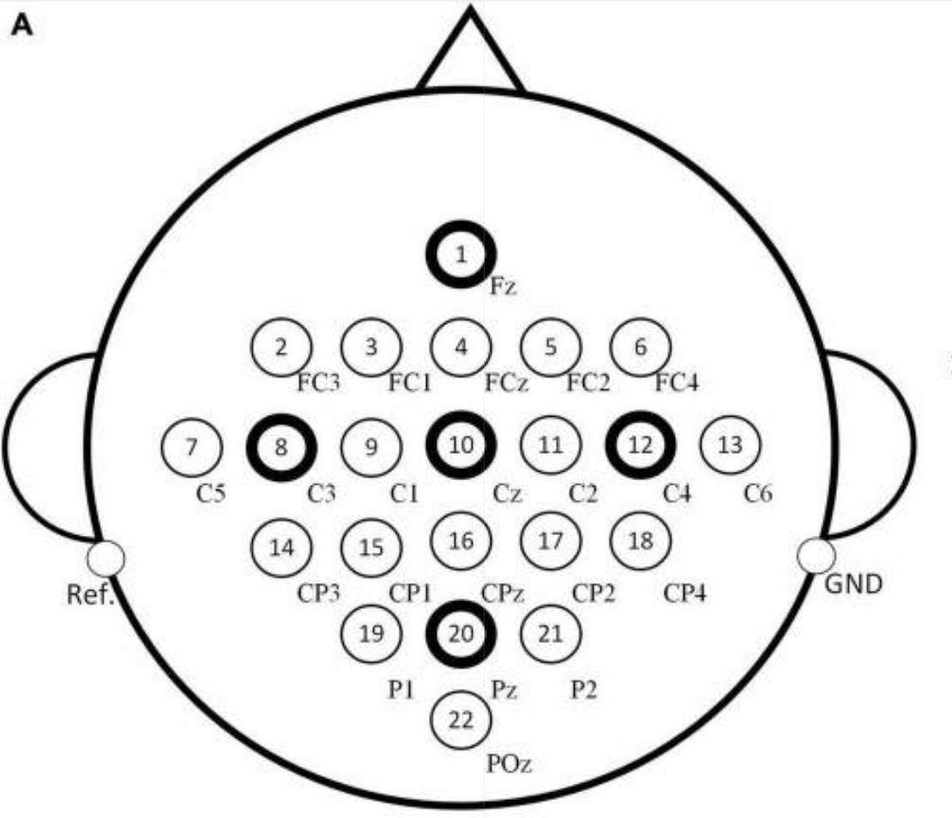

Proposed Methodology

Part I – Reading file

Originally, the method to work create a machine learning model that can classify the EEG Signals was by reading the CSV file containing the data using python, breaking the data into parts called chunks. Each chunk will be run through the VMD function to create 3 different IMFs for each channel.

Part II – Preprocessing

The above IMFs would be denoised using some noise removal algorithm as some of the data can be noisy. The empty values are filled in with the previous given value.

Part III – Feature Extraction

The arithmetic features for each beat / signal for each IMF for each channel. The motion of the body part was also mentioned along with it. The features and labels were appended to another Array.

Part IV – Scaling and Model

The Data would be scaled to make sure that all the values come under a certain range which makes it better for the model. Then the data is split into training and testing sets. The training set is used to train a model (Random Forest Classifier) and the testing set would be used to check the accuracy of the model.

Methodology

Part I –Getting Data

The CSV file containing all the data for all 22 channels was read and the data was collected based on the type of motion the human body performed during that time.

Part II – Processing Data

The EEG signals collected from the brain cannot be denoised as the data from the brain is very random and cannot be predicted perfectly unlike that of ECG signals. Therefore, the denoising of the data has not been performed here. The length of each EEG data is about 201 data points (1.7 seconds).

Part III – Feature Extraction

The arithmetic features were found for each signal of the EEG data. This was then put together with the rest of the features. This data will be used to train our machine learning model.

Part IV – Scaling and Resampling

DMD was then used to make the features better for the algorithm. The data would not be in the same range as the brain data is very random. Therefore, we scaled the data to fall within a particular range. Since the data can be a bit imbalanced, the SMOTE algorithm was used to resample the data.

Part V – Model

Many models such as SVM, Random Forest, Decision Tree etc. were used to determine how well the model was performing. The accuracy, precision, recall and F1 score were generated. The confusion matrix was also generated.

Inference

The highest recorded accuracy was 5%. This shows that the brain data is quite unpredictable and needs more advanced algorithms to classify it. When the data was just scaled, there was an accuracy of 31%. When it was scaled and resampled, the accuracy rose to 40%. When it was combined with DMD, the accuracy hit the highest of 57%.

Result

Model I: Histogram Boosting Classifier  
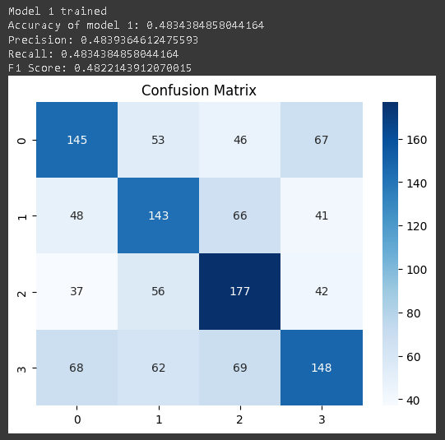  
Figure 1: Results of Histogram Boosting Classifier model

Model II: SVM  
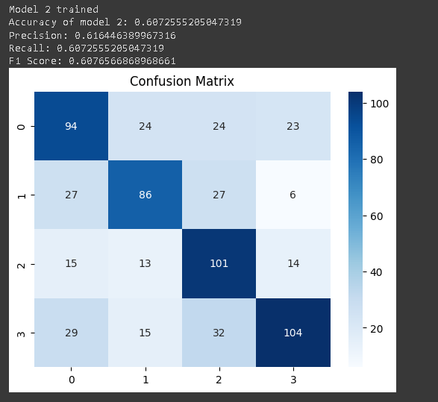

Figure 2: Results of SVM model

Model III: Random Forest  
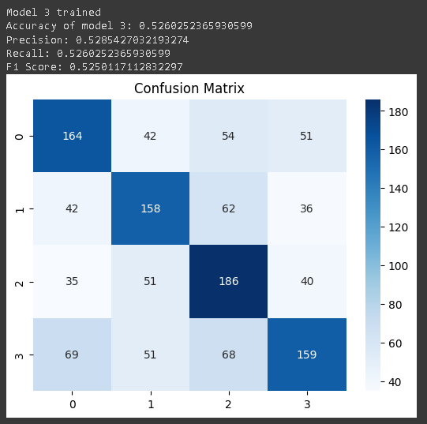

Model IV: Decision Tree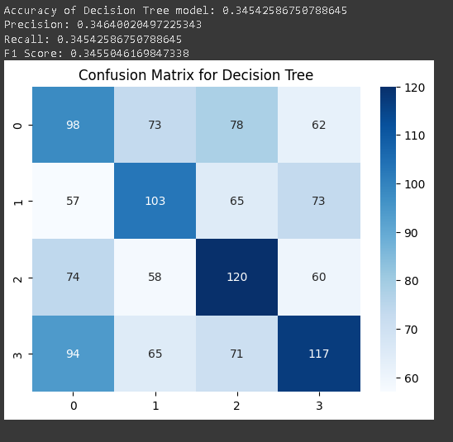

Conclusion

In this project, we tackled the challenging problem of classifying brain signal data from the BCI Competition IV Dataset 2a. Our approach integrated several advanced techniques, including Dynamic Mode Decomposition (DMD) for feature extraction, Synthetic Minority Over-sampling Technique (SMOTE) for balancing the dataset, and standard classification algorithms for building the final models. The performance of various classifiers was evaluated, with a focus on Random Forest and Support Vector Machine (SVM) classifiers.

Future Work

1. Explore in Deep Learning:

While traditional machine learning algorithms provide decent performance and accuracies, opting to do the project in deep learning might boost the model's accuracy to capture intricate patterns in brain data.

1. Real-Time Processing:

Future work could work on optimizing the models to work for real-time data, which is crucial in the application of BCI.

Bibliography

1. <https://www.bbci.de/competition/iv/>
2. <https://github.com/hanyoseob/python-DMD/blob/master/demo_DMD.py>
3. https://www.ncbi.nlm.nih.gov/pmc/articles/PMC10536894/