DIGITAL IMAGE PROCESSING

MINI PROJECT

TOPIC: PRE- PROCESSING OF MAMMOGRAPHY IMAGE FOR EARLY DETECTION OF BREAST CANCER.

## NAME: Anirudh Adiga

**ABSTRACT**

Breast cancer is one of the most prevalent causes of death among women worldwide. Hence, the early detection helps to save the life of the women. Mammography is the basic screening test for breast cancer. It consists of many artefacts, which negatively influences in detection of the breast cancer.

Therefore, removing artefacts and enhancing the image quality is a required process in Computer Aided Diagnosis (CAD) system. The accuracy and efficiency of the CAD is increased by providing exact Region of Interest (ROI). Extracting ROI is a challenging task in pre-processing because the presence of pectoral muscle influences the detection of abnormality. Here, the proposed show that the wiener filter and Contrast Limited Adaptive Histogram Equalization (CLAHE) techniques efficiently aids for enhancing the quality of the image, thereby it also removes the unwanted background and the pectoral muscle by using thresholding and modified region growing technique

respectively. Thus the proposed method is well suited for improving the quality of mammography image for Auto-CAD system.

# INTRODUCTION

Breast cancer ranks as second leading cause of death in women worldwide. According to American Cancer Society, about 1 in 8 women will have breast cancer in her lifetime and only 5% to 10% of breast cancers occur in women with clearly defined genetic link. Hence, the early detection will help to have better quality of life, economical treatment and mental peace of patient and family. With a low dose of X-ray imaging, mammography is most basic screening test for breast cancer and records better visualized internal details of the breast. Usually, mammography images consist of many artefacts and noises and makes medical images too difficult to detect and understand the cancer at the primary stages. Therefore, standardization of image quality and extraction of ROI is essential to limit the hunt for abnormalities. Pre-processing of mammography helps to identifies abnormal areas that cannot be experienced physically or visualized but can be detected through CAD. Imaging techniques play an important role in CAD. The CAD helps doctors and radiologists to diagnose and identify the abnormality quickly and easily. Here, the proposed method helps standardize the image quality and extracting the target ROI. By breast part extraction, muscle part removal and enhancement of mammogram. The proposed algorithm helps radiologist to diagnosis the disease more accurately and takes decision swiftly.

## PROPOSED METHOD:

The main purpose of a breast cancer CAD system is to help the radiologist and doctors to take decision swiftly. By providing exact ROI will help to identify abnormality. The proposed method works in three stages –

* The first step is to remove the background artefacts
* The second step is to reduce the pectoral muscle
* The digital mammography enhanced by using wiener filter and CLAHE

# BLOCK DIAGRAM

**Removal of Background**

**Extracted Breast Profile Binarizing with T= 0.1**

**Input Image**

**(in .jpeg; .jpg, .png)**

**Technique and seed point selected based on**

**orientation of image.**

**Removal of pectoral muscle**

**Enhancement of Image**

**Image quality improved by wiener filter and CLAHE**

**Extracted ROI**

**(Breast Profile)**

## ALGORITHMIC STEPS:

* STEP 1 – The image in the format of .jpg and .jpeg is inputted using

‘imread()’.

* STEP 2 - The original image is cropped and the black ground in the image is deleted. Image is binarized with threshold value 0.1 then the connected component organized in descending order to extract the largest blob which is the breast profile but consists of pectoral muscle.
* STEP 3 - The next stage is used to reduce the pectoral muscle part by using modified region growing technique. The seeded region growing is one of the image segmentation methods , it works in two ways based on selected pixel locational value and other is selection of seed point. The seed point may be selected adaptively or manually. In the proposed method, seed point is selected automatically by considering the orientation of the mammography. This approach determines the neighbouring pixels of seed point and examines whether the next pixels should be added to the region or not. The process is iterated till to extract the complete ROI .
* STEP 4 – The stage is used to enhance the quality of the image using wiener filter and CLAHE filter.
* STEP 5 – The extracted Breast Profile is displayed using ‘imshow()’ .

## CODE:

clc;clear;close all

%% Getting Image

i=imread('infer2.jpg'); figure(1)

imshow(i);title('Original Photo')

% if image is rgb try

**i=rgb2gray(i);** end

%% Crop The Breast

z=im2bw(i,0.1); figure(2)

imshow(z);title('Original B&W') info=regionprops(z); a=cat(1,info.Area); [m,l]=max(a); X=info(l).Centroid; bw2=bwselect(z,X(1),X(2),8); i=immultiply(i,bw2);

figure(3) imshow(i);

title('Getting the Breast and Muscle')

%% Deleting Black Ground

% We will delete the black corners

% So that we can select the muscle

% using bwselect

% convert to B&W first time [x,y]=size(z); tst1=zeros(x,y);

% detect empty rows r1=[];

m=1;

for j=1:x

if z(j,:)==tst1(j,:) r1(m)=j; m=m+1;

end

end

% detect empty columns r2=[];

m=1;

for j=1:y

if z(:,j)==tst1(:,j) r2(m)=j; m=m+1;

end end

% Deleting i(:,r2)=[];

i(r1,:)=[];

figure(4)

imshow(i);title('after deleting background');

%% Deleting the Muscle if i(1,1)~=0

c=3; r=3;

else

r=3;

c=size(i,2)-3; end

z2=im2bw(i,0.5); bw3=bwselect(z2,c,r,8); bw3=~bw3; ratio=min(sum(bw3)/sum(z2)); if ratio>=1

i=immultiply(i,bw3); else

z2=im2bw(i,0.75); bw3=bwselect(z2,c,r,8); ratio2=min(sum(bw3)/sum(z2)); if round(ratio2)==0

lvl=graythresh(i); z2=im2bw(i,1.75*lvl); bw3=bwselect(z2,c,r,8); bw3=~bw3;

i=immultiply(i,bw3); else

bw3=~bw3; i=immultiply(i,bw3);

end end figure(5) imshow(i)

title('Getting only the Breast')

%% Weiner Filter

% We will create average mask [3 3]

% with SNR = 0.2 mask=fspecial('average',[3 3]); SNR=0.2;

i=deconvwnr(i,mask,SNR); figure(6)

imshow(i) title('Weiner Filter')

%% Clahe Filter

i=adapthisteq(i); figure(7) imshow(i) title('Clahe Filter')

## RESULTS:

TEST IMAGE 1:

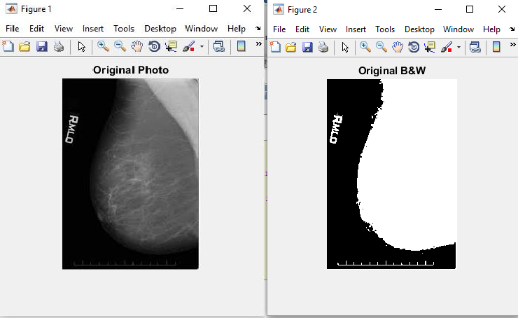

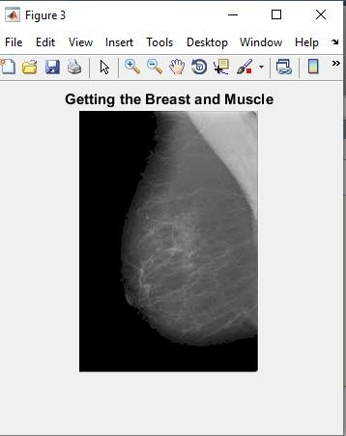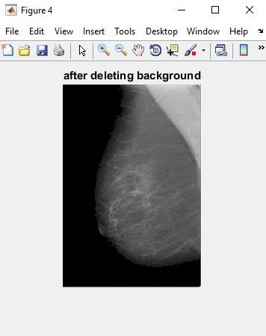

4” Figure S *a x* Figure 6

File Edit View Insert Tools Desktop Window Help F)I/ Edit View Insert Tools Desktop Wind0w Help *

Getting only the Breast Weiner Filter





TEST IMAGE 2-

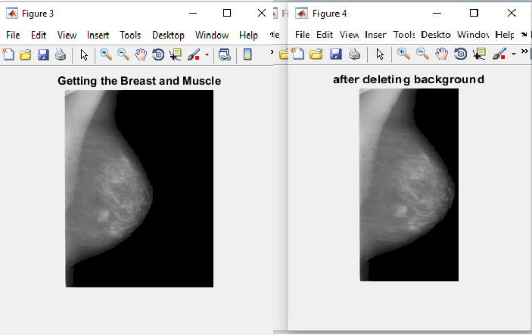

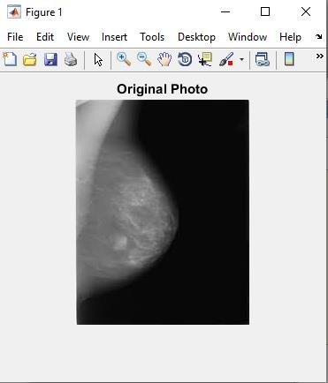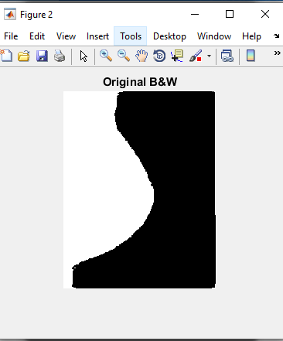

J' Figure fi *D X A'* Figure 6 *— O X*

File Edit Via lnser Tool• Deskto Windo Help ” File Edit Via lnser To ol' Deskto Window Help ^

Getting only the Breast Weiner Filter





TEST IMAGE 3:

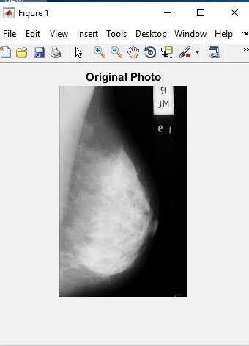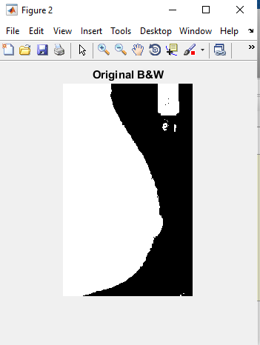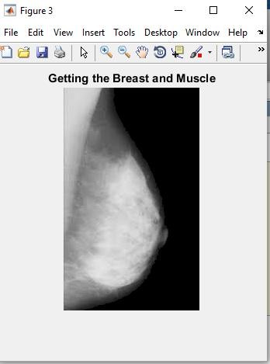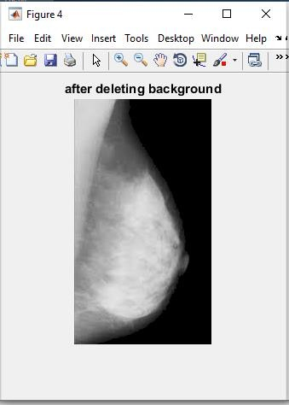

”6” Figure fi *— @ ”T”* Figure 6

File Ed it Vi ew In sert Tools Desktop Window Help • i File Ed it Vi ew InEert To oIE D eEktop Window Help ^

Getting only the Breast Weiner Filter





TEST IMAGE 4:

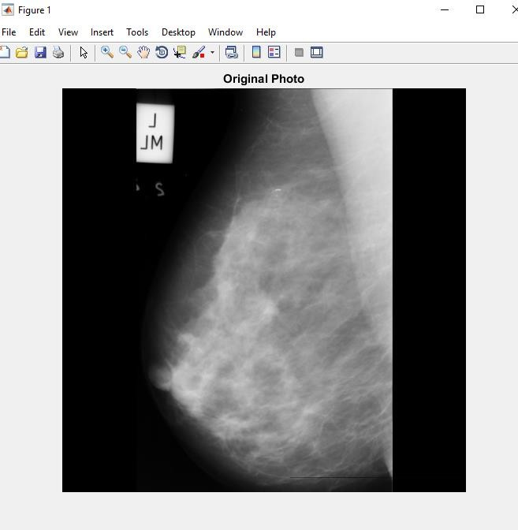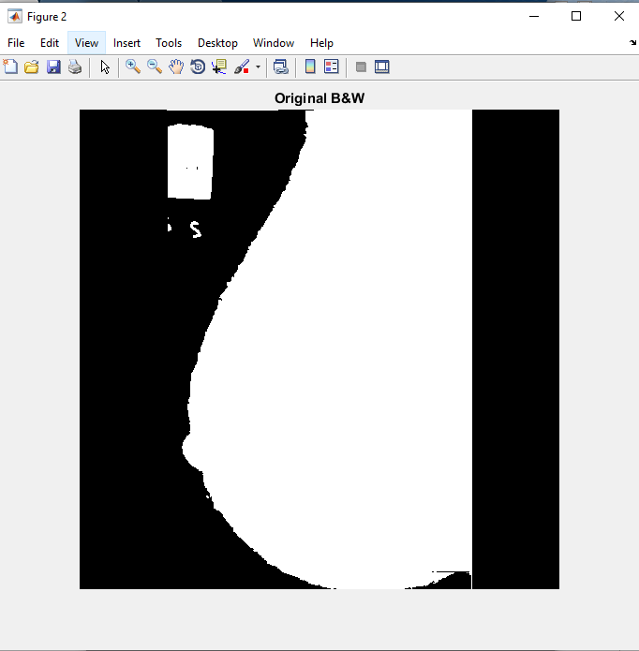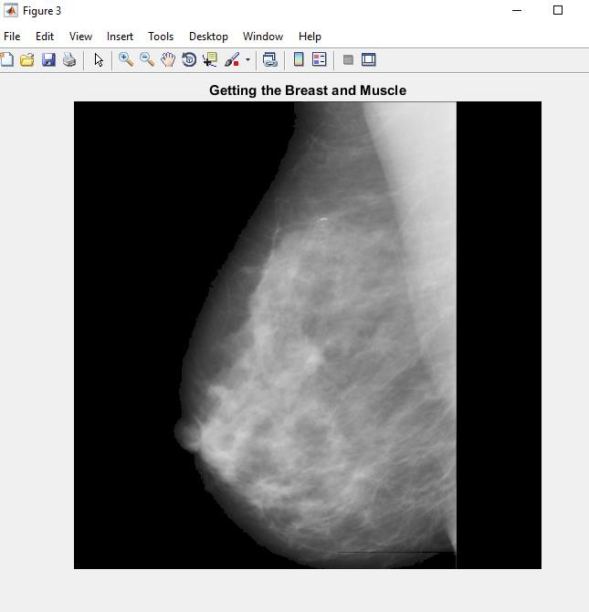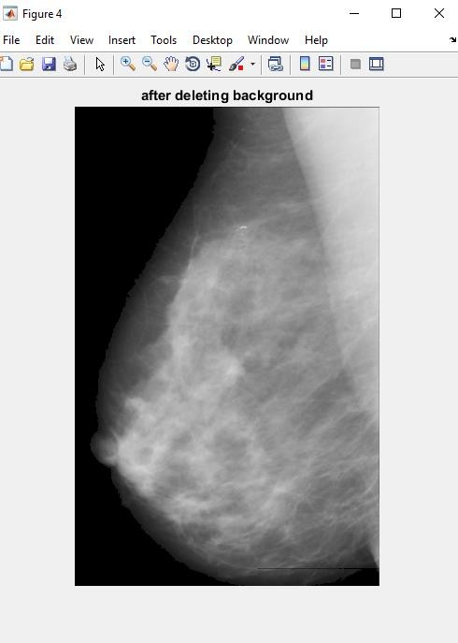

File Edñ View Imert Toob Desktop Window Help

o File Edit Yicw Insert Toob Desktop Window I-klp

•

Gettlng only the Breaat

Welner Filter



TEST IMAGE 5:

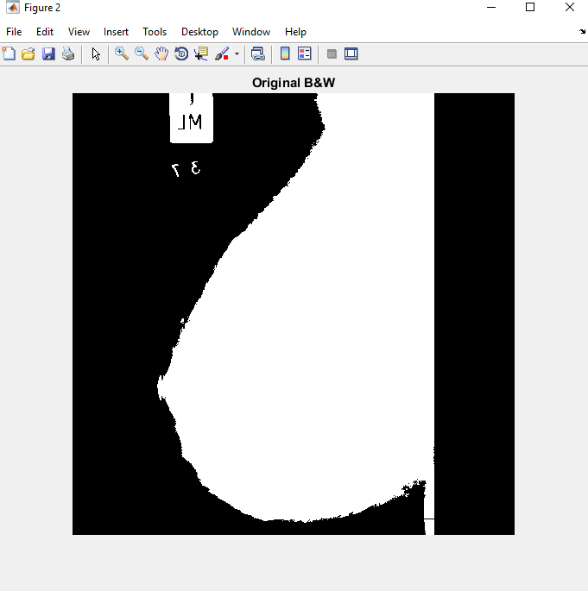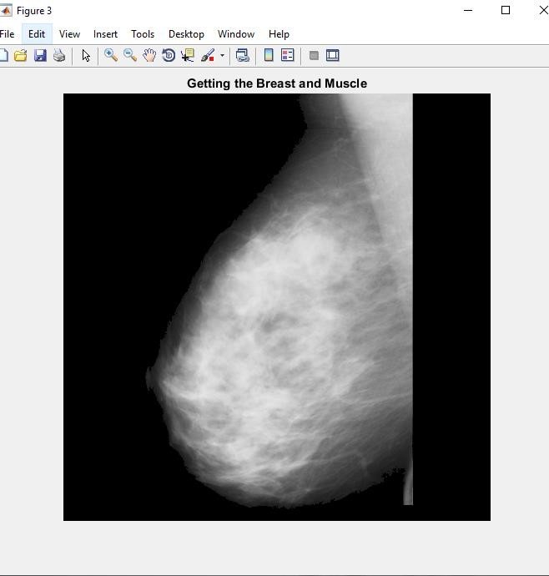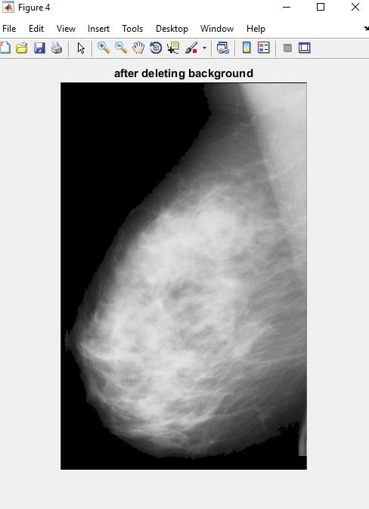

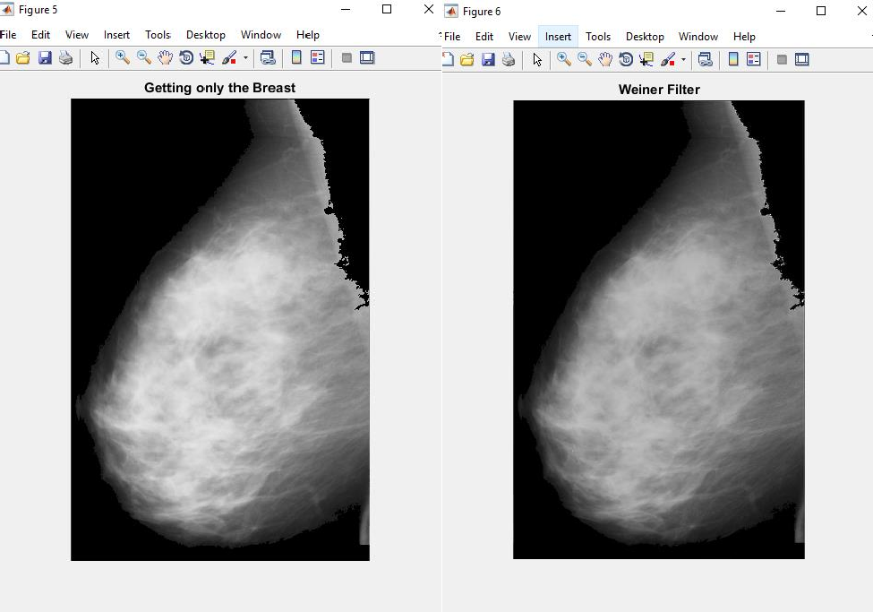

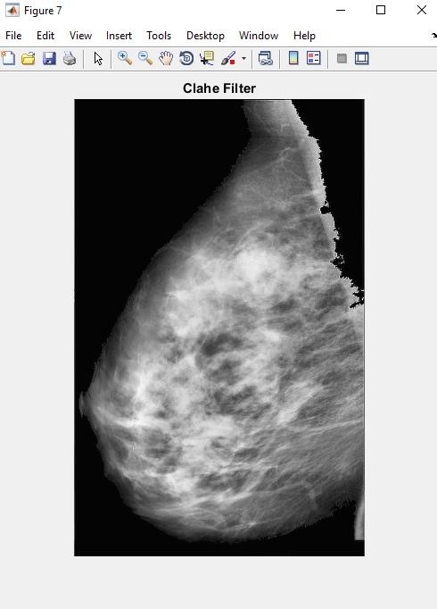

## INFERENTIAL DISCUSSIONS:

In photoshop , if the image in jpeg format is compressed more than 60%, then we are getting a little burred image as the breast profile. This is because when a jpeg format image is compressed the quality of the image reduces as it is compressed more.

But if a jpg format image is compressed the quality will remain the same , only size is reduced. So whenever an image is needed to be compressed, jpg format is recommended.

Result to show compression of a jpeg image more than 60%-

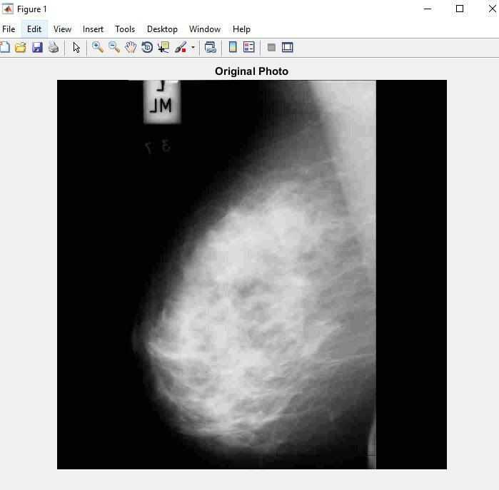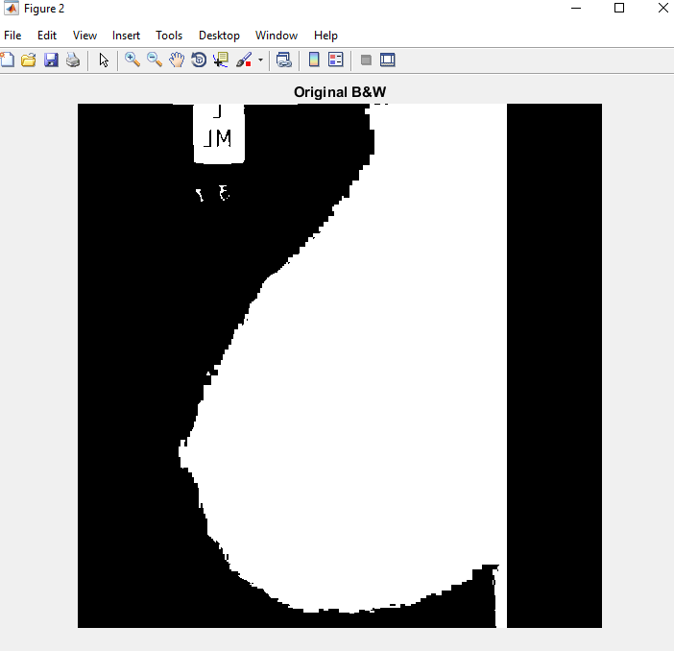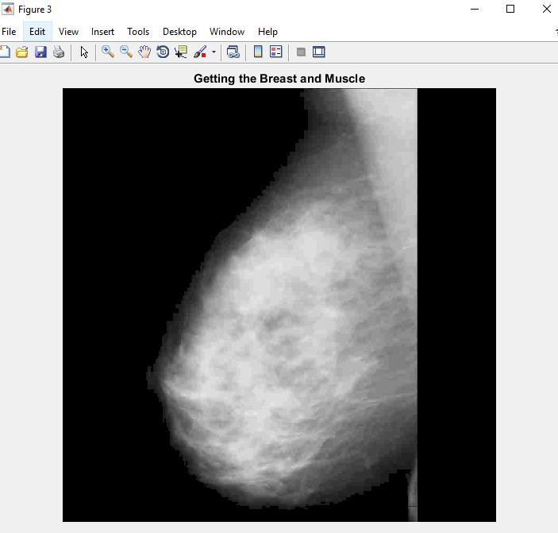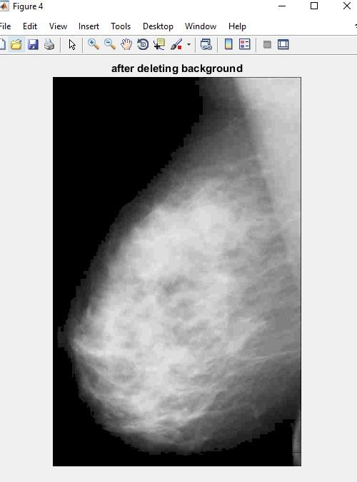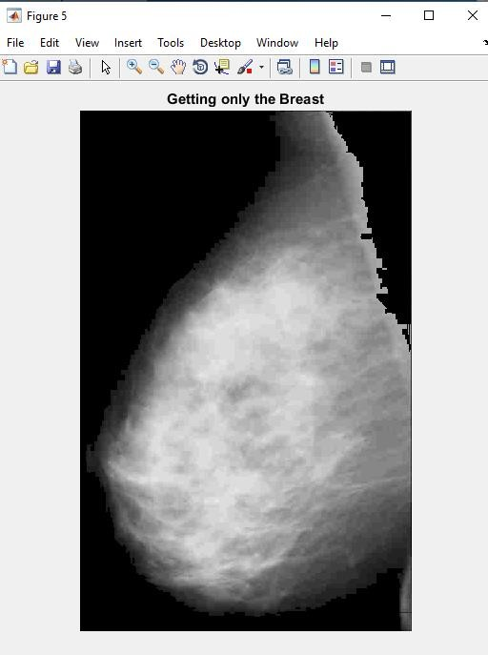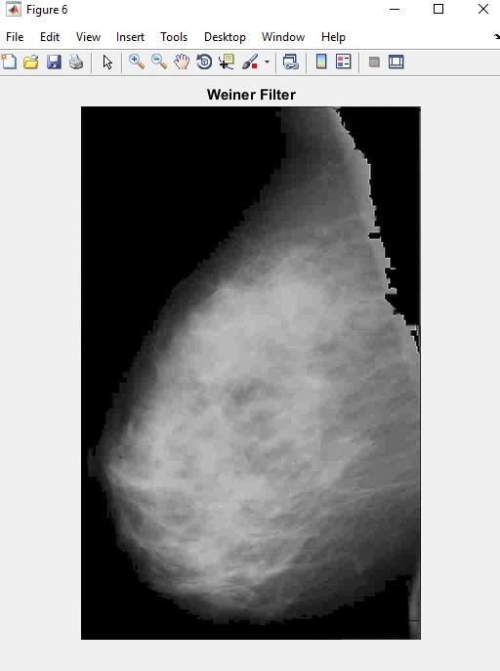

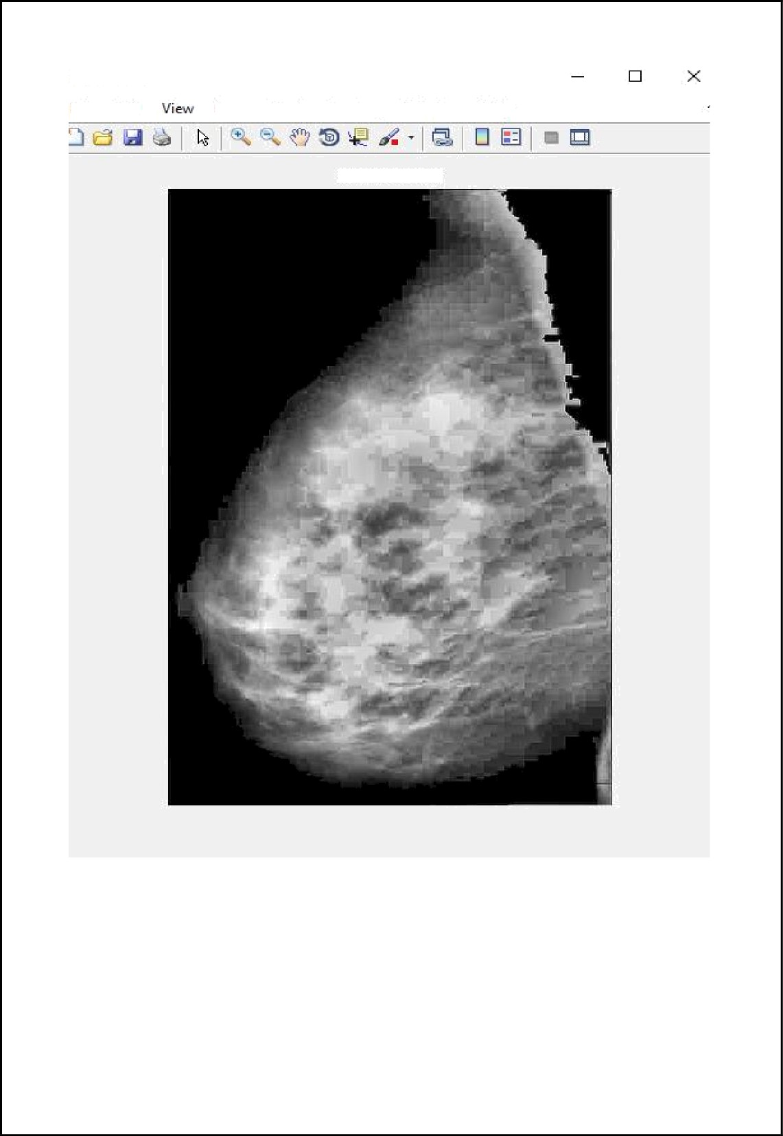Figure 7

Fife Edrt Insert Tools Desktop Window Help

Clahe Filter

## CONCLUSION

Timely screening may help to detect the abnormality but current screening method, the mammography is low dose x-ray image. It may miss the small changes in the breast because of low dose x-ray it generates poor contrast image. The missed changes may lead for serious problem. Hence, CAD system helps to identify the diminutive changes in the breast. This early detection may save the life of the patient. The proposed method of pre-processing presented with removal of background artefacts, pectoral muscle suppression and image quality enrichment helps much in early detection. Our results show that, significant filter mask for wiener filter and CI is 0.2 for CLAHE are influencing factors for enhancement of mammography. The complete pectoral muscle was reduced by modified region growing techniques. The proposed method tested on images of .jpeg; .jpg format and ROI extracted from all the images accurately and proved to be suitable for CAD system of early detection of breast cancer. Collectively, these results prove that effective and convenient assistance for medical diagnosis. Hence, the proposed method can be considered for automated detection of abnormality like benign, malignant and micro calcifications.