**AUTOMATIC PLANT WATRING SYSTEM**

ANIRUDH ADIGA

**ABSTRACT**

Indaily operations related to farming or gardening Watering is the most important cultural practice and the most labour-intensive task. No matter whichever weather it is, either too hot and dry or too cloudy and wet, you want to be able to control the amount of water that reaches your plants. Modem watering systems could be effectively used to water plants when they need it. But this manual process of watering requires two important aspects to be considered: when and how much to water. In order to replace manual activities and making gardener's work easier, we have create automatic plant watering system. By adding automated plant watering system to your garden or agricultural field, you will help all of your plants reach their fullest potential as well as conserving water. Using sprinklers drip emitters, or a combination of both, we can design a system that is ideal for every plant in our yard.

For implementation of automatic plant watering system, we have used combination of sprinkler systems, pipes, and nozzles. This project uses the ATmega328 microcontroller. It is programmed to sense moisture level of plants at particular instance of time, if the moisture content is less than specified threshold which is predefined according to particular plant's water need then desired amount of water is supplied till it reaches threshold. Generally, plants need to be watered twice a day, morning and evening. Thus, the microcontroller is programmed to water plants two times per day. System is designed in such a way that it reports its current state as well as remind the user to add water to the tank. All this notifications are made through mobile application. We hope that through this prototype we all can enjoy having plants, without being worried about absent or forgetfulness. The project depends on a straightforward thought of dampness or moisture of soil. The Arduino based system is modified to detect dampness dimension of plants at specific occurrence of time, if the moisture content is not exactly determined which is the required water substance and as indicated by it the ideal measure of water provided till it achieves edge. This idea is to plan and grow minimal cost system which depends on embedded system for water irrigation system framework. This system utilizes soil moisture sensor to identify the water amount present in soil. The project utilizes Arduino Uno which is a controller to process the data. Irrigating fields is the most important and a very laborious task for the farmers, especially in the summer season. Manual watering increases the difficulty and is time consuming. Thus, we need effective technologies to overcome these problems. Auto-watering systems can be efficiently used to water plants when needed, which controls when and how much watering needs to be done. This system can be effectively used from small gardens to a large crop field, thus also conserving water. We can implement the above prototype using sprinklers or drip emitters for effective irrigation. For large scale implementation, we can use solar panels to conserve energy.

**KEYWORDS-Aurdino uno, Soil moisture sensor, Relay module, Microcontroller ATmega328P.**

**INTRODUCTION**

We as a whole realize that plants are exceptionally helpful to every person in numerous angles. Plants gives us oxygen which is very much essential to live. Numerous individuals grow plants in their homes. Be that as it may, because of progress and deficiency of place numerous individuals used to grow plants in their homes The plants on regular reproducing and watering give the appropriate measure of sun to support life and development.

**PROBLEM STATEMENT-**

Many times, due to busy schedules, people forget to water their plants, which hinder their healthy growth. Also, it is very difficult for farmers to water their fields manually and to provide accurate amount of water for healthy growth of

plants. Management of water also becomes a huge task due to water scarcity, since manual irrigation leads to wastage of water. Also, to avoid empty tank user should be notified to switch ON the motor to fill the tank. To solve this problem we implement the methodology described in figure 1.

**METHODOLOGY -**

Based on our problem statement, we have created a prototype to implement a automatic plant watering system considering all aspects of small gardens to large crop fields. The main components of the project are Arduino UNO, soil

moisture sensor, water level sensor, water pump and GSM module. Using ARDUINO IDE software we can program ARDUINO in such that it irrigates the plants based on the feedback of moisture content provided by the soil moisture

sensor. When moisture content is lower than a prescribed limit, water pump starts irrigating. We can use sprinkler or drip system for irrigation [7]. When moisture content reaches the maximum limit, the water pump automatically

switches off. The user will be notified whenever water content is low and also after the field gets irrigated with the details of temperature and moisture. The water level sensor will be placed inside the tank. When the water level reaches

a lower limit in the tank the user will be notified to switch ON the motor to fill the tank. Also, to avoid overflow, the user will be notified when the water level reaches the maximum limit so that they can switch OFF the motor.

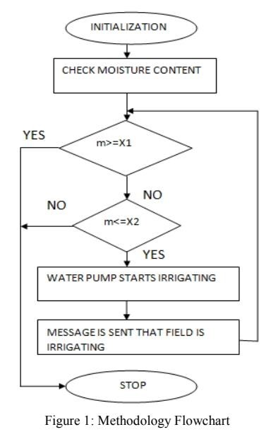

# COMPONENTS USED

# A. ARDUINO UNO -

Arduino is an open-source platform based on easy to use hardware and software which can be used as per requirements by the user. The board is based on Microchip ATmega328P 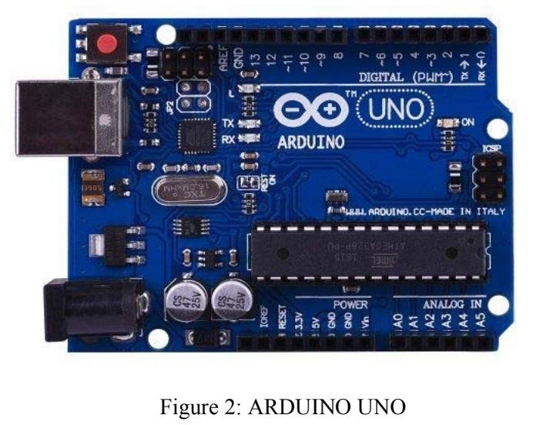microcontroller, consisting of 14 digital pins, 6 analog pins, reset pin and is programmable with the Arduino IDE via a type B USB cable as shown in Figure 2. The board will be programmed such that it measures the moisture amount in the soil as well as water level in the water tank and notifies the user with the readings [9]

**B. SOIL MOISTURE SENSOR-**

This sensor (in Figure 3) measures the soil water content using few properties of the soil, such as dielectric constant, electrical resistance, or interaction with neutrons, as a substitute for the moisture content. The two probes allow current to pass through the soil through which it evaluates the resistance value and thus concludes to the moisture value. Wet soil is a good conductor of electricity, i.e., less resistance. Thus, high moisture level is detected. Dry soil is a bad conductor of electricity, i.e., more resistance, i.e., the moisture level will be low .

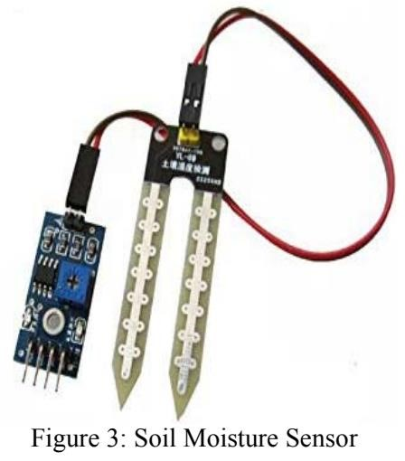

# C. THE RELAY MODULE -

Relay is an electrically operated switch. Many relays for switching solenoid mechanism mechanically operated, but can also be used for other principles of operation. Relays are widely used in early computers to telephones and perform logical operations.

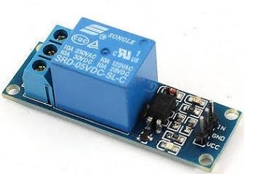

# D.WATER PUMP-

Water is used to perform a specific task of artificially pumping. It can be controlled by an electronic microcontroller. It can be on 1 triggered by sending the signal and turned off as needed. Artificial process is called Water Pumping Station. There are many varieties of pumps. This project uses a small pump connected to the H-bridge.

**CONCLUSION**

The Automated Water Planting System using Arduino is a system that measures the water content in the soil and controls the rate of flow of water. The system uses sensors, placed in soil, to get the amount of water present in the soil. The system, after attaining the moisture content, checks if it is in the scientifically prescribed range. If it is not in the prescribed range, it controls the water content accordingly. This system eliminates the possibilities of human error.

We summarize the important functions or features of watering systems. The functions are important for developing or enhancing automatic plant watering systems. It provides some discussions of the proposed system and its results. Different plants have different watering requirements. Garden centres have a responsibility to cater to the watering needs of many types of plants. Current watering systems in many garden centres are simply timer-controlled sprinkler systems. This method is prone to over- or under-water to some plants as there is no means of monitoring the moisture content of the soil. The prototype proved that this concept is completely viable. However, in order to be a reliable system, a reliable moisture sensing circuit is required. A simple circuit is not accurate enough to be used in a professional garden centre. The project may need to minimize the efforts of major agricultural regions. Many aspects of the system can be customized and used software to fine-tune the requirements of the plant.

This is a low budget project which the farmers of the country can easily afford and can be further improved using technology. This project solves the problem of manual watering and saves a lot of time user. It also focuses on conserving water with increased accuracy in water distribution to the crops and energy. This project includes monitoring soil moisture and supplying water uniformly to the plants using sprinkler or drip system. It also keeps the track of water level. Thus, there is minimal waste of water. The system also allows the delivery to the plant when needed based on the type of plant and soil moisture.

**FUTURESCOPE**

The proposed system is cost efficient, this claim is made on the fact that the proposed system does not need the heavy and expensive hardware for implementation. This type of automated irrigation system consumes 40-50% less water as compared to the traditional system Ideal growth condition is been provided when small amount of water is been applied over large amount of time.

This smart irrigation system extends watering time for plants, and provides ideal growth condition. It saves time and timer delay as per the environmental condition can be added for automatic watering. This smart irrigation system can be adjusted and modified according to the changing environment. Future developments to be made on this work include adding a user programmable aspect to the device, allowing the users to program their own moisture thresholds for group of plants, and adding a system to allow many soil probes to send signals to the microcontroller. This could be achieved by multiplexing the soil probes, reading their signals one at a time.

With the correct adjustments and developments, this system has the potential to improve the health of plants by accurately and reliably providing the correct amount of water to each group of plants and will prove to be a valuable resource for garden centres. This system also has the potential to be affordable enough for many garden centres, large and small. The product can be interfaced with a garden centre’s current sprinkler system, meaning the garden centre must only pay the cost of the control system, the soil probes, and the installation costs. With further research, it can be enhanced to yield more of its functionalities such as automatically calculating energy and water amount consumed by the system. It is simple to operate as it starts by designing the map of your garden and marking the location of planting.

**REFERENCES**

1.M. A. Hanjra and M. E. Qureshi, “Global water crisis and future

food security in an era of climate change,” Food Policy, 2010.

2. K. J. Singh and D. S. Kapoor, “Create your own internet of

things: A survey of iot platforms.” IEEE Consumer Electronics

Magazine, 2017

3. G Alex, Dr.M. Janakiranimathi, “Solar Based Plant Irrigation System”,

IEEE, Chennai, Tamil Nadu, 2016

4. Lala Bhaskar, BarkhaKoli, Punit Kumar, Vivek Gaur, “Automatic Crop

Irrigation System”, IEEE, Noida, India, 2015

5. Jonathan GanaKolo, "Design and Construction of an Automatic

Power Changeover Switch" in AU Journal of Technology, 11(2):

(Oct. 2007)

6. Sanjukumar, R.V. Krishnaiah, "Advance Technique for Soil

Moisture Content Based Automatic Motor Pumping for Agriculture

Land Purpose.

7. Chikankar, Pravina B., Deepak Mehetre, and Soumitra Das. "An

automatic irrigation system using ZigBee in wireless sensor

network." In Pervasive Computing (ICPC), 2015 International

Conference on, pp. 1-5. IEEE,2015.

Reference Links: <https://ieeexplore.ieee.org/document/7557245>

<https://ieeexplore.ieee.org/document/8899452>

<https://ieeexplore.ieee.org/document/8899371>

<https://ieeexplore.ieee.org/document/8712791>

<https://ieeexplore.ieee.org/document/7438404>