Assignment 13

Ques 1 : Follow Up the Instruction mentioned in the Below link and raise a new Pull Request with all the changes.

Link: https://github.com/DARK-art108/git-tutorial

Soln: forked the repo

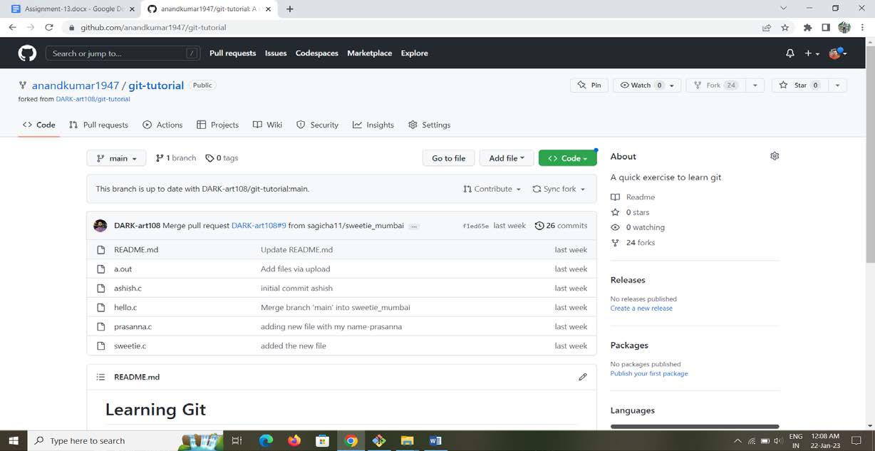

Cloning the repo

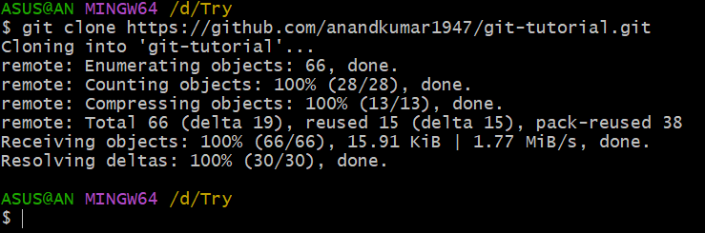

Creating a new branch

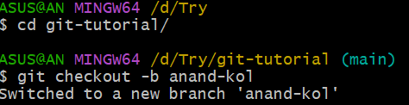

Creating a new file and copying content of hello.c

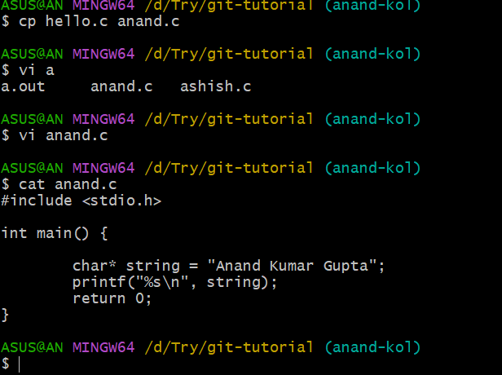

Commiting the changes to branch

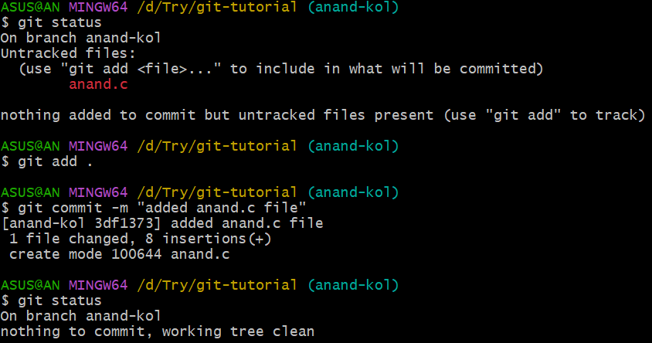

Merging to local main

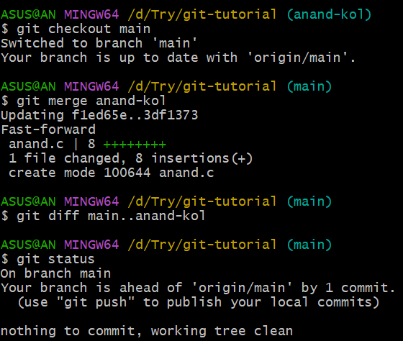

Pushing the code to forked repo

