Ques: Complete the below task:

1. Explain the below AWS Architecture
2. Implement the same in the AWS(only do a proper connection between service)

**NOTE:** *Submission can be done by sharing the proper screenshots of implementation and doc for explanation!*

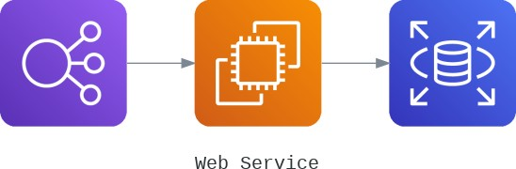

1. **Elastic Load Balancer in AWS**

In simplest terms, cloud computing means storing and accessing the data and programs on remote servers that are hosted on the internet instead of the computer’s hard drive or local server. It is also referred to as Internet-based computing.

Features of cloud

No up-front investment

Lowering operating cost

Highly scalable and efficient

Easy access

Reducing business risks and maintenance expenses

Amazon Web Services

Amazon Web Services is a subsidiary of Amazon.com that provides on-demand cloud computing platforms for individuals, companies, and governments, on a paid subscription basis , pay-as-you-go principle. Amazon Web Services offers a highly reliable, scalable, low-cost infrastructure platform in the cloud.

Elastic load balancer .

Elastic load balancer is a service provided by Amazon in which the incoming traffic is efficiently automatically distributed across a group of backend servers in a manner that increases speed and performance. It helps to improve scalability of your application and secures your applications. Load Balancer allows you to configure health checks for the registered targets. In case any of registered target fails the health check, the load balancer will not route traffic to that unhealthy target. Thereby ensuring your application is highly available and fault tolerant.

A. Classic Load Balancer: It is the traditional form of load balancer which was used initially. It distributes the traffic among the instances and is not intelligent enough to support host-based routing or path-based routing. It ends up reducing efficiency and performance in certain situations. It is operated on connection level as well as request level. Classic  Load Balancer is in between the transport layer (TCP/SSL) or the application layer (HTTP/HTTPS .

B. Application Load Balancer: This type of Load Balancer is used when decisions are to be made related to  HTTP and HTTPS traffic routing. It supports path-based routing and host-based routing. This load balancer works at the Application layer of the OSI Model. The load balancer also supports dynamic host port mapping.

C. Network Load Balancer: This type of load balancer works at the transport layer(TCP/SSL) of the OSI model. It’s capable of handling millions of requests per second.  It is mainly used for load balancing TCP traffic.

D. Gateway Load Balancer: Gateway Load Balancers provides you the facility to deploy, scale, and manage virtual appliances like firewall. Gateway Load Balancers combines a transparent network gateway and then distributes the traffic.

1. **EC2 Instances**

EC2 is a virtual server in the AWS Cloud.AWS EC2 is short for AWS Elastic Cloud Compute.

It makes scaling of capacity up and down easy.It makes the process of increasing and decreasing capacity easier.As a result, you can access the resources at demand.

No upfront investment is needed.You only pay for what you need.EC2 is secure.

1. **AWS RDS**

AWS RDS is short for Amazon Relational Database Service

It provides affordable relational databases in the cloud, that is easy to use.

1.Amazon RDS is a Relational Database Cloud Service

2.Amazon RDS minimizes relational database management by automation

3.Amazon RDS creates multiple instances for high availability and failovers

4.Amazon RDS supports PostgreSQL, MySQL, Maria DB, Oracle, SQL Server, and

5.Amazon Aurora

