Ques : Explain the below aws architecture diagram in detail, also deploy the same aws architecture.

* For this assignment we need to take a look and study the documentation for [SAM CLI](https://docs.aws.amazon.com/serverless-application-model/latest/developerguide/install-sam-cli.html), we need to deploy a ***Hello, World application*** on aws lambda.
* Make sure when we test the lambda url it will respond as **Hello, World.**

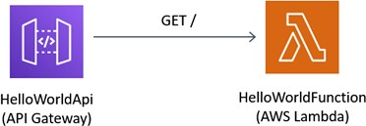

**In the above AWS architecture we have used AWS lambda with amazon API . we can create a web API with an HTTP endpoint for our Lambda function by using Amazon API Gateway. API Gateway provides tools for creating and documenting web APIs that route HTTP requests to Lambda functions. we can secure access to our API with authentication and authorization controls. Our APIs can serve traffic over the internet or can be accessible only within our VPC.**

**Resources in our API define one or more methods, such as GET or POST. Methods have an integration that routes requests to a Lambda function or another integration type. we can define each resource and method individually, or use special resource and method types to match all requests that fit a pattern. A proxy resource catches all paths beneath a resource. The ANY method catches all HTTP methods.**

