Ques 1: Create a container for the below bash script(**prime.sh**).

1. Create a Dockerfile
2. Create a Docker Image

Find the script from here <https://github.com/DARK-art108/Bash-Scripts>

DockerFile of the above script

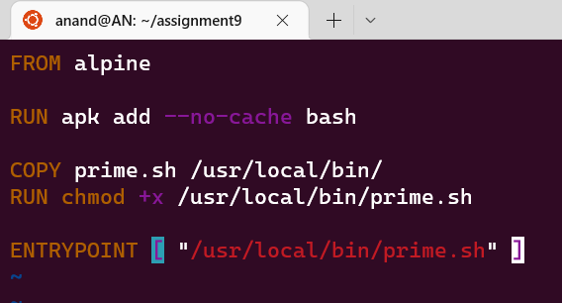

-Building the above Dockerfile

-Then running the container(check) from the created image(prime)

