

**Basic Linux Commands Assignments**

Assignment-1

Connect and disconnect with login Access

* What happens when you login a non-existent users or username?
  + Provide Screenshot and What you understand, explain in short brief?

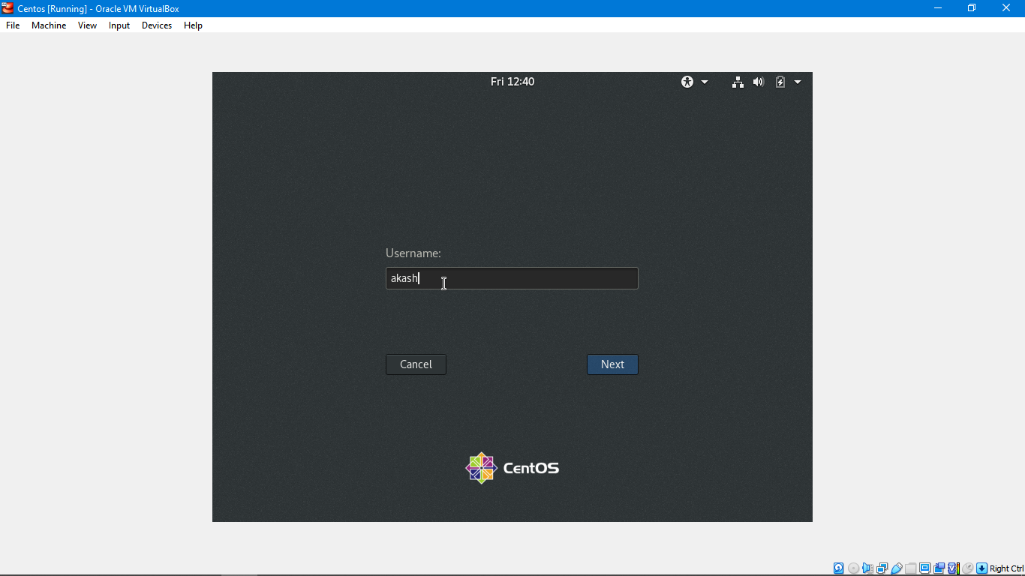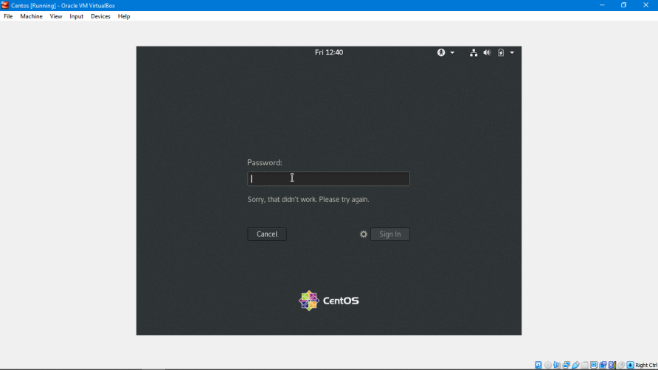

**ANS :- with the above phenomena I understand that we are only able to create user and set its password once at the time of installation and we can only login with that password . No other password or user credentials will work for the first time. But if we want to create more user we can do it after first login with the help of adduser and passwd command and then giving root privileges to that user.following are the command :-**

1. **sudo adduser abc (to create a user with the name “abc”).**
2. **Sudo passwd xyz (to create a password for it “xyz”).**
3. **sudo usermod -aG wheel abc (to give sudo privileges).**

Assignment-2

Password changing

* Login into your account and then change password?
  + Change your password into **IneuR0n#42** and hit the **Enter** key
    - Explain what happen and give screenshot?

**ANS :- password changed successfully which means we can change the password whenever we want to.**

* + Try again to change password but use like password ***1234*** or ***abcd***
    - Explain what happen and give screenshot?

**ANS :- password changed but we got bad password warning as password is short, it is always recommended to create strong password.**

* + Try again to change password but now don’t use any password just hit **Enter** key
    - Explain what happen and give screenshot?

**ANS :- we got no password supplied warning as enter is used to run the command and got to new line and in our case it is doing the same and we would not be able to change password.**

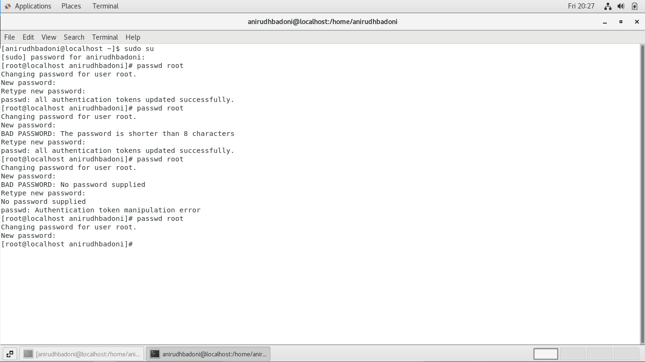

Assignment-3

Working with Directories

* Enter the command **cd /** and then **ls** and then hit **Enter** key
  + Take screenshot and explain what output we got?

**ANS :- whenever we open our terminal and try to find the directory we are on we will find that we are in user directory which is our username so here we just came out of the user directory to the root directory which is the first directory in our file system.**

* Enter the command now **cd /home** and then hit **Enter** key
  + Do **ls,** provide screenshot and explain what is **/home** directory used for?

**ANS:- this is user to go inside the home directory which is inside the root directory.**

* Enter **cd ..** and hit **Enter** key [ *Note: here we have space after cd then use double dot*]
  + Check what happen and give screenshot?

**ANS :- this command is used to come out to the directory we are in to the parent directory of it.**

* Now enter **cd /var/www/html** and then type **cd** and hit **Enter** key
  + Explain what happen and give screenshot?

**ANS :- there is no such directory however there is var directory inside the root directory.**

* Now type **cd /root** and then hit **Enter** key
  + Do **ls,** check any output we have on screen if yes then take screenshot?

**ANS :-This is the home directory of our root user. The / directory is the parental directory for the whole system, whereas this /root directory is the same as our user home directory but it is for the root account If we log in as a root, we will be located in this directory by default. This is a folder for private data and account specific setting of your root account..**

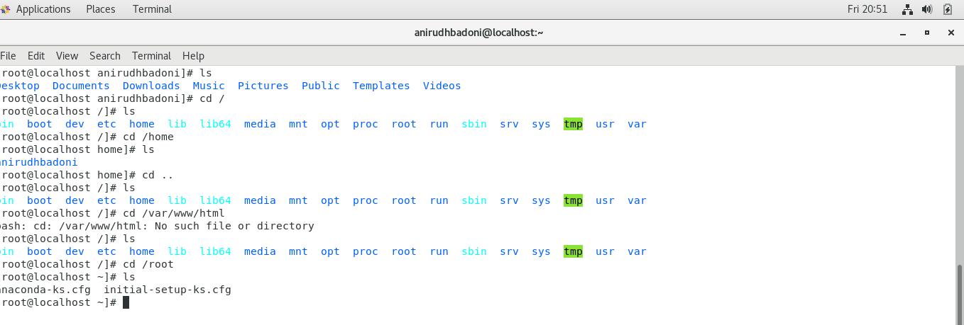

Assignment-4

Working with File Listing

* Go to **cd /etc** and type **ls**
  + Take screenshot and explain what files you have seeing?

**ANS :- folder comprises all system-wide configuration files and some shell scripts that are executed during the system boot. All files here are text files, so they are human readable.**

* + Take screenshot and explain what different output you found compare to previous command you used?

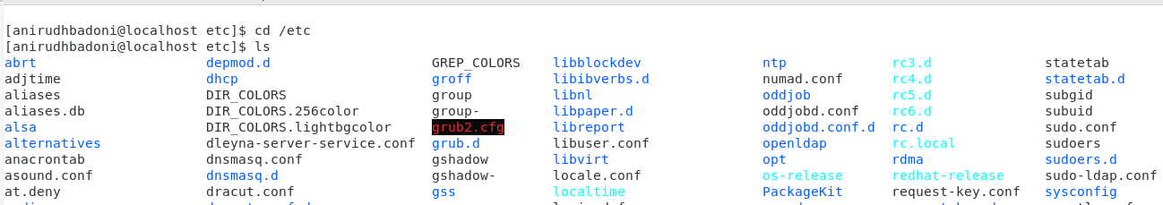

* Then type **ls -al** and hit **Enter** key
  + Take screenshot and explain what new file or directory you found?

**ANS:- this command list all files including hidden files. These are files that start with “.”. and also it list the files in long format i.e. with an index number, owner name, group name, size, and permissions.**

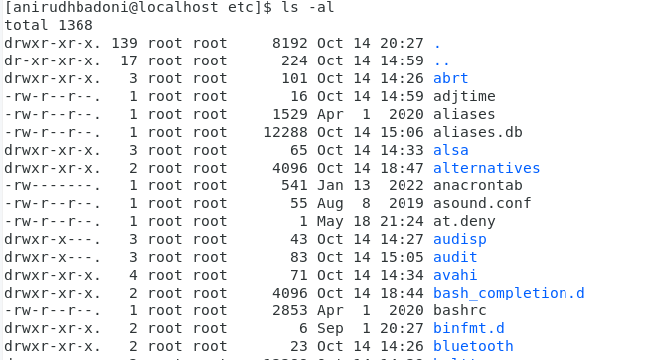

* Then use **ls -i** and hit **Enter** key
  + Now see what different output its shows and take screenshot?

**ANS :-list the files along with their index number.**

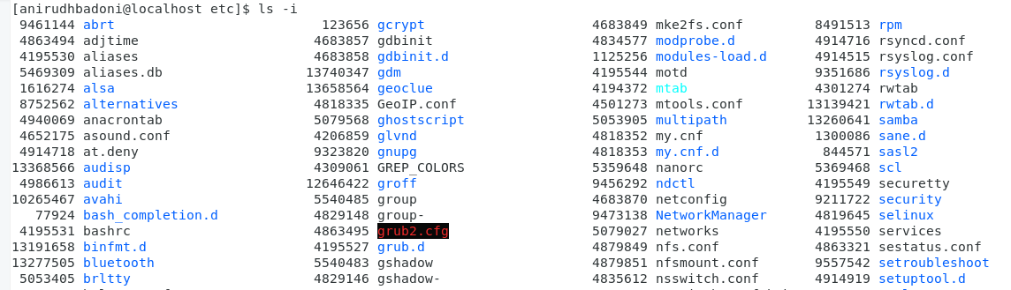

* Then use **ls –help** and see other options about **ls** command
  + Explore it and try with other attribute we can use with **ls** command

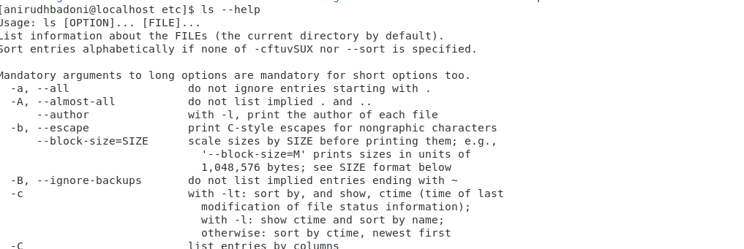

Assignment-5

Know where you are and where you working

*Here we use* ***pwd, cd and ls*** *as combine task to understand where you working on terminal and how you can switch from one directory to another one.*

* Open terminal after restart the linux
  + Check which location you working, type **pwd** and take screenshot
* Now use **cd /var** and hit **Enter** key
  + Do **ls,** and see what output comes, give screenshot?
* Do explore other help options of each command to learn more other things we can do with these commands

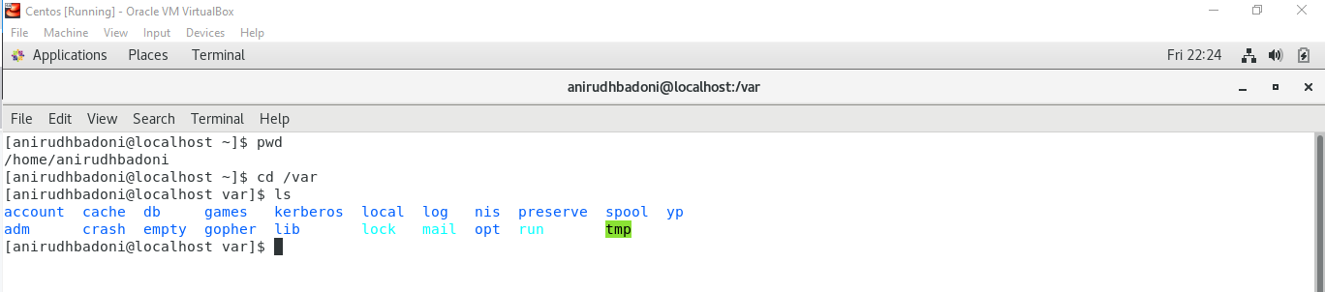

Assignment-6

Install all the dependencies for making centOS full screen.

**ANS :- command and steps used to perform the above tasks were as following(all the commands are given in root level privileges ie.(sudo su)) :-**

1. **yum update**
2. **yum install dkms gcc kernel-devel bzip2 binutils patch glibc-header glibc-devel kernel-header-y**
3. **Go to VirtualBox menu option ‘devices‘ under that you will see ‘insert guest additions cd image’ and install it as root.**
4. **Reboot the centos virtual machine , this was the last step.**

